Preparing date: September , 2024
Teaching date: September, 2024
Week 1 UNIT 1: AT MY BIRTHDAY PARTY
Period 1 Lesson 1
A. OBJECTIVES:
1. Knowledge:
- Sound /p/
- Vocabulary: pasta, popcorn, pizza
- Skills: Integrated skills (speaking and listening)
2. Competences:
- Pronounce correctly pronounce the name of letter P/p and the sound /p/ in isolation.
- Say correctly the words pasta, popcorn, pizza
3. Attitude/ Qualities:
-Actively participate in activities with their classmates in pairs, groups or class. Educate Ss to become studious and obedient students, love food, love learning
English
B. METHODS:
- Work in pairs, work in groups, ask and answer.
- Communicative approach, teaching methods with game, teaching methods by visual, teaching methods by practicing, prediction.
C. TEACHING AIDS:
- Teacher: Posters, laptop, pictures, textbook, lesson plan, TV or projector.
- Students: Textbooks, notebooks, workbooks, school things.
D. PROCEDURE:
Teacher’s activities | Students’ activities | Disabled sts’ activities
1.Warm- up:  Game: Who are you?  *Aims: to help T and ss greet and introduce about each other.  *Procedure:  -T greets the class and introduces yourself, saying: Hello. I’m Miss Huong.  - Encourage Ss to say their names and where they come from (in Vietnamese).  - Introduce (in Vietnamese) Tiếng Anh 2 - Sách học sinh (the number of units, the number of lessons in one unit, and the number of activities in each unit).  - Say “Open your book page 6 and look at Unit 1, Lesson 1”  2. New lesson  Activity 1. 1. Listen and repeat:  *Aims: to correctly pronounce the name of letter P/p and the sound /p/ both in isolation and in the words pasta, popcorn, pizza  *Procedure:  - Have ss look at the picture and draw ss’ attention to the letter P/p, the words next to the things and the colour of the letter P/p.  -Ask ss to point to the letter P/p. Have them listen and repeat the sound of the letter P/p more than once, if necessary.  -Tell ss to point to pizza. Ask them to listen and repeat the word.  -Repeat the same Procedure: with the words: pasta, popcorn, give further support to those ss who find it difficult to do the task.  -Play the recording again and have them listen, point to the letter P/p and the pasta and the popcorn and repeat until they feel confident. Correct pronunciation, if necessary.  -Play the recording again and call some ss to say the letter P/p and the words pasta, popcorn, pizza in front of the class.  Activity 2 2. Point and say:  *Aims: to correctly identify and pronounce the name the words pasta, popcorn, pizza.  *Procedure:  - Have ss look at the picture again and ask them to describe the picture again (in Vietnamese). Draw their attention to the letter P/p, pasta, popcorn, pizza if necessary.  - Get them to point to the letter P/p and say it. Let them point to the word and say,  - Give further support to those ss who find it difficult to do the task.  - Follow the same Procedure: with other things. Give further support to those Ss who find it difficult to do the task.  - Ask ss to work in pairs or in groups to point to the picture and say the sound of the letter P/p and the words. Go around and offer help or correct pronunciation, if necessary.  - Invite two or three ss to point to the picture and say the sound of the letter and the words in front of the class.  - T gets feedback.  Activity 3. *Play Kim’s game:  *Aims: to recognize target words while listening and successfully recall the position of the relevant pictures.  *Procedure:  - Divide the class into 2 teams to play game.  - Display both sets of cards face up on the board. Have ss 2 minutes to memorize their set.  - Turn the card face down on the board. Explain that when you say a correct word you will have one point.  -Have time for ss to play game.  - Count the point for each team and announce the winner. The team with the most points wins. The winning team must then correctly pronounce all of the words.  3. Homework.  - Practice more at home.  - Prepare for the next lesson. | - SS say: Hello. I’m + name.  -SS listen.  -SS open their book.  -Look at the picture and listen.  -Point, listen and repeat.  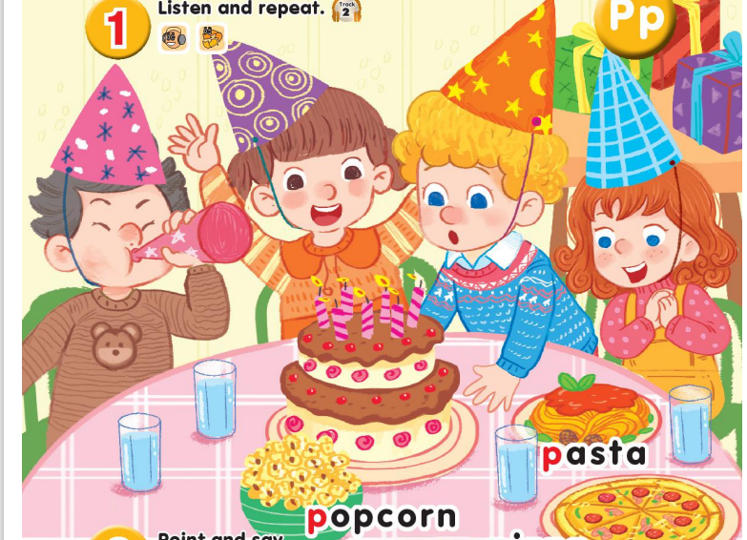  -Ss repeat.  -Ss listen and repeat.  -SS listen, point and repeat.  -SS say in front of the class.  -Look at the picture and describe.  -Point and say  -Work in pairs or in groups.  -Point and say  -Ss look and listen.  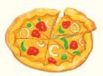  popcorn pizza  paste  -Ss play game.  -SS listen. | - SS say: Hello. I’m + name.  -Look at the picture and listen  -Point, listen and repeat.  -Point and say  -Ss look and listen

E. Adjustments (if necessary):
………………………………………………………………………………………….…..……………………………………………………………………………….
Preparing date: September , 2024
Teaching date: September , 2024
Week 1 UNIT 1: AT MY BIRTHDAY PARTY
Period 2 Lesson 2

A. OBJECTIVES:
1. Knowledge:
- Sound /p/
- Vocabulary: review
- Skills: Integrated skills (speaking and listening)
2. Competences:
- Pronounce correctly pronounce the name of letter P/p and the sound /p/ in isolation.
- Correctly pronounce the words pasta, popcorn, pizza and say the sentence
3. Attitude/ Qualities:
-Actively participate in activities with their classmates in pairs, groups or class. Educate Ss to become studious and obedient students, love food, love learning English
B. METHODS:
- Work in pairs, work in groups, ask and answer.
- Communicative approach, teaching methods with game, teaching methods by visual, teaching methods by practicing, prediction.
C. TEACHING AIDS:
- Teacher: Posters, laptop, pictures, textbook, lesson plan, TV or projector.
- Students: Textbooks, notebooks, workbooks, school things.
D. PROCEDURE:

Teacher’s activities | Students’ activities | Disabled sts’ activities
1.Warm- up: Check-up  *Aims: to help ss remember the words that they have learn in lesson 1.  *Procedure:  -T asks ss to say the letter and the sound they learnt in lesson 1(P/p, /p/)  Say “Open your book page 7 and look at lesson 2”  2. New lesson  Activity 1. 3. Listen and chant  *Aims: to correctly pronounce the words pasta, popcorn, pizza and say the sentence pattern: I like........ in a chant.  *Procedure:  - Have ss look at the chant on p. 7 in their books and draw ss’ attention to the first line and explain its meaning. Ask them to pay attention to the letter P/p and the words: pasta, popcorn, pizza. Check comprehension.  - Play the recording of the first verse for Ss to listen and to get familiarized with the tune.  - Play the recording again, ask ss to listen and repeat the first line. Then play the recording for them to listen and repeat until they feel confident.  - Follow the same Procedure: with the other verse. Show ss how to chant and clap their hands. Correct pronunciation, if necessary.  - Play the recording all the way through. Ask ss to listen and repeat the chant individually and in chorus. Give further support to those ss who find it difficult to do the task.  - Select some ss to the front of the class to chant and clap their hands. The rest of the class may sing the chant along and clap their hands.  Activity 2 4. Listen and tick:  *Aims: to recognize the words pasta, popcorn, pizza and the sentence pattern: I like........ while listening.  *Procedure:  -Have Ss look at two pictures and say what they can see. Draw ss’ attention to the boxes next to the letters a and b. Check comprehension.  -Encourage some ss to point to the pictures and say the words in front of the class.  - Play the recording for ss to listen and tick the box.  - Let ss to listen again and check.  -T gets feedback.  *Keys: 1.a / 2.a  Activity 3. 5. Look and write:  *Aims: to write the letter P/p and complete the words: pasta, popcorn, pizza  *Procedure:  - Have Ss look at the letter P (upper case) and p (lower case). Ask ss to make sure if they recognize the two forms of the letter.  - Tell ss to trace the letter P/p. T can demonstrate by air tracing or tracing the broken lines of the letter P/p on the board.  -Then let ss write the letter. Then find out the missing letter to complete the correct word. Give further support to those Ss who find it difficult to do the task.  - Check the results of ss’ tracing and give feedback. Ask ss to work in pairs and swap their answers. Give ss time to work. Go around and offer help, if necessary.  - Ask some ss to show what they have done.  3. Homework.  - Practice more at home.  - Prepare for the next lesson. | - SS say the letter and the sound.  -SS open their book.  -Look at the picture and listen.  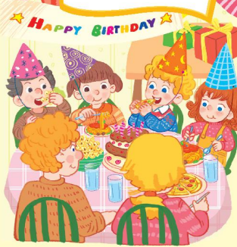  -Ss listen.  -Ss listen and repeat.  -SS listen and chant.  -SS chant.  -SS chant in front of the class.  -Look at the picture and describe.  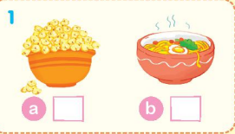  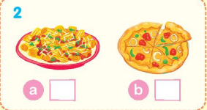  -Point and say  -SS do the task.  -Ss check.  -Ss look and listen.  -Ss listen.  -SS do the task.  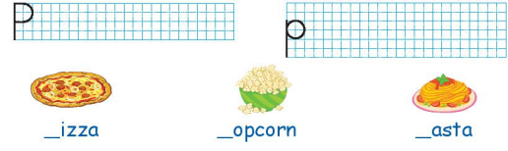  -Check in pairs.  -Ss show their work.  -SS listen. | - SS say the letter and the sound.  -SS open their book  -Look at the picture and listen.  -SS listen and chant.  -Look at the picture and describe.  -Ss look and listen.  -SS do the task.

E. Adjustments (if necessary):
………………………………………………………………………………………….…..……………………………………………………………………………………….….........................................................................................................................................................................................................................................................

