Week 31 Preparing date: April …….,
Period 121 Teaching date: April………,

Unit 18: At the shopping center
Lesson 2 (4, 5, 6)
A. OBJECTIVES:
By the end of the lesson, Ss will be able to:
1. Knowledge:
- listen to and demonstrate understanding of simple communicative contexts in relation to the topic “At the shopping centre”.
- read and write about locations and prices
- Vocabulary: Review
- Skills: speaking, listening, reading and writing.
2. Competences:
- Co-operation: ready to help friends in pair work/ group work.
- Self-control and independent learning: perform listening tasks.
3. Attitude/ Qualities:
- Kindness: Help partners to complete learning tasks.
- Honesty: tell the truth about feelings and emotions.
B. TEACHING AIDS:
- Teacher: Teacher’s guide Pages 260, 261; audio Tracks 78; website hoclieu.vn, posters, laptop, pictures, textbook, lesson plan, TV or projector.
- Students: Pupil’s book Page 55, notebooks, workbooks, school things.
C. PROCEDURES:
Stages/Time | Teacher’s activities | Students’ activities | For Disable  Students  (dành chohs khuyết tật)
1.Warm- up:  (5’)  2.Practice: (27’)  3. Homework. (3’) | Game: Let’s go shopping game (PPT)  *Aims: to create a friendly and active atmosphere in the class to beginning the lesson.  *Procedure:  - Divide the class into 2 teams.  - Have Ss from each team choose an object they want to buy, then answer the question.  - If the Ss answer correctly, they get the points (coins) for that question to buy that object.  - After 6 numbers, the team with the most points is the winner  - Say “Open your book page 55” and look at “Unit 18, Lesson 2 (4,5,6)”.  Activity 1. Listen and number:  *Aims: Ss will be able to listen to and understand four communicative contexts in which characters ask and answer questions about prices and number the correct pictures.  *Procedure:  - Have Ss look at the four picture cues and ask:  + How many pictures are there?  + What can you see in each picture?  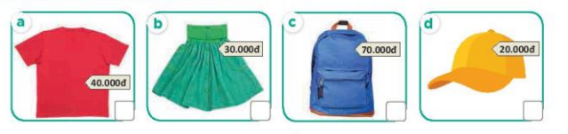  -T ask Ss to guess the answers.  + T writes Ss’guessing on the board.  - Listen to the tape:  + Play the recording  + Play the recording again and get Ss to swap books with their partners.  + Play the recording again to check answers together as a class.  + Write the answers on the board for Ss to correct their answers. Then checks Ss’ guessing.  - Play the recording, sentence by sentence, for the class to listen and repeat in chorus.  Key: 1.c 2. a 3.d 4.b  Activity 2. Look, complete and read.  *Aims: Ss will be able to complete two gapped dialogues about prices with the help of picture cues.  *Procedure:  - Have Ss look at the picture in Question 1 and prompt them to ask and answer questions about the items and their prices 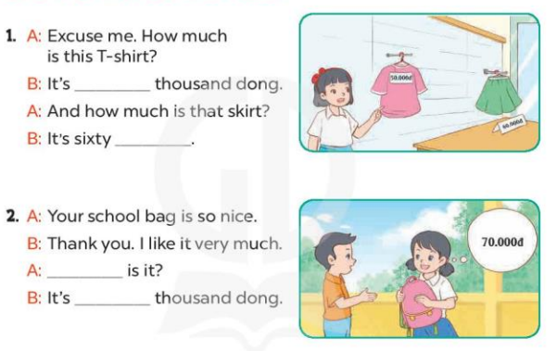  - T models with sentence 1.  + Have Ss look at the sentence.  + Ask them what is missing in the answer (fifty).  + Have Ss complete the gap.  + Have Ss read the completed sentence in chorus.  -Have Ss work in pairs and complete the other sentences.  - Invite pairs of pupils to stand up and read aloud the sentences.  - T gives feedbacks.  Key: 1. fifty; thousand dong  2. How much; seventy  Activity 3. Let’s play- Guess the price!  *Aims: Ss will be able to review the words for prices and items at the shopping centre by playing the game Guess the price!  *Procedure:  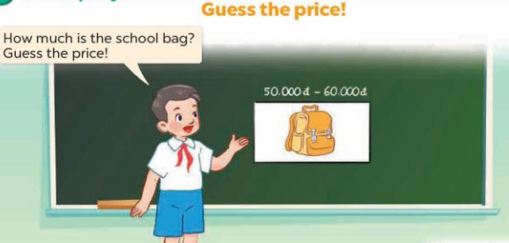  - Tell Ss that they are going to guess the prices of some items as quickly as possible  - Put a picture card ( example: a school bag) on the board.  - Write a price range as a clue to help pupils guess the price (ex: 50.000đ – 60.000đ). Write the correct price on a piece of paper (ex: 55.000đ).  - Ask How much is the school bag?  - Invite some Ss to guess the correct price  + If anyone guesses correctly, show the class the piece of paper.  + Ask the class to read the price.  - Play the game several times with different items.  *Consolidation  *Aims: Ss will be able consolidate and wrap up the content of the lesson.  *Procedure:  - T asks ss to answer the following questions:  + What have you learnt from the lesson today?  +What are the core values of the lesson? (if the teacher can take from the lesson).  - T praises some Ss who are hardworking / active/ good…. as well as encourage others to try more.  - Prepare the new lesson: Unit 18, Lesson 3 (1,2,3). | - Ss listen and play the game  - Ss open their books  -Look at the pictures and say:  + Picture a: a T-shirt with its price tag of forty thousand dong  + Picture b: a skirt with its.  + Picture c: a school bag with its price tag of seventy thousand dong  + Picture d: a hat with its price tag of twenty thousand dong  -Ss guess the answers  - Ss listen to the tape and tick  - Ss listen again, tick and swap books with their partners.  - Ss check their answers together  -Ss write the correct answer and checl ss’ guessing  -Ss listen and repeat.  -Ss look at the pictures and say  -Ss pay attention and answer  -Ss read and complete  -Ss work in pairs and do the task  -Ss read aloud the sentences  - Ss listen  -Ss listen  -Ss play the game  -Ss listen and answer  -Ss listen and take note | - Ss listen and play the game  - Ss open their books  -Look at the pictures and say:  + Picture a: a T-shirt with its price tag of forty thousand dong  + Picture b: a skirt with its.  + Picture c: a school bag with its price tag of seventy thousand dong  + Picture d: a hat with its price tag of twenty thousand dong  -Ss guess the answers  - Ss listen to the tape and tick  - Ss listen again, tick and swap books with their partners.  - Ss check their answers together  -Ss write the correct answer and checl ss’ guessing  -Ss listen and repeat.  -Ss look at the pictures and say  -Ss pay attention and answer  -Ss read and complete  -Ss work in pairs and do the task  -Ss read aloud the sentences  - Ss listen  -Ss listen  -Ss play the game  -Ss listen and answer  -Ss listen and take note

D. ADJUSTMENTS (if necessary):
………………………………………………………………………………………….…..……………………………………………………………………………...………………………………………….…..……………………………………………………………………………….……………………………………………………………………...

Week 31 Preparing date: April ……., 2024
Period 122 Teaching date: April………, 2024

Unit 18: At the shopping center
Lesson 3 (1, 2, 3)
A. OBJECTIVES:
By the end of the lesson, Ss will be able to:
1. Knowledge:
- correctly pronounce the two-syllable words be'hind and be'tween with the stress on the second syllable in isolation and in the sentences The bakery is be'hind the bookshop. and The bakery is be'tween the bookshop and the sports shop.
- listen to and demonstrate understanding of simple communicative contexts in relation to the topic “At the shopping centre”
- Vocabulary: Review
- Skills: speaking, listening, reading and writing.
2. Competences:
- Co-operation: ready to help friends in pair work/ group work.
- Self-control and independent learning: perform listening tasks.
3. Attitude/ Qualities:
- Kindness: Help partners to complete learning tasks.
- Honesty: tell the truth about feelings and emotions
B. TEACHING AIDS:
- Teacher: Teacher’s guide Pages 262, 263; audio Tracks 79, 80, 81; website hoclieu.vn, posters, laptop, pictures, textbook, lesson plan, TV or projector.
- Students: Pupil’s book Page 56, notebooks, workbooks, school things.
C. PROCEDURES:
Stages/Time | Teacher’s activities | Students’ activities | For Disable  Students  (dành chohs khuyết tật)
1.Warm- up:  (5’)  2. Presentation  (9’)  3.Practice: (19’)  4. Homework. (2’) | Game: Who’s faster?  *Aims: to create a friendly and active atmosphere in the class to beginning the lesson.  *Procedure:  - Ask Ss look at the screen  - They look, read and say the number  - If they have the answers they can raise their hands to give the answers  - Say “Open your book page 56” and look at “Unit 18, Lesson 3 (1,2,3)”.  Activity 1. Listen and repeat:  *Aims: Ss will be able to correctly repeat the two-syllable words be'hind and be'tween with the stress on the second syllable in isolation and in the sentences The bakery is be'hind the bookshop. and The bakery is be'tween the bookshop and the sports shop.  *Procedure:  - T gives instruction to the two-syllable words be'hind and be'tween with the stress on the second syllable in isolation and in the sentences The bakery is be'hind the bookshop. and The bakery is be'tween the bookshop and the sports shop.  - Play the recording for the word behind, between  - Encourage Ss to point at the word, sentence while listening.  - Play the recording again and encourage Ss to listen and repeat.  - Do this several times until Ss feel confident.  - T calls some Ss to practice.  - T gives feedbacks.  Activity 2. Listen and circle.  *Aims: Ss will be able to identify the target words behind and between while listening.  *Procedure:  - Elicit the sentences and explain that they have to listen.  - T ask Ss to guess the answers.  + T writes Ss’guessing on the board.  - Listen to the tape:  + Play the recording  + Play the recording again and get Ss to swap books with their partners.  + Play the recording again to check answers together as a class.  + Write the answers on the board for Ss to correct their answers. Then checks Ss’ guessing.  - Play the recording, sentence by sentence, for the class to listen and repeat in chorus.  - Invite one or two Ss to stand up and read the completed sentences.  Key: 1.b 2.c  Activity 3. Let’s chant  *Aims: Ss will be able to say the chant with the correct rhythm and pronunciation.  *Procedure:  - Introduce the title and lyrics of the chant.  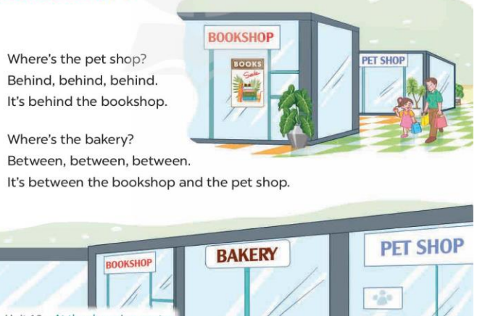  - Play the recording for Ss to listen to the whole chant.  + Have them repeat the title and lyrics line by line.  + Ask Ss to attend to the sounds of the the words behind and between.  - Play the recording all the way through for Ss to listen to pronunciation and melody.  - Play the recording line by line for Ss to listen and repeat  - Play the recording for Ss to chant and clap along.  - Ask Ss to practice chant and clap along in pairs or groups.  - Invite groups to the front of the classroom to perform the chant  -T gives feedback.  *Consolidation  *Aims: Ss will be able consolidate and wrap up the content of the lesson.  *Procedure:  - T asks ss to answer the following questions:  + What have you learnt from the lesson today?  +What are the core values of the lesson? (if the teacher can take from the lesson).  - T praises some Ss who are hardworking / active/ good…. as well as encourage others to try more.  - Practice the chant more.  - Prepare the new lesson: Unit 18, Lesson 3 (4,5,6). | - Ss listen  -Ss play game  - Ss open their books  - Ss recognize the differences about the words with stress  - - Ss listen  - Ss listen and point  - Ss listen again and repeat  -Ss listen again and repeat  -Ss practice  -Ss listen  -Ss listen and say:  -Ss guess the answers  - Ss listen to the tape and circle  - Ss listen again, circle and swap books with their partners.  - Ss check their answers  -Ss write the correct answer and check ss’ guessing  -Ss listen and repeat.  -Ss read the sentences  - Ss look and listen.  -Ss listen to the chant  - Ss listen and repeat line by line without clap their hands.  -Ss note the sounds, words  -Ss listen to melody of the chant  - Ss listen and chant line by line.  - Ss chant and clap along.  - Ss work in groups (two groups) to chant  -Ss perform in front of the class.  -Ss listen.  -Ss answer the questions  -Ss listen and clap their hands  -Ss listen and take note | - Ss listen  -Ss play game  - Ss open their books  - Ss recognize the differences about the words with stress  - - Ss listen  - Ss listen and point  - Ss listen again and repeat  -Ss listen again and repeat  -Ss practice  -Ss listen  -Ss listen and say:  -Ss guess the answers  - Ss listen to the tape and circle  - Ss listen again, circle and swap books with their partners.  - Ss check their answers  -Ss write the correct answer and check ss’ guessing  -Ss listen and repeat.  -Ss read the sentences  - Ss look and listen.  -Ss listen to the chant  - Ss listen and repeat line by line without clap their hands.  -Ss note the sounds, words  -Ss listen to melody of the chant  - Ss listen and chant line by line.  - Ss chant and clap along.  - Ss work in groups (two groups) to chant  -Ss perform in front of the class.  -Ss listen.  -Ss answer the questions  -Ss listen and clap their hands  -Ss listen and take note
D. ADJUSTMENTS (if necessary):
………………………………………………………………………………………….…..……………………………………………………………………………...……………

Week 31 Preparing date: April …….,
Period 123 Teaching date: April………,

Unit 18: At the shopping center
Lesson 3 (4, 5, 6)
A. OBJECTIVES:
By the end of the lesson, Ss will be able to:
1. Knowledge:
- read and write about locations and prices.
- make a shopping list and use it to practise talking about locations and prices in the classroom at Project time.
- Vocabulary: Review
- Skills: speaking, listening, reading and writing.
2. Competences:
- Co-operation: ready to help friends in pair work/ group work.
- Self-control and independent learning: perform reading tasks.
3. Attitude/ Qualities:
- Kindness: Help partners to complete learning tasks.
- Honesty: tell the truth about feelings and emotions.
- Diligence: complete learning tasks.
B. TEACHING AIDS:
- Teacher: Teacher’s guide Pages 264, 265, website hoclieu.vn, posters, laptop, pictures, textbook, lesson plan, TV or projector.
- Students: Pupil’s book Page 57, notebooks, workbooks, school things.
C. PROCEDURES:
Stages/Time | Teacher’s activities | Students’ activities | For Disable  Students  (dành chohs khuyết tật)
1.Warm- up: (5’)  2.Practice: (8’)  3.Production: (19’)  4. Homework. (3’) | Game: Pass the ball  *Aims: to review the vocabulary and structure about greet and respond to greetings.  *Procedure:  .- Divide the class into 3 teams.  - Each team has 1 sticky ball.  - Play the music, Ss in each team take turns passing the ball.  +After the music ends, 3 pupils who have the balls will stand up and say the model sentences.  - Say “Open your book page 57” and look at “Unit 18, Lesson 3 (4,5,6)”.  Activity 1. Read and complete:  *Aims: Ss will be able to read a paragraph and complete a table of information about locations and prices.  *Procedure:  - Have Ss look at the table of gapped information and guess what the missing information is, and what the paragraph is about  - Ask Ss to read through the paragraph once or twice.  - Ask Ss to look at the first gap in the table and encourage them to make a question for it (ex: What is at the bookshop?).  + Help Ss find out the correct answer (book).  + Repeat the same procedure with the other gaps.  + Allow Ss to do the activity independently.  - Have Ss swap their books with a partner and check the answers.  - Select a few pupils to read their answers in front of the class. Check their answers.  Key: 1. book 2. behind the pet shop  3. 50,000 4. ice cream  Activity 2. Let’s write  *Aims: Ss will be able to write a short paragraph about locations, items and prices at the shopping centre with the help of the suggested questions and an incomplete paragraph.  *Procedure:  - Ask pupils to read the title, the given sentence and the questions, then look at the picture to get ideas for their writing.  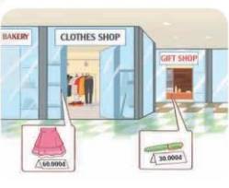  - First, have Ss read the guiding sentence.  + Then ask them to look at the picture to write a sentence about the location of the clothes shop.  + Next, let them write the answer to the question about the price of the skirt.  + After that, let them write sentences about the gift shop and the price of the pen.  -Ask Ss to write the paragraph independently. - Get Ss to swap books with their partners and check their answers in pairs or groups before checking as a class.  Key: Pupils’ own answers  My mother and I are at the shopping centre. The clothes shop is near the bakery. My mother wants to buy a skirt. It’s sixty thousand dong. The gift shop is behind the clothes shop. I want to buy a pen. It’s thirty thousand dong.  Activity 3. Project.  *Aims: Ss will be able to make a shopping list and talk about the locations and prices of certain items in front of the class  *Procedure:  - Explain that Ss are going to talk about the shopping list that they have made at home.  - Have Ss show their shopping lists to their partner.  - Give Ss some time to practise their presentations by themselves and in groups.  - Select a few Ss to give their presentations in front of the class.  *Consolidation  *Aims: Ss will be able consolidate and wrap up the content of the lesson.  *Procedure:  - T asks ss to answer the following questions:  + What have you learnt from the lesson today?  - T praises some Ss who are hardworking / active/ good…. as well as encourage others to try more.  - Prepare the new lesson: Unit 19- Lesson 1 (1,2,3). | - Ss listen  -Ss play game  -Ss play game  - Ss open their books  -Ss look at the table and answer  -Ss read the paragraph  -Ss read the first gap in the table and answer  -Ss find out the correct answer  -Ss do the task  -Ss swap books and check  - Ss check their answer together  -Ss listen  -Ss read the guiding sentence  -Ss look at the piture and answer  -Ss write the answer  -Ss write the answer  -Ss write the paragraph  -Ss swap books and check the answer together.  -Ss listen and note  -Ss show the shopping lists  -Ss practise their presentation in the groups  -Ss perform in front of the class.  -Ss answer the questions  -Ss listen and clap their hands  -Ss listen and take note | - Ss listen  -Ss play game  -Ss play game  - Ss open their books  -Ss look at the table and answer  -Ss read the paragraph  -Ss read the first gap in the table and answer  -Ss find out the correct answer  -Ss do the task  -Ss swap books and check  - Ss check their answer together  -Ss listen  -Ss read the guiding sentence  -Ss look at the piture and answer  -Ss write the answer  -Ss write the answer  -Ss write the paragraph  -Ss swap books and check the answer together.  -Ss listen and note  -Ss show the shopping lists  -Ss practise their presentation in the groups  -Ss perform in front of the class.  -Ss answer the questions  -Ss listen and clap their hands  -Ss listen and take note
D. ADJUSTMENTS (if necessary):
………………………………………………………………………………………….…..……………………………………………………………………………...…………

Week 31 Preparing date: April …….,
Period 124 Teaching date: April………,

Unit 19: The animal world
Lesson 1 (1, 2, 3)
A. OBJECTIVES:
By the end of the lesson, Ss will be able to:
1. Knowledge:
- use the words and phrases crocodiles, giraffes, hippos, lions, in relation to the topic “The animal world”.
– use What are these animals? – They’re ……. to ask and answer questions about animals;
- Vocabulary: crocodile, giraffe, hippo, lion
- Model sentences: A: What are these animals?
B: They’re lions.

- Skills: speaking and listening
2. Competences:
- Co-operation: ready to help friends in pair work/ group work.
- Sociability: Talk to each other, say good words to others.
3. Attitude/ Qualities:
- Kindness: Help partners to complete learning tasks.
- Honesty: tell the truth about feelings and emotions
B. TEACHING AIDS:
- Teacher: Teacher’s guide Pages 268, 269, audio Tracks 82, 83, website hoclieu.vn, posters, laptop, pictures, textbook, lesson plan, TV or projector.
- Students: Pupil’s book Page 58, notebooks, workbooks, school things.
C. PROCEDURES:
Stages/Time | Teacher’s activities | Students’ activities | For Disable  Students  (dành chohs khuyết tật)
1.Warm- up:  (5’)  2. Presentation  (16’)  3.Practice: (7’)  4.Production: (5’)  5. Homework. (2’) | Sing: “I like animal”  *Aims: to create a friendly and active atmosphere in the class to beginning the lesson.  *Procedure:  - Show the song on the screen.  https://www.youtube.com/watch?v=yS1zl4g7HLA  - Ask Ss to listen, sing and dance the song.  - Say “Open your book page 58” and look at “Unit 19, Lesson 1 (1,2,3)”.  Activity 1. Vocabulary.  *Aims: Ss will be able to know the vocabulary in the new lesson.  *Procedure:  -T elicits the new words  + giraffe : hươu cao cổ (visual)  + hippo : hà mã (visual)  + lion :sư tử (visual)  + crocodile : cá sấu (visual)  - T models (3 times).  - T writes the words on the board.  - Checking: Matching  Activity 2. Look, listen and repeat:  *Aims: Ss will be able to understand and correctly repeat the sentences in two communicative contexts (pictures) focusing on asking and answering questions about animals.  *Procedure:  - Have Ss look at Pictures a and b and identify the characters and the animals in the pictures.  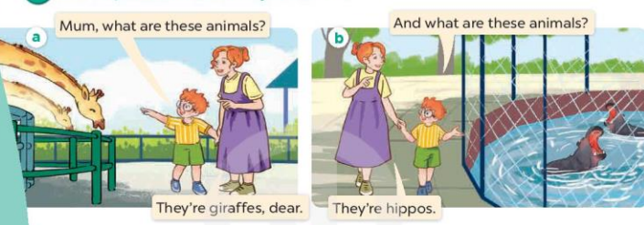  - Play the audio twice (sentence by sentence). Correct their pronunciation where necessary.  - Have Ss to practice the dialogue  - T invites a few pairs to the front of the class to practice.  - T checks pronunciation for ss.  Activity 3 Listen, point and say.  *Aims: Ss will be able to correctly say the words and use What are these animals? – They’re …….. to ask and answer questions about animals  *Procedure:  * Model sentences:  - T asks Ss look at picture a, b and helps Ss know the structure from the dialogue.  - T introduces new structure for Ss.  - T explains, models and gives meaning.  -Have Ss repeat the model sentences.  A: What are these animals?  B: They’re lions  *Drill pictures  - Elicit the names of the animals.  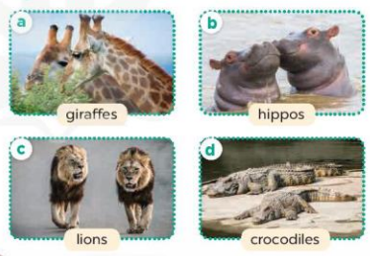  - Run through all the pictures.  - Run through model sentences.  - Have Ss to practise:  - Ask Ss to work in pairs.  - T controls and corrects.  - Invite a few pairs to come to the front of the classroom and point at the pictures and say the questions and answers in front of the class.  - T gives feedbacks.  Activity 4. Let’s talk.  *Aims: Ss will be able to enhance the correct use of What are these animals? – They’re …... to ask and answer questions about animals in a freer context.  *Procedure:  - Have Ss look at the picture and tell them about the animals  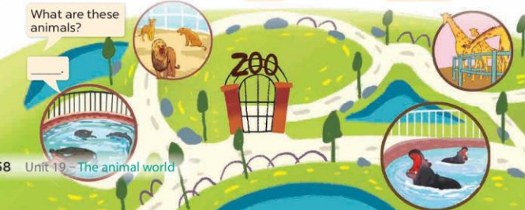  - Put Ss work in pairs  - Ask Ss to say using What are the animals?  They’re…….  - Get Ss to repeat the questions and answers several times.  - Invite some Ss to the front of the class to say about the activity.  *Consolidation  *Aims: Ss will be able consolidate and wrap up the content of the lesson.  *Procedure:  - T asks ss to answer the following questions:  + What have you learnt from the lesson today?  +What are the core values of the lesson? (if the teacher can take from the lesson).  - T review the vocabulary and model sentences.  - T praises some Ss who are hardworking / active/ good…. as well as encourage others to try more.  - Learn the vocabulary and model sentences by heart  - Prepare the new lesson: Unit 19, Lesson 1 (4,5,6). | - Ss listen  - Ss sing a song  - Ss open their books  -Ss listen and answer  - - Ss listen and repeat  + Choral repetition (3 times).  + Individual repetition (3 ss)  - Ss take note  - Ss look, remember and match  -Look at the pictures and say  + In picture a:  Ben: Mum, what are these animals?  Ben's mother: They’re giraffes, dear. + In picture b:  Ben: And what are these animals?  Ben's mother: They’re hippos.  -Ss listen and repeat in chorus (twice)  -Ss work in pairs to practice  -Ss practice the dialogue  -Ss listen  -Ss look at the picture and answer.  -Ss listen  -Ss listen and repeat  -Ss repeat  - Ss look, listen and answer  + Picture a: two giraffes  + Picture b. two hippos  + Picture c. two lions  + Picture d. two crocodiles  -Ss listen and repeat  -Ss practice in chorus  -Ss practice in chorus  -Ss work in pairs to practice  -Ss point and say  -Ss listen.  -Ss look at the picture and listen  + a zoo with crocodiles, lions, giraffes and hippos  -Ss work in pairs  -Ss ask and answer  -Ss repeat the questions and answers  -Ss perform in front of the class.  -Ss answer the questions  - Ss listen  -Ss listen and clap their hands  -Ss listen and take note | - Ss listen  - Ss sing a song  - Ss open their books  -Ss listen and answer  - - Ss listen and repeat  + Choral repetition (3 times).  + Individual repetition (3 ss)  - Ss take note  - Ss look, remember and match  -Look at the pictures and say  + In picture a:  Ben: Mum, what are these animals?  Ben's mother: They’re giraffes, dear. + In picture b:  Ben: And what are these animals?  Ben's mother: They’re hippos.  -Ss listen and repeat in chorus (twice)  -Ss work in pairs to practice  -Ss practice the dialogue  -Ss listen  -Ss look at the picture and answer.  -Ss listen  -Ss listen and repeat  -Ss repeat  - Ss look, listen and answer  + Picture a: two giraffes  + Picture b. two hippos  + Picture c. two lions  + Picture d. two crocodiles  -Ss listen and repeat  -Ss practice in chorus  -Ss practice in chorus  -Ss work in pairs to practice  -Ss point and say  -Ss listen.  -Ss look at the picture and listen  + a zoo with crocodiles, lions, giraffes and hippos  -Ss work in pairs  -Ss ask and answer  -Ss repeat the questions and answers  -Ss perform in front of the class.  -Ss answer the questions  - Ss listen  -Ss listen and clap their hands  -Ss listen and take note
D. ADJUSTMENTS (if necessary):
………………………………………………………………………………………….…..……………………………………………………………………………...………………………………………….…..……………………………………………………………………………….……………………………………………………………………...

