Preparing date: 10/11/2024
Teaching date: 25/11/2024

Week 12
Period 45

Unit 7: Our favourite school activities
Lesson 1 (4, 5, 6)
A. OBJECTIVES:
By the end of the lesson, Ss will be able to:
1. Knowledge:
- listen to and understand four exchanges in which the speakers ask and answer questions about someone’s favourite school activities and number the pictures.
- complete four gapped exchanges with the help of picture cues.
- listen to and complete What school activities does she like? song and to sing it with the correct pronunciation, rhythm and melody.
- Vocabulary: Review
- Skills: speaking, listening, reading and writing.
2. Competences:
- Communication and collaboration: work in pairs and groups to complete the learning tasks.
- Self-control and independent learning: perform pronunciation and speaking tasks.
3. Attitude/ Qualities:
- Show their pride in their school and show their interest in their favorite school activities
B. TEACHING AIDS:
- Teacher: Teacher’s guide Pages 104, 105, 106; audio Tracks 68, 69; website hoclieu.vn, posters, laptop, pictures, textbook, lesson plan, TV or projector.
- Students: Student’s book Page 51, notebooks, workbooks, school things.
C. PROCEDURES:
Teacher’s activities | Students’ activities
1.Warm- up and review: (5’)  Game: Football game  *Aims: to revise the learned words *Procedure:  - Explain how to play the game.  - Tell ss they are going to look at the pictures and answer the questions.  - Divide the class into 3 teams.  - Ss take turns to answer the question.  - Check the pupils’ answers as a whole class.  - If they give the correct answers, they can play football and get the goal.  - The team with more goals will be the winner.  - Say “Open your book page 51” and look at “Unit 7, Lesson 1(4,5,6)”.  2.Practice: (25’)  Activity 1. Listen and number:  *Aims: Ss will be able to listen to and understand four exchanges in which the speakers ask and answer questions about someone’s favourite school activities and number the pictures.  *Procedure:  - Draw ss’ attention to the pictures and ask questions to elicit what each child is doing.  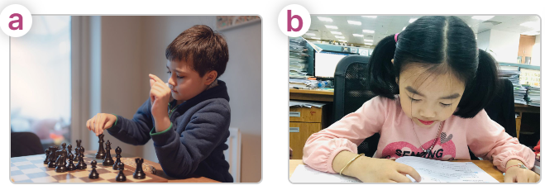  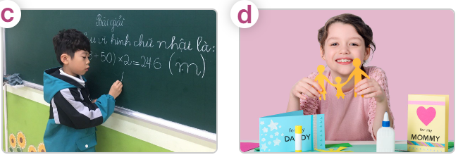  - T ask Ss to guess the answers.  + T writes Ss’guessing on the board.  - Listen to the tape:  + Play the recording  + Play the recording again for pupils to do the task.  + Play the recording a third time for pupils to check their answers.  - Get Ss to swap books with their partner, then check answers as a class.  + Write the answers on the board for Ss to correct their answers. Then checks Ss’ guessing.  - Have Ss to listen and repeat individually and in chorus  Key: 1. b 2. c 3. a 4. d  Activity 2. Read and complete  *Aims: Ss will be able to complete four gapped exchanges with the help of picture cues.  *Procedure:  - Have Ss look at the pictures and read the question and answer, and guess the missing word in the answer.  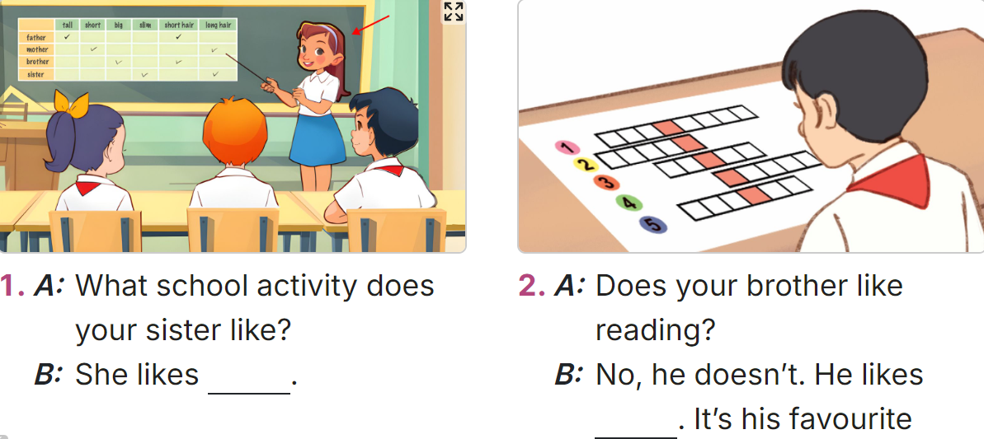  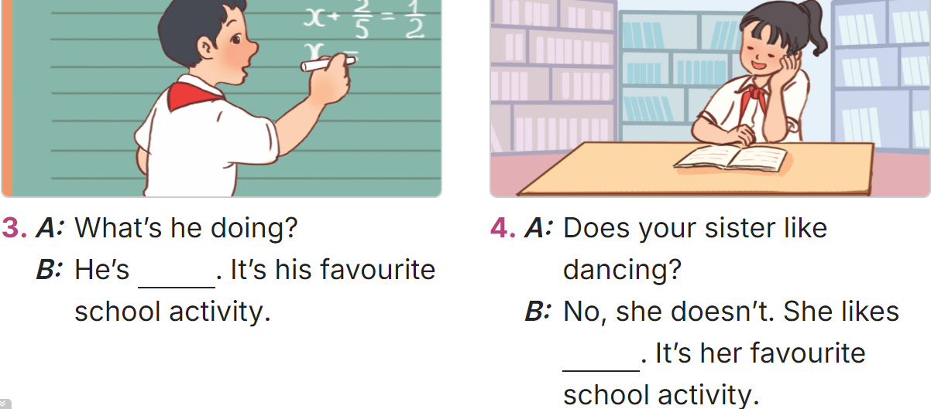  - T models: have Ss read the question and asks what words are missing (doing projects)  - Give Ss a time limit to read the gapped dialogues, look at the pictures and do the task independently.  - Get Ss to swap books with a partner and check their answers before checking as a class.  + Invite one student to write the answers on the board.  - Invite two pairs of Ss to act out the completed dialogues.  Key:  1. doing projects  2. doing word puzzles  3. solving a maths problem  4. reading books  Activity 3. Listen, complete and sing  *Aims: Ss will be able to listen to and complete the song What school activity does she like? and to sing with the correct pronunciation, rhythm and melody.  *Procedure:  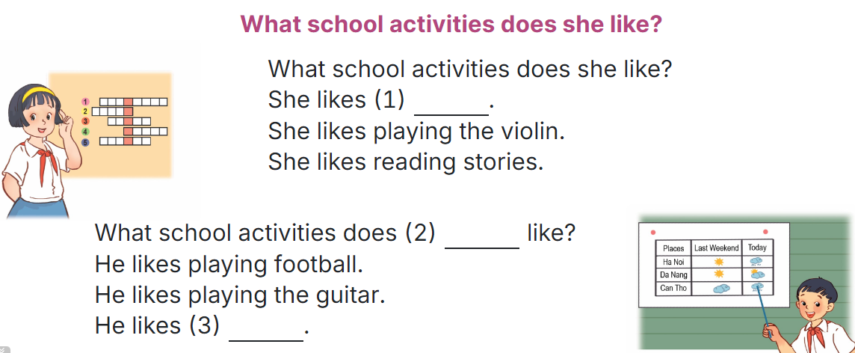  -  - Have ss read the song lyric, look at the relevant picture and guess the missing words and fill in the gap.  - Play the recording all the way through for ss to listen to the whole song.  - Play the recording again for ss to fill in the gaps with the missing words.  - Check answers together as a class.  - Play the recording line by line for ss to listen and repeat.  - Divide the class into two halves to take turns singing the questions and answer.  3. Fun corner and wrap- up (5’)  Game: Lucky number  - Tell ss they are going to choose a number, look at the picture and answer the question or complete the question.  - Divide ss in 2 teams and play the game.  - Give points as the diamonds shown on the screen.  - Which team has more diamonds will be the winner. | -Ss listen to the teacher  -Ss play the game  -Ss play the game  - Ss open their books  -Look at the pictures and say:  + Picture a: a boy playing chess  + Picture b: a girl reading a book  + Picture c: a boy solving a maths problem at the board  + Picture d: a girl making a paper craft  -Ss guess the answers  - Ss listen to the tape  - Ss listen again and do the task.  - Ss listen and check their answers  - Ss swap books with their partner, then check answers as a class and guessing  -Ss write the answer on the board  -Ss listen and repeat  -Ss look at the picture and say  -Ss follow the teacher  - Ss do the task independently.  - Ss swap books with a partner and check their answers.  - Ss write the answers on the board  - Pairs of Ss read the completed dialogues aloud  - Ss pay attention to the title and lyrics of the song and guess the missing words.  - Ss listen  - Ss listen and complete the song.  -Ss check the answer  - Ss listen to the recording and repeat.  - Ss sing  -Ss listen to the teacher  - Ss play the game.
D. ADJUSTMENTS (if necessary):
………………………………………………………………………………………….…..……………………………………………………………………………...…..…

Preparing date: 10/11/2024
Teaching date: 25/11/2024

Week 12
Period 46

Unit 7: Our favourite school activities
Lesson 2 (1, 2, 3)
A. OBJECTIVES:
By the end of the lesson, Ss will be able to:
1. Knowledge:

- understand and correctly repeat the sentences in two communicative contexts focusing on asking and answering questions about why someone likes a school activity.

- correctly say the words and phrases and use Why does he / she like ____? – Because he / she thinks it’s ____. to ask and answer questions about why someone likes a school activity.

- use Why does he / she like ___? – Because he / she thinks it’s _____. in a freer context.

- Vocabulary: fun, good for group work, interesting, useful

- Structures:
A: Why does he / she like solving maths problems?
B: Because he / she thinks it’s useful.
- Skills: speaking and listening
2. Competences:
- Critical thinking and creativity: learn how to ask and answer questions about personal information correctly and fluently.
- Self-control and independent learning: perform speaking tasks.
3. Attitude/ Qualities:
- Show their interest in school subjects when talking about school subjects and school activities.
B. TEACHING AIDS:
- Teacher: Teacher’s guide Pages 106, 107, 108, audio Tracks 70, 71; website hoclieu.vn, posters, laptop, pictures, textbook, lesson plan, TV or projector.
- Students: Students’ book Page 52, notebooks, workbooks, school things.
C. PROCEDURES:
Teacher’s activities | Students’ activities
1.Warm- up and review: (3’)  Game: Slap the board  *Aims: to create a friendly and active atmosphere in the class to beginning the lesson.  *Procedure:  - Divide the class into two groups and stand in two lines.  - Stick the cards with words on the board.  - Call out a word and have the first pupil from each group slap the correct card on the board and say it correctly.  - The first student to slap the correct card wins a point for their group.  - The group with the most points wins. Praise the winner.  - Say “Open your book page 52” and look at “Unit 7, Lesson 2 (1,2,3)”.  2. Presentation (15’)  Activity 1. Vocabulary.  *Aims: Ss will be able to know the vocabulary in the new lesson.  *Procedure:  -T elicits the new words  + fun : vui thích (explain)  + useful : hữu ích (picture)  + interesting : thú vị (translation)  + good for group work : tốt cho hoạt động nhóm (explain)  - T models (3 times).  - T writes the words on the board.  - Checking: Matching  Activity 2. Look, listen and repeat:  *Aims: Ss will be able to understand and correctly repeat the sentences in two communicative contexts,  focusing on asking and answering questions about why someone likes a school activity.  *Procedure:  - Have Ss look at Pictures a and b and identify the characters and what they can see in the pictures.  + Who is he/ she?  + Where is he/ she?  + What is he/ she talking about?  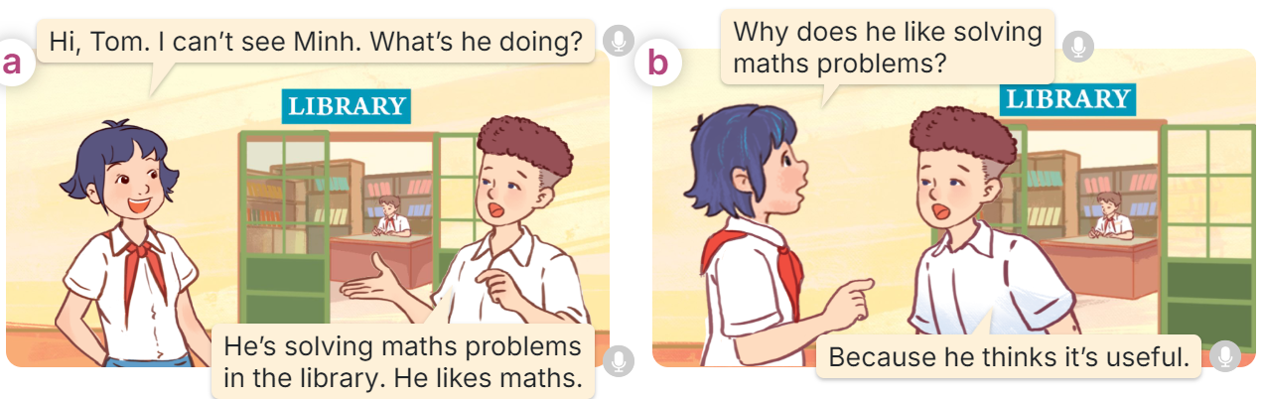  - Play the audio twice (sentence by sentence). Correct their pronunciation where necessary.  - Have Ss to practice the dialogue  - T invites a few pairs to the front of the class to practice.  - T checks pronunciation for ss.  Activity 3 Listen, point and say.  *Aims: Ss will be able to correctly say the words and phrases and use Why does he / she like ____? – Because he / she thinks it’s ____. to ask and answer questions about why someone likes a school activity.  *Procedure:  * Structures:  - T asks Ss look at picture b in activity 1 and helps Ss know the structure from the dialogue.  - T introduces new structures for Ss.  - T explains, models and gives meaning.  - Have Ss repeat the structures  A: Why does he / she like solving maths problems?  B: Because he / she thinks it’s useful.  3.Practice: (7’)  *Drill pictures  - Have Ss look at the pictures and identify the characters and their activities. 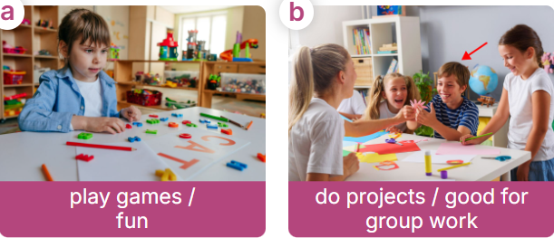  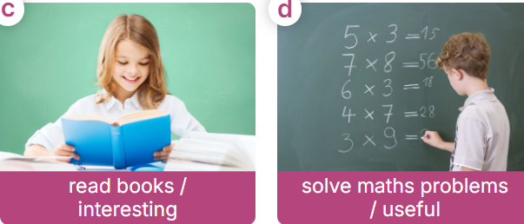  - Remind ss of like+ Verb + -ing  - Have Ss point at pictures, listen and run through all the pictures.  - Have Ss point at the bubbles, listen and run through model sentences.  - Have Ss to practise:  + T asks the first picture, Ss answer  + Ss asks the second picture, T answers  + Group A asks the third picture, group B  answers  + Group B asks the last picture, group A  - Ask Ss to work in pairs to practise asking and answering the Why does he / she like ____? – Because he / she thinks it’s ____.  - T controls and corrects.  - Invite a few pairs to point at the pictures and say the questions and answers in front of the class.  4. Production: (6’)  Activity 4. Let’s talk.  *Aims: Ss will be able to use Why does he / she like ___? – Because he / she thinks it’s _____. in a freer context  *Procedure:  - Ask Ss to look at the pictures and elicit the context  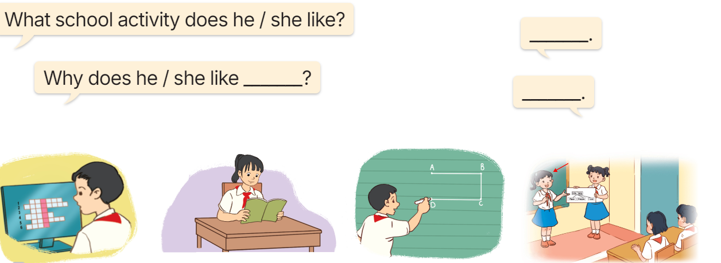  - Point at the ﬁrst building and elicit the question in the ﬁrst speech bubble What school activity does he like? Why does he / she like ___? and the answer in the second speech He/ she likes……. And Because he / she thinks it’s _____.as an example.  - Give Ss time to work in pairs and take turns pointing at each picture to ask and answer using What school activity does he like? Why does he / she like ___?............  - Invite a few pairs to come to the front of the classroom and act out the exchanges.  5. Fun corner and wrap- up (4’)  Game: Snakes and ladders  - Divide the class into 2 teams.  - Ask the first team a question from a unit you’re learning. If they get the answer right, they roll a dice.  - Move their marker along the Snakes and Ladders board.  - Now ask the other team a new question, if they get the answer correct, then they move along the Snakes and Ladders board, too.  - Whenever a team lands on a square where the bottom of the ladder is, then their marker climbs up to the top of the ladder. Whenever a team arrives on a square at the head of a snake, then their marker slides down all the way to the bottom of the snake.  - The first team to reach the end is the winner. | -Ss listen and pay attention  - Ss listen to the teacher  -Ss play the game  .  - Ss listen and open their books  -Ss listen and answer  - - Ss listen and repeat  + Choral repetition (3 times).  + Individual repetition (3 ss)  - Ss take note  - Ss look and match  -Look at the pictures and say.  + In picture a:  Linh: Hi, Tom. I can’t see Minh. What’s he doing?  Tom: He’s solving maths problems in the library. He likes maths.  + In picture b:  Linh: Why does he like solving maths problems?  Tom: Because he thinks it’s useful.  -Ss listen and repeat in chorus (twice)  -Ss work in pairs to practice  -Ss come to the front of the classroom to practice.  -Ss listen  - Ss look at the picture and answer.  -Ss listen  -Ss listen and repeat  -Ss repeat to the structures  - Ss look, listen and repeat  +Picture a: a girl playing games  + Picture b: a boy doing a project with his friends  + Picture c: a girl reading a book  + Picture d: a boy solving a maths problems  -Ss listen to the teacher  -Ss point at pictures, listen and repeat  -Ss point at the bubbles, listen and repeat  -Ss practice in chorus  -Ss practice in chorus  -Ss work in pairs to practise asking and answering the question  - Pairs of Ss point at the pictures and say in front of the class  -Ss look at the picture and say  - Ss look at the first building and elicit the missing words in speech bubbles and say the completed sentences.  - Ss role-play to practise asking and answering questions  - Ss practise asking and answering questions in front of the class.  -Ss listen to the teacher  -Ss play the game  -Ss continute to play the game
D. ADJUSTMENTS (if necessary):
………………………………………………………………………………………….…..……………………………………………………………………………...……

Preparing date: 10/11/2024
Teaching date: 28/11/2024

Week 12
Period 47

Unit 7: Our favourite school activities
Lesson 2 (4, 5, 6)
A. OBJECTIVES:
By the end of the lesson, Ss will be able to:
1. Knowledge:
- listen to and understand two communicative contexts in which pupils ask and answer questions about why someone likes a school activity, and to tick the correct pictures.
- complete two gapped dialogues with the help of picture cues.
- review the target language by asking why someone likes a school activity by playing a game of Making sentences.
- Vocabulary: Review
- Skills: speaking, listening, reading and writing.
2. Competences:
- Communication and collaboration: work in pairs and groups to complete the learning tasks.
3. Attitude/ Qualities:
- Show their love and interest in school activities
B. TEACHING AIDS:
- Teacher: Teacher’s guide Pages 109, 110; audio Tracks 72; website hoclieu.vn, posters, laptop, pictures, textbook, lesson plan, TV or projector.
- Students: Student’s book Page 53, notebooks, workbooks, school things.
C. PROCEDURES:
Teacher’s activities | Students’ activities
1.Warm- up and review: (5’)  Game: Pass the ball  *Aims: to revise the learned words *Procedure:  - Give two different coloured balls to two pupils, a red ball (ask the question) and a yellow ball (answer the question).  - Ask ss to listen to music and pass the ball.  - Stop music suddenly. Have the student with a red ball make a question. Have the student with a yellow ball answer the question.  - Repeat the game several times.  - Say “Open your book page 53” and look at “Unit 7, Lesson 2 (4,5,6)”.  2.Practice: (25’)  Activity 1. Listen and tick:  *Aims: Ss will be able to listen to and understand two communicative contexts in which pupils ask and answer questions about why someone likes a school activity, and to tick the correct pictures.  *Procedure:  - Draw Ss’ attention to the pictures and ask questions to elicit what each student is  doing.  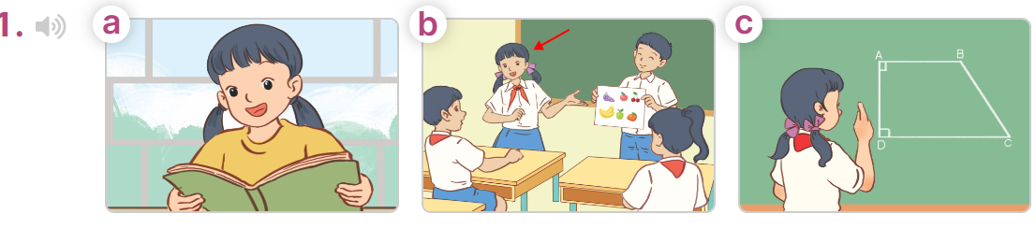  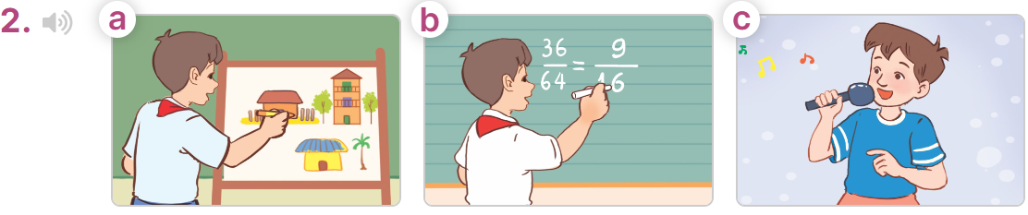  - T ask Ss to guess the answers.  + T writes Ss’guessing on the board.  - Listen to the tape:  + Play the recording  + Play the recording again for pupils to do the task.  + Play the recording a third time for pupils to check their answers.  - Get Ss to swap books with their partner, then check answers as a class.  + Write the answers on the board for Ss to correct their answers. Then checks Ss’ guessing.  - If time allows, play the recording, sentence by sentence, for Ss to listen and repeat individually and in chorus Key: 1. b 2. a  Activity 2. Read and complete  *Aims: Ss will be able to read and complete two gapped dialogues with the help of picture cues.  *Procedure:  - Have Ss look at the pictures and read and guess the missing words.  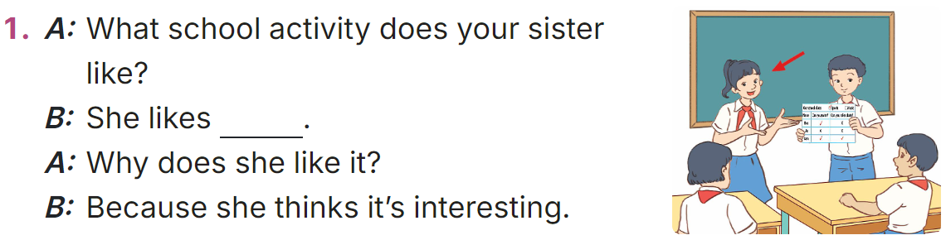  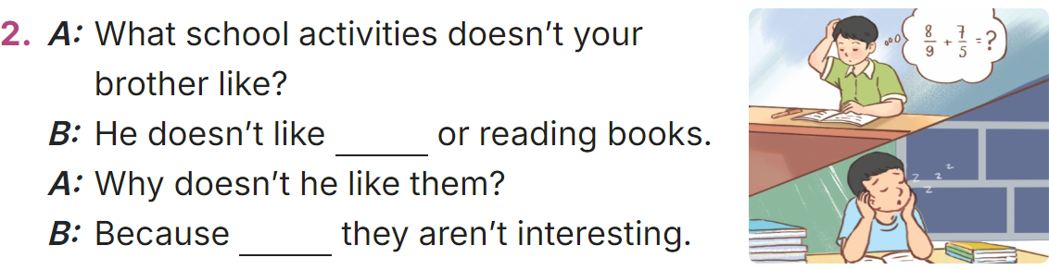  - Model the first sentences: have Ss read the question and ask what words are missing (doing projects)  - Give Ss a time limit to read the gapped dialogues, look at the pictures and do the task independently.  - Get Ss to swap books with a partner and check their answers before checking as a class.  + Invite one student to write the answers on the board.  - Invite two pairs of Ss to act out the completed dialogues.  Key: 1. doing projects  2. solving maths problems; he thinks  Activity 3. Let’s play  *Aims: Ss will be able to review the target language by asking why someone likes a school activity by playing a game of Making sentences.  *Procedure:  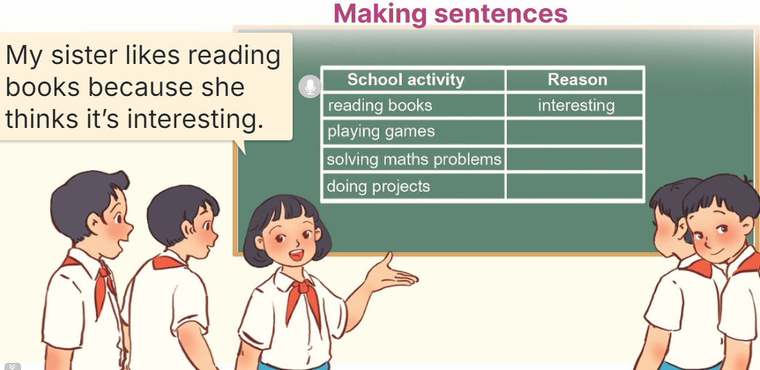  - Introduce and explain how to play the game:  - Give ss a time limit to play the game  - When the time is up, nominate pairs of groups to come to the board to check the answers.  3. Fun corner and wrap- up (5’)  Game: Lucky number  - Divide class into 2 teams: Boys and Girls  - Draw Ss’ attention to the questions on the screen.  - In teams, they take turns choosing the number and looking at the picture then answer the questions. Read the question aloud and answer it. If they have the correct one, they roll the dice and get the points.  - The team with more points wins the game. | -Ss listen to the teacher  -Ss play the game  Ex:  A: Why does she like reading books?  B: Because she thinks it’s interesting.  -Ss continute playing the game  - Ss open their books  -Look at the pictures and say:  + Picture 1a: a girl is reading in the library  + Picture 1b: a girl and a boy are presenting a project  + Picture 1c: a girl is solving a maths problem on the board  + Picture 2a: a boy drawing a picture  + Picture 2b: a boy solving a maths problem on the board  + Picture 2c: a boy singing a song  -Ss guess the answers  - Ss listen to the tape  - Ss listen again and do the task.  - Ss listen and check their answers  - Ss swap books with their partner, then check answers as a class and guessing  -Ss write the answer on the board  -Ss listen and repeat  -Ss look at the picture and say  -Ss follow the teacher  - Ss do the task independently.  - Ss swap books with a partner and check their answers.  - Ss write the answers on the board  - Pairs of Ss read the completed dialogues aloud  -Ss listen  - Ss say the actions of the characters in the pictures.  - Ss practise asking and answering questions in front of the class.  -Ss listen to the teacher  - Ss play the game.
D. ADJUSTMENTS (if necessary):
………………………………………………………………………………………….…..……………………………………………………………………………...…..…

Preparing date: 10/11/2024
Teaching date: 28/11/2024

Week 12
Period 48

Unit 7: Our favourite school activities
Lesson 3 (1, 2, 3)
A. OBJECTIVES:
By the end of the lesson, Ss will be able to:
1. Knowledge:
- correctly stress the words 'solving and 'reading in isolation and in the sentences He likes 'solving maths problems. and Her favourite school activity is 'reading books.
- identify the stress on some two-syllable words and circle the word with a different stress pattern from the other two words.
- say the chant with the correct pronunciation, word stress and rhythm.
- Vocabulary: Review
- Skills: speaking, listening, reading and writing.
2. Competences:
- Communication and collaboration: work in pairs and groups to complete the learning tasks.
- Self-control and independent learning: perform pronunciation and listening tasks.
3. Attitude/ Qualities:
- Explore their talents and critical think about skills they can get from each school activities
B. TEACHING AIDS:
- Teacher: Teacher’s guide Pages 111, 112, 113; audio Tracks 73, 74, 75; website hoclieu.vn, posters, laptop, pictures, textbook, lesson plan, TV or projector.
- Students: Students’ book Page 54, notebooks, workbooks, school things.
C. PROCEDURES:
Teacher’s activities | Students’ activities
1.Warm- up and review: (5’)  Sing: A ram sam sam  *Aims: to create a friendly and active atmosphere in the class to beginning the lesson.  *Procedure:  - - Show the song on the screen.  https://www.youtube.com/results?search_query=a+ram+sam+sam  - Ask pupils to listen, sing and dance the song.  - Say “Open your book page 54” and look at “Unit 7, Lesson 3 (1, 2, 3)”.  2. Presentation (9’)  Activity 1. Listen and repeat:  *Aims: Ss will be able to correctly stress the words 'solving and 'reading in isolation and in the sentences  He likes 'solving maths problems. and Her favourite school activity is 'reading books.  *Procedure:  - Have Ss point at the words 'solving and 'reading with the stress on the first syllable, in isolation and in the sentences He likes 'solving maths problems. and Her favourite school activity is 'reading books  - Play the recording for Ss to listen and repeat in chorus and individually until they feel confident.  - Let Ss work in pairs or groups, saying the words and reading the sentences.  - T invites some Ss to practice.  3.Practice: (17’)  Activity 2. Circle, listen and check.  *Aims: Ss will be able to identify the stress on some two-syllable words and circle the word with a different stress pattern from the other two words.  *Procedure:  - Tell Ss circle the word having a different stress from each line. Then listen to the recording to check their answers.  - Set a time for Ss to do the task.  - Play the recording, once or twice, for Ss to listen and check their answers.  - Get Ss to swap books with a partner and check their answers before checking as a class.  - Play the recording again for Ss to double-check their answers.  - Invite a few Ss to read aloud all the words in the words.  Key: 1. a 2. b 3. c  Activity 3. Let’s chant  *Aims: Ss will be able to say the chant with the correct pronunciation, word stress and rhythm.  *Procedure:  - Introduce the title and lyrics of the chant.  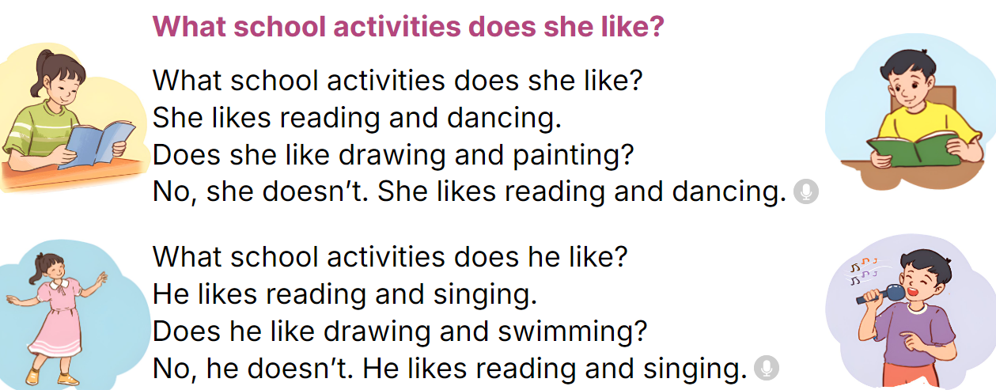  - Play the recording for Ss to listen to the whole chant.  + Have them repeat the title and lyrics line by line.  + Ask Ss to attend to two-syllable words with the stress on the second syllable in the chant, 'reading, 'dancing, 'drawing and 'painting .  - Play the recording all the way through for Ss to listen to pronunciation and melody.  - Play the recording line by line for Ss to listen and repeat  - Play the recording for Ss to chant and clap along.  - Ask Ss to practice chant and clap along in pairs or groups.  - Invite groups to the front of the classroom to perform the chant  3. Fun corner and wrap- up (4’)  Game: Guess the actions  - Call out one student to come to the front of class and whisper to him or her  the name of an action, ex: reading books  - Ask him or her to do the action without making any sounds.  - Let other ss in the class guess the actions.  - Give points for the team that has the student do the action and the one gives the correct answers. | - Ss sing and dance the song  - Ss open their books  - - Ss point and pay attention  - Ss listen to the recording again and repeat.  -Ss work in pairs and practice  -Ss say the words and sentences  - Ss pay and listen to the teacher’s explanation.  - Ss do the task  - Ss listen to the recording to check their answers (individual)  - Ss swap books with a partner and check the answers  - Ss listen to the recording again and check their answers again.  - Ss stand up and read aloud the words.  - Ss look and listen.  - Ss listen to the chant  - Ss listen and repeat line by line without clap their hands  - Ss note the rhythm and pronunciation.  -Ss listen to melody of the chant  - Ss listen and chant line by line.  - Ss chant and clap along.  - Ss work in groups (two groups) to chant  -Ss perform in front of the class.  -Ss listen  -Ss play the game  -Ss play the game
D. ADJUSTMENTS (if necessary):
………………………………………………………………………………………….…..……………………………………………………………………………...……

