Week 35 Preparing date: ……….……. 2025
Period 137 Teaching date: ……….. ……, 2025

Review 4
Parts 3, 4, 5
A. OBJECTIVES:
By the end of the lesson, Ss will be able to:
1. Knowledge:
- read and match five pairs of target sentence patterns.
- read and show understanding of a text about Tom’s trip to Phu Quoc by circling the correct answers.
- write a short paragraph about 40 words about a planened holiday. Using given questions.
- Vocabulary: Review
- Skills: speaking, listening, reading and writing.
2. Competences:
- Communication and collaboration: work in pairs and teams to complete the learning tasks.
- Self-control and independent learning: perform reading and writing tasks.
3. Attitude/ Qualities:
- Study hard to review the vocabulary and sentence patterns they have learnt.
- Be honest in the learning tasks.
B. TEACHING AIDS:
- Teacher: Teacher’s guide Pages 332, 333; website hoclieu.vn, posters, laptop, pictures, textbook, lesson plan, TV or projector.
- Students: Pupil’s book Page 71, notebooks, workbooks, school things.
C. PROCEDURES:
Teacher’s activities | Students’ activities
1.Warm- up and review: (5’)  Game: Throw the dice  *Aims: to revise the sentence structures they have learnt.  *Procedure:  - Explain how to play the game.  - Have pupils play in 3 teams  - Have them take turns to answer the questions.  - If their answers are correct, they throw the dice to get points for their team.  - Team with most points will be the winner.  - Say “Open your book page 71” and look at Review 4.  2.Practice: (18’)  Activity 1. Read and match  *Aims: Ss will be able to read and match five pairs of target sentence patterns  *Procedure:  - Tell Ss about this activity. Point at sentence 1, elicit the answer and models.  - Give Ss work in pairs to do the sentence 2,3,4,5.  - Tell Ss to swap their books with their partners, then check answers together as a class.  - Write the correct answers on the board for Ss to correct their answers.  - Invite some pairs to stand up and read the matched exchanges aloud.  Key: 1 d 2 e 3 b 4 a 5 c  Activity 2. Read and circle  *Aims: Ss will be able to read and understand a text and circle the correct answers about Tom’s trip to Phu Quoc for a holiday  *Procedure:  - Explain that they have to read the text and answer five questions by circling the correct options.  - Have ss read the text to find the specific information and circle the correct answer for each question.  - Set a time limit for ss to do the task.  - Get ss to swap their answers with a partner, then check answers together as a class.  Key: 1.c 2.c 3.c 4.a 5.b  3.Production: (8’)  Activity 3. Let’s write  *Aims: Ss will be able to write a short paragraph about someone’s holiday.  *Procedure:  - Ask ss to read the guiding questions  - Model the first question together and ask ss to read the question and elicit  - Give ss time to complete the paragraph independently.  - Get ss to swap their writings with a partner  - Invite a few Ss to read their writings in front of the class.  Suggested answer:  I am going to visit Ba Na Hills in Da Nang this summer. I am going to get there by train. It is about eight hundred kilometres from Ha Noi. I am going to take the cable car to the centre of Ba Na Hills. I am going to walk on Golden Bridge. I am going to visit the old buildings and take photos there. I think Ba Na Hills is a beautiful place for a summer holiday.  4. Fun corner and wrap- up (4’)  Game: Spin the wheel  - Divide the class into 2 teams (Boys and Girls).  - Teacher chooses and ask one question on the slide.  - Ss take turn to answer the question.  - If the answer is correct, they will spin the wheel and get the points for their team.  - The team with the most points is the winner. | - Ss listen and pay attention  -Ss play game  -Ss praise the winner.  - Ss open their books  -Ss look at the sentence 1 and say  -Ss work in pairs and match  -Ss swap their books and match  -Ss check their answer  -Ss read aloud  - Ss pay attention and follow the teacher’s instructions.  - Ss read the text and find the information  - Ss do the task.  - Ss swap books and check answers  - Ss read the guiding questions.  - Ss read the question and and write the first sentence.  - Ss complete the paragraph independently.  - Ss swap their writings  - Ss read their writings in front of the class.  -Ss listen to the teacher  -Ss play the game  -Ss continue playing the game.
D. ADJUSTMENTS (if necessary):
………………………………………………………………………………………….…..……………………………………………………………………………...…….
Week 35 Preparing date: ……. ……., 2025
Period 138 Teaching date: ………………, 2025

Extension activities
A. OBJECTIVES:
By the end of the lesson, Ss will be able to:
1. Knowledge:
- revise the target vocabulary by doing the quiz What type of story is it?
- revise the target vocabulary about types of story by completing sentences using words from a box.
- complete a short paragraph about story preferences and favourite stories.
- Vocabulary: Review
- Skills: speaking, writing and listening
2. Competences:
- Co-operation: ready to help friends in pair work/ group work.
- Sociability: Talk to each other, say good words to others.
3. Attitude/ Qualities:
- Kindness: Help partners to complete learning tasks.
B. TEACHING AIDS:
- Teacher: Teacher’s guide Pages 334, 335; website hoclieu.vn, posters, laptop, pictures, textbook, lesson plan, TV or projector.
- Students: Student’s book Page 72, 73, notebooks, workbooks, school things.
C. PROCEDURES:
Teacher’s activities | Students’ activities
1.Warm- up: (3’)  Game: Pass the cards  *Aims: to create a friendly and active atmosphere in the class to beginning the lesson.  *Procedure:  - Give a card to a student.  - Play music. Have that student pass the card to the next one.  - Stop music suddenly. Have the student holding a card to ask a question and invite another student to answer the question.  - Repeat the game several times.  - Say “Open your book page 72, 73” and look at “Extension activites”.  2. Practice (28’)  Activity 1. Do the quiz  *Aims: Ss will be able to revise vocabulary related to activities by correctly categorising activities.  *Procedure:  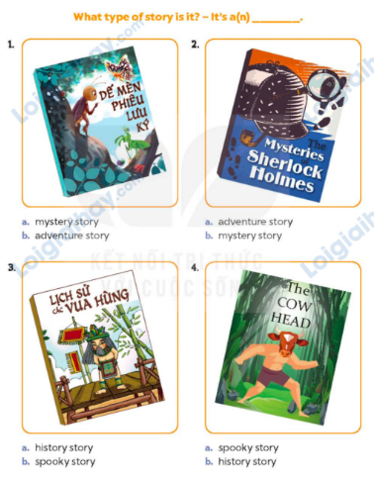  - Look at the pictures and learn some words about types of story.  - Tell ss the goal of the quiz and explain that they have to read the title and look at the cover of each story and guess what type of story it is.  - Draw ss’ attention to the two answer options (a and b).  - Set a time limit for ss to do the task independently.  - Get ss to compare their answers with a partner, then check answers together as a class.  - Get ss work in pairs ask and answer using the sentence pattern and picture hints  Key: 1. b 2. b 3. a 4. a  Activity 2. Read and complete  *Aims: Ss will be able to revise the target vocabulary about types of story by completing sentences using words from a box.  *Procedure:  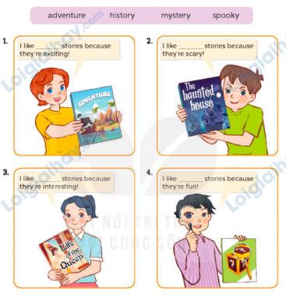  - Tell Ss the goal of the activity and elicit the character’s name and the title of the book  - Have Ss read the sentences and elicit and answer.  - Have Ss time to complete independenlty.  - Have ss check their answer in pairs, before checking as a class.  Key: 1. adventure 2. spooky  3. history 4. mystery  Activity 3. Write and say  *Aims: Ss will be able to complete a short paragraph about story preferences and favourite stories.  *Procedure:  - Tell ss the goal of the activity and explain that they have to complete a short paragraph about stories with their own information.  - Have ss read the first sentence aloud and point at each gap and ask What is missing? (a type of story; why I like it).  - Have ss complete the gaps independently, then check their answers as a class.  - Have ss present their favourite books to the class. They should say what types of story they are, who the main characters are and what happens.  Ex:  I like adventure stories because they are exciting. My favourite adventure story is Treasure Island.  3. Fun corner and wrap- up (4’)  Sing a song: A ram sam sam  - Show the song on the screen.  https://www.youtube.com/watch?v=SwjvlJCelN0  - Ask Ss to listen, sing and dance the song. | - Ss listen  - Ss play the game  Ex: A: Where are you going to visit this summer?  B: I’m goinf to Ly Son Island.  -Ss continue playing the game  -Ss open the book  -Look at the picture, read the words  - Ss read the title and look at the cover of each story and guess what type of story it is.  - Ss look at the two options  and choose the correct answers.  - Ss do the task independently  - Ss compare answers with a partner  -Ss check answer  -Ss listen to the teacher  -Ss read and answer  -Ss read and do the task  -Ss check the answer together  - Ss listen to teacher’s instructions  - Ss read the first sentence aloud, guess, guess what type of information they need to complete.  - Ss complete paragraphs  - Ss present their favourite books to the class  - Ss listen, sing and dance together
D. ADJUSTMENTS (if necessary):
………………………………………………………………………………………….…..……………………………………………………………………………...……

Week 35 Preparing date: ……..….., 2025
Period 139, 140 Teaching date: ………….. 2025

The final term test

A. OBJECTIVES:
By the end of the lesson, Ss will be able to:
1. Knowledge:
- Check Ss’ comprehension about this theme and get marks.
- Vocabulary: Review
- Model sentences: Review
- Skills: speaking, writing, reading and listening
2. Competences:
- Co-operation: ready to help friends in pair work/ group work.
- Sociability: Talk to each other, say good words to others.
3. Attitude/ Qualities:
- Kindness: Help partners to complete learning tasks.
- Honesty: tell the truth about feelings and emotions
B. TEACHING AIDS:
- Teacher: Textbook, lesson plan, TV or projector, wordsheets.
- Students: School things.
C. PROCEDURES:
Teacher’s activities | Students’ activities
Give the students papers test to do | Whole class to do the test.
D. ADJUSTMENTS (if necessary):
……………………………………………………………………………………….…..……………………………………………………………………………...……

