Week 10 Preparing date: November ……., 2024
Period 37 Teaching date: November ………, 2024

Extension activities
A. OBJECTIVES:
By the end of the lesson, Ss will be able to:
1. Knowledge:
- read six descriptions of jobs and match them to the jobs and places of work.
- complete a table about jobs, workplaces and job activities.
- talk about future jobs and give reasons for wanting these jobs.
- Vocabulary: Review
- Skills: speaking, writing and listening
2. Competences:
- Co-operation: ready to help friends in pair work/ group work.
- Sociability: Talk to each other, say good words to others.
3. Attitude/ Qualities:
- Kindness: Help partners to complete learning tasks.
B. TEACHING AIDS:
- Teacher: Teacher’s guide Pages 93, 94; website hoclieu.vn, posters, laptop, pictures, textbook, lesson plan, TV or projector.
- Students: Student’s book Page 42, 43, notebooks, workbooks, school things.
C. PROCEDURES:
Teacher’s activities | Students’ activities
1.Warm- up: (3’)  Sing: Head, shoulders, knees and toes  *Aims: to create a friendly and active atmosphere in the class to beginning the lesson.  *Procedure:  - Show the song on the screen.  https://www.youtube.com/watch?v=WX8HmogNyCY  - Ask Ss to listen, sing and dance the song.  - Say “Open your book page 42, 43” and look at “Extension activites”.  2. Practice (28’)  Activity 1. Look and read. Choose and write the correct words on the lines  *Aims: Ss will be able to read six descriptions of jobs and match them to the jobs and places of work.  *Procedure:  - Have Ss look at the pictures and ask  + What do you see in the pictures?      - Draw pupils’ attention to the pictures.  - Have Ss work independently to read and choose the picture that matches each one.  - Get Ss swap the books and check  - Check answers together as a class.  Key: 1 - school 2 –doctor 3 – theatre  4 - reporter 5 – firefighter 6 - garden  Activity 2. Complete the table about jobs  *Aims: Ss will be able to complete a table about jobs, workplaces and job activities.  *Procedure:  - Tell Ss the goal of the activity.  - Have Ss point to each heading and give examples, ex: doctor, help people.  - Have Ss read and complete the reat of the table.  - Have ss check their answer in pairs, the check as a class.  Key:  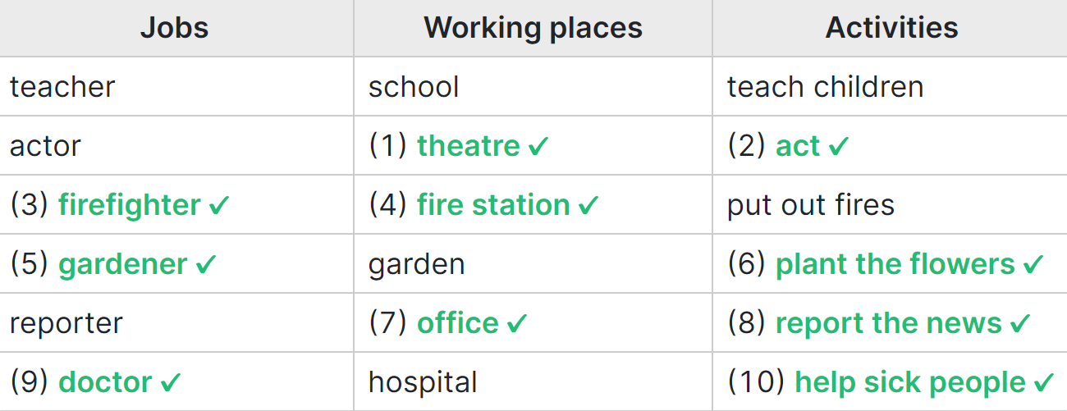  Activity 3. Work in groups. Talk about what you want to be in the future. Say why you like this job.  *Aims: Ss will be able to talk about future jobs and give reasons for wanting these jobs.  *Procedure:  - Tell Ss the goal of the activity  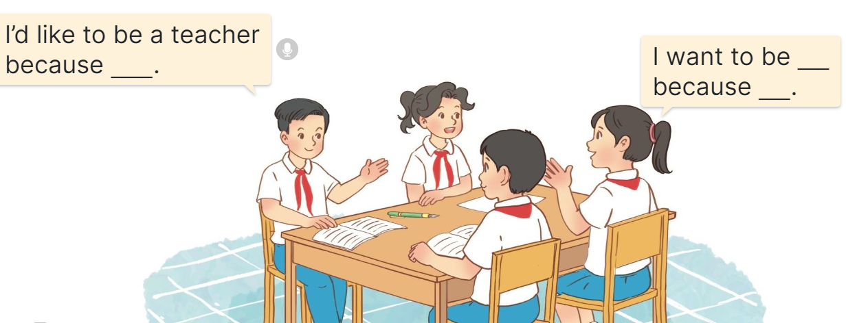  - Have Ss read the sentences in the speech bubbles aloud.  - Have ss name as many jobs as they can and write.  - Revise the questions and the answers  - Put ss work in groups and talk about the job in the future.  - Have a few groups repeat the conversations in front of the class.  Ex: I’d like to be a teacher because I want to teach children.  I’d like to be a biological professor because I like studying.  3. Fun corner and wrap- up (4’)  Game: “Kim’s game”  - Divide the class into two teams.  - Display many words and phrases on the board. Give sls two minutes to memorise these words and phrases.  - Turn the word cards face down on the board. In their teams, the ss try to write down many words as they can remember.  - Check the answers as the class.  - Count the points for each team and announce the winner. The team with the most points wins. | - Ss listen  - Ss sing a song  -Ss open the book  -Ss look at the picture and answer  - - Ss note  -Ss do the task  -Ss swap the books and check  -Ss check together  -Ss listen to the teacher  -Ss read and do the task  -Ss work in pair and check  -Ss pay attention  -Ss read aloud  -Ss work in groups and talk  -Ss repeat the conversations  - Ss listen to the teacher  -Ss play the game  Ex: sandwich, pink, pizza, Japanese, American, building, friendly, active, play the violin, go for a walk, water the flowers, firefighter, gardener.  -Ss praise the winner
D. ADJUSTMENTS (if necessary):
………………………………………………………………………………………….…..……………………………………………………………………………...……

Week 10 Preparing date: November ………, 2024
Period 38 Teaching date: Novemer …….., 2024

Unit 6: Our school rooms
Lesson 1 (1, 2, 3)
A. OBJECTIVES:
By the end of the lesson, Ss will be able to:
1. Knowledge:

- understand and correctly repeat the sentences in two communicative contexts focusing on asking and answering questions about the location of rooms in a school

- use Where’s the ___? – It’s on the ___. to ask and answer questions about the location of a room in a school

- use Where’s the _____? – It’s on the _____. in a freer context.

- Vocabulary: first ﬂoor, ground ﬂoor, second ﬂoor, third ﬂoor.

- Structures:
A: Where’s the library?
B: It’s on the second floor.
- Skills: speaking and listening
2. Competences:
- Critical thinking and creativity: learn how to ask and answer questions about personal information correctly and fluently.
- Self-control and independent learning: perform speaking tasks.
3. Attitude/ Qualities:
- Show their love and interest in school.
B. TEACHING AIDS:
- Teacher: Teacher’s guide Pages 88, 89, 90, audio Tracks 56, 57, website hoclieu.vn, posters, laptop, pictures, textbook, lesson plan, TV or projector.
- Students: Students’ book Page 44, notebooks, workbooks, school things.
C. PROCEDURES:
Teacher’s activities | Students’ activities
1.Warm- up and review: (3’)  Game: Slap the board  *Aims: to revise the vocabulary about different rooms that pupils have learnt in English 4.  *Procedure:  - Prepare some flashcards about different jobs and stick on the board  (library, computer room, classroom, music room…)  - Divide class into 2 groups: Tom and Jerry.  - How to play:  + Each group chooses five Ss to play.  + Class will read aloud.  + Look at the picture, listen and slap the picture you heard.  + Who faster will get 1 mark.  + Which group with higher mark is the winner.  - Say “Open your book page 44” and look at “Unit 6, Lesson 1 (1,2,3)”.  2. Presentation (15’)  Activity 1. Vocabulary.  *Aims: Ss will be able to know the vocabulary in the new lesson.  *Procedure:  -T elicits the new words  + ground floor : tầng trệt (picture)  + first floor : tầng 1 (picture)  + second floor : tầng 2 (picture)  + third floor : tầng 3 (picture )  - T models (3 times).  - T writes the words on the board.  - Checking: Matching  Activity 2. Look, listen and repeat:  *Aims: Ss will be able to understand and correctly repeat the sentences in two communicative contexts focusing on asking and answering questions about the location of rooms in a school.  *Procedure:  - Have Ss look at Pictures a and b and identify the characters and say what they are talking  + Who is he/ she?  + Where is he/ she?  + What are they talking about?  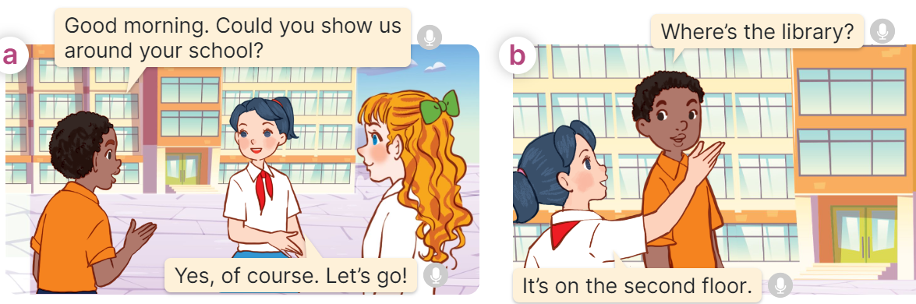  - Play the audio twice (sentence by sentence). Correct their pronunciation where necessary.  - Have Ss to practice the dialogue  - T invites a few pairs to the front of the class to practice.  - T checks pronunciation for ss.  Activity 3 Listen, point and say.  *Aims: Ss will be able to correctly say the phrases and use “Where’s the ____? – It’s on the ____. to ask and answer questions about the location of a room in a school.  *Procedure:  * Structures:  - T asks Ss look at picture b in activity 1 and helps Ss know the structure from the dialogue.  - T introduces new structures for Ss.  - T explains, models and gives meaning.  - Have Ss repeat the structures  A: Where’s the library?  B: It’s on the second floor.  3.Practice: (7’)  *Drill pictures  - Have Ss look at the pictures and say what they can see in the pictures.  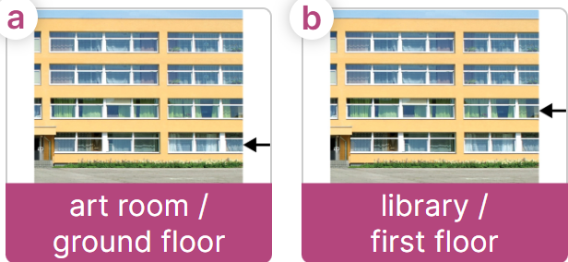  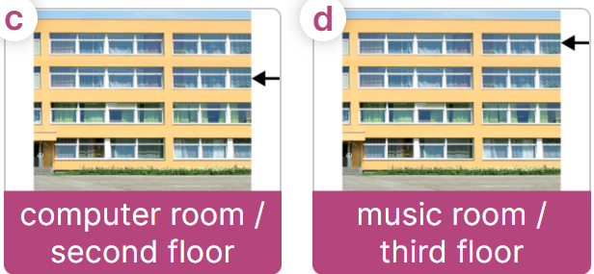  - Have Ss point at pictures, listen and run through all the pictures.  - Have Ss point at the bubbles, listen and run through model sentences.  - Have Ss to practise:  + T asks the first picture, Ss answer  + Ss asks the second picture, T answers  + Group A asks the third picture, group B  answers  + Group B asks the last picture, group A  - Ask Ss to work in pairs to practise asking and answering the Where’s the …….?  - It’s on the ……..  - T controls and corrects.  - Invite a few pairs to point at the pictures and say the questions and answers in front of the class.  4. Production: (6’)  Activity 4. Let’s talk.  *Aims: Ss will be able to use Where’s the ____? – It’s on the ____. in a free context  *Procedure:  - Ask Ss to look at the pictures and elicit the context  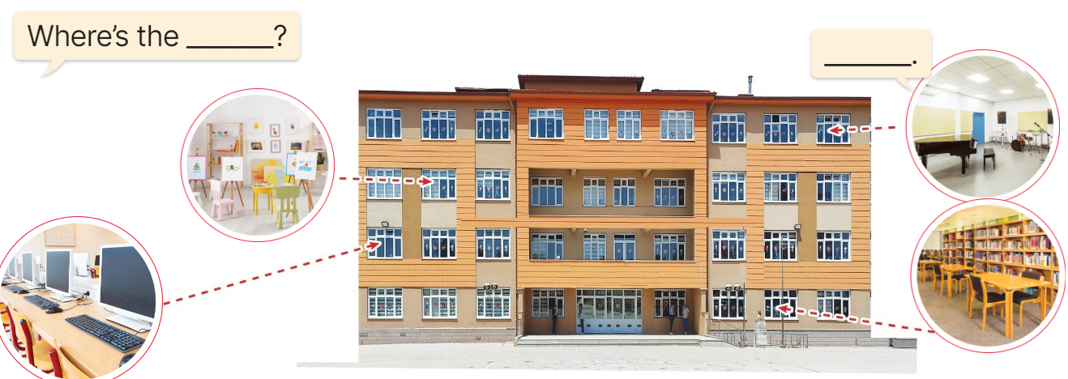  - Point at the ﬁrst building and elicit the question in the ﬁrst speech bubble Where’s the……? and the answer in the second speech bubble It’s ……. as an example.  - Give Ss time to work in pairs and take turns pointing at each picture to ask and answer using structures.  - Invite a few pairs to come to the front of the classroom and act out the exchanges.  5. Fun corner and wrap- up (4’)  Game: Spin the wheel  - Divide class into 2 teams: Boys and Girls  - Draw ss’ attention to the questions on the screen.  - In teams, they take turns spinning the wheel and answer the questions. Read the question aloud and answer it. If they have the correct ones, they get the points.  - The team with more points wins the game. | -Ss listen and pay attention  - Ss listen to the teacher  -Ss play the game  .  -Ss continute playing the game  - Ss listen and open their books  -Ss listen and answer  - - Ss listen and repeat  + Choral repetition (3 times).  + Individual repetition (3 ss)  - Ss take note  - Ss look and match  -Look at the pictures and say.  + In picture a:  Boy: Good morning. Could you show us around your school?  Mai: Yes, of course. Let’s go!  + In picture b:  Boy: Where’s the library?  Mai: It’s on the second floor.  -Ss listen and repeat in chorus (twice)  -Ss work in pairs to practice  -Ss come to the front of the classroom to practice.  -Ss listen  - Ss look at the picture and answer.  -Ss listen  -Ss listen and repeat  -Ss repeat to the structures  - Ss look, listen and repeat  +Picture a: an art room on the ground floor  + Picture b: a library on the first floor  + Picture c: a computer room on the second floor  + Picture d: a music room on the third floor  -Ss point at pictures, listen and repeat  -Ss point at the bubbles, listen and repeat  -Ss practice in chorus  -Ss practice in chorus  -Ss work in pairs to practise asking and answering the question  - Pairs of Ss point at the pictures and say in front of the class  -Ss look at the picture and say  + four rooms (computer room, art room, music room and library) located on different floors of a school building.  - Ss look at the first building and elicit the missing words in speech bubbles and say the completed sentences.  - Ss role-play to practise asking and answering questions  - Ss practise asking and answering questions in front of the class.  -Ss listen to the teacher  -Ss play the game  -Ss continute the game
D. ADJUSTMENTS (if necessary):
………………………………………………………………………………………….…..……………………………………………………………………………...……

Week 10 Preparing date: October …….., 2024
Period 39 Teaching date: October ………., 2024

Unit 6: Our school rooms
Lesson 1 (4, 5, 6)
A. OBJECTIVES:
By the end of the lesson, Ss will be able to:
1. Knowledge:
- listen to and understand four communicative contexts in which the characters ask and answer questions about the location of a room in a school and tick or cross the correct pictures
- complete four gapped exchanges with the help of picture cues
- sing the song Where are the rooms in our school? with the correct pronunciation, rhythm and melody.
- Vocabulary: Review
- Skills: speaking, listening, reading and writing.
2. Competences:
- Communication and collaboration: work in pairs and groups to complete the learning tasks.
- Self-control and independent learning: perform listening and reading tasks.
3. Attitude/ Qualities:
- Knowing their way around the school and recognizing different spaces can help pupils feel more comfortable and secure in their learning environment.
B. TEACHING AIDS:
- Teacher: Teacher’s guide Pages 90, 91, 92; audio Tracks 58, 59; website hoclieu.vn, posters, laptop, pictures, textbook, lesson plan, TV or projector.
- Students: Student’s book Page 45, notebooks, workbooks, school things.
C. PROCEDURES:
Teacher’s activities | Students’ activities
1.Warm- up and review: (5’)  Game: Hot potato  *Aims: to create a friendly and active atmosphere in the class to beginning the lesson.  *Procedure:  - Ss pass the ball while the teacher plays the music. When the music stops, the pupil holding the ball says a word or sentence learnt in the lesson.  - Say “Open your book page 45” and look at “Unit 6, Lesson 1 (4,5,6)”.  2.Practice: (25’)  Activity 1. Listen and tick or cross:  *Aims: Ss will be able to listen to and understand four communicative contexts in which the characters ask and answer questions about the location of a room in a school and tick or cross the correct pictures.  *Procedure:  - Draw Ss’ attention to the pictures and ask questions  + How many pictures are there?  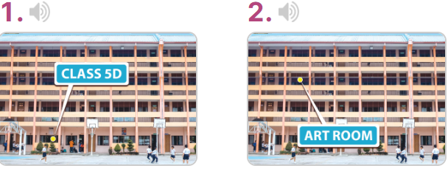  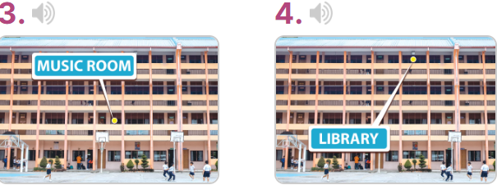  - T ask Ss to guess the answers.  + T writes Ss’guessing on the board.  - Listen to the tape:  + Play the recording  + Play the recording again for ss to do the task.  + Play the recording a third time for ss to check their answers.  - Get Ss to swap books with their partner, then check answers as a class.  + Write the answers on the board for Ss to correct their answers. Then checks Ss’ guessing.  - If time allows, play the recording, sentence by sentence, for Ss to listen and repeat individually and in chorus Key: 1. v 2. x 3. x 4. v  Activity 2. Read and complete  *Aims: Ss will be able to complete four gapped exchanges with the help of picture cues.  *Procedure:  - Have Ss read the sentences and elicit the answer to fill in the gap.  (ex: first).  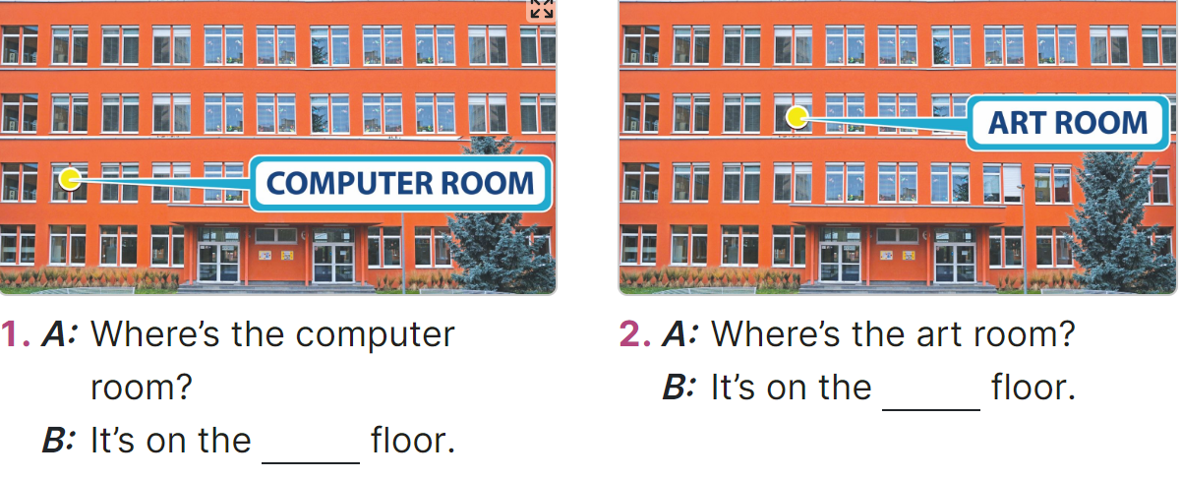  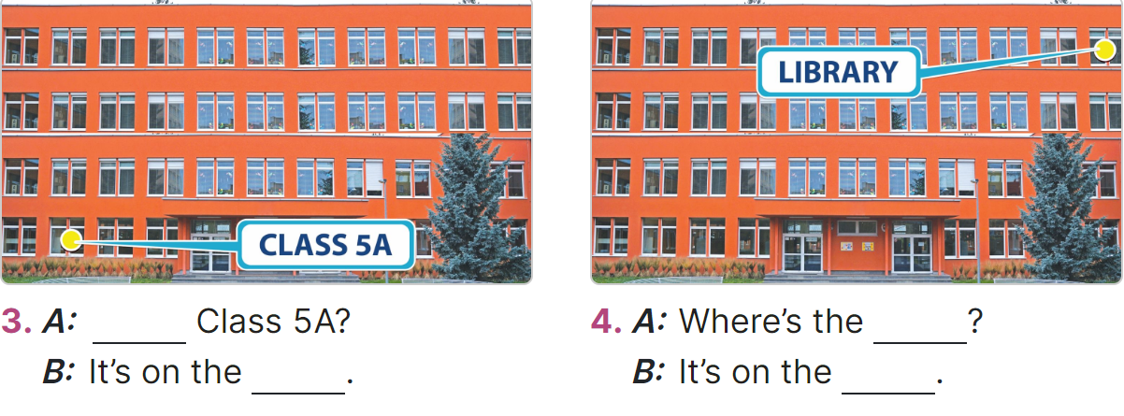  - Give Ss a time limit to read the gapped dialogues, look at the pictures and do the task independently.  - Get Ss to swap books with a partner and check their answers before checking as a class.  + Invite one student to write the answers on the board.  - Invite two pairs of Ss to act out the completed dialogues.  Key: 1. first  2. second  3. Where’s; ground floor  4. library; third floor  Activity 3. Let’s sing  *Aims: Ss will be able to sing the song Where are the rooms in our school? with the correct pronunciation, rhythm and melody.  *Procedure:  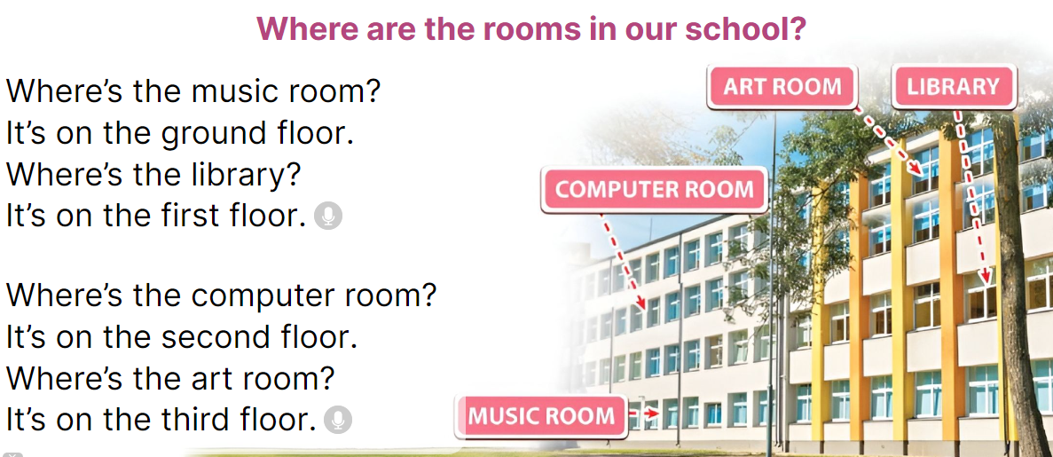  - Introduce the title and lyrics of the song: Where are the rooms in our school? song.  Play the recording for Ss to listen to the whole song.  + Have them repeat the title and lyrics line by line.  - Play the recording all the way through for Ss to listen to pronunciation and melody of the song.  - Play the recording line by line for Ss to listen, repeat  - Play the recording for Ss to sing and do actions.  - Ask Ss to practice singing and doing actions in pairs or groups.  - Invite groups to the front of the classroom to perform the song  -T gives feedback.  3. Fun corner and wrap- up (5’)  Game: Roll the dice  - Divide the class into groups of six. Have each student count the numbers from one to six.  - Ask a student from each group to roll the dice to choose a pupil asking the question.  - Have that student ask the question and invite another student of the group to answer  the question about future jobs.  - The student who gives the correct answers will continue rolling the dice. | -Ss listen to the teacher  -Ss play the game  - Ss open their books  -Look at the pictures and say:  + Picture 1: Class 5D on the ground floor  + Picture 2: Art room on the second floor  + Picture 3: Music room on the first floor  + Picture 4: Library on the third floor  -Ss guess the answers  - Ss listen to the tape  - Ss listen again and do the task.  - Ss listen and check their answers  - Ss swap books with their partner, then check answers as a class and guessing  -Ss listen and repeat  -Ss look at the picture and read, fill the gap  - Ss do the task independently.  - Ss swap books with a partner and check their answers.  - Ss write the answers in the notebook  - Pairs of Ss read the completed dialogues aloud  -Ss look and listen to the teacher  -Ss listen to the song  - Ss listen and repeat line by line without the action.  -Ss listen to melody of the song  - Ss listen and sing line by line.  - Ss sing and do actions.  - Ss work in groups (two groups) to sing.  -Ss perform in front of the class.  -Ss listen  -Ss listen to the teacher  - Ss play the game.  Ex. A: Where is the library?  B: It’s on the ground floor.  - Ss continue playing the game.  - Ss praise the winner.
D. ADJUSTMENTS (if necessary):
………………………………………………………………………………………….…..……………………………………………………………………………...…..…

Week 10 Preparing date: October ………, 2024
Period 40 Teaching date: October …….., 2024
Unit 6: Our school rooms
Lesson 2 (1, 2, 3)
A. OBJECTIVES: By the end of the lesson, Ss will be able to:
1. Knowledge:

- understand and correctly repeat the sentences in two communicative contexts focusing on asking for and giving directions in a school.

- use Could you tell me the way to the computer room, please? - ________. to ask for and give directions in a school;

- use Where’s ______? – It’s on the ______. and Could you show me the way to _____, please? – ____. in a freer context.

- Vocabulary: go along, go downstairs, go past, go upstairs.
- Structures:
A: Could you show me the way to the computer room, please?
B: Go upstairs. It’s on the first floor.
- Skills: speaking and listening
2. Competences:
- Critical thinking and creativity: learn how to ask and answer questions about personal information correctly and fluently.
- Self-control and independent learning: perform pronunciation and speaking tasks.
3. Attitude/ Qualities:
- Show their pride in their school and raise awareness about the location of different rooms in their school.
B. TEACHING AIDS:
- Teacher: Teacher’s guide Pages 92, 93, 94, audio Tracks 60, 61; website hoclieu.vn, posters, laptop, pictures, textbook, lesson plan, TV or projector.
- Students: Students’ book Page 46, notebooks, workbooks, school things.
C. PROCEDURES:
Teacher’s activities | Students’ activities
1.Warm- up and review: (3’)  Game: School tour  *Aims: to create a friendly and active atmosphere in the class to beginning the lesson.  *Procedure:  - Display the slide of 6 doors.  - Put Ss in 3 teams. Each team chooses a door and completes the questions and the answer by looking at the picture cues.  - Check Ss’ pronunciation and their answers. Give points as the stars appeared on the screen to the team having the correct answer.  - Continue playing until all six doors are opened.  - Say “Open your book page 46” and look at “Unit 6, Lesson 2 (1,2,3)”.  2. Presentation (15’)  Activity 1. Vocabulary.  *Aims: Ss will be able to know the vocabulary in the new lesson.  *Procedure:  -T elicits the new words  + go along: đi dọc theo (situation)  + go downstairs: đi lên lầu (picture)  + go upstair: đi xuống lầu (situation)  + go past: đi qua (picture)  - T models (3 times).  - T writes the words on the board.  - Checking: Rub out and remember  Activity 2. Look, listen and repeat:  *Aims: Ss will be able to understand and correctly repeat the sentences in two communicative contexts focusing on asking for and giving directions in a school  *Procedure:  - Have Ss look at Pictures a and b and identify the characters  + What can you see in the picture?  + What are they talking about?  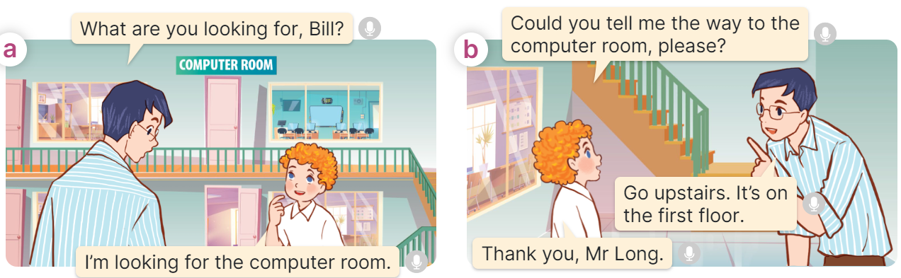  - Play the audio twice (sentence by sentence). Correct their pronunciation where necessary.  - Have Ss to practice the dialogue  - T invites a few pairs to the front of the class to practice.  - T checks pronunciation for ss.  Activity 3 Listen, point and say.  *Aims: Ss will be able to correctly say the phrases and use Could you show me the way to the computer room, please? - ______. to ask for and give directions in a school.  *Procedure:  * Structures:  - T asks Ss look at picture b in activity 1 and helps Ss know the structure from the dialogue.  - T introduces new structures for Ss.  - T explains, models and gives meaning.  - Have Ss repeat the structures  A: Could you show me the way to the computer room, please?  B: Go upstairs. It’s on the first floor.  3.Practice: (7’)  *Drill pictures  - Have Ss look at the pictures and say what they can see in the pictures.  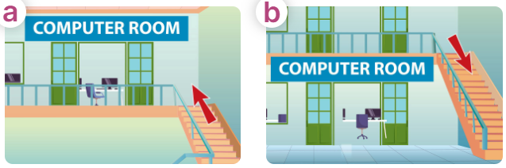  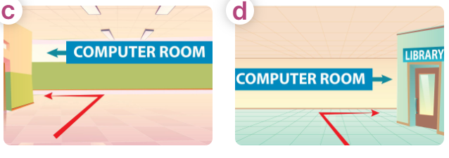  - Have Ss point at pictures, listen and run through all the pictures.  - Have Ss point at the bubbles, listen and run through model sentences.  - Have Ss to practise:  + T asks the first picture, Ss answer  + Ss asks the second picture, T answers  + Group A asks the third picture, group B  answers  + Group B asks the last picture, group A  - Ask Ss to work in pairs to practise asking and answering the question Could you show me the way to the computer room, please?  - Go upstairs. It’s on the first floor.  - T controls and corrects.  - Invite a few pairs to point at the pictures and say the questions and answers in front of the class.  4. Production: (6’)  Activity 4. Let’s talk.  *Aims: Ss will be able to use Could you show me the way to……., please? – ____.in a freer context.  *Procedure:  - Ask Ss to look at the pictures and point to the locations of each of the school rooms  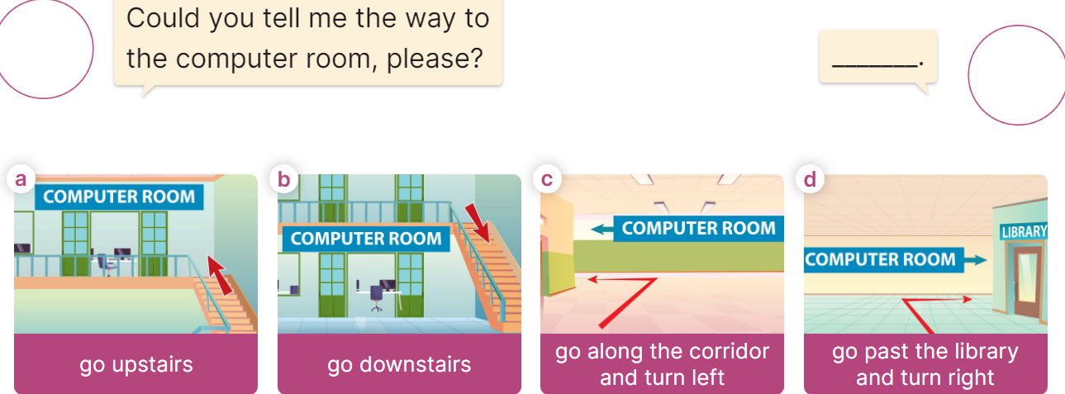  - Remind Ss that Could you show me the way to……., please? – ____. are used to ask and answer questions about the reasons why someone would like to be a certain job.  - Give Ss time to work in pairs and take turns pointing at each picture to ask and answer using Could you show me the way to……., please? – ____.  - Invite a few pairs to come to the front of the classroom and act out the exchanges.  5. Fun corner and wrap- up (4’)  Game: Pass the teddy bears  - Divide the class into 2 teams: boys and girls.  - Draw Ss’ attention to the questions on the screen.  - In teams, they take turns looking at the picture and answer the questions. Read the question aloud and answer it. If they have the correct ones, they will get the points.  - The team with more points wins the game. | -Ss listen and pay attention  -Ss play the game  - Ss listen and open their books  -Ss listen and answer  - - Ss listen and repeat  + Choral repetition (3 times).  + Individual repetition (3 ss)  - Ss take note  - Ss look, remember and write  -Look at the pictures and say.  + In picture a:  Mr Long: What are you looking for, Bill?  Bill: I’m looking for the computer room.  + In picture b:  Bill: Could you tell me the way to the computer room, please?  Mr. Long: Go upstairs. It’s on the first floor.  Bill: Thank you  -Ss listen and repeat in chorus (twice)  -Ss work in pairs to practice  -Ss come to the front of the classroom to practice.  -Ss listen  - Ss look at the picture and answer.  -Ss listen  -Ss listen and repeat  -Ss repeat to the structures  - Ss look, listen and repeat  +Picture a: a go upstairs  + Picture b: go downstairs  + Picture c: go along the corridor and turn left  + Picture d: go past the library and turn right  -Ss point at pictures, listen and repeat  -Ss point at the bubbles, listen and repeat  -Ss practice in chorus  -Ss practice in chorus  -Ss work in pairs to practise asking and answering the question  - Pairs of Ss point at the pictures and say in front of the class  -Ss look at the picture and say  - Ss listen to the teacher  - Ss role-play to practise asking and answering questions about address  - Ss practise asking and answering questions in front of the class.  -Ss listen to the teacher  -Ss play the game  Ex:  A: Could you tell me the way to the computer room, please?  B: Go upstairs and turn right.  -Ss play the game  -Ss congratulate the winner.
D. ADJUSTMENTS (if necessary):
……………………………………………………………………………………….…..……………………………………………………………………………...……
Compiled by facebook Huong Le - 0374629390

