Week 16 Preparing date: December ….., 2024
Period 61 Teaching date: December ….., 2024

Unit 9: Our sports day
Lesson 3 (4, 5, 6)
A. OBJECTIVES:
By the end of the lesson, Ss will be able to:
1. Knowledge:
- listen to and demonstrate understanding of simple exchanges in relation to the topic "Our sports day";
- read and write about sports days;
- make a sports day poster and present it to the class at Project time.
- Vocabulary: Review
- Skills: speaking, listening, reading and writing.
2. Competences:
- Written communication: write about the colours of school things
- Critical thinking: complete a task in reading a text.
- Co-operation: ready to help friends in pair work/ group work.
- Self-control and independent learning: perform listening tasks.
3. Attitude/ Qualities:
- Kindness: Help partners to complete learning tasks.
- Honesty: tell the truth about feelings and emotions.
- Diligence: complete learning tasks.
B. TEACHING AIDS:
- Teacher: Teacher’s guide Pages 136, 137; website hoclieu.vn, posters, laptop, pictures, textbook, lesson plan, TV or projector.
- Students: Pupil’s book Page 67, notebooks, workbooks, school things.
C. PROCEDURES:
Stages/Time | Teacher’s activities | Students’ activities
1.Warm- up: (5’)  2.Practice: (8’)  3.Production: (19’)  4. Homework. (3’) | “Chant”  *Aims: to review the vocabulary and structure about greet and respond to greetings.  *Procedure:  - Ask Ss chant and do the actions in Unit 9, Lesson 3 page 66 in groups.  - Give point for the groups and encourage them.  - Say “Open your book page 67” and look at “Unit 9, Lesson 3 (4, 5, 6)”.  Activity 1. Read and tick True or False:  *Aims: Ss will be able to read and show understanding of a text by deciding if the statements are true or false.  *Procedure:  - Have pupil look at the text, the four statements and read it together as a class.  - Have pupils pay attention to the sentences about sports day and what the boys, the girls do on sports day in the text. - Give pupils time to tick the correct boxes.  - Tell pupils to swap books with a partner, then check answers together as a class.  -Write the correct answers on the board.  - Ask the pupils to read the text aloud in front of the class.  Key: 1. T 2. F 3. T 4. F  Activity 2. Let’s write  *Aims: Ss will be able to read, understand and complete the gapped text about a sports day.  *Procedure:  - Tell the class the goal of this activity: Pupils are to read the gapped text and fill in the gaps.  - Write the first gapped sentence on the board: Our school sports day is in… .  - Read the sentence, point at it and encourage pupils to say the answer.  - Give pupils time to write the answer.  - Invite a few pupils to read the sentences they have completed in front of the class.  Key: Pupils’ answer  Ex: Our sports day is in November. We play sports and games in the school playground. The boys play badminton. The girls play football. The teachers play basketball. We all love our sports day.  Activity 3. Project.  *Aims: Ss will be able to make sports day posters at home and present them to the class, using the target language.  *Procedure:  - Explain that they are going to show sports day posters that they have made at home and tell the class about their sports day.  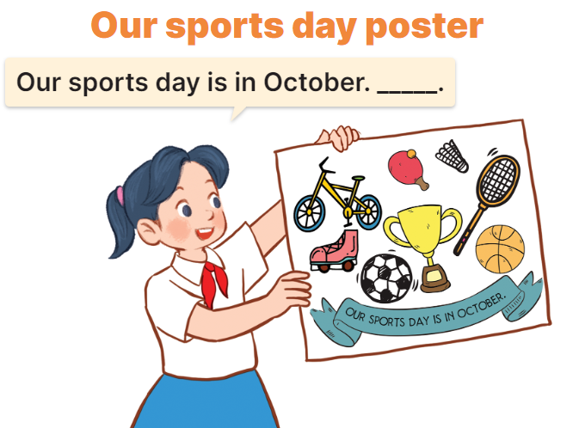  - Have pupils work in groups of five. Each pupil shows his / her poster and tells the group about sports day, ex: Our sports day is in October. I cycle. My friends play badminton.  - Invite some pupils to show their work and talk about their sports days.  - Have pupils stick their posters on the walls of the classroom as a display.  *Consolidation  *Aims: Ss will be able consolidate and wrap up the content of the lesson.  *Procedure:  - T asks ss to answer the following questions:  + What have you learnt from the lesson today?  +What are the core values of the lesson? (if the teacher can take from the lesson).  - T praises some Ss who are hardworking / active/ good…. as well as encourage others to try more.  - Prepare the new lesson: Unit 10, Lesson 1 (1, 2, 3). | - Ss listen and chant  - Ss open their books  -Ss read together  -Ss pay attention  -Ss tick the correct boxes  -Ss swap their answers and check their answer  -Ss write the correct answer  -Ss read aloud  -Ss listen and read  -Ss pay attention  -Ss listen and say the answer  -Ss do the task  -Ss read the sentences aloud  - Ss listen  -Ss work in groups and say the picture  -Ss show the picture and talk about their sports day in font of the the class  -Ss stick their posters on the walls and vote the best beautiful poster.  -Ss answer the questions  -Ss listen and clap their hands  -Ss listen and take note
D. ADJUSTMENTS (if necessary):
………………………………………………………………………………………….…

Week 16 Preparing date: December ….., 2023
Period 62 Teaching date: December ….., 2023

Unit 10: Our summer holiday
Lesson 1 (1, 2, 3)
A. OBJECTIVES:
By the end of the lesson, Ss will be able to:
1. Knowledge:
- use the phrases at the campsite, at the zoo, in the countryside, on the beach in relation to the topic “Our summer holidays”
- use Were you ………last weekend? – Yes, I was. / No, I wasn’t. to ask and answer questions about if someone was somewhere in the past
- listen to and demonstrate understanding of simple communicative contexts in relation to the topic “Our summer holidays”.
- Vocabulary: at the zoo, on the beach, at the campsite, in the countryside.
- Skills: speaking and listening
2. Competences:
- Self-control and independent learning: perform listening tasks.
- Communication and collaboration: work in pairs or groups.
- Sociability: talk to each other, say good words to others.
3. Attitude/ Qualities:
- Kindness: Help partners to complete learning tasks.
- Honesty: tell the truth about feelings and emotions
B. TEACHING AIDS:
- Teacher: Teacher’s guide Pages 138,139,140;, audio Tracks 97, 98, website hoclieu.vn, posters, laptop, pictures, textbook, lesson plan, TV or projector.
- Students: Pupil’s book Page 68, notebooks, workbooks, school things.
C. PROCEDURES:
Stages/Time | Teacher’s activities | Students’ activities
1.Warm- up:  (5’)  2. Presentation  (16’)  3.Practice: (7’)  4.Production: (7’)  5. Homework. (2’) | Jigsaw puzzle  *Aims: to create a friendly and active atmosphere in the class to beginning the lesson.  *Procedure:  - Divide class into 4 groups: Tom, Jerry, Miu and Chit.  - Ask Ss look at the pieces of picture.  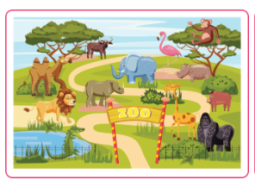  - Ask Ss go to the board and jigsaw puzzle into the correct picture.  -T checks who’s the winner?  - Say “Open your book page 68” and look at “Unit 10, Lesson 1 (1,2,3)”.  Activity 1. Vocabulary.  *Aims: Ss will be able to know the vocabulary in the new lesson.  *Procedure:  -T elicits the new words  + at the zoo : ở sở thú (situation)  + on the beach : trên bãi biển  (picture)  + at the campsite :ở điểm cắm trại  (picture)  + in the countryside : ở miền quê  (picture)  + yesterday : ngày hôm qua  (translation)  - T models (3 times).  - T writes the words on the board.  - Checking: Rub out and remember  Activity 2. Look, listen and repeat:  *Aims: Ss will be able to understand and correctly repeat the sentences in two communicative contexts in which pupils ask and answer questions about if someone was somewhere in the past  *Procedure:  - Have Ss look at Pictures a and b and identify the characters (Bill and Mai) in the pictures.  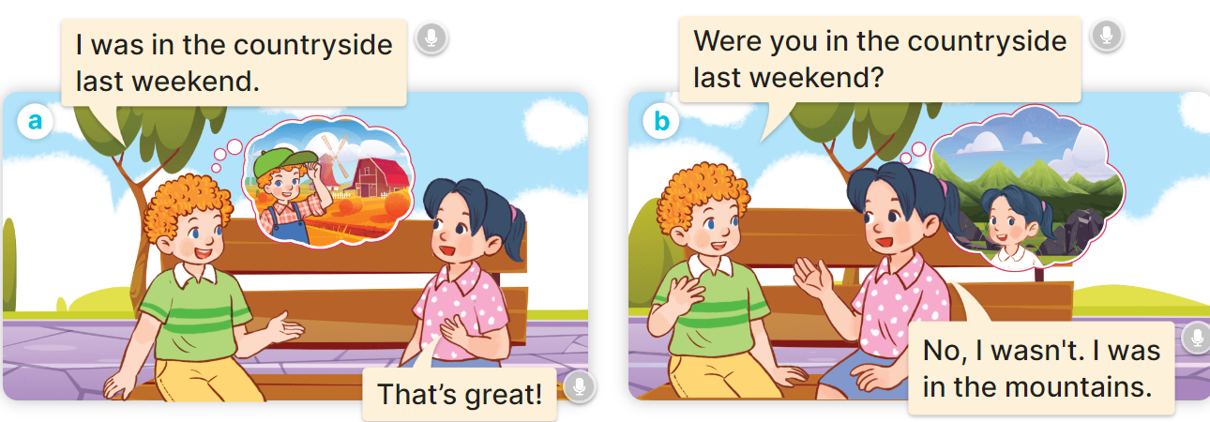  - Play the audio twice (sentence by sentence). Correct their pronunciation where necessary.  - Have Ss to practice the dialogue  - T invites a few pairs to the front of the class to practice.  - T checks pronunciation for ss.  Activity 3 Listen, point and say.  *Aims: Ss will be able to correctly say the words and phrases and use Were you ….. last weekend? – Yes, I was. / No, I wasn’t. to ask and answer questions about if someone was somewhere in the past.  *Procedure:  * Model sentences:  - T asks Ss look at picture b and helps Ss know the structure from the dialogue.  - T introduces new structure for Ss.  - T explains, models and gives meaning.  -Have Ss repeat the model sentences.  A: Were you in the countryside last weekend?  B: Yes, I was. / No, I wasn’t  *Drill pictures  - Have pupils look at pictures a, b, c and d and identify the characters and the locations.  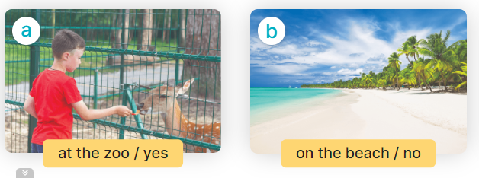  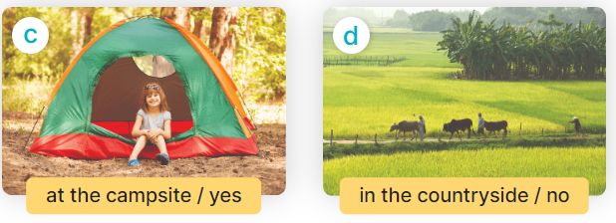  - Run through all the pictures.  - Run through model sentences.  +Run through question sentence  +Run through answer sentence  - Have Ss to practise:  + T asks, Ss answer picture a  + Ss asks, T answers picture b  + Group A ask, group B answer picture c  + Group B ask, group A answer picture d  - Ask Ss to work in pairs.  - T controls and corrects.  - Invite a few pupils to stand up, point at each school thing in the picture and say the sentence aloud.  - T gives feedbacks.  Activity 4. Let’s talk.  *Aims: Ss will be able to enhance the correct use of Were you ……..last weekend? – Yes, I was. / No, I wasn’t. to ask and answer questions about if someone was somewhere in the past in a freer context.  *Procedure:  - Ask questions to help them identify the places  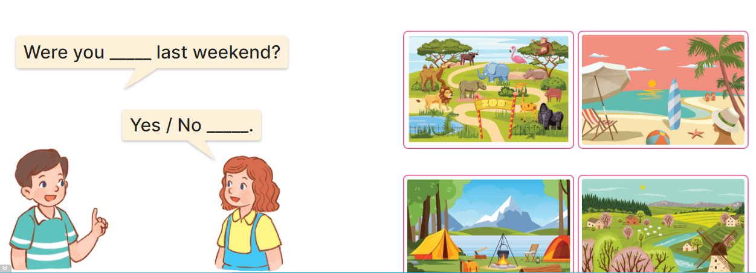  - Have Ss look at the picture and say the activities  - Have Ss look at the first speech bubble and read Were you at the zoo last weekend?  - Then have them point to the pupils at the campsite and complete the gapped answer in the second bubble (Ex: Yes, I was/ No, I wasn’t)  - After that, let them say aloud.  - Give Ss time to practise say the sentence Were you…last weekend?  - Invite some Ss to practise talking about school break time activities in front of the class.  *Consolidation  *Aims: Ss will be able consolidate and wrap up the content of the lesson.  *Procedure:  - T asks ss to answer the following questions:  + What have you learnt from the lesson today?  +What are the core values of the lesson? (if the teacher can take from the lesson).  - T review the vocabulary and model sentences.  - T praises some Ss who are hardworking / active/ good…. as well as encourage others to try more.  - Learn the vocabulary and model sentences by heart  - Prepare the new lesson: Unit 10, Lesson 1 (4,5,6). | - Ss listen  -Ss look at the pieces of the picture  -Ss put into the correct picture  -Ss check  -Ss open their books  -Ss listen and answer  - - Ss listen and repeat  + Choral repetition (3 times).  + Individual repetition (3 ss)  - Ss take note  - Ss look, remember and write  -Look at the pictures and say  + In picture a:  Bill: Were you in the mountains last weekend?  Mai: Yes, I was.  + In picture b:  Mai: Were you in the mountains last weekend, too?  Bill: No, I wasn’t. I was at the zoo.  -Ss listen and repeat in chorus (twice)  -Ss work in pairs to practice  -Ss practice the dialogue  -Ss listen  -Ss look at the picture and answer.  -Ss listen  -Ss listen and repeat  -Ss repeat  - Ss look, listen and answer  + Picture a: a boy at the zoo / yes  + Picture b: a boy on the beach / no  + Picture c: a girl at the campsite / yes + Picture d: a boy in the countryside / no  -Ss listen and repeat  -Ss practice in chorus, individuals.  -Ss practice in chorus, individuals.  -Ss work in pairs  -Ss point and say  -Ss listen.  -Ss look at the picture and answer  + at the campsite, on the beach, at the zoo, in the countryside  -Ss point and say  -Ss read the sentence  -Ss point and complete  -Ss say aloud  -Ss say the sentence  -Ss practice  -Ss answer the questions  - Ss listen  -Ss listen and clap their hands  -Ss listen and take note
D. ADJUSTMENTS (if necessary):
………………………………………………………………………………………….…..……………………………………………………………………………...………………………………………….…..……………………………………………………………………………….……………………………………………………………………...

Week 16 Preparing date: December ….., 2023
Period 63 Teaching date: December ….., 2023

Unit 10: Our summer holiday
Lesson 1 (4, 5, 6)
A. OBJECTIVES:
By the end of the lesson, Ss will be able to:
1. Knowledge:
- use the phrases at the campsite, at the zoo, in the countryside, on the beach in relation to the topic “Our summer holidays”
- listen to and demonstrate understanding of simple communicative contexts in relation to the topic “Our summer holidays”.
- Vocabulary: Review
- Skills: speaking, listening, reading and writing.
2. Competences:
- Written Communication: complete the sentences.
- Self-control and independent learning: perform listening tasks.
- Communication and collaboration: work in pairs or groups.
3. Attitude/ Qualities:
- Show pride in where they were to and what they did in their summer holidays
B. TEACHING AIDS:
- Teacher: Teacher’s guide Pages 140, 141, 142; audio Tracks 99, 100, website sachmem.vn, posters, laptop, pictures, textbook, lesson plan, TV or projector.
- Students: Pupil’s book Page 69, notebooks, workbooks, school things.
C. PROCEDURES:
Stages/Time | Teacher’s activities | Students’ activities
1.Warm- up:  (5’)  2.Practice: (27’)  3. Homework. (3’) | Slap the board  *Aims: to create a friendly and active atmosphere in the class to beginning the lesson.  *Procedure:  - Divide class into 2 groups: Tom and Jerry.  - How to play:  + Each group chooses five Ss to play.  + Class will read aloud.  + Look at the picture, listen and slap the picture you heard.  + Who faster will get 1 mark.  + Which group with higher mark is the winner.  - T gives feedback.  - Say “Open your book page 69” and look at “Unit 10, Lesson 1 (4,5,6)”.  Activity 1. Listen and tick:  *Aims: Ss will be able to listen to and understand two communicative contexts about if someone was somewhere in the past and tick the correct pictures.  *Procedure:  - Elicit the name of the character and their activities in each picture.  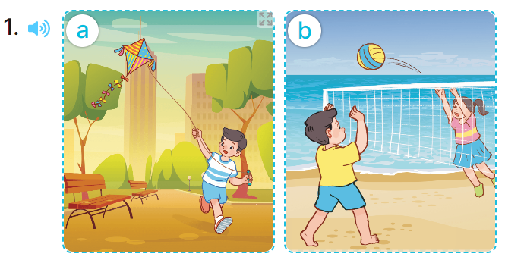  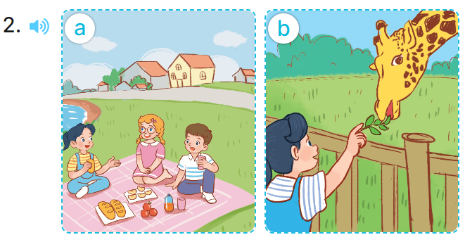  - T ask Ss to guess the answers.  + T writes Ss’guessing on the board.  - Listen to the tape:  + Play the recording  + Play the recording again and get Ss to swap books with their partners.  + Play the recording again to check answers together as a class.  + Write the answers on the board for Ss to correct their answers. Then checks Ss’ guessing.  - Play the recording, sentence by sentence, for the class to listen and repeat in chorus.  Key: 1. b 2. b  Activity 2. Look, complete and read  *Aims: Ss will be able to complete two gapped sentences and two gapped exchanges with the help of picture cues.  *Procedure:  - Have Ss look at the pictures and identify the the characters and places in the picture  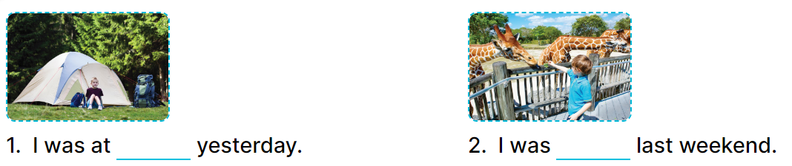  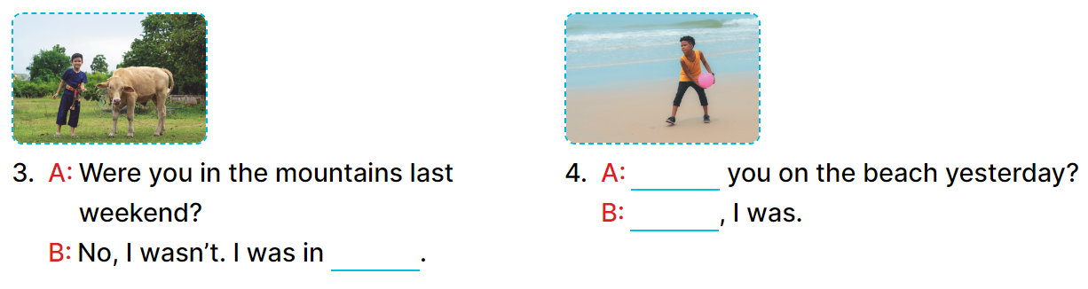  - Have Ss look at the four incomplete sentences. Elicit and model with picture 1  + Ask Ss to read the sentence 1 in chorus.  + Ask Ss what word is missing in the gap (the campsite). Then have them complete the sentence (I was at the campsite yesterday.)  -Have Ss work in pairs and complete the sentences 2, 3, 4.  - Ask a few Ss to stand up and read the sentences aloud.  -T gives feedbacks.  Key:  1.the campsite  2. at the zoo  3. the countryside  4. Were/ yes  Activity 3. Let’s sing  *Aims: Ss will be able to sing the song Were you on the beach yesterday? with the correct pronunciation, rhythm and melody.  *Procedure:  - Introduce the title and lyrics of the song and check comprehension.  + What is the song about?  + What are they doing?  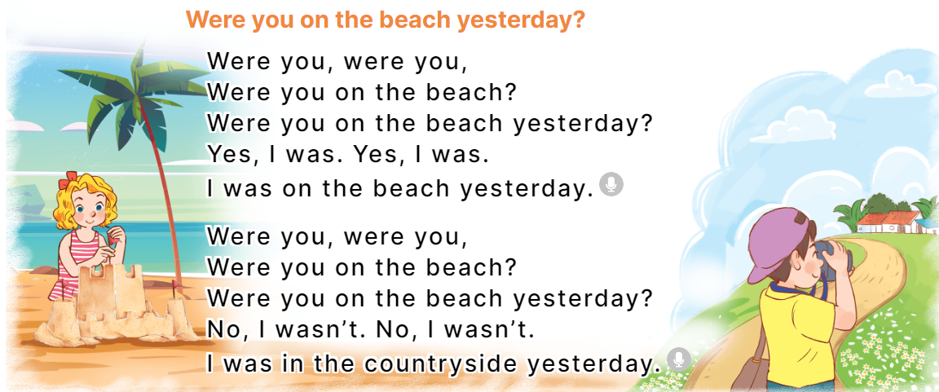  - Play the recording for Ss to listen to the whole song.  + Have them repeat the title and lyrics line by line.  + Tell Ss to point at the pictures while singing.  - Play the recording all the way through for Ss to listen to pronunciation and melody of the song.  - Play the recording line by line for Ss to listen, repeat and point to the pictures  - Play the recording for Ss to sing and do actions.  - Ask Ss to practice singing and doing actions in pairs or groups.  - Invite groups to the front of the classroom to perform the song  -T gives feedback.  *Consolidation  *Aims: Ss will be able consolidate and wrap up the content of the lesson.  *Procedure:  - T asks ss to answer the following questions:  + What have you learnt from the lesson today?  +What are the core values of the lesson? (if the teacher can take from the lesson).  - T praises some Ss who are hardworking / active/ good…. as well as encourage others to try more.  - Practice part 5 again.  - Prepare the new lesson: Unit 10, Lesson 2 (1,2,3). | - Ss listen  -Ss listen  - Ss play game  -Ss congratuate the winner  - Ss open their books  -Look at the pictures and say:  + Picture 1a. Nam at the park  + Picture 1b. Nam on the beach  + Picture 2a. Mai in the countryside  + Picture 2b. Mai at the zoo.  -Ss guess the answers  - Ss listen to the tape and tick  - Ss listen again, tick and swap books with their partners.  - Ss check their answers and guessing  -Ss listen and repeat.  -Ss look at the picture and say  -Ss look and answer  -Ss read  -Ss say and write  -Ss work in pairs and complete  -Ss read aloud  -Ss listen and answer  -Ss listen to the song  - Ss listen and repeat line by line without the action.  -Ss point to the pictures while singing  -Ss listen to melody of the song  - Ss listen and sing line by line.  - Ss sing and do actions.  + Ss work in groups (two groups) to sing.  -Ss perform in front of the class.  -Ss listen  -Ss answer the questions  -Ss listen and clap their hands  -Ss listen and take note
D. ADJUSTMENTS (if necessary):
………………………………………………………………………………………….…..……………………………………………………………………………...………………………………………….…..……………………………………………………………………………….……………………………………………………………………...

Week 16 Preparing date: December ….., 2023
Period 64 Teaching date: December ….., 2023

Unit 10: Our summer holiday
Lesson 2 (1, 2, 3)
A. OBJECTIVES:
By the end of the lesson, Ss will be able to:
1. Knowledge:
- use the phrases Bangkok, London, Sydney and Tokyo in relation to the topic “Our summer holidays”
- use Where were you last summer? – I was in …. to ask and answer questions about where
- someone was in the past; listen to and demonstrate understanding of simple communicative contexts in relation to the topic “Our summer holidays”.
- Vocabulary: Bangkok, London, Sydney, Tokyo
- Skills: speaking and listening
2. Competences:
- Self-control and independent learning: perform listening tasks.
- Communication and collaboration: work in pairs or groups.
- Sociability: talk to each other, say good words to others.
3. Attitude/ Qualities:
- Kindness: Help partners to complete learning tasks.
- Honesty: tell the truth about feelings and emotions
B. TEACHING AIDS:
- Teacher: Teacher’s guide Pages 142, 143, 144; audio Tracks 101, 102, website hoclieu.vn, posters, laptop, pictures, textbook, lesson plan, TV or projector.
- Students: Pupil’s book Page 70, notebooks, workbooks, school things.
C. PROCEDURES:
Stages/Time | Teacher’s activities | Students’ activities
1.Warm- up:  (3’)  2. Presentation  (16’)  3.Practice: (7’)  4.Production: (7’)  5. Homework. (2’) | Game: Play Game (ppt)  *Aims: to create a friendly and active atmosphere in the class to beginning the lesson.  *Procedure:  - Divide the class into 3 teams.  - Pupils from each team take turns choose a letter and answer a question  - Pupils answer correctly get some points  - Say “Open your book page 70” and look at “Unit 10, Lesson 2 (1, 2, 3)”.  Activity 1. Vocabulary.  *Aims: Ss will be able to know the vocabulary in the new lesson.  *Procedure:  -T elicits the new words  + Bangkok : Băng Cốc (thủ đô nước Thái Lan) (translation)  + Sydney : Xít-ni (thành phố nước úc) (translation)  + London :Luân Đôn (thủ đô nước Anh) (translation)  + Tokyo : To-ky-o (thủ đô nước Nhật Bản) (translation)  - T models (3 times).  - T writes the words on the board.  - Checking: Rub out and remember  Activity 2. Look, listen and repeat:  *Aims: Ss will be able to understand and correctly repeat the sentences in two communicative contexts focusing on asking and answering questions about where someone was in the past.  *Procedure:  - Have Ss look at Pictures a and b and identify the characters, places and activities..  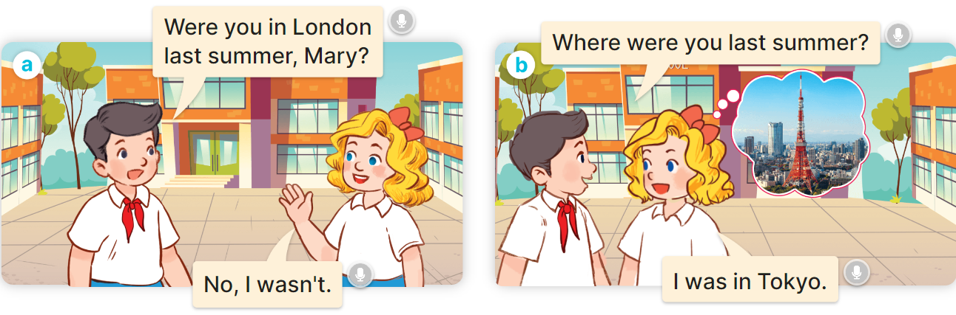  - Play the audio twice (sentence by sentence). Correct their pronunciation where necessary.  - Have Ss to practice the dialogue  - T invites a few pairs to the front of the class to practice.  - T checks pronunciation for ss.  Activity 3 Listen, point and say.  *Aims: Ss will be able to correctly say the words and use Where were you last summer? – I was in….. to ask and answer questions about where someone was in the past.  *Procedure:  * Model sentences:  - T asks Ss look at picture b and helps Ss know the structure from the dialogue.  - T introduces new structure for Ss.  - T explains, models and gives meaning.  - Have Ss repeat the model sentences.  A Where were you last summer  B: I was in Tokyo  *Drill pictures  - Have pupils look at the pictures and elicit the places in the pictures.      - Run through all the pictures.  - Run through model sentences.  +Run through question sentence  +Run through answer sentence  - Have Ss to practise:  + T asks, Ss answer picture a  + Ss asks, T answers picture b  + Group A ask, group B answer picture c  + Group B ask, group A answer picture d  - Ask Ss to work in pairs.  - T controls and corrects.  - Invite a few pupils to stand up, point at each school thing in the picture and say the sentence aloud.  - T gives feedbacks  Activity 4. Let’s talk.  *Aims: Ss will be able to enhance the correct use of Where were you last summer? – I was in…... to ask and answer questions about where someone was in the past in a freer context.  *Procedure:  - Have Ss look at the picture and elicit the question and the answer in context.  + Who are they?  + Where are they?  + How many places are there?    - Have Ss look at the picture and say the break time activites.  - Have Ss look at the first speech bubble and read Where were you last summer?  - Have Ss point the activities, ask and answer the questions about break time activities  - Give Ss time to practise asking and answering the question Where were you last summer? – I was……. in pairs.  - Invite a few pairs to practise asking and answering questions about break time activites in front of the class.  *Consolidation  *Aims: Ss will be able consolidate and wrap up the content of the lesson.  *Procedure:  - T asks ss to answer the following questions:  + What have you learnt from the lesson today?  +What are the core values of the lesson? (if the teacher can take from the lesson).  - T review the vocabulary and model sentences.  - T praises some Ss who are hardworking / active/ good…. as well as encourage others to try more.  - Learn the vocabulary and model sentences by heart  - Prepare the new lesson: Unit 10, Lesson 2 (4,5,6). | - Ss listen  -Ss play game  -Ss open their books  -Ss listen and answer  - - Ss listen and repeat  + Choral repetition (3 times).  + Individual repetition (3 ss)  - Ss take note  - Ss look, remember and write  -Look at the pictures and say  + In picture a:  Nam: Were you in London last summer, Mary?  Mary: No, I wasn’t.  + In picture b:  Nam: Where were you last summer?  Mary: I was in Tokyo.  -Ss listen and repeat in chorus (twice)  -Ss work in pairs to practice  -Ss practice the dialogue  -Ss listen  -Ss look at the picture and answer.  -Ss listen  -Ss listen and repeat  -Ss repeat  - Ss look, listen and answer  + Picture a: Mai standing by Big Ben  + Picture b: Nam standing by Opera House  + Picture c: Mary standing by Tokyo Tower  + Picture d: Bill standing by Temple of the Golden Buddha  -Ss listen and repeat  -Ss practice in chorus, individuals.  -Ss practice in chorus, individuals.  -Ss work in pairs  - Ss listen to the teacher  -Ss point and say  -Ss listen.  -Ss look at the picture and answer  + a picture of Temple of the Golden Buddha; a picture of Tokyo Tower; a picture of Big Ben; a picture of Opera House  -Ss point and say  -Ss read the sentence  -Ss point, ask and answer  -Ss ask and answer  -Ss work in pairs, point and ask and answer  -Ss answer the questions  - Ss listen  -Ss listen and clap their hands  -Ss listen and take note
D. ADJUSTMENTS (if necessary):
………………………………………………………………………………………….…..……………………………………………………………………………...………………………………………….…..……………………………………………………………………………….……………………………………………………………………...

