Week 13
Period 49 Teaching date: November 27,28,29, 2024

Unit 7: Our timetables
Lesson 3 (4, 5, 6)
I. OBJECTIVES:
By the end of the lesson, Ss will be able to:
1. Knowledge:
- Identify the specific information by scanning the text about Minh and circle the correct answers.
- Write about pupil’s school subjects.
- Present their timetable to the class at the Project time
- Vocabulary: Review
- Skills: speaking, listening, reading and writing.
2. Competences:
- Critical Thinking: self-introduce
- Co-operation: ready to help friends in pair work/ group work.
- Self-control and independent learning: perform listening tasks.
3. Attitude/ Qualities:
- Kindness: Help partners to complete learning tasks.
- Honesty: tell the truth about feelings and emotions.
- Diligence: complete learning tasks.
II. TEACHING AIDS:
- Teacher: Teacher’s guide Pages 110, 111; website hoclieu.vn, posters, laptop, pictures, textbook, lesson plan, TV or projector.
- Students: Pupil’s book Page 55, notebooks, workbooks, school things.
III. PROCEDURES:
Stages/Time | Teacher’s activities | Students’ activities
1.Warm- up: (5’)  2.Practice: (8’)  3.Production: (19’)  4. Homework. (3’) | Game: “Chant”  *Aims: to review the vocabulary and structure about greet and respond to greetings.  *Procedure:  - Ask Ss chant and do the actions in Unit 7, Lesson 3 page 54 in groups.  - Give point for the groups and encourage them.  - Say “Open your book page 55” and look at “Unit 7, Lesson 3 (4, 5, 6)”.  Activity 1. Read and circle:  *Aims: Ss will be able to read and show understanding the text by choosing the best options to complete the sentences *Procedure:  - Tell pupils the goal of the activity and explain that they should read the sentences and choose the correct options.  - Model number 1: have pupils read the sentence and guess the missing words. Then have them read the text and choose the correct option.  - Have pupils to do the task independently.  - Get pupils to swap their books with a partner and check their answers before checking as a class.  - Invite one or two pupils to read the text and the completed sentences in front of the class.  Key: . b 2. a 3. b 4. b  Activity 2. Let’s write  *Aims: Ss will be able to read, understand and complete a gapped text about pupils’ timetables using the target language.  *Procedure:  - Explain that the gaps in the text focus on their names and their timetables.  - Model the first gap and have pupils do the first gapped sentence together as an example.  - Give pupils time to complete the text independently.  - Invite one or two pupils to read their completed texts in front of the class.  Ex: My name is Huong. I go to school from Mondays to Fridays. I have Vietnamese and maths today. I have English on Mondays, Thursdays and Fridays. I have science on Wednesdays and Thursdays. I have music on Tuesdays. I like music very much.  Activity 3. Project.  *Aims: Ss will be able to make and present their timetables to the class.  *Procedure:  - Explain that they must show the timetables that they have prepared at home and present them to the class.  - Have pupils work in groups of three.  + Each pupil shows his / her timetable and tells the group about it, ex: Look at the timetable. I have Vietnamese and maths every day. I have English on Mondays, Wednesdays, and Fridays. I have music on Thursdays.  - Invite a few pupils to show their timetables and tell the class about them.  *Consolidation  *Aims: Ss will be able consolidate and wrap up the content of the lesson.  *Procedure:  - T asks ss to answer the following questions:  + What have you learnt from the lesson today?  +What are the core values of the lesson? (if the teacher can take from the lesson).  - T praises some Ss who are hardworking / active/ good…. as well as encourage others to try more.  - Prepare the new lesson: Unit 8, Lesson 1 (1, 2, 3). | - Ss listen and chant  - Ss open their books  - Ss look at the passage and listen  -Ss read and guess the missing words  -Ss do the task  -Ssswap books and check their answer  -Ss check their answer  -Ss read aloud  -Ss look and listen  -Ss read and fill  -Ss do the task  -Ss read the complete texts  -Ss listen  -Ss work in groups  -Ss perform in front of the class  -Ss answer the questions  -Ss listen and clap their hands  -Ss listen and take note
IV. ADJUSTMENTS (if necessary):
………………………………………………………………………………………….…..……………………………………………………………………………...…………

Week 13
Period 50 Teaching date: November 27,28,29, 2023

Unit 8: My favourite subjects
Lesson 1 (1, 2, 3)
I. OBJECTIVES:
By the end of the lesson, Ss will be able to:
1. Knowledge:
- use the words and phrases art, music, PE, IT, an English teacher, a maths teacher, a painter and a singer in relation to the topic “My favourite subjects”.
- use What’s your favourite subject? – It’s …..to ask and answer questions about someone’s favourite subject;
- listen to and demonstrate understanding of simple communicative contexts in relation to the topic “My favourite subjects”.
- Vocabulary: PE, IT, favourite.
- Skills: speaking and listening
2. Competences:
- Self-control and independent learning: perform listening tasks.
- Communication and collaboration: work in pairs or groups.
- Sociability: talk to each other, say good words to others.
3. Attitude/ Qualities:
- Show pride in what they can do and great respect for other people’s abilities by using appropriate gesture and intonation when asking and answering about abilities.
II. TEACHING AIDS:
- Teacher: Teacher’s guide Pages 112, 113, audio Tracks 77, 78, website hoclieu.vn, posters, laptop, pictures, textbook, lesson plan, TV or projector.
- Students: Pupil’s book Page 56, notebooks, workbooks, school things.
III. PROCEDURES:
Stages/Time | Teacher’s activities | Students’ activities
1.Warm- up:  (5’)  2. Presentation  (16’)  3.Practice: (7’)  4.Production: (7’)  5. Homework. (2’) | Game: Who says faster  *Aims: to create a friendly and active atmosphere in the class to beginning the lesson.  *Procedure:  - Hold some flashcards about subjects, then reveal it slowly.  - Ask What is it?  - Ask the Ss guess the answer as fast as possible.  - Then have Ss do the same with the rest.  - This can be played in groups to make it more interesting  - Say “Open your book page 56” and look at “Unit 8, Lesson 1 (1,2,3)”.  Activity 1. Vocabulary.  *Aims: Ss will be able to know the vocabulary in the new lesson.  *Procedure:  -T elicits the new words  + favourite : yêu thích (situation)  + PE= Physical Education: môn thể dục  (realia)  + IT= Information Technology : môn tin học (realia)  - T models (3 times).  - T writes the words on the board.  - Checking: Rub out and remember  Activity 2. Look, listen and repeat:  *Aims: Ss will be able to understand and correctly repeat the sentences in two communicative contexts focusing on asking and answering questions about someone’s favourite subject.  *Procedure:  - Have Ss look at Pictures a and b and identify the characters (Linh and Ben) in the pictures.  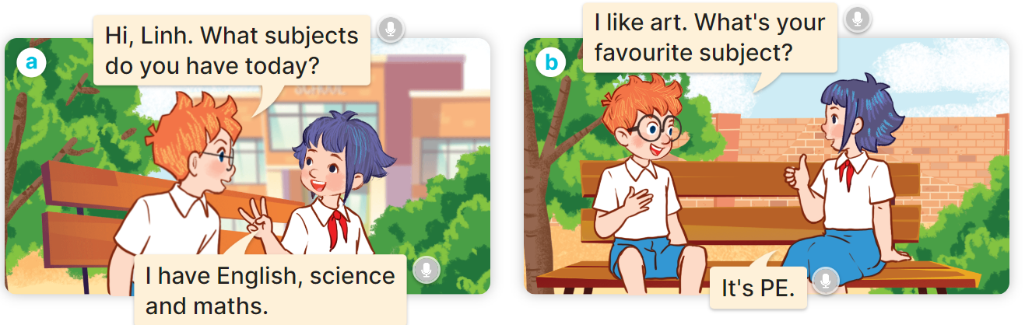  - Play the audio twice (sentence by sentence). Correct their pronunciation where necessary.  - Have Ss to practice the dialogue  - T invites a few pairs to the front of the class to practice.  - T checks pronunciation for ss.  Activity 3 Listen, point and say.  *Aims: Ss will be able to correctly say the words and use What’s your favourite subject? – It’s …….. to ask and answer questions about someone’s favourite subject.  *Procedure:  * Model sentences:  - T asks Ss look at picture a and helps Ss know the structure from the dialogue.  - T introduces new structure for Ss.  - T explains, models and gives meaning.  -Have Ss repeat the model sentences.  A: What’s your favourite subject? B: It’s PE  *Drill pictures  - Have Ss look at the pictures and elicit the subjects.  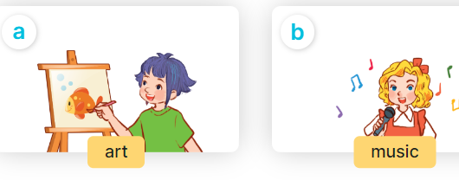  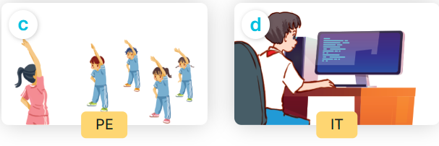  - Run through all the pictures.  - Run through model sentences.  - Have Ss to practise:  +Tell Ss to point the subjects in the picture when they are repeating the sentence  - T controls and corrects.  - Invite a few pupils to stand up, point at each school thing in the picture and say he sentence aloud.  - T gives feedbacks.  Activity 4. Let’s talk.  *Aims: Ss will be able to enhance the correct use of What’s your favourite subject? – It’s …… to ask and answer questions about someone’s favourite subject in a freer context.  *Procedure:  - Draw pupils’ attention to the two speech bubbles.  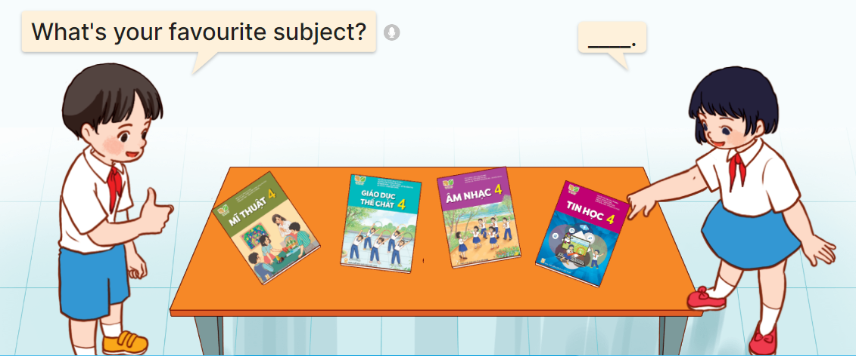  - Ask them to look at the girl’s speech bubble to identify what the answer should be. ex: It’s IT.  - Get pupils to repeat the question and answer several times.  - Have pupils to work in pairs, point at the different books, ask and answer questions about their favourite subjects using What’s your favourite subject? – …..  - Invite some pairs to take turns asking and answering questions about their favourite subjects in front of the class.  *Consolidation  *Aims: Ss will be able consolidate and wrap up the content of the lesson.  *Procedure:  - T asks ss to answer the following questions:  + What have you learnt from the lesson today?  +What are the core values of the lesson? (if the teacher can take from the lesson).  - T review the vocabulary and model sentences.  - T praises some Ss who are hardworking / active/ good…. as well as encourage others to try more.  - Learn the vocabulary and model sentences by heart  - Prepare the new lesson: Unit 8, Lesson 1 (4,5,6). | - Ss listen  -Ss play the game  -Ss play the game  -Ss open the books  -Ss listen and answer  - - Ss listen and repeat  + Choral repetition (3 times).  + Individual repetition (3 ss)  - Ss take note  - Ss look, remember and write  -Look at the pictures and say  + In picture a:  Ben: Hi, Linh. What subjects do you have today?  Linh: I have English, science and maths.  + In picture b:  Linh: I like art. What’s your favourite subject?  Ben: It’s PE.  -Ss listen and repeat in chorus (twice)  -Ss work in pairs to practice  -Ss practice the dialogue  -Ss listen  -Ss look at the picture and answer.  -Ss listen  -Ss listen and repeat  -Ss repeat  - Ss look, listen and answer  + Picture a. A girl painting  + Picture b. Five children singing  + Picture c. A group of pupils doing physical exercise  + Picture d. A boy and a girl working on a computer  -Ss listen and repeat  -Ss practice in chorus, individuals.  -Ss point and say  -Ss listen.  -Ss look at the picture and answer  + a boy pointing at textbooks on a table, and asking a girl about her favourite subject.  -Ss look at the picture and answe  -Ss repeat the question and answer  -Ss work in pairs, point and say  -Ss ask and answer their favourite subjects in front of the class.  -Ss answer the questions  - Ss listen  -Ss listen and clap their hands  -Ss listen and take note
IV. ADJUSTMENTS (if necessary):
………………………………………………………………………………………….…..……………………………………………………………………………...………………………………………….…..……………………………………………………………………………….……………………………………………………………………...

Week 13
Period 51 Teaching date: November 27,28,29, 2023

Unit 8: My favourite subjects
Lesson 1 (4, 5, 6)
I. OBJECTIVES:
By the end of the lesson, Ss will be able to:
1. Knowledge:
- use the words and phrases art, music, PE, IT in relation to the topic “My favourite subjects”.
– use What’s your favourite subject? – It’s ……... to ask and answer questions about someone’s favourite subject.
– listen to and demonstrate understanding of simple communicative contexts in relation to the topic “My favourite subjects”.
– read and write about someone’s favourite subject.
- Vocabulary: Review
- Skills: speaking, listening, reading and writing.
2. Competences:
- Written Communication: complete the sentences.
- Self-control and independent learning: perform listening tasks.
- Communication and collaboration: work in pairs or groups.
3. Attitude/ Qualities:
- Kindness: Help partners to complete learning tasks.
- Diligence: complete learning tasks.
II. TEACHING AIDS:
- Teacher: Teacher’s guide Pages 114, 115,116; audio Tracks 83; website hoclieu.vn, posters, laptop, pictures, textbook, lesson plan, TV or projector.
- Students: Pupil’s book Page 57, notebooks, workbooks, school things.
III. PROCEDURES:
Stages/Time | Teacher’s activities | Students’ activities
1.Warm- up:  (5’)  2.Practice: (27’)  3. Homework. (3’) | Sentence Puzzle  *Aims: to create a friendly and active atmosphere in the class to beginning the lesson.  *Procedure:  - Divide the class into groups of four.  - Give each group a sentence that is broken/cut in to pieces.  - Ask Ss to arrange them to make a complete sentence, then read it aloud.  - The group makes it first will be the winner.  - Say “Open your book page 57” and look at “Unit 8, Lesson 1 (4,5,6)”.  Activity 1. Listen and tick or cross:  *Aims: Ss will be able to listen to and understand four communicative contexts in which pupils ask and answer questions about their favourite subjects, and tick or cross the pictures.  *Procedure:  - Elicit the subjects in each picture.  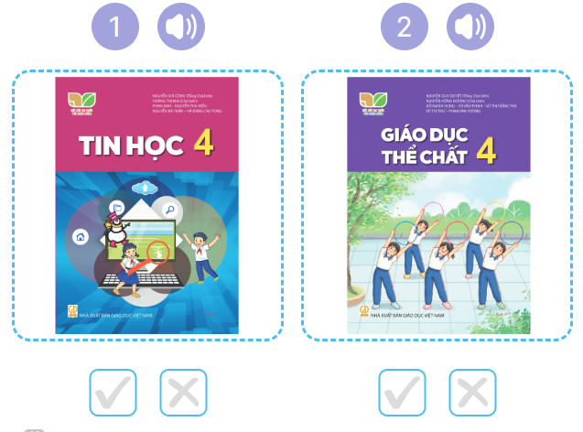  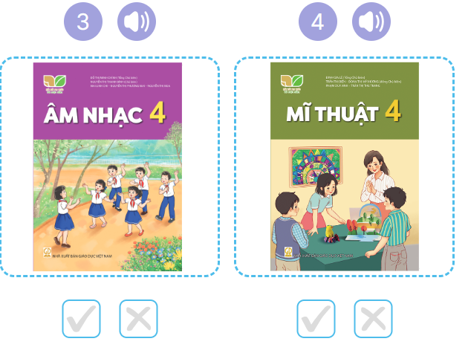  - T ask Ss to guess the answers.  + T writes Ss’guessing on the board.  - Listen to the tape:  + Play the recording  + Play the recording again and get Ss to swap books with their partners.  + Play the recording again to check answers together as a class.  + Write the answers on the board for Ss to correct their answers. Then checks Ss’ guessing.  - Play the recording, sentence by sentence, for the class to listen and repeat in chorus.  Key: 1. v 2. x 3.v 4.x  Activity 2. Look, complete and read  *Aims: Ss will be able to complete four exchanges about characters’ favourite subjects with the help of picture cues  *Procedure:  - Ask pupils to look at the pictures and identify the subjects. 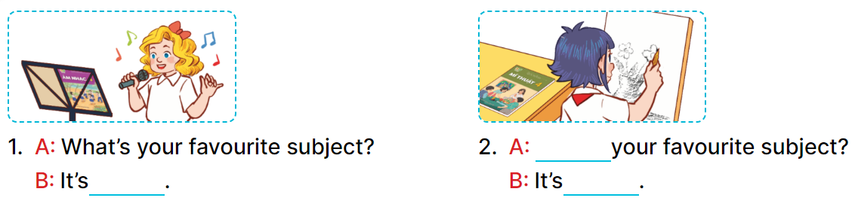  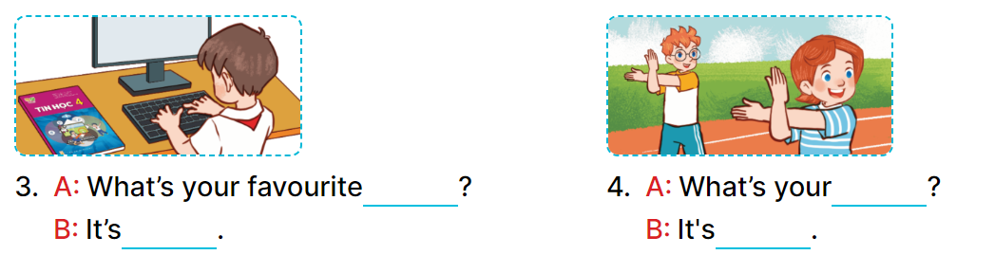  - Have Ss look at the four incomplete sentences. Elicit and model with picture 1  + Ask Ss to read the sentence 1 in chorus.  + Ask Ss what word is missing in the gap (music). Then have them complete the sentence (It’s music).  -Have Ss work in pairs and complete the sentences 2, 3, 4.  - Ask a few Ss to stand up and read the sentences aloud.  -T gives feedbacks.  Key:  1. music 2. What’s; art  3. subject; IT  4. favourite subject; PE  Activity 3. Let’s sing  *Aims: Ss will be able to sing the song My favourite subject with the correct pronunciation, rhythm and melody.  *Procedure:  - Have pupils read the song to familiarize themselves with the lyrics  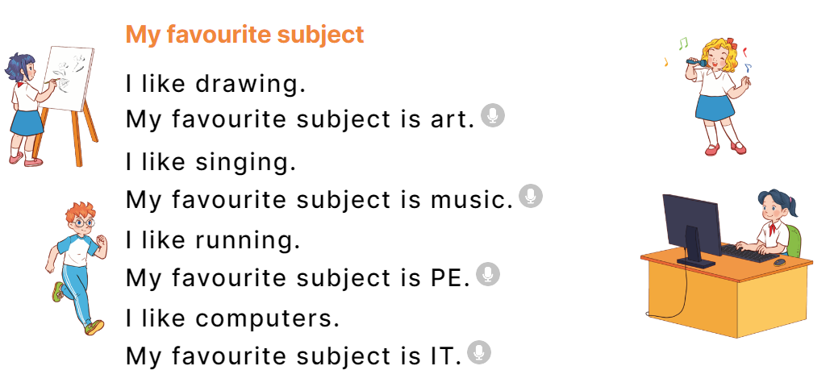  - Play the recording for Ss to listen to the whole song.  + Have them repeat the title and lyrics line by line.  + Tell Ss to point at the pictures while singing.  - Play the recording all the way through for Ss to listen to pronunciation and melody of the song.  - Play the recording line by line for Ss to listen, repeat and point to the pictures  - Play the recording for Ss to sing and do actions.  - Ask Ss to practice singing and doing actions in pairs or groups.  - Invite groups to the front of the classroom to perform the song  -T gives feedback.  *Consolidation  *Aims: Ss will be able consolidate and wrap up the content of the lesson.  *Procedure:  - T asks ss to answer the following questions:  + What have you learnt from the lesson today?  +What are the core values of the lesson? (if the teacher can take from the lesson).  - T praises some Ss who are hardworking / active/ good…. as well as encourage others to try more.  - Practice part 5 again.  - Prepare the new lesson: Unit 8, Lesson 2 (1,2,3). | - Ss listen  -Ss listen  - Ss arrange and read aloud  -Ss congratuate the winner  - Ss open their books  -Look at the pictures and say:  + Picture 1: An IT textbook  + Picture 2: A PE textbook  + Picture 3: A music textbook  + Picture 4: . An art textbook  -Ss guess the answers  - Ss listen to the tape and tick/ cross  - Ss listen again, tick/ cross and swap books with their partners.  - Ss check their answers and guessing  -Ss listen and repeat.  -Ss look at the picture and say  -Ss look and answer  -Ss read  -Ss say and write  -Ss work in pairs and complete  -Ss read aloud  -Ss read the song  -Ss listen to the song  - Ss listen and repeat line by line without the action.  -Ss point to the pictures while singing  -Ss listen to melody of the song  - Ss listen and sing line by line.  - Ss sing and do actions.  + Ss work in groups (two groups) to sing.  -Ss perform in front of the class.  -Ss listen  -Ss answer the questions  -Ss listen and clap their hands  -Ss listen and take note
IV. ADJUSTMENTS (if necessary):
………………………………………………………………………………………….…..……………………………………………………………………………...………………………………………….…..……………………………………………………………………………….……………………………………………………………………...

Week 13
Period 52 Teaching date: November 27,28,29, 2023
Unit 8: My favourite subjects
Lesson 2 (1, 2, 3)
I. OBJECTIVES:
By the end of the lesson, Ss will be able to:
1. Knowledge:
- – use the words and phrases art, music, PE, IT, an English teacher, a maths teacher, a painter and a singer in relation to the topic “My favourite subjects”.
– use Why do you like ……..? – Because I want to be ……... to ask for and give reasons for liking a school subject.
– listen to and demonstrate understanding of simple communicative contexts in relation to the topic “My favourite subjects”.
- Vocabulary: English teacher, maths teacher, painter
- Skills: speaking and listening
2. Competences:
- Critical Thinking: self-introduce
- Co-operation: ready to help friends in pair work/ group work.
- Sociability: Talk to each other, say good words to others.
3. Attitude/ Qualities:
- Kindness: Help partners to complete learning tasks.
- Honesty: tell the truth about feelings and emotions
II. TEACHING AIDS:
- Teacher: Teacher’s guide Pages 116, 117, 118, audio Tracks 81, 82, website hoclieu.vn, posters, laptop, pictures, textbook, lesson plan, TV or projector.
- Students: Pupil’s book Page 58, notebooks, workbooks, school things.
III. PROCEDURES:
Stages/Time | Teacher’s activities | Students’ activities
1.Warm- up:  (3’)  2. Presentation  (16’)  3.Practice: (7’)  4.Production: (7’)  5. Homework. (2’) | Pass the subjects  *Aims: to create a friendly and active atmosphere in the class to beginning the lesson.  *Procedure:  - Review the previous lesson by having the class pass the school things with the music.  - When the music stops, who have subjects have to say the sentence: I like music.  - Say “Open your book page 52” and look at “Unit 8, Lesson 2 (1, 2, 3)”.  Activity 1. Vocabulary.  *Aims: Ss will be able to know the vocabulary in the new lesson.  *Procedure:  -T elicits the new words  + English teacher : giáo viên tiếng anh (example)  + maths teacher: giáo viên Toán (example)  + painter :họa sĩ (example)  - T models (3 times).  - T writes the words on the board.  - Checking: Rub out and remember  Activity 2. Look, listen and repeat:  *Aims: Ss will be able to understand and correctly repeat the sentences in two communicative contexts focusing on asking for and giving reasons for liking a school subject, English.  *Procedure:  - Have Ss look at Pictures a and b and identify the characters and the reason why Nam likes English. 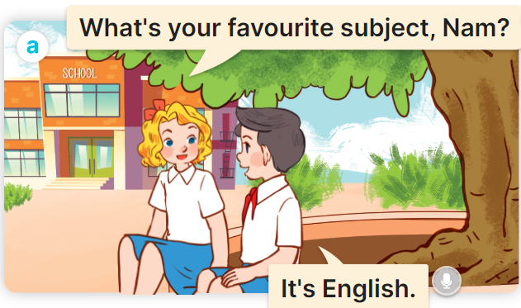  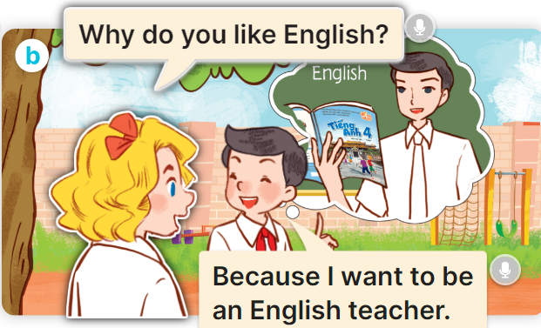  - Play the audio twice (sentence by sentence). Correct their pronunciation where necessary.  - Have Ss to practice the dialogue  - T invites a few pairs to the front of the class to practice.  - T checks pronunciation for ss.  Activity 3 Listen, point and say.  *Aims: Ss will be able to correctly say the words and phrases and use Why do you like …….? – Because I want to be ……. to ask for and give reasons for liking a school subject, English.  *Procedure:  * Model sentences:  - T asks Ss look at picture b and helps Ss know the structure from the dialogue.  - T introduces new structure for Ss.  - T explains, models and gives meaning.  -Have Ss repeat the model sentences.  A: Why do you like English.?  B: Because I want to be an English teacher  *Drill pictures  - Have Ss look at the pictures and elicit the reason why each pupil likes his / her favourite subject.  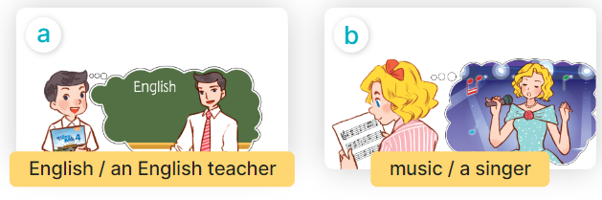  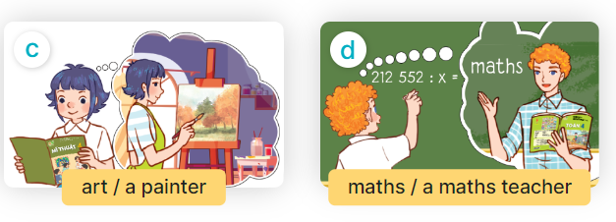  - Run through all the pictures.  - Run through model sentences.  +Run through question sentence  +Run through answer sentence  - Have Ss to practise:  + T asks, Ss answer picture a  + Ss asks, T answers picture b  + Group A ask, group B answer picture c  + Group B ask, group A answer picture d  - Ask Ss to work in pairs.  - T controls and corrects.  - Invite a few pairs to come to the front of the classroom and point at the pictures and say the questions and answers in front of the class.  - T gives feedbacks.  4.Production: (7’)  Activity 4. Let’s talk.  *Aims: Ss will be able to enhance the correct use of Why do you like …….? – Because I want to be …….. ask for and give reasons for liking a school subjects in a freer context.  *Procedure:  - Have pupils look at the picture and explain that a group of four pupils are in the playground  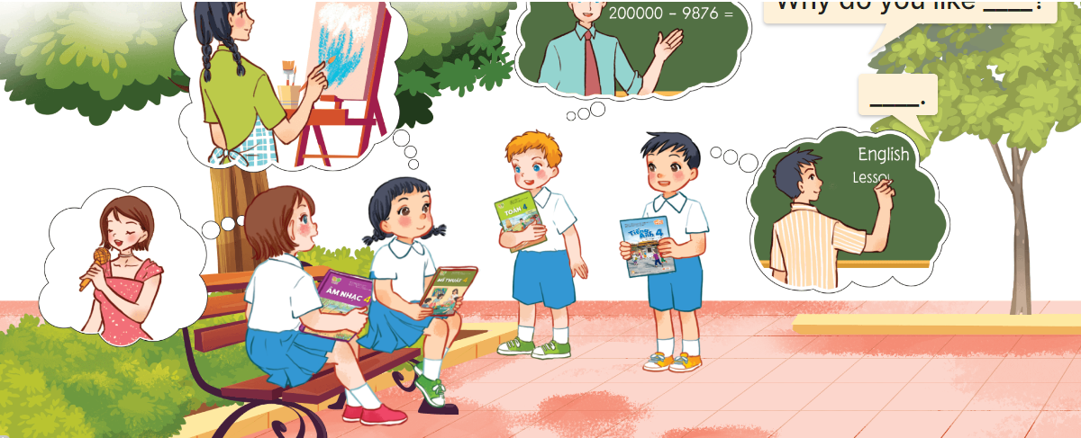  - Ask pupils to look at the first girl with black hair with the art textbook and ask pupils to identify her favourite subject (art) and what she want to be in the future (painter).  - Divide the class into two groups to role-play the girls/ boys and an interviewer.  - Have pupils work in pairs to practise asking and answering the question  Why do you like……? – ……...  - Invite pairs of pupils to the front of the classroom to take turns asking for and giving reasons why they like the subject.  *Consolidation  *Aims: Ss will be able consolidate and wrap up the content of the lesson.  *Procedure:  - T asks ss to answer the following questions:  + What have you learnt from the lesson today?  +What are the core values of the lesson? (if the teacher can take from the lesson).  - T review the vocabulary and model sentences.  - T praises some Ss who are hardworking / active/ good…. as well as encourage others to try more.  - Learn the vocabulary and model sentences by heart  - Prepare the new lesson: Unit 8, Lesson 2 (4,5,6). | - Ss listen  - Ss play game  -Ss open their books  -Ss listen and answer  - - Ss listen and repeat  + Choral repetition (3 times).  + Individual repetition (3 ss)  - Ss take note  - Ss look, remember and write  -Look at the pictures and say  + In picture a:  Mary: What’s your favourite subject, Nam?  Nam: It’s English  + In picture b:  Mary: Why do you like English?  Nam: Because I want to be an English teacher.  -Ss listen and repeat in chorus (twice)  -Ss work in pairs to practice  -Ss practice the dialogue  -Ss listen  -Ss look at the picture and answer.  -Ss listen  -Ss listen and repeat  -Ss repeat  - Ss look, listen and answer  + Picture a: English / an English teacher  + Picture b: music / a singer  + Picture c: art / a painter  + Picture d: maths / a maths teacher  -Ss listen and repeat  -Ss practice in chorus  -Ss practice in chorus  -Ss work in pairs to practice  -Ss point and say  -Ss listen.  -Ss look at the picture and answer  + Four pupils with textbooks in hand asking each other for and giving reasons for liking a school subject  -Ss look at the picture and answer  -Ss work in groups to ask and answer.  -SS ask and answer  -Ss answer the questions  - Ss listen  -Ss listen and clap their hands  -Ss listen and take note
IV. ADJUSTMENTS (if necessary):
………………………………………………………………………………………….…..……………………………………………………………………………...…………

