Week 5
Period 17 Teaching date: October 8th, 10th, 2024

Unit 3: My week
Lesson 1 (1, 2, 3)
I. OBJECTIVES:
By the end of the lesson, Ss will be able to:
- understand and correctly repeat the sentences in two communicative contexts (pictures) in which pupils ask and answer questions about the days of the week.
- correctly say the words and use What day is it today? – It’s ………. to ask and answer questions about the days of the week.
- enhance the correct use of What day is it today? – It’s …….. to ask and answer questions about the days of the week in a freer context.
- Critical Thinking: self-introduce
- Co-operation: ready to help friends in pair work/ group work.
- Sociability: Talk to each other, say good words to others.
- Kindness: Help partners to complete learning tasks.
- Honesty: tell the truth about feelings and emotions
II. TEACHING AIDS:
- Teacher: Teacher’s guide Pages 43, 44, 45, audio Tracks 26, 27, website hoclieu.vn, posters, laptop, pictures, textbook, lesson plan, TV or projector.
- Students: Pupil’s book Page 22, notebooks, workbooks, school things.
III. PROCEDURES:
Stages/Time | Teacher’s activities | Students’ activities
1.Warm- up:  (5’)  2. Presentation  (16’)  3. Practice: (7’)  4.Production: (5’)  5. Homework. (2’) | Sing: What day is it today?  - Show the song on the screen.  https://www.youtube.com/watch?v=ij0iWJB2uMo  - Ask pupils to listen, sing and dance the song.  - Say “Open your book page 22” and look at “Unit 3, Lesson 1 (1,2,3)”.  Activity 1. Vocabulary.  -T elicits the new words  + Monday : thứ 2 (situation)  + Tuesday : thứ 3 (situation)  + Wednesday :thứ 4 (situation)  + Thursday : thứ 5 (translation)  + Friday : thứ 6 (translation)  + Saturday : thứ 7 (situation)  + Sunday : chủ nhật (situation)  + today : hôm nay (translation)  - T models (3 times).  - T writes the words on the board.  - Checking: Matching  Activity 2. Look, listen and repeat:  - Have Ss look at Pictures a and b and identify the characters in the pictures.  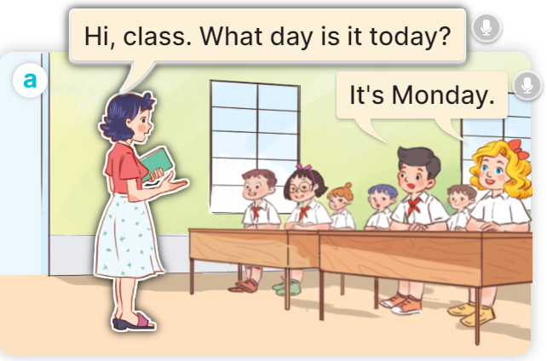  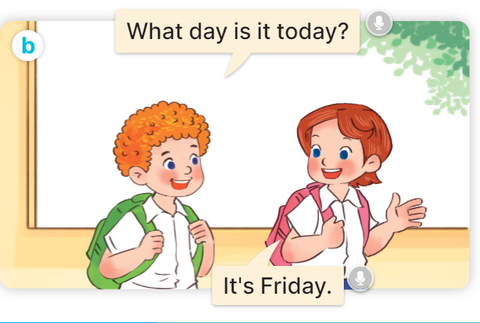  - Play the audio twice (sentence by sentence). Correct their pronunciation where necessary.  - Have Ss to practice the dialogue  - T invites a few pairs to the front of the class to practice.  - T checks pronunciation for ss.  Activity 3 Listen, point and say.  * Model sentences:  - T asks Ss look at picture a, b and helps Ss know the structure from the dialogue.  - T introduces new structure for Ss.  - T explains, models and gives meaning.  - Have Ss repeat the model sentences.  A: What day is it today?  B: It’s Monday.  *Drill pictures  - Elicit and check comprehension the name of each character.      - Run through all the pictures.  - Run through model sentences.  - Have Ss to practise:  + T says the first picture  + Ss says the second picture  + Group A says the third picture  + Group B say the last picture.  - Ask Ss to work in pairs.  - T controls and corrects.  - Invite a few pairs to come to the front of the classroom, point at the relevant character in each picture, and act out his/her role.  - Encourage Ss to practise speaking English.  - T gives feedbacks.  Activity 4. Let’s talk.  - T asks ss to guess each character and what the children say.  + What can you see in the picture?  +Who are they?  +Where are they?  +What are they saying?  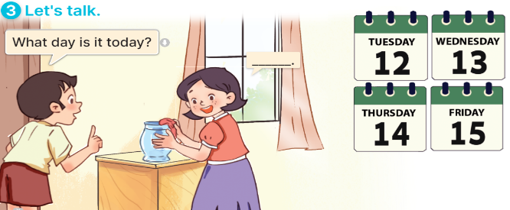  - T fills the gaps and writes the sentences on the board.  - T models  - T asks Ss to greet and introduce someone. (groups of four)  - Invite some groups to perform.  - Give feedbacks  - T review the vocabulary and model sentences.  - T praises some Ss who are hardworking / active/ good…. as well as encourage others to try more.  - Learn the vocabulary and model sentences by heart  - Prepare the new lesson: Unit 3, Lesson 1 (4,5,6). | - Ss sing and dance the song  - Ss open their books  -Ss listen and answer  - - Ss listen and repeat  + Choral repetition (3 times).  + Individual repetition (3 ss)  - Ss take note  - Ss look, remember and match  -Look at the pictures and get to know the characters in the pictures.  + In picture a: Ms Hoa says: Hi, class. What day is it today? And Mr Long says: It’s Monday.  + In picture b: Mai says: That’s Mr Long. And Bill says: Hello, Mr Long.  -Ss listen and repeat in chorus (twice)  -Ss work in pairs to practice  -Ss practice the dialogue  -Ss listen  -Ss look at the picture and answer.  -Ss listen  -Ss listen and repeat  -Ss repeat to the introduce someone.  - Ss look, listen and answer  +Picture a: Monday  + Picture b: Tuesday  + Picture c: Wednesday  + Picture d: Thursday  -Ss listen and repeat  -Ss practice in chorus  -Ss practice  -Ss work in pairs to practice  -Ss point and say  -Ss listen.  -Ss listen  -Ss look at the picture and answer  + a boy asks a girl about the days of the week: Tuesday, Wednesday, Thursday, Friday (illustrated by calendars).  -Ss note  - Ss say the completed sentences.  -Ss pay attention  -Ss work in groups  -Ss perform in front of the class  - Ss listen  -Ss listen and clap their hands  -Ss listen and take note

IV. ADJUSTMENTS (if necessary):
………………………………………………………………………………………….…..……………………………………………………………………………...………………………………………….…..………………………………………

Week 5
Period 18 Teaching date: October 8th, 10th, 2024
Unit 3: My week
Lesson 1 (4,5,6)
I. OBJECTIVES:
By the end of the lesson, Ss will be able to:
- listen to and understand two communicative contexts about the days of the week and tick the correct pictures.
- complete four gapped exchanges with the help of picture cues.
- revise target words about the days of the week by playing the game Slap the board.
- Vocabulary: Review
- Skills: speaking, listening, reading and writing.
- Critical Thinking: self-introduce
- Co-operation: ready to help friends in pair work/ group work.
- Self-control and independent learning: perform listening tasks.
- Kindness: Help partners to complete learning tasks.
- Honesty: tell the truth about feelings and emotions.
- Communication and collaboration: work in pairs and groups to complete the learning tasks
II. TEACHING AIDS:
- Teacher: Teacher’s guide Pages 45,46,47; audio Tracks 29; website hoclieu.vn, posters, laptop, pictures, textbook, lesson plan, TV or projector.
- Students: Pupil’s book Page 23, notebooks, workbooks, school things.
III. PROCEDURES:
Stages/Time | Teacher’s activities | Students’ activities
1.Warm- up:  (5’)  2.Practice: (20’)  3. Production  5’  4. Homework. (5’) | Game: Lucky number  - Divide the class into 2 teams (boys and girls).  - Each team takes turns to choose a number.  - They need to ask and answer with the picture corresponding to that number to get points.  - The group with more points at the end of the game will be the winner.  - Praise the winner, encourage the other team.  - Say “Open your book page 23” and look at “Unit 3, Lesson 1 (4,5,6)”.  Activity 1. Listen and tick:  - Elicit the days of the week.  - Point at the pictures respectively to explain the context.  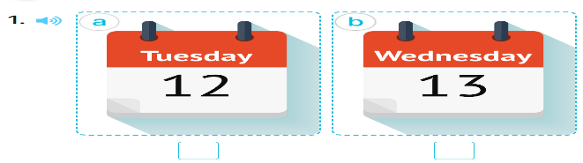  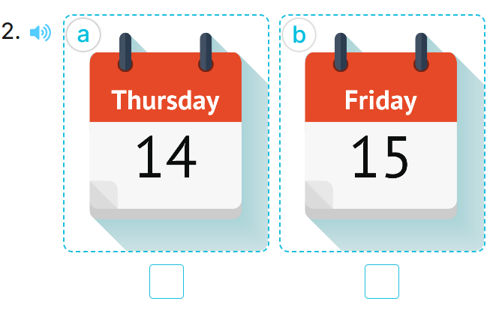  - T ask Ss to guess the answers.  + T writes Ss’guessing on the board.  - Listen to the tape:  + Play the recording  + Play the recording again and get Ss to swap books with their partners.  + Play the recording again to check answers together as a class.  + Write the answers on the board for Ss to correct their answers. Then checks Ss’ guessing.  - Play the recording, sentence by sentence, for the class to listen and repeat in chorus.  Key: 1.b 2.a  Activity 2. Look, complete and read.  - Have pupils look at the pictures and identify the days of the week in the pictures. 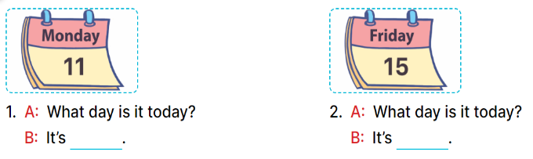  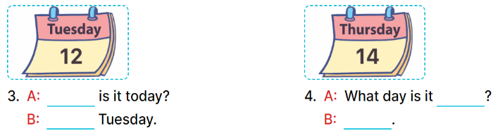  - Have Ss look at the two incomplete dialogue and elicits the missing words in the sentences.  - T models with picture 1  + Ask Ss what is missing in the sentence.  + Have Ss look at the picture and complete the gap, then read the completed sentence in chorus.  -Have Ss work in groups and complete the picture 2.  - Ask a few Ss to stand up and read the completed sentences aloud.  -T gives feedbacks.  Key:  - Monday 2. Friday  - 3. What day; It’s  - 4. today; It’s Thursday  Activity 3. Let’s play: Slap the board  - Tell pupils that they are going to listen to and slap the correct words as quickly as possible.  - Have them look at the days of the week on the board to recall the days of the week.  - Call two pupils to the front. Get them to stand at a certain distance from the board.  - Say a day of the week using It’s …….with one of the words on the board, for example, It’s Monday.  - The pupil who is the quickest to slap the right word (Monday) gets one point.  - The pupil who slaps the most words is the winner.  - Invite a few pairs to the front of the class to play the game.  - Praise pupils if they perform well.  - T praises some Ss who are hardworking / active/ good…. as well as encourage others to try more.  - Practice part 5 again.  - Prepare the new lesson: Unit 3, Lesson 2 (1,2,3). | - Ss listen to the rule  - Ss play game  Ex: What day is it today?  It’s Tuesday.  -Ss listen  - Ss open their books  -Look at the pictures and say:  + Picture 1a: Tuesday  + Picture 1b: Wednesday  + Picture 2a: Thursday  + Picture 2b: Friday  -Ss guess the answers  - Ss listen to the tape and tick  - Ss listen again, tick and swap books with their partners.  -Ss listen again and check  - Ss check their answers and guessing  -Ss listen and repeat.  -Ss look at the picture and say:  -Ss look and answer  -Ss answer: Monday  -Ss look, complete and read the completed sentence in chorus.  -Ss work in groups and complete the sentences  -Ss read aloud  -Ss listen  - Ss look and listen.  - Ss listen  - Ss pay attention  -Ss play the game  -Ss listen and play games  -Ss listen  -Ss listen and clap their hands  -Ss listen and take note

IV. ADJUSTMENTS (if necessary):
………………………………………………………………………………………….…..……………………………………………………………………………...………………………………………….…..………………………………………

Week 5
Period 19 Teaching date: October 9th, 11th, 2024

Unit 3: My week
Lesson 2 (1, 2, 3)
A. OBJECTIVES:
By the end of the lesson, Ss will be able to:
- understand and correctly repeat the sentences in two communicative contexts focusing on asking and answering questions about what someone does on certain days of the week.
- correctly say the phrases and use What do you do on ……? – I ……... to ask and answer questions about what someone does on certain days of the week.
- enhance the correct use of What do you do on ……? – ………. to ask and answer questions about what someone does on certain days of the week in a freer context.
- Co-operation: ready to help friends in pair work/ group work.
- Sociability: Talk to each other, say good words to others.
- Kindness: Help partners to complete learning tasks.
- Honesty: tell the truth about feelings and emotions
II. TEACHING AIDS:
- Teacher: Teacher’s guide Pages 47,48,49; audio Tracks 29,30, website hoclieu.vn, posters, laptop, pictures, textbook, lesson plan, TV or projector.
- Students: Pupil’s book Page 24, notebooks, workbooks, school things.
III. PROCEDURES:
Stages/Time | Teacher’s activities | Students’ activities
1.Warm- up:  (5’)  2. Presentation  (12’)  3.Practice: (10’)  4.Production:  5’  5. Homework. (2’) | Game: Pass the ball  - T gives Ss a ball.  - T asks Ss to listen to music and transfer a ball around the class.  - When the music stops, Ss who keep a ball have to look at the picture and answer the question using: What day is it today? and It’s……..  - T gives feedback.  - Say “Open your book page 24” and look at “Unit 3, Lesson 2 (1,2,3)”.  Activity 1. Vocabulary.  -T elicits the new words  + study at school : học ở trường (situation)  + do housework : làm việc nhà (situation)  + listen to music : nghe nhạc (mime)  + stay at home : ở nhà (translation)  - T models (3 times).  - T writes the words on the board.  - Checking: What and where  Activity 2. Look, listen and repeat:  - Have Ss look at Pictures a and b and identify the characters in the pictures.  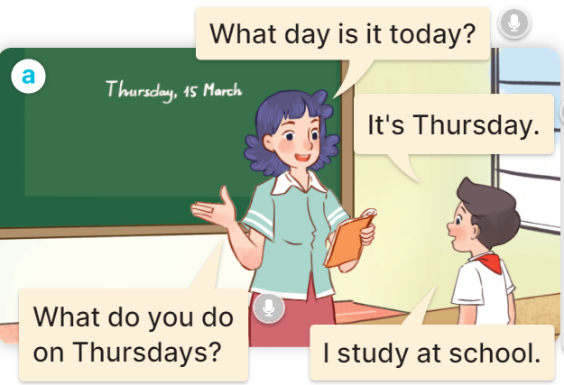  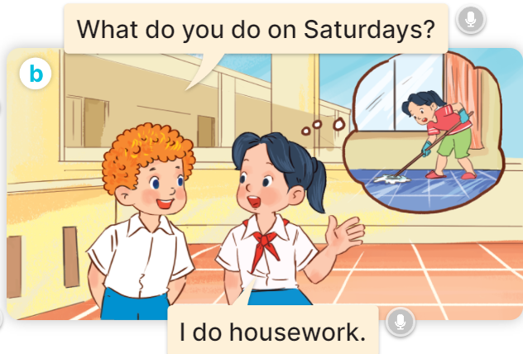  - Play the audio twice (sentence by sentence). Correct their pronunciation where necessary.  - Have Ss to practice the diaguage  - T invites a few pairs to the front of the class to practice.  - T checks pronunciation for ss.  Activity 3. Listen, point and say.  * Model sentences:  - T asks Ss look at picture a, b and helps Ss know the structure from the dialogue.  - T introduces new structure for Ss.  - T explains, models and gives meaning.  - Have Ss repeat the model sentences.  A: What do you do on Mondays?  B: I study at school.  *Drill pictures  - Have pupils look at the pictures and elicit the activities and the days of the week.    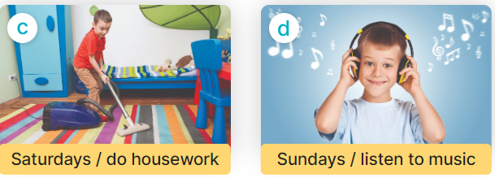  - Run through all the pictures.  - Run through model sentences.  + Run through the questions  + Run through the answers  - Have Ss to practise:  + T asks Ss answer (change role).  + Ss – Ss (change role).  - Ask Ss to work in pairs.  - T controls and corrects.  - Invite a few pairs to come to the front of the classroom, point at the relevant character in each picture, and act out his/her role.  - Invite Ss to go to the board and role play. Encourage Ss to practise speaking English.  - T gives feedbacks.  Activity 4. Let’s talk.  - Ask questions to help them identify the context.  + What can you see in the picture?  +Who are they?  +Where are they?  +What are they saying?  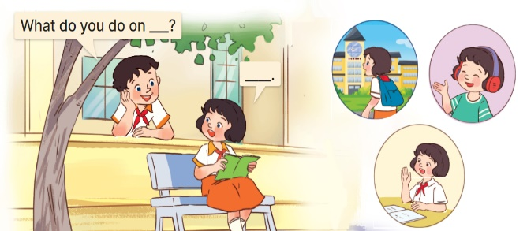  - T fills the gaps and writes the sentences on the board.  - T models  - T asks Ss use of What do you do on….? to ask, and answer (work in pairs)  - Invite some groups to perform.  - Give feedbacks  - T review the vocabulary and model sentences.  - T praises some Ss who are hardworking / active/ good…. as well as encourage others to try more.  - Learn the vocabulary and model sentences by heart  - Prepare the new lesson: Unit 3, Lesson 2 (4,5,6). | - Ss listen  - Ss play the game  - Ss open their books  -Ss listen and answer  - - Ss listen and repeat  + Choral repetition (3 times).  + Individual repetition (3 ss)  - Ss take note  - Ss look, remember and slap  -Look at the pictures and get to know the characters in the pictures.  + In picture a:  Ms Hoa: What day is it today?  Nam: It’s Thursday.  Ms Hoa: What do you do on Thursdays?  Nam: I study at school.  – In picture b:  Bill: What do you do on Saturdays?  Mai: I do housework.  -Ss listen and repeat in chorus (twice)  -Ss work in pairs to practice  -Ss practice the diaguage  -Ss listen  -Ss look at the picture and answer.  -Ss listen  -Ss listen and repeat  -Ss repeat to the introduce someone  -Ss listen and answer  - Ss look, listen and repeat  - Ss practice in chorus  Ex: Mondays/ study at school  A: What do you do on Mondays?  B: I study at school.  -Ss work in pairs to practice  -Ss listen  -Ss point and say  -Ss go to the board and role play.  -Ss listen  -Ss look at the picture and answer  + A boy asks a girl about what she does on Tuesdays, Fridays and Sundays (illustrated by the calendars and her activities)  -Ss note  - Ss say the completed sentences.  -Ss work in pairs  -Ss perform in front of the class.  -Ss listen  - Ss listen  -Ss listen and clap their hands  -Ss listen and take note

D. ADJUSTMENTS (if necessary):
………………………………………………………………………………………….…..……………………………………………………………………………...………………………………………….…..……………………………………………………………………………….………………………………………………

Week 5
Period 20 Teaching date: October 9th, 11th, 2024

Unit 3: My week
Lesson 2 (4, 5, 6)
I. OBJECTIVES:
By the end of the lesson, Ss will be able to:
- listen to and understand four communicative contexts about days of the week and what someone does on certain days of the week and number the correct pictures.
- complete four gapped exchanges with the help of picture cues.
- sing the song My week with the correct pronunciation, rhythm and melody.
- Co-operation: ready to help friends in pair work/ group work.
- Self-control and independent learning: perform listening tasks.
- Kindness: Help partners to complete learning tasks.
- Honesty: tell the truth about feelings and emotions.
- Diligence: complete learning tasks.
II. TEACHING AIDS:
- Teacher: Teacher’s guide Pages 49, 50,51; audio Tracks 31, 32; website hoclieu.vn, posters, laptop, pictures, textbook, lesson plan, TV or projector.
- Students: Pupil’s book Page 25, notebooks, workbooks, school things.
III. PROCEDURES:
Stages/Time | Teacher’s activities | Students’ activities
1.Warm- up:  (5’)  2. Practice: (27’)  3. Homework. (3’) | Play a game: Guess the pictures  - The first Ss has to take the last four or three letters of that word and form a new word.  - The second Ss does the same, and the chain continues until a Ss is unable to form a word.  - The Ss who fails to form a word or misspells it is out of the game.  -T give feedback  - Say “Open your book page 25” and look at “Unit 3, Lesson 2 (4,5,6)”.  Activity 1. Listen and number:  - Elicit the activities and the days of the week.  - Point at the pictures respectively to explain the context.      - T ask Ss to guess the answers.  + T writes Ss’guessing on the board.  - Listen to the tape:  + Play the recording  + Play the recording again and get Ss to swap books with their partners.  + Play the recording again to check answers together as a class.  + Write the answers on the board for Ss to correct their answers. Then checks Ss’ guessing.  - Play the recording, sentence by sentence, for the class to listen and repeat in chorus.  Key: 1. c 2. d 3. b 4. a  Activity 2. Look, complete and read  - Have pupils look at the pictures and identify the days of the week and the activities in the pictures.  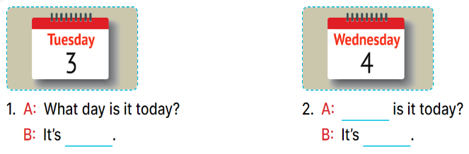  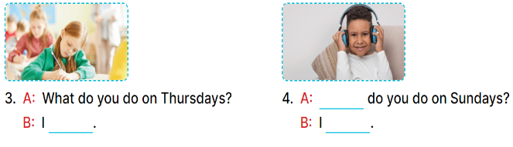  - Have Ss look at the four incomplete dialogue and elicits the missing words in the sentences.  - T models with picture 1  + Ask Ss what is missing in the sentence.  + Have Ss look at the picture and complete the gap, then read the completed sentence in chorus.  -Have Ss work in groups and complete the picture 2, 3 and 4.  - Ask a few Ss to stand up and read the completed sentences aloud.  -T gives feedbacks.  Key: 1. Tuesday  2. What day; Wednesday  3. study at school  4. What; listen to music  Activity 3. Let’s sing.  - Draw pupils’ attention to the title and lyrics of the song.  - Encourage pupils to point at the characters’ activities to reinforce their understanding.  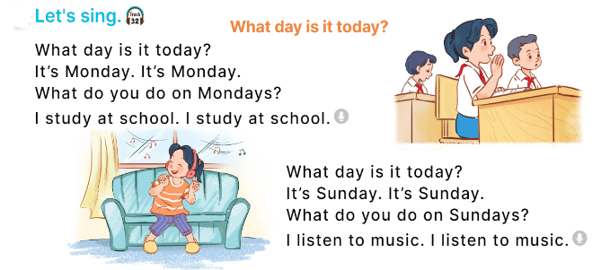  - Play the recording all the way through for pupils to listen to the whole song.  - Play the recording line by line for pupils to listen and repeat.  - Play the recording all the way through for pupils to sing along.  - Play the recording again for pupils to sing and clap along with the recording.  - Pupils can sing the song What day is it today? with the correct pronunciation, rhythm and melody.  - T praises some Ss who are hardworking / active/ good…. as well as encourage others to try more.  - Practice part 5 again.  - Prepare the new lesson: Unit 3, Lesson 3 (1,2,3). | - Sing and dance the song in chorus.  - Ss open their books  -Look at the pictures and say:  a. a girl listening to music on Sundays  b. a calendar: Friday  c. a calendar: Monday  d. a boy doing housework on Saturdays  -Ss guess the answers  - Ss listen to the tape and write number  - Ss listen again, write number and swap books with their partners.  - Ss check their answers and guessing  -Ss listen and repeat.  -Ss look and answer  -Ss answer: It’s Tuesday.  -Ss look, complete and read the completed sentence in chorus.  -Ss work in groups and complete the sentence  -Ss read aloud  - Ss listen  -Ss listen to the song  -Ss listen and repeat line by line  -Ss listen and sing along  -Ss sing and clap along  -Ss sing with the correct pronunciation, rhythm and melody.  -Ss listen and clap their hands  -Ss listen

IV. ADJUSTMENTS (if necessary):
………………………………………………………………………………………….…..……………………………………………………………………………...………………………………………….…..………………………………………

LESSON PLAN
Subject: English; Class: 3A, 3B
Unit 3: Our friends
Lesson 1 (1,2,3)
Period: 17; Date of teaching: 09,10/10/2024
I. OBJECTIVES: By the end of the lesson, Ss will be able to
- use the words this, that, it, yes, no, friend, teacher, Mr (Mr Long), Ms (Ms Hoa) in relation to the topic “Our friends”
- use This is / That’s ….. to introduce someone.
- Critical Thinking: self-introduce
- Co-operation: ready to help friends in pair work/ group work.
- Sociability: Talk to each other, say good words to others.
- Kindness: Help partners to complete learning tasks.
- Honesty: tell the truth about feelings and emotions
II. TEACHING AIDS: Student’s book, extra boards, TV access to the internet, pictures.
III. PROCEDURES
Stages/Time | Teacher’s activities | Students’ activities
1.Warm- up:  (5’)  2. Presentation  (15’)  3. Practice: (7’)  4.Production: (5’)  5. Homework. (3’) | Sing: How old are you?  - Show the song on the screen.  https://www.youtube.com/watch?v=-2to7NkYMPk  - Ask pupils to listen, sing and dance the song.  - Say “Open your book page 22” and look at “Unit 3, Lesson 1 (1,2,3)”.  Activity 1. Vocabulary.  -T elicits the new words  + this : đây, này  + that : đó, kia  + Mr :ông, thầy  + Ms : bà, cô  - T models (3 times).  - T writes the words on the board.  - Checking: Matching  Activity 2. 1. Listen, point and repeat:  - Have Ss look at Pictures a and b and identify the characters in the pictures.  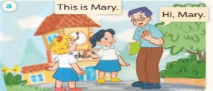  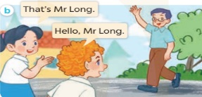  - Play the audio twice (sentence by sentence). Correct their pronunciation where necessary.  - Have Ss to practice the dialogue  - T invites a few pairs to the front of the class to practice.  - T checks pronunciation for ss.  Activity 3 2. Listen, point and say.  * Model sentences:  - T asks Ss look at picture a, b and helps Ss know the structure from the dialogue.  - T introduces new structure for Ss.  - T explains, models and gives meaning.  -Have Ss repeat the model sentences.  This is Mary.  That’s Mr Long.  * That’s = That is  *Drill pictures  - Elicit and check comprehension the name of each character.  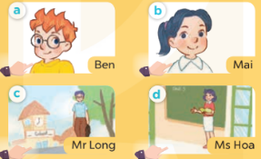  - Run through all the pictures.  - Run through model sentences.  - Have Ss to practise:  + T says the first picture  + Ss says the second picture  + Group A says the third picture  + Group B say the last picture.  - Ask Ss to work in pairs.  - T controls and corrects.  - Invite a few pairs to come to the front of the classroom, point at the relevant character in each picture, and act out his/her role.  - Encourage Ss to practise speaking English.  - T gives feedbacks.  Activity 4. Let’s talk.  - T asks ss to guess each character and what the children say.  + What can you see in the picture?  +Who are they?  +Where are they?  +What are they saying?  - T fills the gaps and writes the sentences on the board.  - T models  - T asks Ss to greet and introduce someone. (groups of four)  - Invite some groups to perform.  - Give feedbacks  - T review the vocabulary and model sentences.  - T praises some Ss who are hardworking / active/ good…. as well as encourage others to try more.  - Learn the vocabulary and model sentences by heart  - Prepare the new lesson: Unit 3, Lesson 1 (4,5,6). | - Ss sing and dance the song  - Ss open their books  -Ss listen and answer  - Ss listen and repeat  + Choral repetition (3 times).  + Individual repetition (3 ss)  - Ss take note  - Ss look, remember and match  -Look at the pictures and get to know the characters in the pictures.  + In picture a: Mai says: This is Mary. And Mr Long says: Hi, Mary.  + In picture b: Mai says: That’s Mr Long. And Bill says: Hello, Mr Long.  -Ss listen and repeat in chorus (twice)  -Ss work in pairs to practice  -Ss practice the dialogue  -Ss listen  -Ss look at the picture and answer.  -Ss listen  -Ss listen and repeat  -Ss repeat to the introduce someone.  - Ss look, listen and answer  +Picture a: Ben, a British male pupil  + Picture b: Mai, a Vietnamese female pupil  + Picture c: Mr Long, a Vietnamese male teacher  + Picture d: Ms Hoa, a Vietnamese female teacher  -Ss listen and repeat  -Ss practice in chorus  -Ss work in pairs to practice  -Ss point and say  -Ss listen.  -Ss listen  -Ss look at the picture and answer  + Minh and Mai meet Bill and Mary in the school playground. Minh introduces Bill to Mai, then Minh introduces Mary to Mai. They greet and introduce themselves to each other.  -Ss note  - Ss say the completed sentences.  -Ss work in groups  -Ss perform in front of the class.  - Ss listen  -Ss listen and clap their hands  -Ss listen and take note

IV. ADJUSTMENT ………………………………………………………………………………………………………………….....................................................................................................................................................................................................................................................................................................................................................................

LESSON PLAN
Subject: English; Class: 3A, 3B
Unit 3: Our friends
Lesson 1 (4, 5, 6)
Period: 18; Date of teaching: 09,10/10/2024
I. OBJECTIVES: By the end of the lesson, Ss will be able to
- listen to and understand two communicative contexts in which pupils introduce someone and respond to the introduction.
- read and complete the sentences correctly.
- sing the song “This is Linh” with the correct pronunciation and melody.
- Critical Thinking: self-introduce
- Co-operation: ready to help friends in pair work/ group work.
- Self-control and independent learning: perform listening tasks.
- Kindness: Help partners complete learning tasks.
- Honesty: tell the truth about feelings and emotions.
- Diligence: complete learning tasks.
II. TEACHING AIDS: sachmem.vn, posters, laptop, pictures, textbook, lesson plan, TV
III. PROCEDURES
Stages/Time | Teacher’s activities | Students’ activities
1.Warm- up:  (5’)  2.Practice: (27’)  3. Homework. (3’) | Game: Sentence Puzzle  - Divide the class into groups of four.  - Give each group a sentence that is broken/cut into pieces.  - Ask them to arrange them to make a complete sentence, then read it aloud.  - The group that makes it first will be the winner.  - Say “Open your book page 11” and look at “Unit 3, Lesson 1 (4,5,6)”.  Activity 1. Listen and tick:  - Elicit the names of the characters in the pictures.  - Point at the pictures respectively to explain the context.  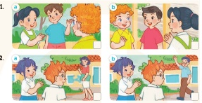  - T ask Ss to guess the answers.  + T writes Ss’guessing on the board.  - Listen to the tape:  + Play the recording  + Play the recording again and get Ss to swap books with their partners.  + Play the recording again to check answers together as a class.  + Write the answers on the board for Ss to correct their answers. Then checks Ss’ guessing.  - Play the recording, sentence by sentence, for the class to listen and repeat in chorus.  Key: 1.b 2.a  Activity 2. Look, complete and read.  - Get Ss to look at the pictures and identify the characters  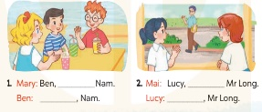  - Have Ss look at the two incomplete dialogue and elicits the missing words in the sentences.  - T models with picture 1  + Ask Ss what is missing in the sentence.  + Have Ss look at the picture and complete the gap, then read the completed sentence in chorus.  -Have Ss work in groups and complete the picture 2.  - Ask a few Ss to stand up and read the completed sentences aloud.  -T gives feedbacks.  Key:  1. this is – Hello / Hi  2. that’s – Hello  Activity 3. Let’s sing.  - Introduce the title and lyrics of the song: “This is Linh” song.  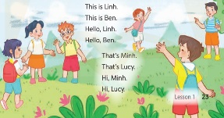  - Play the recording for Ss to listen to the whole song.  + Have them repeat the title and lyrics line by line.  + Tell Ss to point at the relevant character while singing his or her name.  - Play the recording all the way through for Ss to listen to the pronunciation and melody of the song.  - Play the recording line by line for Ss to listen, repeat and point at the relevant character.  - Play the recording for Ss to sing and do actions.  - Ask Ss to practice singing and doing actions in pairs or groups.  - Invite groups to the front of the classroom to perform the song  -T gives feedback.  - T praises some Ss who are hardworking / active/ good…. as well as encourage others to try more.  - Practice part 5 again.  - Prepare the new lesson: Unit 3, Lesson 2 (1,2,3). | - Ss listen to the rule  - Ss play game  -Ss listen  - Ss open their books  -Look at the pictures and say:  + Picture 1a: Mai introduces Minh to Bill.  + Picture 1b: Mai introduces Nam to Bill.  + Picture 2a: Linh introduces Ms Hoa to Ben.  + Picture 2b: Linh introduces Mr Long to Ben.  -Ss guess the answers  - Ss listen to the tape and tick  - Ss listen again, tick and swap books with their partners.  - Ss check their answers and guessing  -Ss listen and repeat.  -Ss look at the picture and say:  + They’re Ben, Mary, Nam and Mai, Mr Long and Lucy.  -Ss look and answer  -Ss answer: This is Nam/ Hi, hello  -Ss look, complete and read the completed sentence in chorus.  -Ss complete the sentence  -Ss read aloud  - Ss look and listen.  -Ss listen to the song  - Ss listen and repeat line by line without the action.  -Ss point to the character while singing  -Ss listen to the melody of the song  - Ss listen and sing line by line.  - Ss sing and do actions.  + Ss work in groups (two groups) to sing.  -Ss perform in front of the class.  -Ss listen  -Ss listen and clap their hands  -Ss listen and take note

IV. ADJUSTMENT ………………………………………………………………………………………………………………….....................................................................................................................................................................................................................................................................................................................................................................

LESSON PLAN
Subject: English; Class: 3A, 3B
Unit 3: Our friends
Lesson 2 (1, 2, 3)
Period: 19; Date of teaching: 10/10/2024
I. OBJECTIVES: By the end of the lesson, Ss will be able to
-use the words this, that, it, yes, no, friend, teacher, Mr (Mr Long), Ms (Ms Hoa) in relation to the topic “Our friends”;
-use Is this / that ? – Yes, it is. / No, it isn’t. It’s….. to ask and answer questions about someone;
-ask and answer questions about someone in contexts.
- Critical Thinking: self-introduce
- Co-operation: ready to help friends in pair work/ group work.
- Sociability: Talk to each other, say good words to others.
- Kindness: Help partners complete learning tasks.
- Honesty: tell the truth about feelings and emotions
II. TEACHING AIDS: sachmem.vn, posters, laptop, pictures, textbook, lesson plan, TV, a ball
III. PROCEDURES
Stages/Time | Teacher’s activities | Students’ activities
1.Warm- up:  (3’)  2. Presentation  (13’)  3.Practice: (10’)  4.Production: (7’)  5. Homework. (2’) | Game: Roll the dice  - Divide the class into 2 teams.  - Each team choose a character on the slide (Nam or Mary) for their team.  - The 2 teams take turns to choose letters to go to the questions. For each correct answer, pupils can roll the dice and click the coloured stones to move their characters.  - The team who finishes first will be the winner.  - Say “Open your book page 24” and look at “Unit 3, Lesson 2 (1,2,3)”.  Activity 1. Vocabulary.  -T elicits the new words  + friend : bạn bè  + teacher : giáo viên  + yes : vâng, có  + no : không  - T models (3 times).  - T writes the words on the board.  - Checking: What and where  Activity 2. Listen, point and repeat:  - Have Ss look at Pictures a and b and identify the characters in the pictures.  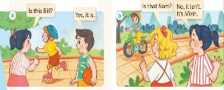  - Play the audio twice (sentence by sentence). Correct their pronunciation where necessary.  - Have Ss to practice the diaguage  - T invites a few pairs to the front of the class to practice.  - T checks pronunciation for ss.  Activity 3. Listen, point and say.  * Model sentences:  - T asks Ss look at picture a, b and helps Ss know the structure from the dialogue.  - T introduces new structure for Ss.  - T explains, models and gives meaning.  - Have Ss repeat the model sentences.  A: Is this Bill?  B: Yes, it is  A: Is that’s Nam?  B: No, it isn’t. It’s Minh.  * It’s = it is  *Drill pictures  - Elicit and check comprehension the name of each character.  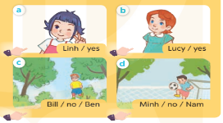  - Run through all the pictures.  - Run through model sentences.  + Run through the questions  + Run through the answers  - Have Ss to practise:  + T asks – Ss answer (change role).  + Ss – Ss (change role).  - Ask Ss to work in pairs.  - T controls and corrects.  - Invite a few pairs to come to the front of the classroom, point at the relevant character in each picture, and act out his/her role.  - Invite Ss to go to the board and role play. Encourage Ss to practise speaking English.  - T gives feedbacks.  Activity 4. Let’s talk.  - T asks ss to guess each character and what the children say.  + What can you see in the picture?  +Who are they?  +Where are they?  +What are they saying?  - T fills the gaps and writes the sentences on the board.  - T models  - T asks Ss use of Is this/ that…….? to ask , and answer (groups of four)  - Invite some groups to perform.  - Give feedbacks  - T review the vocabulary and model sentences.  - T praises some Ss who are hardworking / active/ good…. as well as encourage others to try more.  - Learn the vocabulary and model sentences by heart  - Prepare the new lesson: Unit 3, Lesson 2 (4,5,6). | - Ss listen  - Ss play the game  - Ss open their books  -Ss listen and answer  - Ss listen and repeat  + Choral repetition (3 times).  + Individual repetition (3 ss)  - Ss take note  - Ss look, remember and slap  -Look at the pictures and get to know the characters in the pictures.  + In picture a: Mai asks: Is this Bill? And Nam answers Yes, it is.  – In picture b: Mary asks Is that Nam? And Mai answers: No, it isn’t. It’s Minh  -Ss listen and repeat in chorus (twice)  -Ss work in pairs to practice  -Ss practice the diaguage  -Ss listen  -Ss look at the picture and answer.  -Ss listen  -Ss listen and repeat  -Ss repeat to the introduce someone  -Ss listen and answer  - Ss look, listen and repeat  - Ss practice in chorus  -Ss work in pairs to practice  -Ss listen  -Ss point and say  -Ss go to the board and rold play.  -Ss listen  -Ss look at the picture and answer  + A picture of Bill and Mai in the park. Bill asks Mai about Linh and Nam.  -Ss note  - Ss say the completed sentences.  -Ss work in groups  -Ss perform in front of the class.  - Ss listen  -Ss listen and clap their hands  -Ss listen and take note

IV. ADJUSTMENT ………………………………………………………………………………………………………………….....................................................................................................................................................................................................................................................................................................................................................................

LESSON PLAN
Subject: English; Class: 3A, 3B
Unit 3: Our friends
Lesson 2 (4, 5, 6)
Period: 20; Date of teaching: 10/10/2024
I. OBJECTIVES: By the end of the lesson, Ss will be able to
- listen to and understand communicative in contexts.
- look, complete and read the dialogues with the help of picture cues
- Critical Thinking: self-introduce
- Co-operation: ready to help friends in pair work/ group work.
- Self-control and independent learning: perform listening tasks.
- Kindness: Help partners complete learning tasks.
- Honesty: tell the truth about feelings and emotions.
- Diligence: complete learning tasks.
II. TEACHING AIDS: sachmem.vn, posters, laptop, pictures, textbook, lesson plan, TV
III. PROCEDURES
Stages/Time | Teacher’s activities | Students’ activities
1.Warm- up:  (5’)  2.Practice: (27’)  3. Homework. (3’) | Sing a song: Hello  - Show the song on the screen.  https://www.youtube.com/watch?v=O13gITUS5t4  - Ask pupils to listen, sing and dance the song.  - Say “Open your book page 13” and look at “Unit 3, Lesson 2 (4,5,6)”.  Activity 1. Listen and number:  - Elicit the names of the characters in the pictures.  - Point at the pictures respectively to explain the context.  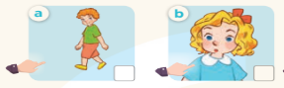    - T ask Ss to guess the answers.  + T writes Ss’guessing on the board.  - Listen to the tape:  + Play the recording  + Play the recording again and get Ss to swap books with their partners.  + Play the recording again to check answers together as a class.  + Write the answers on the board for Ss to correct their answers. Then checks Ss’ guessing.  - Play the recording, sentence by sentence, for the class to listen and repeat in chorus.  Key: 1. b 2. a 3. d 4. c  Activity 2. Look, complete and read  - Elicit the context and check comprehension  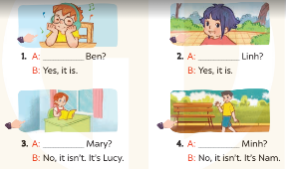  - Have Ss look at the four incomplete dialogue and elicits the missing words in the sentences.  - T models with picture 1  + Ask Ss what is missing in the sentence.  + Have Ss look at the picture and complete the gap, then read the completed sentence in chorus.  -Have Ss work in groups and complete the picture 2, 3 and 4.  - Ask a few Ss to stand up and read the completed sentences aloud.  -T gives feedbacks.  Key: 1. Is this 2. Is this 3. Is that 4. Is that  Activity 3. Let’s play.  - Tell pupils to work in pairs.  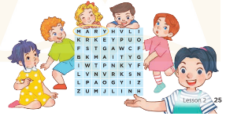  - Model the activity by identifying the picture of Mary first, draw Ss' attention to the word Mary in the table.  - Point to the picture of Mary and ask: “Is this Mary?” Ask a ss to answer the question: “Yes, it is.”  - Have pupils play the game. Explain that after identifying six characters in the pictures and circling  - Give Ss time to play the game.  - Invite a few pairs to perform the game in front of the class.  - Give feedbacks  Key:  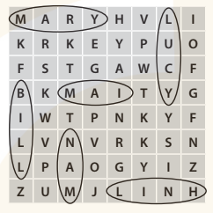  - T praises some Ss who are hardworking/active/ good…. as well as encourages others to try more.  - Practice part 5 again.  - Prepare the new lesson: Unit 3, Lesson 3 (1,2,3). | - Sing and dance the song in chorus.  - Ss open their books  -Look at the pictures and say:  + Picture a: Bill  + Picture b: Mary  + Picture c: Ben  + Picture d: Lucy  -Ss guess the answers  - Ss listen to the tape and write number  - Ss listen again, write number and swap books with their partners.  - Ss check their answers and guessing  -Ss listen and repeat.  -Ss look and answer  -Ss answer: Is this Ben?  -Ss look, complete and read the completed sentence in chorus.  -Ss complete the sentence  -Ss read aloud  - Ss listen  -Ss play game  - Ss listen  -Ss listen and clap their hands  -Ss listen

IV. ADJUSTMENT ………………………………………………………………………………………………………………….....................................................................................................................................................................................................................................................................................................................................................................

Period: 9 Preparing date: October 8th, 2024
Teaching date: October 11th, 2024
Fun time 1
I. OBJECTIVES:
By the end of the lesson, Ss will be able to:
- identify some learnt words bell, pen, pencil, red, chips and fish.
- say the words bell, pen, pencil, red, chips and fish correctly.
- identify the letters they have learnt (I/i, E/e).
- read the learnt words (chips, pen, pencil, milk)
- Know how to sing exactly.
- Know how to practise some sounds.
- Co-operation: ready to help friends in pair work/ group work.
-Actively participate in activities with their classmates in pairs, groups or class. Educate Ss to become studious and obedient students, love food, love learning
English
- Work in pairs, work in groups, ask and answer.
- Communicative approach, teaching methods with game, teaching methods by visual, teaching methods by practicing, prediction.
II. TEACHING AIDS:
- Teacher: Posters, laptop, pictures, textbook, lesson plan, TV or projector.
- Students: Textbooks, notebooks, workbooks, school things.
III. PROCEDURES:
Stages/ Time | Teacher’s activities | Students’ activities
1.Warm- up:  (5’)  2. Practice  (27’)  3. Homework.  (3’) | Sing a song  - Greet the class and introduce yourself.  - Ask pupils to read the chant in Unit 2 . Divide the class into two teams (A and B), and each reads the chant aloud. Teacher can also ask team A reads a line, then team B reads the following line.  - Have pupils open their books and look at Fun time 2, saying Open your books and look  at Fun time 1, please!  Activity 1. 1 . Circle and match. Then say.  - Ask pupils to look at the picture and the line of letters. Find and circle the words.  - Encourage pupils to speak out the words illustrated by the pictures.  - Model one word with the class. Ask pupils to circle the words in the line individually and match the words with the pictures.  - Have pupils exchange their answers in pairs. Then call some pupils to show their work. Give comments, saying Well done!  - Get pupils to work in pairs or groups, point to the words and say the words until they feel confident. Correct pronunciation, if necessary.  - Call a few pupils to say the words in front of the class  * Keys:  Activity 2 2. Let’s play  - Have pupils work in two big groups (A and B). Have them look at the picture. Tell them that you will draw one letter in the air with your finger. The first pupil of each team that correctly identifies what you have drawn, if he/she identifies correctly, the team scores a point.  - Model the first time with the pupils so that they can understand how to play.  - Have the whole class play the game several times before they compete.  - Divide the class into two teams. Call one or two pupils to be the observers of the game. Use all the letters pupils have learnt (I and E), both upper and lower case. Rememer to give points to the winner of each round.  - Calculate the points and praise the winner  - Practice more at home.  - Prepare for the next lesson. | - SS say: Hello. I’m + name.  -Ss listen and sing  -  Ss open their book.  -Look at the picture and listen.  -Ss speak the words.  -Ss do the task  -Ss exchange their answer in pairs  -Ss work in group  -Ss say in front of class  -Ss listen  -Ss listen  -Ss play the game  -Ss play the game  -Ss listen  -Ss listen.

IV. Adjustments (if necessary):
………………………………………………………………………………………….…..……………………………………………………………………………….
....................................................................................................................................

Week 5 Preparing date: October 8th, 2024
Period 10 Teaching date: October 11th, 2024
Unit 3: At the street market
Lesson 1
I. OBJECTIVES:
By the end of the lesson, Ss will be able to:
- pronounce the sound of the letter A/a in isolation and in the words
apple, bag, can, hat correctly.
- Sound /a/
- Vocabulary: apple, bag, can, hat
- Skills: speaking and listening
- Know how to practise some sounds.
- Co-operation: ready to help friends in pair work/ group work.
-Actively participate in activities with their classmates in pairs, groups or class. Educate Ss to become studious and obedient students, love learning
English
- Work in pairs, work in groups, ask and answer.
- Communicative approach, teaching methods with game, teaching methods by visual, teaching methods by practicing, prediction.
II. TEACHING AIDS:
- Teacher: Posters, laptop, pictures, textbook, lesson plan, TV or projector.
- Students: Textbooks, notebooks, workbooks, school things.
III. PROCEDURES:
Stages/Time | Teacher’s activities | Students’ activities
1.Warm- up:  (5’)  2. Presentation  (12’)  3.Practice: (16’)  Production:  4. Homework. (2’) | Play game: Pelmanism  -Step 1 Greet the class, saying Hi, I’m _____. Spend a few minutes revising the previous lesson  by asking the class to sing the song in Unit 2, Lesson 3, Activity 8 and clap their hands.  - If time allows, let pupils play the game Pelmanism.  - Step 2 :Have pupils open their books and look at Unit 3, Lesson 1, saying Open the books and  look at Unit 3, Lesson 1, please  Activity 1. 1. Listen and repeat:  - Step 1: Have pupils look at the picture and describe it.  - Step 2: Ask pupils to point to the letter A/a. Have them listen and repeat the sound of the letter A/a  - Step 3: Tell pupils to point to the hat and the word hat, saying Point to the hat and the word “hat”. Ask them to listen and repeat the word.  - Step 4: Repeat the same procedure with the words apple, bag and can.  - Step 5: Play the recording again and have them listen, point to the letter A/a and the words apple, bag, can, hat and repeat until they feel confident.  Give further support to those pupils who find it difficult to do the task.  - Step 6 Call a few pupils to pronounce the sound of the letter A/a and say the words apple, bag, can, hat in front of the class (you may say Great!  when they perform well).  Activity 2 2. Point and say:  - Step 1: Have pupils look at the picture again  - Step 2: Get them to point to the letter A/a and say it, saying Point to the letter A/a and say, please!  - Step 3: Ask pupils to point to the apple and say the word apple as a model, saying Point and say, please! Remind them of the sound of the letter a in  the word apple. Then ask one pupil to point to the apple and to say the word apple in front of the class. Correct pronunciation, if necessary.  - Step 4: Follow the same procedure with other things. Go around and correct pronunciation, if necessary.  - Step 5: Ask pupils to work in pairs or in groups to look at the picture, point to the letter A/a, the things and say the sound of the letter A/a and  the words. Go around, offer help and correct pronunciation, if necessary.  - Step 6: Invite a few pupils to point to the picture and say the sound of the letter and the words in front of the class. If they performed well,  praise them, saying Well done! or Very good!  - T gets feedback.  Activity 3. *Play Slap the board  - Step 1: Greet and sing together.  - Step 2: Play a game.  - Step 3: Divide class into 2 groups: Tom and Jerry.  - How to play:  + Each group chooses five Ss to play.  + Class will read aloud.  + Look at the picture, listen and slap the picture you heard.  + Who faster will get 1 mark.  + Which group with higher mark is the winner.  - Step 4: T gives feedback.  - Practice more at home.  - Prepare for the next lesson. | - Ss say: Hello. I’m + name.  -Ss listen and play the game  -Ss open their book.  -Look at the picture and listen.  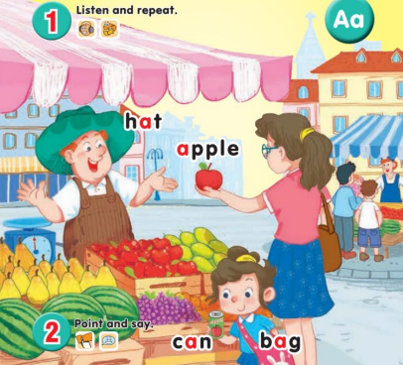  -Point, listen and repeat.  -Ss listen and repeat.  -SS listen, point and repeat.  -SS say in front of the class.  -Look at the picture and describe.  -Point and say  - Ss listen  -Work in pairs or in groups.  -Point and say  - Ss listen  -Ss look and listen.  apple hat  bag can  -Ss play game.  -Ss listen.

IV. Adjustments (if necessary):
………………………………………………………………………………………….…..……………………………………………………………………………….
....................................................................................................................................

Duyệt của tổ trưởng Người thực hiện

