Week 4
Period 13 Teaching date: October 1st, 3rd,2024

Unit 2: Time and daily routines.
Lesson 2 (1, 2, 3)
I. OBJECTIVES:
By the end of the lesson, Ss will be able to:
- understand and correctly repeat the sentences in two communicative contexts focusing on asking and answering questions about the characters’ daily routines.
- correctly say the phrases and use What time do you…… – I……. at ……. to ask and answer questions about daily routines.
-enhance the correct use of What time do you ……..? - I …….at ………… to ask and answer about someone’s daily routines.
- Oral Communication: speak about names, ask and answer the questions.
- Co-operation: ready to help friends in pair work/ group work.
- Self-control and independent learning: perform learning tasks.
- Show their responsibility by noticing the time and follow the timetable on time.
II. TEACHING AIDS:
- Teacher: Teacher’s guide Pages 34, 35, 36, 37, audio Tracks 19,20, website hoclieu.vn, posters, laptop, pictures, textbook, lesson plan, TV or projector.
- Students: Pupil’s book Page 18, notebooks, workbooks, school things.
III. PROCEDURES:
Stages/Time | Teacher’s activities | Students’ activities
1.Warm- up:  (3’)  2. Presentation  (16’)  3.Practice: (7’)  4.Production: (7’)  5. Homework. (2’) | Game: Which clocks says…..  - Spend a few minutes revising the previous lesson by having the class play the game Which clock says ...?  - Say “Open your book page 18” and look at “Unit 2, Lesson 2 (1,2,3)”.  Activity 1. Vocabulary.  -T elicits the new words  + get up : thức dậy (situation)  + have breakfast : ăn sáng (situation)  + go to school : đi học (picture)  + go to bed : đi ngủ (picture)  + do homework:làm bài tập về nhà (picture)  +wash face : rửa mặt (mime)  + clean teeth : đánh răng (mime)  - T models (3 times).  - T writes the words on the board.  - Checking: Rub out and remember  Activity 2. Look, listen and repeat:  - Have pupils look at Pictures a and b and identify the characters in the pictures.  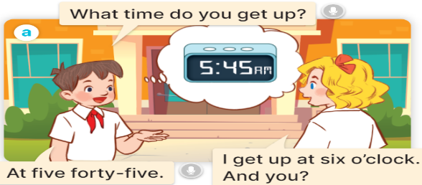  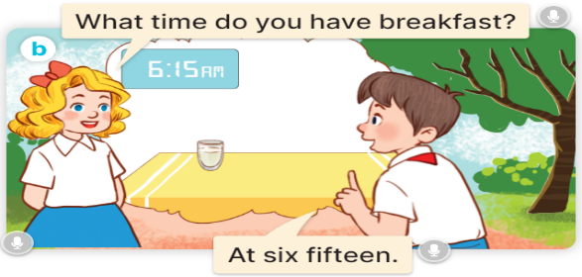  - Play the audio twice (sentence by sentence). Correct their pronunciation where necessary.  - Have Ss to practice the dialogue  - T invites a few pairs to the front of the class to practice.  - T checks pronunciation for ss.  Activity 3 Listen, point and say.  * Model sentences:  - T asks Ss look at picture a and helps Ss know the structure from the dialogue.  - T introduces new structure for Ss.  - T explains, models and gives meaning.  -Have Ss repeat the model sentences.  A: What time do you get up?  B: I get up at six o’clock.  *Drill pictures  - Elicit and check comprehension the activities and the time from them.  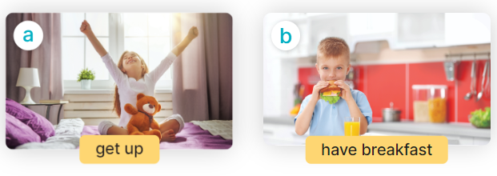  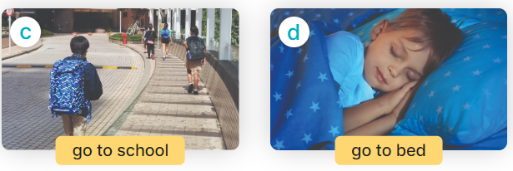  - Run through all the pictures.  - Run through model sentences.  + Run through the questions.  + Run through the answers.  - Have Ss to practise:  + T asks the first – Ss answer (change role).  + Ss – Ss (change role).  - Ask Ss to work in pairs to ask and answer the question What time do you….? I……at…  - T controls and corrects.  - Invite a few pairs to come to the front of the classroom, point at the relevant character in each picture, and act out his/her role.  - Encourage Ss to practise speaking English.  - T gives feedbacks.  Activity 4. Let’s talk.  - Have pupils look at the picture and explain that Nam and Lucy are asking and answering questions about Lucy’s daily routines.  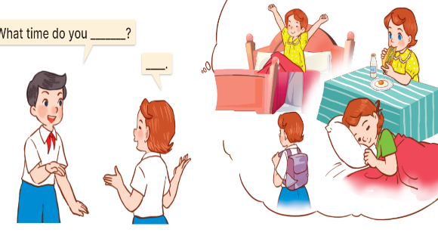  - T asks Ss look at the first speech bubble and ask What time do you get up?  - Get Ss to repeat the question and the answer several times in pairs.  - T models: Go around the classroom, pointing to Ss and asking What time do you……?  - Ask Ss ask and answer the question What time do you …..? – I ……at ………..  - Invite some groups to perform in front of the class.  - Give feedbacks  - T review the vocabulary and model sentences.  - T praises some Ss who are hardworking / active/ good…. as well as encourage others to try more.  - Learn the vocabulary and model sentences by heart  - Prepare the new lesson: Unit 2, Lesson 2 (4,5,6). | - Ss listen.  - Ss play the game  - Ss open their books  -Ss listen and answer  - Ss listen and repeat  + Choral repetition (3 times).  + Individual repetition (3 ss)  - Ss take note  - Ss look, remember and write  -Look at the pictures and get to know the characters in the pictures.  + In picture a: Minh asks: What time do you get up? And Mary answers: I get up at six o’clock. And you?  Minh answers: At five forty five.  + In pucture b: Mary asks: What time do you have breakfast? And Minh answers: At six fifteen.  -Ss listen and repeat in chorus (twice)  -Ss work in pairs to practice  -Ss practice the dialogue  -Ss listen  -Ss look at the picture and answer.  -Ss listen  -Ss listen and repeat  -Ss repeat to the introduce and respond to greetings.  -Ss look at the picture and answer  + In picture a: a girl is getting up; a clock shows 5:00 AM  + In picture b: a boy is having breakfast; a clock shows 6:15 AM  + In picture c: a pupil is going to school; a clock shows 1:15 PM  + In picture d: a boy is sleeping in bed; a clock shows 9:00 PM  - Ss look, listen and repeat  - Ss practice in chorus  - Ss practice in chorus  -Ss work in pairs to practice  -Ss take turns pointing at the pictures, asking and answering the question in front of the class.  -Ss note  -Ss look at the picture and listen  -Ss look and answer  + I get up at five fifteen.  -Ss repeat the question and answer  -Ss ask and answer  - Ss ask and answer the question  - Ss perform in front of the class.  -Ss listen and clap their hands  -Ss listen and take note

iV. ADJUSTMENTS (if necessary):
………………………………………………………………………………………….…..……………………………………………………………………………...………………………………………….…..……………………………………………………………………………….……………………………………………………………………...

Week 4
Period 14 Teaching date: October 1st, 3rd., 2024

Unit 2: Time and daily routines
Lesson 2 (4,5,6)
I. OBJECTIVES:
By the end of the lesson, Ss will be able to:
- listen to and understand four communicative contexts in which pupils ask and answer questions about daily routines and number the correct pictures.
- complete four gapped exchanges with the help of picture cues.
- sing the song What time do you go to school? with the correct pronunciation, rhythm, and melody.
- Critical Thinking: self-introduce
- Communication and collaboration: work in pairs and groups to complete the learning tasks.
- Self-control and independent learning: perform listening tasks.
- Kindness: Help partners to complete learning tasks.
- Show their responsibility by noticing the time and follow the timetable on time.
- Diligence: complete learning tasks.
II. TEACHING AIDS:
- Teacher: Teacher’s guide Pages 37,38,39; audio Tracks 21, 22; website hoclieu.vn, posters, laptop, pictures, textbook, lesson plan, TV or projector.
- Students: Pupil’s book Page 19, notebooks, workbooks, school things.
III. PROCEDURES:
Stages/Time | Teacher’s activities | Students’ activities
1.Warm- up:  (5’)  2.Practice: (27’)  3. Homework. (3’) | Game: Magic wheel  - Press “Spin” to play.  - If pupils have the correct answer, they will get the points shown on the slide.  - The team having higher scores will be the winner at the end of the game.  - Say “Open your book page 19” and look at “Unit 2, Lesson 2 (4,5,6)”.  Activity 1. Listen and number:  - Elicit the activities and the time in the pictures  - Draw pupils’ attention to the boxes at the bottom right-hand corners of the pictures.  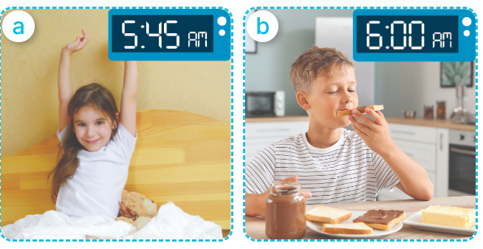  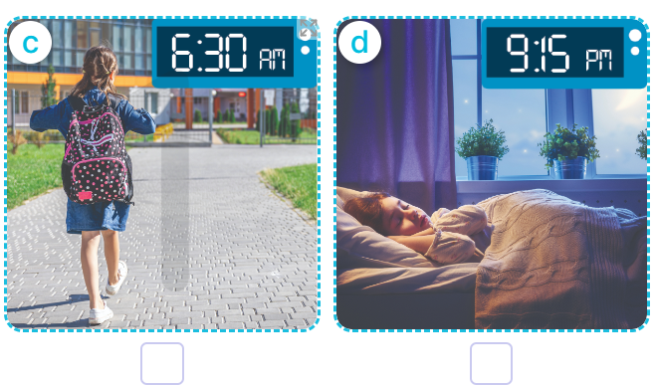  - T ask Ss to guess the answers.  + T writes Ss’guessing on the board.  - Listen to the tape:  + Play the recording  + Play the recording again and get Ss to swap books with their partners.  + Play the recording again to check answers together as a class.  + Write the answers on the board for Ss to correct their answers. Then checks Ss’ guessing.  - Play the recording, sentence by sentence, for the class to listen and repeat in chorus.  Key: 1. d 2. c 3. a 4. B  Activity 2. Look, complete and read.  - Get Ss to look at the pictures and identify the ages  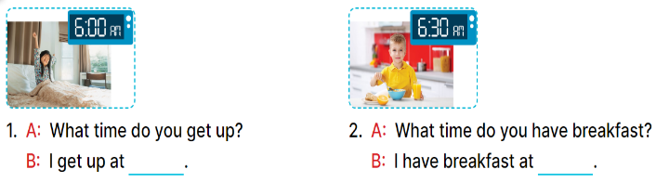  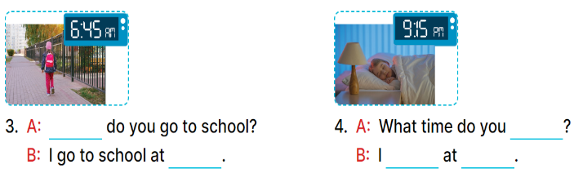  - Have Ss look at the four incomplete sentences and elicits the missing words in the sentences.  - T models with sentence 1  + Ask Ss what is missing in the sentence.  + Have Ss look at the picture and complete the gap, then read the completed sentence in chorus.  -Have Ss work in groups and complete the sentence 2, 3, 4.  - Ask a few Ss to stand up and read the completed sentences aloud.  -T gives feedbacks.  Key:  1. six o’clock 2. six thirty  3. What time; six forty-five  4. go to bed; go to bed; nine fifteen  Activity 3. Let’s sing.  - Introduce the title and lyrics of the song:  “ What time do you go to school?” song.  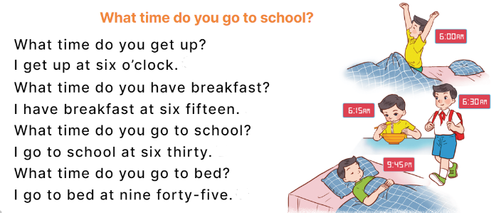  - Play the recording for Ss to listen to the whole song.  + Have them repeat the title and lyrics line by line.  - Play the recording all the way through for Ss to listen to pronunciation and melody of the song.  - Play the recording line by line for Ss to listen, repeat  - Play the recording for Ss to sing and do actions.  - Ask Ss to practice singing and doing actions in pairs or groups.  - Invite groups to the front of the classroom to perform the song  -T gives feedback.  - T praises some Ss who are hardworking / active/ good…. as well as encourage others to try more.  - Prepare the new lesson: Unit 2, Lesson 3 (1,2,3). | - Ss listen  -Ss play game  - Ss open their books  -Look at the pictures and say:  + Picture a: a girl getting up at 5:45 a.m.  + Picture b: a boy having breakfast at 6:00 a.m.  + Picture c: a girl going to school at 6:30 a.m.  + Picture d: a girl is in bed at 9:15 p.m.  -Ss guess the answers  - Ss listen to the tape and write number  - Ss listen again, write and swap books with their partners.  - Ss check their answers together  -Ss write the correct answers and check ss’ answers  -Ss listen and repeat.  -Ss look at the pictures and say:  + A boy is holding a birthday cake with number 7 in picture a  + A girl is holding a birthday cake with number 8 in picture b  +A girl is holding a birthday cake with number 9 in picture b  - Ss listen and answer  -Ss answer: I get up at six o’clock.  -Ss look, complete and read the completed sentence in chorus.  -Ss complete the sentence  -Ss read the sentence aloud  -Ss look and listen to the teacher  -Ss listen to the song  - Ss listen and repeat line by line without the action.  -Ss listen to melody of the song  - Ss listen and sing line by line.  - Ss sing and do actions.  - Ss work in groups (two groups) to sing.  -Ss perform in front of the class.  -Ss listen  -Ss listen to the teacher.  -Ss listen and take note
IV. ADJUSTMENTS (if necessary):
………………………………………………………………………………………….…..……………………………………………………………………………...………………………………………….…..………………………………………

Week 4
Period 15 Teaching date: September 12th, 13 th, 2024

Unit 2: Time and daily routines
Lesson 3 (1, 2, 3)
I. OBJECTIVES:
By the end of the lesson, Ss will be able to:
- correctly repeat the sounds of the letters t and d in isolation, in the words get and bed, and in the questions What time do you get up? and What time do you go to bed?
- identify the sounds of the letters t and d in sentences while listening.
- say the chant with the correct rhythm and pronunciation.
- Co-operation: ready to help friends in pair work/ group work.
- Sociability: Talk to each other, say good words to others.
- Kindness: Help partners to complete learning tasks.
- Honesty: tell the truth about feelings and emotions
II. TEACHING AIDS:
- Teacher: Teacher’s guide Pages 39, 40; audio Tracks 23, 24, 25; website hoclieu.vn, posters, laptop, pictures, textbook, lesson plan, TV or projector.
- Students: Pupil’s book Page 20, notebooks, workbooks, school things.
III. PROCEDURES:
Stages/Time | Teacher’s activities | Students’ activities
1.Warm- up:  (5’)  2. Presentation  (9’)  3.Practice: (19’)  3. Production  4. Homework. (2’) | Game: Pass the ball  - T gives Ss a ball.  - T asks Ss to listen to music and transfer a ball around the class.  - When the music stops, Ss who keep a ball have to answer the question using: What time do you …….and I ……..  - T gives feedback.  - Say “Open your book page 20” and look at “Unit 2, Lesson 3 (1,2,3)”.  Activity 1. Listen and repeat:  - T gives instruction to the letter t and d, the word get and bed , and the sentences What time do you get up? and What time do you go to bed?  - Have pupils look at the letter t, d, listen to the recording and repeat the letter until they feel confident.  - Have pupils point at the word get, listen to the recording and repeat the word until they feel confident.  - Get pupils to point at the sentence What time do you get up?, What time do you go to bed?  listen to the recording and repeat it several times.  - Invite a few pupils to stand up to listen to and repeat the sentence.  - Give pupils a time limit to practise pronouncing the letters, saying the words, and reading the sentences in pairs or groups.  Activity 2. Listen and circle.  - Have pupils read the incomplete sentences.  - Explain that they must listen to the recording and circle the correct options to complete the sentences.  - Play the recording and have pupils listen and circle the correct options.  - Get pupils to swap books with a partner to check their answers before checking as a class.  - Invite a few pupils to stand up and read the completed sentences.  Key: 1.c 2.a  Activity 3. Let’s chant  - Introduce the title and lyrics of the chant.  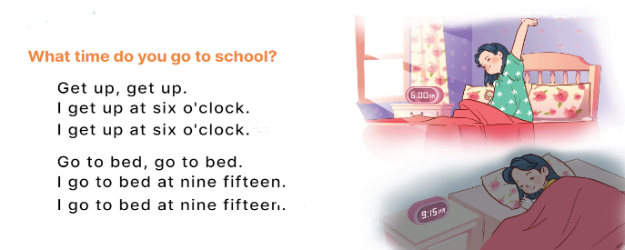  - Play the recording for Ss to listen to the whole chant.  + Have them repeat the title and lyrics line by line.  + Ask Ss to attend to the sounds of the letters t and d and the words get and bed.  - Play the recording all the way through for Ss to listen to pronunciation and melody.  - Play the recording line by line for Ss to listen and repeat  - Play the recording for Ss to chant and clap along.  - Ask Ss to practice chant and clap along in pairs or groups.  - Invite groups to the front of the classroom to perform the chant  -T gives feedback.  - T review the vocabulary and model sentences.  - T praises some Ss who are hardworking / active/ good…. as well as encourage others to try more.  - Practice the chant more.  - Draw and colour a paper birthday cake.  - Prepare the new lesson: Unit 2, Lesson 3 (4,5,6). | - Ss listen  -Ss listen the rules  - Ss play the game  - Ss open their books  - Ss recognize the differences about color of letter  - Ss listen and repeat  - Ss listen, point and repeat  - Ss listen again and repeat  -Ss listen again and repeat  -Ss practice in pairs/ groups  -Ss listen and say:  + Number 1: I……..at six thirty.  + Number 2:I …..at five forty-five.  -Ss listen  - Ss listen to the tape and circle  - Ss listen again, circle and swap books with their partners.  - Ss read the sentences  - Ss look and listen.  -Ss listen to the chant  - Ss listen and repeat line by line without clap their hands  -Ss note the sounds, word  -Ss listen to melody of the song  - Ss listen and chant line by line.  - Ss chant and clap along.  - Ss work in groups (two groups) to chant  -Ss perform in front of the class.  -Ss listen  - Ss listen  -Ss listen and clap their hands  -Ss listen and take note
IV. ADJUSTMENTS (if necessary):
………………………………………………………………………………………….…..……………………………………………………………………………...………………………………………………………………………………………

Week 4
Period 16 Teaching date: September 12 th,13 th, 2024

Unit 2: Time and daily routines
Lesson 3 (4,5,6)
I. OBJECTIVES:
By the end of the lesson, Ss will be able to:
- read and match the activities in a paragraph with the clocks showing the corresponding time.
- complete a paragraph about pupils’ daily routines.
- draw pictures of their daily routines at home and present them to the class by using the target language.
- Critical Thinking: self-introduce
- Co-operation: ready to help friends in pair work/ group work.
- Self-control and independent learning: perform presentation skill.
- Kindness: Help partners to complete learning tasks.
- Honesty: tell the truth about feelings and emotions.
- Diligence: complete learning tasks.
II. TEACHING AIDS:
- Teacher: Teacher’s guide Pages 41,42; website hoclieu.vn, posters, laptop, pictures, textbook, lesson plan, TV or projector.
- Students: Pupil’s book Page 21, notebooks, workbooks, school things.
III. PROCEDURES:
Stages/Time | Teacher’s activities | Students’ activities
1.Warm- up: (5’)  2.Practice: (8’)  3.Production: (19’)  4. Homework. (3’) | Game: “Chant”  - Ask Ss chant and do the actions in Unit 2, Lesson 3 page 20 in groups.  - Give point for the groups and encourage them.  - Say “Open your book page 21” and look at “Unit 2, Lesson 3 (4,5,6)”.  Activity 1. Read and match:  - Show the pictures and ask Ss some questions:  + What’s this?  + What time is it?  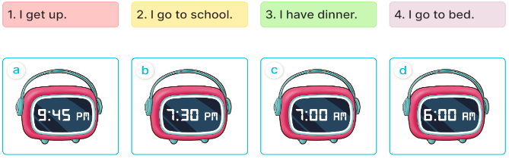  - Have pupils read the paragraph, the sentences, and the time on the clocks.  - Model Sentence 1 (clock d).  - Set a time limit for pupils to do the activity independently.  - Get pupils to swap books with a partner and check their answers before checking as a class.  - Invite some pupils to stand up to read the paragraph aloud.  -Tgives feedback.  Key: 1. d 2. c 3. b 4. a  Activity 2. Let’s write  - Tell pupils what they are going to do.  - Ask pupils what the paragraph is about (daily routines).  - Set a time limit for pupils to complete the paragraph independently.  - Get pupils to swap books and check their answers in pairs or groups before checking as a class.  - T gives feedback.  .Key: Pupil’s answer  Ex: I get up at six o’clock. I have breakfast at seven o’clock. I go to school at seven fifteen. What about you? What time do you go to school?  Activity 3. Project.  - Ask Ss to draw pictures of their daily routines at home as homework before learning Unit 2 -Lesson 3 (4,5,6)  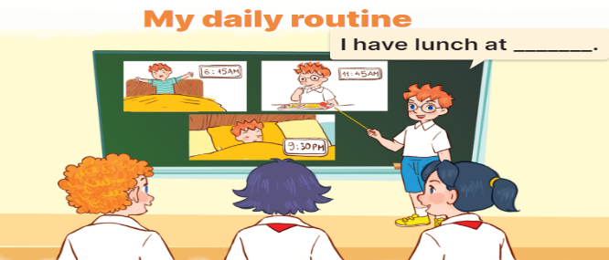  - Explain that pupils have to show simple pictures of their daily routines (getting up, having breakfast, etc.)  - Invite a pupil to the front of the class to model the presentation.  - Put the key presentation language on the board (ex: I get up at six fifteen.).  - Have pupils repeat the key presentation language a few times to make them feel confident when they present their daily routines before an audience.  - Set a time limit for pupils to work in groups.  - Invite a few pupils to the front of the class to present the project.  - T praises some Ss who are hardworking / active/ good…. as well as encourage others to try more.  - Prepare the new lesson: Unit 3, Lesson 1 (1,2,3). | - Ss listen and chant  - Ss open their books  - Ss look at the pictures and answer  -Ss read and match  -Ss listen  -Ss do the activity and match  -Ss swap books and check their answer  -Ss read the paragraph aloud.  -Ss listen  -Ss listen to the teacher  -Ss listen and answer  -Ss complete the paragraph  -Ss swap books and check their answers  -Ss listen  - Ss draw pictures of their daily routines at home.  -Ss listen to the teacher  -Ss pay attention  -Ss repeat the key presentation  -Ss work in groups  -Ss present the project  -Ss listen and clap their hands  -Ss listen and take note

IV. ADJUSTMENTS (if necessary):
………………………………………………………………………………………….…..……………………………………………………………………………...…………

Week 4
Period 13 Teaching date: October 2nd, 3rd, 2024.

Unit 2: Our names
Lesson 2 (1, 2, 3)
I. OBJECTIVES:
By the end of the lesson, Ss will be able to:
- use the words what, your, name, my, how old, years old in relation to the topic “Our names”;
- use How old are you? - I'm……. to ask and answer questions about someone’s age;
- Oral Communication: speak about names, ask and answer the questions
- Co-operation: ready to help friends in pair work/ group work.
- Sociability: Talk to each other, say good words to others.
- Kindness: Help partners to complete learning tasks.
- Honesty: tell the truth about feelings and emotions
- Diligence: complete learning tasks
II. TEACHING AIDS:
- Teacher: Teacher’s guide Pages 29, 30, audio Tracks 18,19, website sachmem.vn, posters, laptop, pictures, textbook, lesson plan, TV or projector.
- Students: Pupil’s book Page 18, notebooks, workbooks, school things.
III. PROCEDURES:
Stages/Time | Teacher’s activities | Students’ activities
1.Warm- up:  (3’)  2. Presentation  (16’)  3.Practice: (7’)  4.Production: (7’)  5. Homework. (2’) | Game: Guess the pictures  - The first Ss has to take the last four or three letters of that word and form a new word.  - The second Ss does the same, and the chain continues until a Ss is unable to form a word.  - The Ss who fails to form a word or misspells it is out of the game.  -T give feedback  - Say “Open your book page 18” and look at “Unit 2, Lesson 2 (1,2,3)”.  Activity 1. Vocabulary.  -T elicits the new words  + how old : bao nhiêu tuổi  (situation)  + year : tuổi, năm (situation)  - T models (3 times).  - T writes the words on the board.  - Checking: Rub out and remember  Activity 2. Listen, point and repeat:  - Have pupils look at Pictures a and b and identify the characters in the pictures.  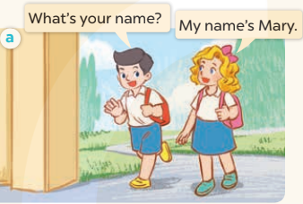  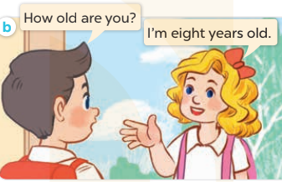  - Play the audio twice (sentence by sentence). Correct their pronunciation where necessary.  - Have Ss to practice the dialogue  - T invites a few pairs to the front of the class to practice.  - T checks pronunciation for ss.  Activity 3 Listen, point and say.  * Model sentences:  - T asks Ss look at picture a and helps Ss know the structure from the dialogue.  - T introduces new structure for Ss.  - T explains, models and gives meaning.  -Have Ss repeat the model sentences.  A: How old are you?  B: I’m eight years old.  *Drill pictures  - Elicit and check comprehension the name of each character.  - Run through all the pictures.  - Run through model sentences.  + Run through the questions.  + Run through the answers.  - Have Ss to practise:  + T asks the first – Ss answer (change role).  + Ss – Ss (change role).  - Ask Ss to work in pairs to ask and answer the question How old are you? I’m……  - T controls and corrects.  - Invite a few pairs to come to the front of the classroom, point at the relevant character in each picture, and act out his/her role.  - Encourage Ss to practise speaking English.  - T gives feedbacks.  Activity 4. Let’s talk.  - Have Ss look at the picture and explain that the two children want to buy some birthday cakes. The shop assistant asks their ages and the children answer  - T asks Ss look at the first speech bubble and ask How old are you?  - Get Ss to repeat the question and the answer several times in pairs.  - T models: Go around the classroom, pointing to Ss and asking What’s your name?  - Ask Ss ask and answer about their own ages in pairs.  - Invite some groups to perform in front of the class.  - Give feedbacks  - T review the vocabulary and model sentences.  - T praises some Ss who are hardworking / active/ good…. as well as encourage others to try more.  - Learn the vocabulary and model sentences by heart  - Prepare the new lesson: Unit 2, Lesson 2 (4,5,6). | - Ss listen.  -Ss look at the board  - Ss play the game  - Ss listen and clap their hands  - Ss open their books  -Ss listen and answer  - Ss listen and repeat  + Choral repetition (3 times).  + Individual repetition (3 ss)  - Ss take note  - Ss look, remember and write  -Look at the pictures and get to know the characters in the pictures.  + In picture a: Nam asks: What’s your name? And Mary answers: My name’s Mary.  + In pucture b: Nam asks: How old are you? And Mary answers: I’m eight years old..  -Ss listen and repeat in chorus (twice)  -Ss work in pairs to practice  -Ss practice the dialogue  -Ss listen  -Ss look at the picture and answer.  -Ss listen  -Ss listen and repeat  -Ss repeat to the introduce and respond to greetings.  -Ss look at the picture and answer  + In picture a: A girl is holding a birthday cake with number 7.  + In picture b: A girl is holding a birthday cake with number 8.  + In picture c: A boy is holding a birthday cake with number 9.  + In picture d: A boy is holding a birthday cake with number 10.  - Ss look, listen and repeat  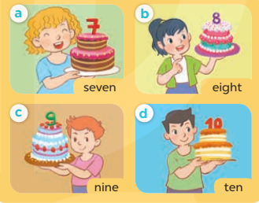  -Ss practice in chorus  -Ss work in pairs to practice  -Ss point and ask and answer  -Ss listen.  -Ss listen  -Ss look at the picture and listen  -Ss look and answer  + I’m four years old.  -Ss ask and answer  - Ss answer  -Ss work in pairs  -Ss perform in front of the class.  - Ss listen  -Ss listen and clap their hands  -Ss listen and take note

IV. ADJUSTMENTS (if necessary):
………………………………………………………………………………………….…..……………………………………………………………………………...………………………………………….…..……………………………………
Week 4
Period 14 Teaching date: October 2nd, 3rd, 2024.

Unit 2: Our names
Lesson 2 (4,5,6)
I. OBJECTIVES:
By the end of the lesson, Ss will be able to:
- listen to and demonstrate understanding of simple communicative contexts in relation to the topic "Our names"
- read and write about people’s names and ages.
- Critical Thinking: self-introduce
- Co-operation: ready to help friends in pair work/ group work.
- Self-control and independent learning: perform listening tasks.
- Kindness: Help partners to complete learning tasks.
- Honesty: tell the truth about feelings and emotions.
- Diligence: complete learning tasks.
II. TEACHING AIDS:
- Teacher: Teacher’s guide Pages 31,32; audio Tracks 20; website sachmem.vn, posters, laptop, pictures, textbook, lesson plan, TV or projector.
- Students: Pupil’s book Page 19, notebooks, workbooks, school things.
III. PROCEDURES:
Stages/Time | Teacher’s activities | Students’ activities
1.Warm- up:  (5’)  2.Practice: (27’)  3. Homework. (3’) | Game: Chain game  -Have Ss look at the example.  -Divide the class into groups of four.  -Have the ss stand up.  -Have Student A turn to Student B and ask the question, then have Student B answer.  -Next, have Student B turn to Student C and ask the question, then have Student C answer.  -Continue until all students have practiced.  -Have some groups demonstrate the activity in front of the class.  - T gives feedback.  - Say “Open your book page 19” and look at “Unit 2, Lesson 2 (4,5,6)”.  Activity 1. Listen and number:  - Elicit the ages of the characters in the pictures.  - Point at the pictures respectively to explain the context.  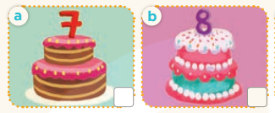    - T ask Ss to guess the answers.  + T writes Ss’guessing on the board.  - Listen to the tape:  + Play the recording  + Play the recording again and get Ss to swap books with their partners.  + Play the recording again to check answers together as a class.  + Write the answers on the board for Ss to correct their answers. Then checks Ss’ guessing.  - Play the recording, sentence by sentence, for the class to listen and repeat in chorus.  Key: 1. b 2. d 3. c 4. a  Activity 2. Look, complete and read.  - Get Ss to look at the pictures and identify the ages  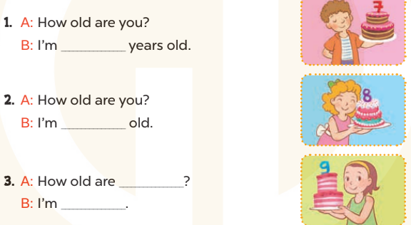  - Have Ss look at the four incomplete sentences and elicits the missing words in the sentences.  - T models with sentence 1  + Ask Ss what is missing in the sentence.  + Have Ss look at the picture and complete the gap, then read the completed sentence in chorus.  -Have Ss work in groups and complete the sentence 2, 3.  - Ask a few Ss to stand up and read the completed sentences aloud.  -T gives feedbacks.  Key:  1. seven 2. eight years  3. you; nine years’ old  Activity 3. Let’s sing.  - Introduce the title and lyrics of the song: “How old are you?” song.  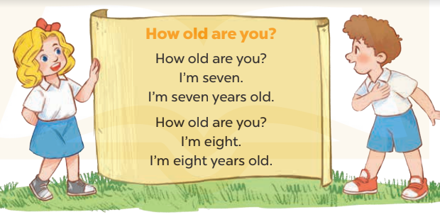  - Play the recording for Ss to listen to the whole song.  + Have them repeat the title and lyrics line by line.  - Play the recording all the way through for Ss to listen to pronunciation and melody of the song.  - Play the recording line by line for Ss to listen, repeat  - Play the recording for Ss to sing and do actions.  - Ask Ss to practice singing and doing actions in pairs or groups.  - Invite groups to the front of the classroom to perform the song  -T gives feedback.  - T praises some Ss who are hardworking / active/ good…. as well as encourage others to try more.  - Ask and answer about the pictures on page 19.  - Prepare the new lesson: Unit 2, Lesson 3 (1,2,3). | - Ss listen  -Ss play game  - Ss open their books  -Look at the pictures and say:  + Picture a: birthday cake with number 7  + Picture b: birthday cake with number 8  + Picture c: birthday cake with number 9  + Picture d: birthday cake with number 10  -Ss guess the answers  - Ss listen to the tape and write number  - Ss listen again, write and swap books with their partners.  - Ss check their answers and guessing  -Ss listen and repeat.  -Ss look at the pictures and say:  + A boy is holding a birthday cake with number 7 in picture a  + A girl is holding a birthday cake with number 8 in picture b  +A girl is holding a birthday cake with number 9 in picture b  -Ss listen and answer  -Ss answer: I’m seven years old  -Ss look, complete and read the completed sentence in chorus.  -Ss complete the sentence  -Ss read aloud  -Ss look and listen to the teacher  -Ss listen to the song  - Ss listen and repeat line by line without the action.  -Ss listen to melody of the song  - Ss listen and sing line by line.  - Ss sing and do actions.  - Ss work in groups (two groups) to sing.  -Ss perform in front of the class.  -Ss listen  -Ss listen and clap their hands  -Ss listen and take note
IV. ADJUSTMENTS (if necessary):
………………………………………………………………………………………….…..……………………………………………………………………………...………………………………………….…..……………………………………………………………………………….……………………………………………………………………...

Week 4
Period 15 Teaching date: October 3rd, 2024.

Unit 2: Our names
Lesson 3 (1, 2, 3)
I. OBJECTIVES:
By the end of the lesson, Ss will be able to:
- correctly pronounce the sounds of the letters m and n in isolation, in the words Mary and Nam, and in the sentences I’m Mary and My name’s Nam;
- use the words what, your, name, my, how old, years old in relation to the topic “Our names”;
- Co-operation: ready to help friends in pair work/ group work.
- Sociability: Talk to each other, say good words to others.
- Kindness: Help partners to complete learning tasks.
- Honesty: tell the truth about feelings and emotions
II. TEACHING AIDS:
- Teacher: Teacher’s guide Pages 32, 33; audio Tracks 22, 23, 24; website sachmem.vn, posters, laptop, pictures, textbook, lesson plan, TV or projector.
- Students: Pupil’s book Page 20, notebooks, workbooks, school things.
III. PROCEDURES:
Stages/Time | Teacher’s activities | Students’ activities
1.Warm- up:  (5’)  2. Presentation  (9’)  3.Practice: (19’)  4. Homework. (2’) | Game: Pass the ball  - T gives Ss a ball.  - T asks Ss to listen to music and transfer a ball around the class.  - When the music stops, Ss who keep a ball have to answer the question using: How old are you? and I’m…..years old  - T gives feedback.  - Say “Open your book page 14” and look at “Unit 2, Lesson 3 (1,2,3)”.  Activity 1. Listen and repeat:  - T gives instruction to the letter m and n, the word Mary and Nam, and the sentences I’m Mary. and My name’s Nam.  - Play the recording for the letter m, n  - Encourage Ss to point at the letter/ word/ sentence while listening.  - Play the recording again and encourage Ss to listen and repeat. - Do this several times until Ss feel confident.  - T calls some Ss to practice.  - T gives feedbacks.  Activity 2. Listen and circle.  - Elicit the sentences and the gap-fill options.  - T ask Ss to guess the answers.  + T writes Ss’guessing on the board.  - Listen to the tape:  + Play the recording  + Play the recording again and get Ss to swap books with their partners.  + Play the recording again to check answers together as a class.  + Write the answers on the board for Ss to correct their answers. Then checks Ss’ guessing.  - Play the recording, sentence by sentence, for the class to listen and repeat in chorus.  - Invite one or two Ss to stand up and read the completed sentences.  Key: 1.b 2.c  Activity 3. Let’s chant  - Introduce the title and lyrics of the chant.  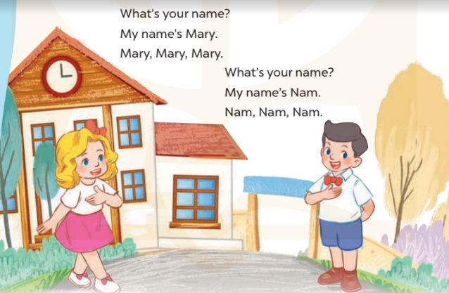  - Play the recording for Ss to listen to the whole chant.  + Have them repeat the title and lyrics line by line.  + Ask Ss to attend to the sounds of the letters m and n and the words Mary and Nam.  - Play the recording all the way through for Ss to listen to pronunciation and melody.  - Play the recording line by line for Ss to listen and repeat  - Play the recording for Ss to chant and clap along.  - Ask Ss to practice chant and clap along in pairs or groups.  - Invite groups to the front of the classroom to perform the chant  -T gives feedback.  - T review the vocabulary and model sentences.  - T praises some Ss who are hardworking / active/ good…. as well as encourage others to try more.  - Practice the chant more.  - Draw and colour a paper birthday cake.  - Prepare the new lesson: Unit 2, Lesson 3 (4,5,6). | - Ss listen  -Ss listen the rules  - Ss play the game  - Ss open their books  - Ss recognize the differences about color of letter  - - Ss listen  - Ss listen and point  - Ss listen again and repeat  -Ss listen again and repeat  -Ss practice  -Ss listen  -Ss listen and say:  + Number 1: Hi, I’m…..  + Number 2:Hello, My name’s …..  -Ss guess the answers  - Ss listen to the tape and circle  - Ss listen again, circle and swap books with their partners.  - Ss check their answers and guessing  -Ss listen and repeat.  -Ss read the sentences  - Ss look and listen.  -Ss listen to the chant  - Ss listen and repeat line by line without clap their hands  -Ss note the sounds, words  -Ss listen to melody of the song  - Ss listen and chant line by line.  - Ss chant and clap along.  - Ss work in groups (two groups) to chant  -Ss perform in front of the class.  -Ss listen  - Ss listen  -Ss listen and clap their hands  -Ss listen and take note

IV. ADJUSTMENTS (if necessary):
………………………………………………………………………………………….…..……………………………………………………………………………...………………………………………….…..………………………………………

Week 4
Period 16 Teaching date: October 3rd, 2024.

Unit 2: Our names
Lesson 3 (4,5,6)
I. OBJECTIVES:
By the end of the lesson, Ss will be able to:
- use the words what, your, name, my, how old, years old in relation to the topic “Our names”
- read and write about people’s names and ages.
- Critical Thinking: self-introduce
- Co-operation: ready to help friends in pair work/ group work.
- Self-control and independent learning: perform listening tasks.
- Kindness: Help partners to complete learning tasks.
- Honesty: tell the truth about feelings and emotions.
- Diligence: complete learning tasks.
II. TEACHING AIDS:
- Teacher: Teacher’s guide Pages 33, 34; website sachmem.vn, posters, laptop, pictures, textbook, lesson plan, TV or projector.
- Students: Pupil’s book Page 21, notebooks, workbooks, school things.
III. PROCEDURES:
Stages/Time | Teacher’s activities | Students’ activities
1.Warm- up:  (5’)  2.Practice: (8’)  3.Production: (19’)  4. Homework. (3’) | Game: “Chant”  - Ask Ss chant and do the actions in Unit 2, Lesson 3 page 20 in groups.  - Give point for the groups and encourage them.  - Say “Open your book page 21” and look at “Unit 2, Lesson 3 (4,5,6)”.  Activity 1. Read and match:  - Ask Ss some questions:  + Who are they?  + What are they talking about?  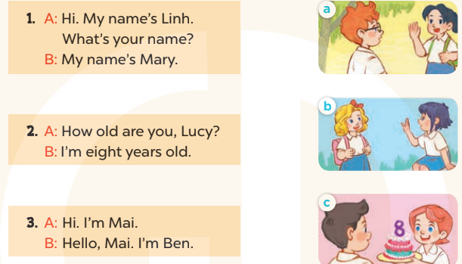  - T models with sentence 1.  + Get Ss to read Sentence 1  + Have Ss look at the pictures and match the dialogue with the correct one.  -Have Ss work in pairs and match the sentences 2, 3.  - Tell Ss to swap books with a partner, then check answers together as a class.  - Write the correct answers on the board for pupils to correct their answers.  - Invite pairs of Ss to stand up and role play  -T gives feedbacks.  Key: 1. b 2. c 3. a  Activity 2. Let’s write  - Have Ss read the dialogue and ask some questions:  + Who asks the questions?  + What are the questions about?  + Who has to write the answers?  - Check their comprehension and remind Ss to write their personal information.  - Give Ss time to write the answers to the questions independently  - Get Ss to swap books with a partner, then check the answers together as a class.  - Ask a few Ss to stand up and role play the dialogue in front of the class.  -T gives feedbacks.  Key: Pupil’s answer  Activity 3. Project.  - Ask Ss to make a paper birthday cake as homework at the beginning of Unit 2 -Lesson 3 (4,5,6)  - Stick the birthday cake sample on the board and model with the name, age.  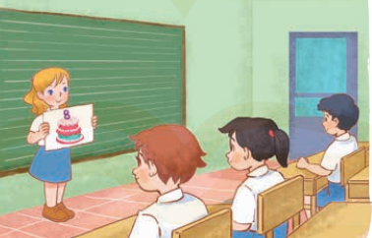  - T asks ss to work in groups and show his / her birthday cake and say about his / her name and age.  - T calls some Ss to the front of the class to present their cake, and saying Hello. My name’s….  I’m…….years old.  - Have Ss to stick their birthday cakes on the wall of the classroom  - Create a class display of birthday cakes and vote for the best decorated one.  - T gives feedback.  - T praises some Ss who are hardworking / active/ good…. as well as encourage others to try more.  - Prepare the new lesson: Unit 3, Lesson 1 (1,2,3). | - Ss listen and chant  - Ss open their books  - Ss look at the pictures and answer  + In picture a: Ben and Mai say to greeting  + In picture b: Mary and Linh say to greeting  + In picture c: Lucy is holding a birthday cake with number 8.  -Ss read and match  -Ss work in pairs and match  -Ss swap books and check  -Ss check the correct their answers  -Ss role play  -Ss listen  -Ss look at the dialogue and say:  + It’s Minh  + Names and ages.  + Themself  -Ss listen to the teacher  -Ss write  -Ss swap books and check their answers  -Ss role play  -Ss listen  - Ss drew and coloured a paper bithday cale at home.  -Ss listen to the teacher  -Ss work in groups  -Ss present their birthday cake  - Ss stick their birthday cakes on the wall of the classroom.  -Ss vote  -Ss listen  -Ss listen and clap their hands  -Ss listen and take note
IV. ADJUSTMENTS (if necessary):
………………………………………………………………………………………….…..……………………………………………………………………………...…………

Week 4
Period 7 Teaching date: October 4th , 2024

Unit 2: In the dining room
Lesson 2
I OBJECTIVES:
By the end of the lesson, Ss will be able to:
- say the sound of the letter C/c and the words cake, car, cat, cup in a chant.
- recognize the words in different situations when listening.
- trace the letter C/c.
- Co-operation: ready to help friends in pair work/ group work.
- Know how to practise some sounds.
- Know how to chant exactly.
-Actively participate in activities with their classmates in pairs, groups or class. Educate Ss to become studious and obedient students, love learning English
- Work in pairs, work in groups, ask and answer.
- Communicative approach, teaching methods with game, teaching methods by visual, teaching methods by practicing, prediction.
II. TEACHING AIDS:
- Teacher: Posters, laptop, pictures, textbook, lesson plan, TV or projector.
- Students: Textbooks, notebooks, workbooks, school things.
III. PROCEDURES:
Stages/  Time | Teacher’s activities | Students’ activities
1.Warm- up:  (7’)  2. Practice  (17’)  3.Production  (8’)  4. Homework.  (3’) | Check-up  - Greet the class and introduce yourself, saying Hi, I’m____  - Ask pupils to look at the picture in Lesson 1 and say the sound of the letter C/c and four words car, cat, cake and cup.  - Get pupils to open their books and look at Lesson 2.  Activity 1. 3. Listen and chant  Step 1:- Have pupils look at the chant and ask them to pay attention to the letter C/c and the word cup.  Step 2- Play the recording of the first line for pupils to listen and to get familiarized with the tune.  Step 3- Play the recording again, ask pupils to listen and repeat the first line. Then play the recording for them to listen and repeat until they feel confident.  Step 4- Follow the same procedure with the other lines. Show pupils how to chant and clap their hands.  Step 5- Play the recording all the way through. Ask pupils to listen and repeat the chant individually and in chorus.  Step 6- Select some pupils to the front of the class to chant and clap their hands.  Step 7- If they sing the chant well, praise them, saying Well done! or Very good.  Activity 2 4. Listen and tick:  Step 1- Have pupils look at the first two pictures and say what they can see. Check comprehension.  Step 2- Encourage some pupils to point to the pictures and say the words in front of the class  + Play the recording of the first sentence for pupils to hear.  + Point to the tick √ and ask pupils, saying What do you see? You see a tick?  + After you hear the recording, say “a cat” and you tick the box a, you give the right answer. So a is the correct answer.  Step 3:- Ask pupils to look at the last two pictures and listen.  Step 4- Ask pupils to say what they have heard and ticked.  *Keys: 1. a . cat 2. a. cake  Activity 3. 5. Look and trace:  Step 1- Have pupils look at the letter C (upper case) and c (lower case).  Step 2- Write the upper case C and the lower case c in broken lines on the board.  Step 3- Check to make sure pupils understand the letters written in solid lines and those in broken lines.  Step 4- Tell pupils to trace the letter C/c.  Step 5- Check the results of pupils’ tracing and give feedback.  Step 6- Ask some pupils to show what they have done. Praise them if they have done well, saying Well done! or You’ve done a good job!  Step 7- If there is enough time, write the letter C/c in broken lines on the board and invite some pupils to trace them.  - Practice more at home.  - Prepare for the next lesson. | - SS say the letter and the sound.  -SS open their book.  -Ss listen.  -Ss listen and repeat.  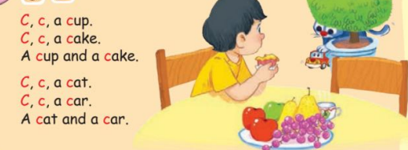  -Ss listen and chant the first line  -Ss listen, chant the first line  -Ss listen, chant the other lines and clap their hands  -Ss listen and chant all the chant  -Ss chant in front of the class  -Look at the picture and describe.  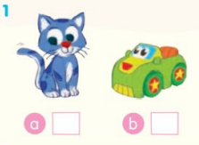  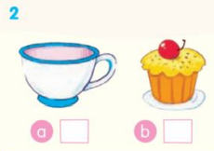  -Point and say  -Ss do the task.  -Ss check.  -Ss look and listen.  - Ss listen  - Ss do the task.    -Check in pairs.  -Ss show their work.  -Ss listen.

IV. Adjustments (if necessary):
………………………………………………………………………………………….…..……………………………………………………………………………………….….........................................................................................................................................................................................................................................................

Teaching date: October 4th , 2024
Period 8
Unit 2: In the dining room
Lesson 3

A. OBJECTIVES:
By the end of the lesson, Ss will be able to:
- use “I have a _____.” to talk about possession.
- sing a song with the structure “I have a _____.
- Know how to sing exactly.
- Know how to practise some sounds.
- Co-operation: ready to help friends in pair work/ group work.
-Actively participate in activities with their classmates in pairs, groups or class. Educate Ss to become studious and obedient students, love learning
English
- Work in pairs, work in groups, ask and answer.
- Communicative approach, teaching methods with game, teaching methods by visual, teaching methods by practicing, prediction.
II. TEACHING AIDS:
- Teacher: Posters, laptop, pictures, textbook, lesson plan, TV or projector.
- Students: Textbooks, notebooks, workbooks, school things.
III. PROCEDURES:
Stages/ Time | Teacher’s activities | Students’ activities
1.Warm- up:  (5’)  2.Presentation  3. Practice  (27’)  3. Homework.  (3’) | Sing a song  - Greet the class and introduce yourself, saying: Hi. I’m + name.  - Have a group of pupils to sing the chant on page 10 in front of the class. The class claps hands.  - Get pupils to open their books and look at Lesson 3 p. 11.  Activity 1. 6. Listen and repeat:  Step 1- Have pupils look at the picture and describe it.  Step 2- Have pupils look at the sentence “I have a car” saying Look at the sentence “I have a car.”, please!  Step 3- Play the recording several times for pupils to listen and repeat the sentence.  Step 4- Invite a few pupils to listen and repeat the sentence “I have a car” in front of the class.  Step 5- Play the recording for pupils to listen and repeat.  Step 6- Play the recording again and let pupils listen and repeat the sentence “I have a car”.  Step 7- Correct pronunciation to make sure pupils can repeat correctly the sentence.  Activity 2 7. Let’s talk:  - Step 1 Have pupils look at the bubble to understand how the language is used (I have a _____). Explain the meaning of the sentence, if necessary.  Step 2- Have pupils look at the first picture. Say Look at Picture a, please! Point to the car and ask them, saying What is this? Tell them that It’s a car. Then point to the bubble and the car and say I have a car.  Step 3- Ask pupils to say the sentence “I have a car.” in chorus and individually.  Step 4- Follow the same procedure with Pictures b, c, d. Give further support to those pupils who find it difficult to do the task, if necessary.  Step 5- Ask a few pupils to point to the pictures and say “I have a _____.”,saying Now practise saying what you have. Offer help, if necessary.  Step 6- Invite some pairs of pupils to practise pointing to the pictures or flashcards and say what they have in front of the class.  Activity 3. 8. Let’s sing  Step 1- Have pupils look at the song and ask them to pay attention to the letter C/c and the word cup.  - Step 2 Play the recording of the first line for pupils to listen and to get familiarized with the tune.  - Step 3 Play the recording again, ask pupils to listen and repeat the first line. Then play the recording for them to listen and repeat until they feel confident.  - Step 4 Follow the same procedure with the other lines. Show pupils how to chant and clap their hands.  - Step 5 Play the recording all the way through. Ask pupils to listen and repeat the song individually and in chorus.  - Step 6 Select some pupils to the front of the class to sing and clap their hands.  - Step 7 If they sing the song well, praise them, saying Well done! or Very good.  - Practice more at home.  - Prepare for the next lesson. | - SS say: Hello. I’m + name.  -Ss listen and sing  -Ss open their book.  -Look at the picture and listen.  -Listen and repeat.  -Ss listen and repeat.  -Ss say in front of the class.  -Ss listen and repeat  -Ss listen  -Look at the picture and describe.  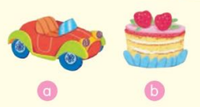  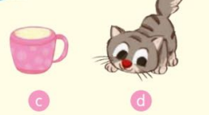  -Point and say  -Work in pairs or in groups.  -Point and say  -Ss say in front of the class  -Ss look and listen.  -Ss listen and sing the first line  -Ss listen, sing the first line  -Ss listen, sing the other lines and clap their hands  -Ss listen and sing all the song  -Ss sing in front of the class  -Ss listen.

IV. Adjustments (if necessary):
………………………………………………………………………………………….…..……………………………………………………………………………….
....................................................................................................................................

Duyệt của tổ trưởng Người thực hiện

