Week 27 Preparing date: March …., 2025
Period 108 Teaching date: March …, 2025

Unit 16: Weather
Lesson 2 (1, 2, 3)
A. OBJECTIVES:
By the end of the lesson, Ss will be able to:
1. Knowledge:
- use the words bakery, bookshop, food stall, supermarket and water park in relation to the topic “Weather”.
- use Do you want to go to the ……..? – Great! Let’s go./ Sorry, I can’t. to make suggestions to go somewhere and respond
- Vocabulary: bakery, bookshop, food stall, supermarket and water park.
- Model sentences:
A: Do you want to go to the water park?
B: Great! Let’s go./ Sorry, I can’t.
- Skills: speaking and listening
2. Competences:
- Co-operation: ready to help friends in pair work/ group work.
- Sociability: Talk to each other, say good words to others.
3. Attitude/ Qualities:
- Kindness: Help partners to complete learning tasks.
- Honesty: tell the truth about feelings and emotions
B. TEACHING AIDS:
- Teacher: Teacher’s guide Pages 232, 233; audio Tracks 56, 57, website sachmem.vn, posters, laptop, pictures, textbook, lesson plan, TV or projector.
- Students: Pupil’s book Page 42, notebooks, workbooks, school things.
C. PROCEDURES:
Teacher’s activities | Students’ activities | Notes
1.Warm- up: (3’)  Game: Who says faster  *Aims: to create a friendly and active atmosphere in the class to beginning the lesson.  *Procedure:  - Hold a weather card, then reveal it slowly.  - Ask What’s the weather?  - Ask the Ss guess the answer as fast as possible.  - Then have Ss do the same with the rest.  - This can be played in groups to make it more interesting.  - Say “Open your book page 42” and look at “Unit 16, Lesson 2 (1,2,3)”.  2. Presentation(16’)  Activity 1. Vocabulary.  *Aims: Ss will be able to know the vocabulary the new lesson.  *Procedure:  -T elicits the new words  + food stall : cửa hàng thực phẩm (picture)  + bookshop : hiệu sách (example)  + supermarket : siêu thị (example)  + bakery : tiệm bánh mì (translation)  + water park : công viên nước (picture)  - T models (3 times).  - T writes the words on the board.  - Checking: What and where  Activity 2. Look, listen and repeat:  *Aims: Ss will be able to understand and correctly repeat the sentences in two communicative contexts focusing on making suggestions to go somewhere and responding. *Procedure:  - Have Ss look at Pictures a and b and identify the characters in the pictures.  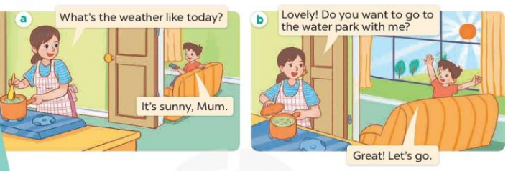  - Play the audio twice (sentence by sentence). Correct their pronunciation where necessary.  - Have Ss to practice the diaguage  - T invites a few pairs to the front of the class to practice.  - T checks pronunciation for ss.  Activity 3. Listen, point and say.  *Aims: Ss will be able to correctly say the words and use Do you want to go to the …….? – Great! Let’s go. / Sorry, I can’t. to make suggestions to go somewhere and respond.  *Procedure:  * Model sentences:  - T asks Ss look at picture b and helps Ss know the structure from the dialogue.  - T introduces new structure for Ss.  - T explains, models and gives meaning.  - Have Ss repeat the model sentences.  A: Do you want to go to the water park?  B: Great! Let’s go./ Sorry, I can’t.  3.Practice: (7’)  *Drill pictures  - Have Ss look at the pictures and elicit the names of the places.  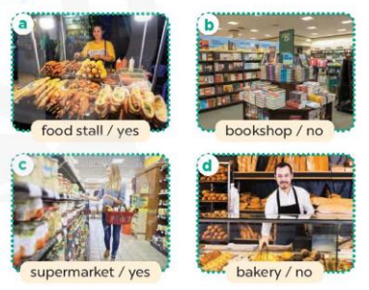  - Run through all the pictures.  - Run through model sentences.  +Run through the question sentences  +Run through the answer sentences  - Have Ss to practise:  + T asks, Ss answer picture a  + Ss ask, T answers picture b  + Group A ask, group B answer picture c  + Group B ask, group A answer picture d  - Ask Ss to work in pairs.  - T controls and corrects.  - Invite a few pairs to come to the front of the classroom, point at the pictures and say the questions and answers in front of the class.  - T gives feedbacks.  4.Production: (7’)  Activity 4. Let’s talk.  *Aims: Ss will be able to enhance the correct use of Do you want to go to the ……? – Great! Let’s go. / Sorry, I can’t. to make suggestions to go somewhere and respond in a freer context.  *Procedure:  - Have Ss look at the picture and say the names of the places in the picture.  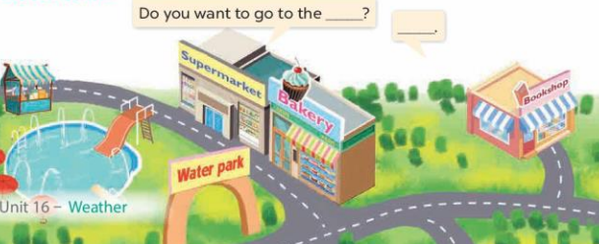  - Put Ss into pairs and encourage them to ask and answer questions using Do you want to go to the……? − …….  - Invite some pairs to stand up to perform their exchanges.  *Consolidation  *Aims: Ss will be able consolidate and wrap up the content of the lesson.  *Procedure:  - T asks ss to answer the following questions:  + What have you learnt from the lesson today?  - T review the vocabulary and model sentences.  - T praises some Ss who are hardworking / active/ good…. as well as encourage others to try more.  5. Homework. (2’)  - Learn the vocabulary and model sentences by heart  - Prepare the new lesson: Unit 16, Lesson 2 (4,5,6). | - Ss listen  - Ss play the game  - Ss open their books  -Ss listen and answer  - - Ss listen and repeat  + Choral repetition (3 times).  + Individual repetition (3 ss)  - Ss take note  - Ss look, remember and write  -Look at the pictures and get to know the characters in the pictures.  + In picture a:  Minh’s mother: What’s the weather like today?  Minh: It’s sunny, Mum  – In picture b:  Minh’s mother: Lovely! Do you want to go to the water park with me?  Minh: Great! Let’s go.  -Ss listen and repeat in chorus (twice)  -Ss work in pairs to practice  -Ss practice the diaguage  -Ss listen  -Ss look at the picture and answer.  -Ss listen  -Ss listen and repeat  -Ss repeat  -Ss listen and answer  +Picture a: a food stall  +Picture b. a bookshop  +Picture c. a supermarket  +Picture d. a bakery  - Ss look, listen and repeat  - Ss practice in chorus  - Ss practice in chorus  -Ss work in pairs to practice  -Ss listen  -Ss go to the board and point and say  -Ss listen  -Ss look at the picture and answer  + a map of an area with a supermarket, bakery, water park, bookshop and food stall.  -Ss work in pairs to ask and answer the question  -Ss perform in front of the class  -Ss answer the questions  - Ss listen  -Ss listen and clap their hands  -Ss listen and take note
D. ADJUSTMENTS (if necessary):
………………………………………………………………………………………….…..……………………………………………………………………………...……………

