Week 28 Preparing date: March ……., 2025
Period 110 Teaching date: March…………, 2025

Unit 16: Weather
Lesson 3 (1, 2, 3)
A. OBJECTIVES:
By the end of the lesson, Ss will be able to:
1. Knowledge:
- correctly repeat correctly pronounce the words 'sunny and 'rainy with the stress on the first syllable in isolation and in the sentences It’s 'sunny today. and I don’t like 'rainy weather.
– listen to and demonstrate understanding of simple communicative contexts in relation to the topic “Weather”.
- Vocabulary: Review
- Skills: speaking, listening, reading and writing.
2. Competences:
- Co-operation: ready to help friends in pair work/ group work.
- Self-control and independent learning: perform listening tasks.
3. Attitude/ Qualities:
- Kindness: Help partners to complete learning tasks.
- Honesty: tell the truth about feelings and emotions
B. TEACHING AIDS:
- Teacher: Teacher’s guide Pages 237, 238; audio Tracks 59, 60, 61; website hoclieu.vn, posters, laptop, pictures, textbook, lesson plan, TV or projector.
- Students: Pupil’s book Page 44, notebooks, workbooks, school things.
C. PROCEDURES:
Teacher’s activities | Students’ activities | Notes
1.Warm- up: (5’)  Game: Find and circle the words  *Aims: to create a friendly and active atmosphere in the class to beginning the lesson.  *Procedure:  - Divide class into 2 groups  - Ask Ss to find and circle the words that they learnt.  - Which groups find the best correct words is winner.  - Give Ss time to play the game.  Rows: rainy  Columns: cloudy, windy, sunny  -T checks who’s winner?  - Say “Open your book page 44” and look at “Unit 16, Lesson 3 (1,2,3)”.  2. Presentation(9’)  Activity 1. Listen and repeat:  *Aims: Ss will be able to correctly pronounce the words 'sunny and 'rainy with the stress on the first syllable in isolation and in the sentences It’s 'sunny today. and I don’t like 'rainy weather. with correct pronunciation and intonation.  *Procedure:  - T gives instruction to the words 'sunny and 'rainy with the stress on the first syllable in isolation and in the sentences It’s 'sunny today. and I don’t like 'rainy weather.  - Play the recording for the words 'sunny and 'rainy and the sentence.  - Play the recording and encourage Ss to point at the word and sentence while listening  - Play the recording again and encourage Ss to listen and repeat.  - Do this several times until Ss feel confident.  - T calls some Ss to practice.  - T gives feedbacks.  3.Practice: (19’)  Activity 2. Listen and circle.  *Aims: Ss will be able to identify the target words sunny and rainy while listening.  *Procedure:  - Explain what pupils have to do and check comprehension.  - Play the recording for Ss to listen.  - Play the recording again for pupils to listen and circle the correct options.  - Have Ss to swap books with a partner, then check the answers as a class.  - Write the correct answers on the board.  - Invite one or two pupils to stand up, listen to and repeat the sentences  Key: 1.c 2.a  Activity 3. Let’s chant  *Aims: Ss will be able to say the chant with the correct rhythm and pronunciation.  *Procedure:  - Introduce the title and lyrics of the chant.  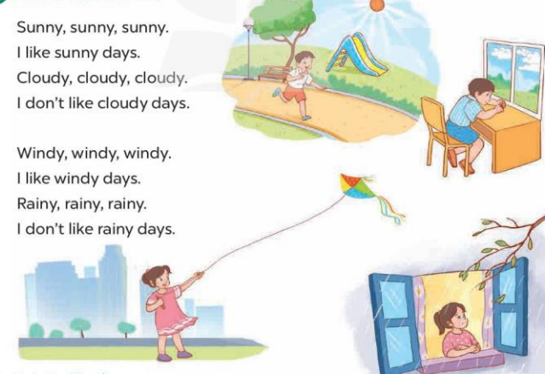  - Play the recording for Ss to listen to the whole chant.  + Have them repeat the title and lyrics line by line.  + Ask Ss to attend to two-syllable words with the stress on the first syllable in the chant, ex: sunny, cloudy, windy and rainy  - Play the recording all the way through for Ss to listen to pronunciation and melody.  - Play the recording line by line for Ss to listen and repeat  - Play the recording for Ss to chant and clap along.  - Ask Ss to practice chant and clap along in pairs or groups.  - Invite groups to the front of the classroom to perform the chant  -T gives feedback.  *Consolidation  *Aims: Ss will be able consolidate and wrap up the content of the lesson.  *Procedure:  - T asks ss to answer the following questions:  + What have you learnt from the lesson today?  +What are the core values of the lesson? (if the teacher can take from the lesson).  - T praises some Ss who are hardworking / active/ good…. as well as encourage others to try more.  4. Homework. (2’)  - Prepare the new lesson: Unit 16, Lesson 3 (4,5,6). | - Ss listen  -Ss play game  - Ss open their books  - Ss recognize the what word stress is  - - Ss listen  - Ss listen and point  - Ss listen again and repeat  -Ss listen again and repeat  -Ss practice  -Ss listen  -Ss pay attention and say  - Ss listen to the tape  - Ss listen again and circle  - Ss swap books and check their answers  -Write the correct answer  -Ss listen and repeat.  - Ss look and listen.  -Ss listen to the chant  - Ss listen and repeat line by line without clap their hands  -Ss note the words  -Ss listen to melody of the chant  - Ss listen and chant line by line.  - Ss chant and clap along.  - Ss work in groups (two groups) to chant  -Ss perform in front of the class.  -Ss listen  -Ss listen.  -Ss answer the questions  -Ss listen and clap their hands  -Ss listen and take note
  S | B | K | K | E | P | S | C | C | T
  U | E | T | E | E | D | D | C | L | H
  N | E | U | A | A | E | C | O | O | I
  N | A | M | W | F | C | C | S | U | N
  Y | A | B | I | N | N | L | S | D | K
  R | A | I | N | Y | I | S | F | Y | B
  S | R | O | D | R | C | V | T | A | H
  M | M | T | Y | H | R | S | T | A | Y
  D | P | P | B | E | S | E | R | S | M
  A | C | E | B | F | A | Z | Y | W
D. ADJUSTMENTS (if necessary):
………………………………………………………………………………………….…

