Week 28 Preparing date: March ……., 2025
Period 109 Teaching date: March……, 2025

Unit 16: Weather
Lesson 2 (4, 5, 6)
A. OBJECTIVES:
By the end of the lesson, Ss will be able to:
1. Knowledge:
- listen to and demonstrate understanding of simple communicative contexts in relation to the topic “Weather”.
- read and write about the weather and suggestions to go somewhere”.
- Vocabulary: Review
- Skills: speaking, listening, reading and writing.
2. Competences:
- Co-operation: ready to help friends in pair work/ group work.
- Self-control and independent learning: perform listening tasks.
3. Attitude/ Qualities:
- Kindness: Help partners to complete learning tasks.
- Diligence: complete learning tasks.
B. TEACHING AIDS:
- Teacher: Teacher’s guide Pages 235, 236; audio Tracks 58; website hoclieu.vn, posters, laptop, pictures, textbook, lesson plan, TV or projector.
- Students: Pupil’s book Page 43, notebooks, workbooks, school things.
C. PROCEDURES:
Teacher’s activities | Students’ activities | Notes
1.Warm- up: (5’)  Game: “Guessing game”  *Aims: to create a friendly and active atmosphere in the class to beginning the lesson.  *Procedure:  - Ask Ss to draw a place they want to go into the air, their friends try to guess and say Let’s go…. and respond accordingly.  - Say “Open your book page 43” and look at “Unit 16, Lesson 2 (4,5,6)”.  2.Practice: (27’)  Activity 1. Listen and match:  *Aims: Ss will be able to listen to and understand two communicative contexts in which pupils make suggestions to go somewhere and respond, and match the characters with the right pictures. *Procedure:  - Have Ss look at the pictures and identify the two characters and the places 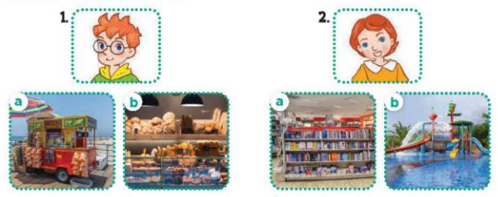  - T ask Ss to guess the answers.  + T writes Ss’guessing on the board.  - Listen to the tape:  + Play the recording  + Play the recording again and get Ss to swap books with their partners.  + Play the recording again to check answers together as a class.  + Write the answers on the board for Ss to correct their answers. Then checks Ss’ guessing.  - Play the recording, sentence by sentence, for the class to listen and repeat in chorus.  Key: 1.b 2. a  Activity 2. Look, complete and read.  *Aims: Ss will be able to complete two gapped exchanges with the help of picture cues.  *Procedure:  - Have Ss look at the pictures and identify the weather in the pictures.  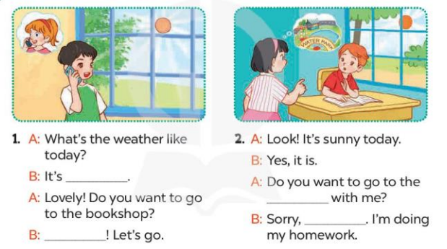  - T models with sentence 1.  + Have Ss look at the sentence.  + Ask them what is missing in the answer (sunny).  + Have Ss complete the gap.  + Have Ss read the completed sentence in chorus.  -Have Ss work in pairs and complete the other sentences.  - Invite pairs of pupils to stand up and read aloud the sentences.  -T gives feedbacks.  Key: 1. sunny; Great 2. water park; I can't  Activity 3. Let’s play  Slap the board and say  *Aims: Ss will be able to revise the target vocabulary items and structures by playing Slap the board and say game.  *Procedure:  - Tell Ss how to play the game.  + Put five flashcards or write the names of five places on the board.  + Divide the class into four teams.  + Ask one representative of each team to come to the front.  - Example: I want to go to the bookshop.  + The pupil who is the quickest to slap the correct picture / word gets one point for his / her team.  + Repeat the same procedure with the other pictures / words on the board.  - The team that gets the most points at the end of the game wins.  *Consolidation  *Aims: Ss will be able consolidate and wrap up the content of the lesson.  *Procedure:  - T asks ss to answer the following questions:  + What have you learnt from the lesson today?  +What are the core values of the lesson? (if the teacher can take from the lesson).  - T praises some Ss who are hardworking / active/ good…. as well as encourage others to try more.  3. Homework. (3’)  - Prepare the new lesson: Unit 16, Lesson 3 (1,2,3). | - Ss listen and play the game  - Ss open their books  -Look at the pictures and say:  Number 1: a picture of Ben  - a picture of a food stall (a)  - a picture of a bakery (b)  Number 2: a picture of Lucy  + a picture of a bookshop (a  + a picture of a water park (b)  -Ss guess the answers  - Ss listen to the tape and draw the line  - Ss listen again, match and swap books with their partners.  - Ss check their answers and guessing  -Ss write he correct anwer  -Ss listen and repeat.  -Ss look at the pictures and say  -Ss listen and answer  -Ss say the missing word  -Ss read and complete  -Ss work in pairs and complete  -Ss read aloud the sentences  - Ss listen.  - Ss listen the rule of the game  -Ss play the game  -Ss listen and answer  -Ss listen and take note
D. ADJUSTMENTS (if necessary):
………………………………………………………………………………………….…..……………………………………………………………………………...……………

