Week 27 Preparing date: March …., 2025
Period 107 Teaching date: March …, 2025

Unit 16: Weather
Lesson 1 (4, 5, 6)
A. OBJECTIVES:
By the end of the lesson, Ss will be able to:
1. Knowledge:
- use What was the weather like yesterday / last weekend? – It was …….. to ask and answer questions about the weather in the past.
– listen to and demonstrate understanding of simple communicative contexts in relation to the topic “Weather”
- Vocabulary: Review
- Skills: speaking, listening, reading and writing.
2. Competences:
- Co-operation: ready to help friends in pair work/ group work.
- Self-control and independent learning: perform listening tasks.
3. Attitude/ Qualities:
- Kindness: Help partners to complete learning tasks.
- Honesty: tell the truth about feelings and emotions.
- Diligence: complete learning tasks.
B. TEACHING AIDS:
- Teacher: Teacher’s guide Pages 230, 231; audio Tracks 54, 55; website hoclieu.vn, posters, laptop, pictures, textbook, lesson plan, TV or projector.
- Students: Pupil’s book Page 41, notebooks, workbooks, school things.
C. PROCEDURES:
Teacher’s activities | Students’ activities | Notes
1.Warm- up: (5’)  Game: Miming game  *Aims: to create a friendly and active atmosphere in the class to beginning the lesson.  *Procedure:  - Divide S into groups  - One pupil acts to show his favourite weather, he/she is not allowed to say or write but acts or uses body language.  - Groups get more answers win and get stickers  - Change and give the miming pupil cues if necessary.  - Say “Open your book page 41” and look at “Unit 16, Lesson 1 (4,5,6)”.  2.Practice: (27’)  Activity 1. Listen and number:  *Aims: Ss will be able to listen to and understand four communicative contexts in which pupils ask and answer questions about the weather and number the correct pictures.  *Procedure:  - Elicit the weather in each picture.  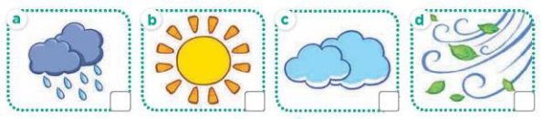  - T ask Ss to guess the answers.  + T writes Ss’guessing on the board.  - Listen to the tape:  + Play the recording  + Play the recording again and get Ss to swap books with their partners.  + Play the recording again to check answers together as a class.  + Write the answers on the board for Ss to correct their answers. Then checks Ss’ guessing.  - Play the recording, sentence by sentence, for the class to listen and repeat in chorus.  Key: 1. d 2. a 3.c 4.b  Activity 2. Look, complete and read  *Aims: Ss will be able to complete four gapped exchanges with the help of picture cues.  *Procedure:  - Get Ss to look at the pictures and identify the weather in the pictures.  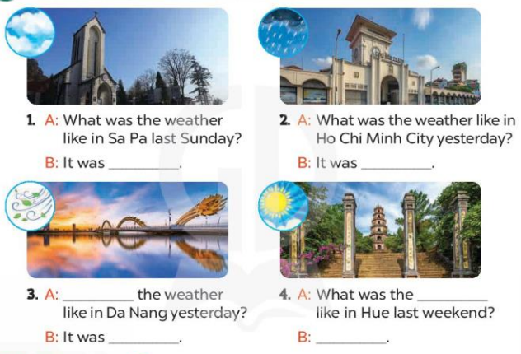  - Have Ss look at the four dialogue and the pictures. Elicit and model with picture 1  + Ask Ss to read the sentence 1 in chorus.  + Ask them what is missing in the question (cloudy). Then have them complete the gap (It was cloudy.).  -Have Ss work in pairs and complete the dialogue 2, 3, 4.  - Ask a few Ss to stand up and read the sentences aloud.  -T gives feedbacks.  Key:  1. cloudy 2. rainy 3. What was; windy  4. weather; It was sunny  Activity 3. Let’s sing  *Aims: Ss will be able to sing the song What was the weather like yesterday? with the correct pronunciation and melody.  *Procedure:  - Introduce the title and lyrics of the song: “ What was the weather like yesterday? ”  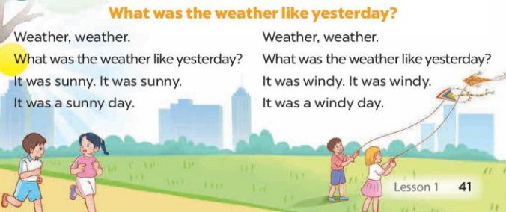  - Play the recording for Ss to listen to the whole song.  + Have them repeat the title and lyrics line by line.  + Tell Ss to point at the pictures while singing.  - Play the recording all the way through for Ss to listen to pronunciation and melody of the song.  - Play the recording line by line for Ss to listen, repeat and point to the pictures  - Play the recording for Ss to sing and do actions.  - Ask Ss to practice singing and doing actions in pairs or groups.  - Invite groups to the front of the classroom to perform the song  -T gives feedback.  *Consolidation  *Aims: Ss will be able consolidate and wrap up the content of the lesson.  *Procedure:  - T asks ss to answer the following questions:  + What have you learnt from the lesson today?  +What are the core values of the lesson? (if the teacher can take from the lesson).  - T praises some Ss who are hardworking / active/ good…. as well as encourage others to try more.  3. Homework. (3’)  - Practice part 5 again.  - Prepare the new lesson: Unit 16, Lesson 2 (1,2,3) | - Ss listen  - Ss play game  - Ss open their books  -Look at the pictures and say:  + Picture 1: a rainy weather icon  + Picture 2: a sunny weather icon  + Picture 3: a cloudy weather icon  + Picture 4: a windy weather icon  -Ss guess the answers  - Ss listen to the tape and write number  - Ss listen again, write and swap books with their partners.  - Ss check their answers and guessing  -Ss write the correct answer  -Ss listen and repeat.  -Ss look at the picture and say  -Ss look and answer  -Ss read  -Ss say and complete  -Ss work in pairs and complete  -Ss read the sentences aloud  - Ss listen  -Ss listen to the song  - Ss listen and repeat line by line without the action.  -Ss point to the pictures while singing  -Ss listen to melody of the song  - Ss listen and sing line by line.  - Ss sing and do actions.  + Ss work in groups (two groups) to sing.  -Ss perform in front of the class.  -Ss listen  -Ss answer the questions  -Ss listen and clap their hands  -Ss listen and take note
D. ADJUSTMENTS (if necessary):
………………………………………………………………………………………….…..……………………………………………………………………………...……………

