Week 26 Preparing date: March ……, 2025
Period 103, 104 Teaching date: March ……, 2025

Review 3
Parts 1, 2, 3, 4, 5
A. OBJECTIVES:
By the end of the lesson, Ss will be able to:
1. Knowledge:
- correctly use the following sentence patterns:
+Where do you live? – I live ____.
+What’s the ____ like? – It’s ____.
+What does he / she do? – He’s / She’s ____.
+Where does he / she work? – He / She works ____.
+What does he / she look like? – He’s / She’s ____.
+What does he / she look like? – He / She has ____.
+When do you watch TV? – I watch TV ____.
+What do you do in the morning? – I ____.
+Where does he / she go on Saturdays? – He / She goes to the ____.
+What does he / she do on Sundays? – He / She ____.
- Vocabulary: Review
- Skills: speaking, listening, reading and writing.
2. Competences:
- Co-operation: ready to help friends in pair work/ group work.
- Self-control and independent learning: perform listening tasks.
3. Attitude/ Qualities:
- Kindness: Help partners to complete learning tasks.
- Honesty: tell the truth about feelings and emotions.
- Diligence: complete learning tasks.
B. TEACHING AIDS:
- Teacher: Teacher’s guide Pages 222, 223; Track 51; website hoclieu.vn, posters, laptop, pictures, textbook, lesson plan, TV or projector.
- Students: Pupil’s book Page 36, 37, notebooks, workbooks, school things.
C. PROCEDURES:
Teacher’s activities | Students’ activities | Notes
1.Warm- up: (5’)  Game: Whispering  *Aims: to review the vocabulary and structure about greet and respond to greetings.  *Procedure:  - Divide class into 2 groups.  -Ask 5 Ss in each group stand in a straight line.  - T says a word or phrase to the first pupil in this line.  - Then, the first pupil whispers what she/ he hear to the second person in line; the second one whispers what he/ she hears to the third one and so on until the last pupil in group hears the word or phrase.  - The last pupil says the word or phrase out loud.  - The faster group has correct word or phrase is the winner.  - Say “Open your book page 36, 37” and look at Review 3.  2.Practice: (25’)  Activity 1. Listen and number:  *Aims: Ss will be able to listen to and understand four communicative contexts and number the correct pictures.  *Procedure:  - Elicit what is shown in each picture.  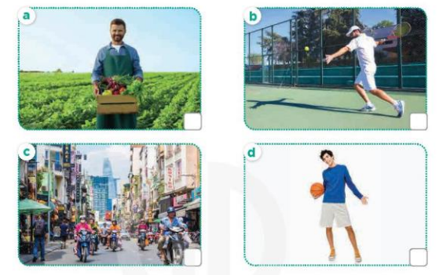  - T ask Ss to guess the answers.  + T writes Ss’guessing on the board.  - Listen to the tape:  + Play the recording  + Play the recording again and get Ss to swap books with their partners.  + Play the recording again to check answers together as a class.  + Write the answers on the board for Ss to correct their answers. Then checks Ss’ guessing.  - Play the recording, sentence by sentence, for the class to listen and repeat in chorus.  Key: 1. c 2. a 3. d 4. b  Activity 2. Ask and answer  *Aims: Ss will be able to ask and answer questions using picture cues.  *Procedure:  - Get them to look at Mary’s thought bubble to identify what the girl looks like.  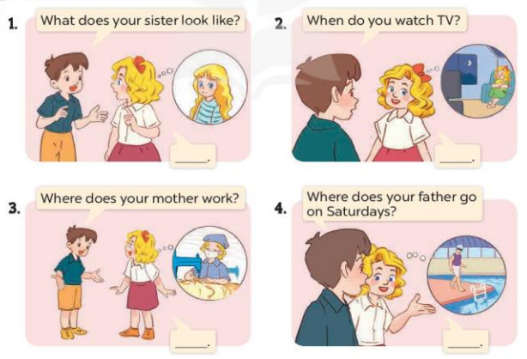  - Draw pupils’ attention to Nam’s question (What does your sister look like?).  - Have Ss look at the girl in Mary’s thought bubble to answer the question.  - Have Ss work in pairs to role-play the four exchanges.  - Invite some pairs of Ss to stand up and take it in turns to role-play the target exchanges  Activity 3. Read and match  *Aims: Ss will be able to read and match pairs of target sentence patterns  *Procedure:  - Draw pupils’ attention to the sentences. Point at Sentence 1, elicit the answer and give feedback. + Draw a line to match Sentence 1 with the letter d.  - Give Ss time to do the task individually  - Get Ss to swap books with a partner, then check answers as a class.  - Write the correct answers on the board.  - Invite some pairs of pupils to stand up and read the matched exchanges aloud.  Key: 1.d 2. a 3. e 4. c 5. b  Activity 4. Read and complete  *Aims: Ss will be able to read and show understanding of a text by completing the gaps.  *Procedure:  - Draw Ss’ attention to the words in the box and the paragraph.  + Point at the first gapped sentence and have pupils read it aloud as a class.  + Elicit the missing word and give feedback.  + Complete the sentence and get pupils to read the completed sentence in chorus.  - Give Ss time to do the task individually.  - Get Ss to swap books with a partner, then check answers as a class.  - Write the correct answers on the board.  - Invite a few Ss to stand up and read the completed paragraph aloud.  Key:1. factory 2. slim 3. works 4. pupil 5. watch  3.Production: (10’)  Activity 5. Let’s write  *Aims: Ss will be able to use the target language to complete a gapped paragraph using a picture cue.  *Procedure:  - Ask Ss to read the gapped text and fill in the gaps using the picture cue.  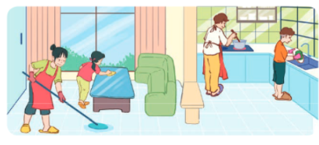  - Write the sentence with the first gap on the board: My father ____.  - Ask Ss to point at the father in the picture and encourage pupils to say what he does on Sundays (cooks meals). Give pupils time to write the answers.  - Invite a few pupils to read the paragraph they have completed in front of the class.  Key: 1. cooks meals 2. cleans the floor  3. washes the dishes 4. clean the table  *Consolidation  *Aims: Ss will be able consolidate and wrap up the content of the lesson.  *Procedure:  - T asks ss to answer the following questions:  + What have you learnt from the lesson today?  - T praises some Ss who are hardworking / active/ good…. as well as encourage others to try more.  4. Homework. (3’)  - Prepare the new lesson: Extension activities | - Ss listen  -Ss play game  - Ss open their books  -Look at the pictures and say:  + Picture a. a farmer  + Picture b: a man playing tennis  + Picture c: a busy street  + Picture d: a tall boy  -Ss guess the answers  - Ss listen to the tape and write number  - Ss listen again, write number and swap books with their partners.  -Ss write the answer and check their answers and guessing  -Ss listen and repeat.  -Look at the pictures and say  - Ss pay attention  -Ss an swer the question  -Ss work in pairs and role play  -Ss role play in front of the class  -Ss read and match sentence 1  -Ss do the task  -Ss swap their books and check answer  -Ss erite the correct answer  -Ss read aloud  -Ss read the passge  -Ss read the first gapped sentence  -Ss complete and read aloud the completed sentence  -Ss do the task  -Ss swap books and check answer  -Ss write the correct answer  -Ss read the completed paragraph aloud  -Ss role play sentence 1  -Ss write the first gap  -Ss point the picture and write  -Ss read the paragraph in font of the class  -Ss listen  -Ss listen and clap their hands  -Ss listen and take note
D. ADJUSTMENTS (if necessary):
……………………………………………………………………………………………

