Week 26 Preparing date: March …., 2025
Period 102 Teaching date: March ……, 2025

Unit 15: My family’s weekend
Lesson 3 (4, 5, 6)
A. OBJECTIVES:
By the end of the lesson, Ss will be able to:
1. Knowledge:
- read and write about where someone goes and what someone does at the weekend;
- make notes about where their family members go and what they do at the weekend, and present the results to the class at Project time
- Vocabulary: Review
- Skills: speaking, listening, reading and writing.
2. Competences:
- Co-operation: ready to help friends in pair work/ group work.
- Self-control and independent learning: perform reading tasks.
3. Attitude/ Qualities:
- Honesty: tell the truth about feelings and emotions.
- Diligence: complete learning tasks.
B. TEACHING AIDS:
- Teacher: Teacher’s guide Pages 220, 221, website hoclieu.vn, posters, laptop, pictures, textbook, lesson plan, TV or projector.
- Students: Pupil’s book Page 35, notebooks, workbooks, school things.
C. PROCEDURES:
Teacher’s activities | Students’ activities | Notes
1.Warm- up: (5’)  Game: Catch the sentence (PPT)  *Aims: to review the vocabulary and structure about greet and respond to greetings.  *Procedure:  - Divide the class into 2 or 3 teams  - T calls one pupil from each team to come up to the front.  - T explains the rules:  - Letters or words will appear then disappear.  - Read them quickly, the quicker one gets points for their team.  - Say “Open your book page 35” and look at “Unit 15, Lesson 3 (4, 5, 6)”.  2.Practice: (8’)  Activity 1. Read and tick True or False:  *Aims: Ss will be able to read a text and decide whether the statements about Ben and his family’s Sunday activities are true or false.  *Procedure:  - Draw pupils’ attention to the four statements, focusing on the activities of each member of Ben’s family on Sunday.  - Ask Ss to read the text individually first, then in pairs to decide if the statements are true or false.  - Have Ss to do the task.  - Select a few pupils to read their answers in front of the class.  - Check answers as a class and give explanations where necessary.  Key: 1. T 2. F 3. T 4. T  3.Production: (19’)  Activity 2. Let’s write  *Aims: Ss will be able to complete a text about what Mai’s family members do at the weekend by writing the target words in the gaps.  *Procedure:  - Explain to the class the goal of this activity.  - Ask Ss to read each gapped sentence, look at the picture and fill in the gap.  - Give Ss time to write their answers  - Ask Ss to swap and correct their answers in pairs.  - Check the answers as a class.  Key: Pupils’ own answers  Example: Mai and her family do a lot of things at the weekend. On Saturdays, her father goes to the sports centre. Her mother goes to the supermarket. Her brother goes to the zoo. Mai does her homework at home. On Sundays, her family has dinner together.  Activity 3. Project.  *Aims: Ss will be able to make notes about where pupils’ family members go and what they do at the weekend, and present the results to the class, using the target language.  *Procedure:  - Explain that they have to look at the notes they have prepared at home and present the results to the class.  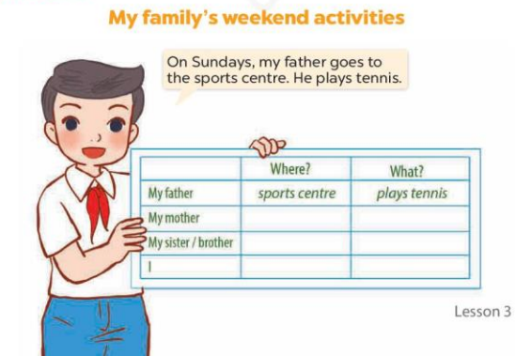  - Have pupils work in groups of five.  + Each pupil looks at his / her notes and tells the group about where each member of his / her family goes at the weekend and what each of them does there.  - Invite a few pupils to look at their notes and tell the class about them, ex: On Sundays, my father goes to the sports centre. He plays tennis.  *Consolidation  *Aims: Ss will be able consolidate and wrap up the content of the lesson.  *Procedure:  - T asks ss to answer the following questions:  + What have you learnt from the lesson today?  - T praises some Ss who are hardworking / active/ good…. as well as encourage others to try more.  4. Homework. (3’)  - Prepare the new lesson: Review 3. | - Ss listen  -Ss play game  - Ss open their books  - Ss read and answer  -Ss read and choose the correct answer  -Ss do the task  -Ss read the answer in front of the class  -Ss check the correct their answers  -Ss listen  -Ss read and answer  -Ss write  -Ss swap books and check their answers  -Ss check  -Ss listen and answer  -Ss work in groups  -Ss tell the group  -Ss perform in front of the class.  -Ss answer the questions  -Ss listen and clap their hands  -Ss listen and take notes

