Week 26 Preparing date: March …., 2025
Period 101 Teaching date: March ……, 2025

Unit 15: My family’s weekend
Lesson 3 (1, 2, 3)
A. OBJECTIVES:
By the end of the lesson, Ss will be able to:
1. Knowledge:
- correctly repeat the sounds of the letters g and s in isolation, in the words go and television, and in the sentences I go to the cinema on Saturdays. and We watch television on Sundays
- identify the target words go and television while listening.
- say the chant with the correct rhythm and pronunciation.
- Vocabulary: Review
- Skills: speaking, listening, reading and writing.
2. Competences:
- Co-operation: ready to help friends in pair work/ group work.
- Self-control and independent learning: perform listening tasks.
3. Attitude/ Qualities:
- Kindness: Help partners to complete learning tasks.
- Honesty: tell the truth about feelings and emotions
B. TEACHING AIDS:
- Teacher: Teacher’s guide Pages 218, 219; audio Tracks 48, 49, 50; website hoclieu.vn, posters, laptop, pictures, textbook, lesson plan, TV or projector.
- Students: Pupil’s book Page 34, notebooks, workbooks, school things.
C. PROCEDURES:
Stages | Teacher’s activities | Students’ activities
1.Warm- up: (5’)  2. Presentation  (9’)  3.Practice: (19’)  4. Homework. (2’) | 1.Warm- up: (5’)  Game: play the Build the city game (PPT)  *Aims: to create a friendly and active atmosphere in the class to beginning the lesson.  *Procedure:  - Divide the class into 2 teams, Ss choose any number, the teacher clicks on the NUMBER to go to the question, after pupils answer correctly, the teacher clicks on the key next to it to unlock.  - Teacher clicks on start to build to go to the city building slide.  - Teacher clicks on the corresponding picture to put the object in the right place.  - The game ends when the city is built.  - Teachers can also add points for students to have more fun  - Say “Open your book page 34” and look at “Unit 15, Lesson 3 (1,2,3)”.  2. Presentation(9’)  Activity 1. Listen and repeat:  *Aims: Ss will be able to correctly pronounce the sounds of the letters g and s in isolation, in the words go and television, and in the sentences I go to the cinema on Saturdays. and We watch television on Sundays  *Procedure:  - T gives instruction to the letters g and s in isolation, in the words go and television, and in the sentences I go to the cinema on Saturdays. and We watch television on Sundays  - Play the recording for the letter ea.  - Encourage Ss to point at the letter/ word/ sentence while listening.  - Play the recording again and encourage Ss to listen and repeat.  - Do this several times until Ss feel confident.  - T calls some Ss to practice.  - T gives feedbacks.  3.Practice: (19’)  Activity 2. Listen and circle.  *Aims: Ss will be able to identify the target words go and television while listening.  *Procedure:  - Elicit the sentences and explain that they have to listen.  - T ask Ss to guess the answers.  + T writes Ss’guessing on the board.  - Listen to the tape:  + Play the recording  + Play the recording again and get Ss to swap books with their partners.  + Play the recording again to check answers together as a class.  + Write the answers on the board for Ss to correct their answers. Then checks Ss’ guessing.  - Play the recording, sentence by sentence, for the class to listen and repeat in chorus.  - Invite one or two Ss to stand up and read the completed sentences.  Key: 1.c 2.d  Activity 3. Let’s chant  *Aims: Ss will be able to say the chant with the correct rhythm and pronunciation.  *Procedure:  - Introduce the title and lyrics of the chant.  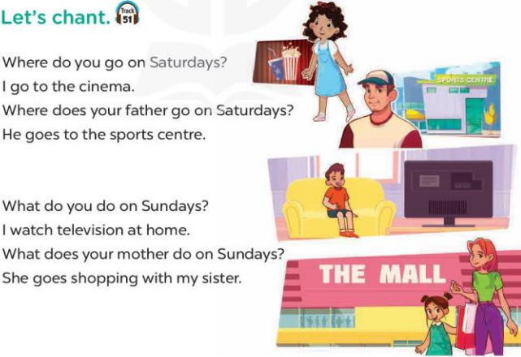  - Play the recording for Ss to listen to the whole chant.  + Have them repeat the title and lyrics line by line.  + Ask Ss to attend to the sounds of the letters g and s and the words go and television  - Play the recording all the way through for Ss to listen to pronunciation and melody.  - Play the recording line by line for Ss to listen and repeat  - Play the recording for Ss to chant and clap along.  - Ask Ss to practice chant and clap along in pairs or groups.  - Invite groups to the front of the classroom to perform the chant  -T gives feedback.  *Consolidation  *Aims: Ss will be able consolidate and wrap up the content of the lesson.  *Procedure:  - T asks ss to answer the following questions:  + What have you learnt from the lesson today?  +What are the core values of the lesson? (if the teacher can take from the lesson).  - T praises some Ss who are hardworking / active/ good…. as well as encourage others to try more.  4. Homework. (2’)  - Practice the chant more.  - Prepare the new lesson: Unit 15, Lesson 3 (4,5,6). | - Ss listen  -Ss play game  - Ss open their books  - Ss recognize the differences about color of letter  - - Ss listen  - Ss listen and point  - Ss listen again and repeat  -Ss listen again and repeat  -Ss practice  -Ss listen  -Ss listen and say  -Ss guess the answers  - Ss listen to the tape and circle  - Ss listen again, circle and swap books with their partners.  - Ss check their answers and guessing  -Ss write the answer  -Ss listen and repeat.  -Ss read the sentences  - Ss look and listen.  -Ss listen to the chant  - Ss listen and repeat line by line without clap their hands  -Ss note the sounds, words  -Ss listen to melody of the chant  - Ss listen and chant line by line.  - Ss chant and clap along.  - Ss work in groups (two groups) to chant  -Ss perform in front of the class.  -Ss listen  -Ss listen.  -Ss answer the questions  -Ss listen and clap their hands  -Ss listen and take note

D. ADJUSTMENTS (if necessary):
………………………………………………………………………………………….…..……………………………………………………………………………...……………

