Week 25 Preparing date: March ……, 2025
Period 100 Teaching date: March.…….., 2025

Unit 15: My family’s weekend
Lesson 2 (4, 5, 6)
A. OBJECTIVES:
By the end of the lesson, Ss will be able to:
1. Knowledge:
- use the words and phrases cinema, shopping centre, sports centre, swimming pool in relation to the topic “My family’s weekends”
-listen to and demonstrate understanding of simple communicative contexts in relation to the topic “My family’s weekends”
- Vocabulary: Review
- Skills: speaking, listening, reading and writing.
2. Competences:
- Co-operation: ready to help friends in pair work/ group work.
- Self-control and independent learning: perform listening tasks.
3. Attitude/ Qualities:
- Kindness: Help partners to complete learning tasks.
- Honesty: tell the truth about feelings and emotions.
B. TEACHING AIDS:
- Teacher: Teacher’s guide Pages 216, 217; audio Tracks 47; website hoclieu.vn, posters, laptop, pictures, textbook, lesson plan, TV or projector.
- Students: Pupil’s book Page 33, notebooks, workbooks, school things.
C. PROCEDURES:
Teacher’s activities | Students’ activities | Notes
1.Warm- up: (5’)  Game: “Lucky wheel”  *Aims: to create a friendly and active atmosphere in the class to beginning the lesson.  *Procedure:  - Teacher divides the class into 2 teams (boys and girls).  - Each team takes turns to choose the flag and answer the question.  - The team that has more points is the winner.  - Say “Open your book page 33” and look at “Unit 15, Lesson 2 (4,5,6)”.  2.Practice: (27’)  Activity 1. Listen and match:  *Aims: Ss will be able to listen to and understand four communicative contexts aboutwhat a family member does at the weekend and match the correct pictures  *Procedure:  - Ask questions to help Ss identify the people in the pictures and the icons.  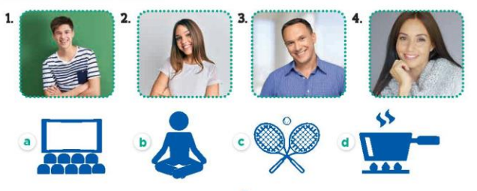  - T ask Ss to guess the answers.  + T writes Ss’guessing on the board.  - Listen to the tape:  + Play the recording  + Play the recording again and get Ss to swap books with their partners.  + Play the recording again to check answers together as a class.  + Write the answers on the board for Ss to correct their answers. Then checks Ss’ guessing.  - Play the recording, sentence by sentence, for the class to listen and repeat in chorus.  Key: 1.c 2. d 3. a 4. b  Activity 2. Look, complete and read.  *Aims: Ss will be able to complete two gapped exchanges with the help of picture cues.  *Procedure:  - Have Ss look at the pictures and identify the people and their activities in the pictures 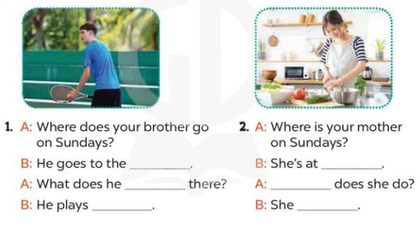  - Have Ss look at the two gapped exchanges. Draw their attention to the missing words.  - Have Ss look at the first gap. Ask them what word is missing (sports centre). Then have them complete the sentence (He goes to the sports centre.).  +Get them to guess the missing words in the following sentences (do; tennis).  - Repeat the same procedure with Exchange 2.  - Get Ss to swap books with a partner and check their answers before checking as a class.  - Ask a few pairs to read the completed exchanges aloud.  -T gives feedbacks.  Key: 1. sports centre; do; tennis  2. home; What; cooks meals  Activity 3. Let’s play.  *Aims: Ss will be able to revise target words about family weekend activities by playing Matching game  *Procedure:  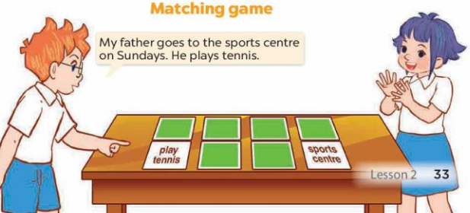  - Tell Ss that they are going to play Matching game in pairs.  - The player turns over a pair of cards.  +If the cards show an activity and a place that matches, the player scores a point, ex: the card play tennis matches the card sports centre.  - The player continues to turn over pairs of cards.  + If the cards do not match, the other player has a turn.  + The player who gets more points is the winner.  - Have Ss work in pairs. Invite one or two pairs to the front of the class to play the game.  - Ask Ss to make sentences with the words on the cards they have, ex: My father goes to the sports centre on Sundays. He plays tennis.  *Consolidation  *Aims: Ss will be able consolidate and wrap up the content of the lesson.  *Procedure:  - T asks ss to answer the following questions:  + What have you learnt from the lesson today?  +What are the core values of the lesson? (if the teacher can take from the lesson).  - T praises some Ss who are hardworking / active/ good…. as well as encourage others to try more.  3. Homework. (3’)  - Prepare the new lesson: Unit 15, Lesson 3 (1,2,3). | - Sing and dance the song in chorus.  - Ss open their books  -Look at the pictures and say:  + Picture a: cinema icon  + Picture b: yoga icon  + Picture c: tennis icon  + Picture d: cooking icon  -Ss guess the answers  - Ss listen to the tape and match  - Ss listen again, match and swap books with their partners.  - Ss check their answers and guessing  -Ss write the answer  -Ss listen and repeat.  -Ss look at the pictures and say  -Ss look at the gap and pay attention  -Ss answer and complete the sentence  -Ss read and complete  -Ss do the task with exchange 2  -Ss swap books and check answer  -Ss read the completed  - Ss listen  - Ss listen  -Ss play the game  - Ss play the game  -Ss listen and answer  -Ss listen and take note

D. ADJUSTMENTS (if necessary):
………………………………………………………………………………………….…..……………………………………………………………………………...………………………………………….…..…………………………………………………………

