Week 25 Preparing date: March …, 2025
Period 97 Teaching date: March ….., 2025

Unit 15: My family’s weekend
Lesson 1 (1, 2, 3)
A. OBJECTIVES:
By the end of the lesson, Ss will be able to:
1. Knowledge:
- use the words and phrases cinema, shopping centre, sports centre, swimming pool in relation to the topic “My family’s weekends”
– use Where does he / she go on Saturdays? – He / She goes to the ………to ask and answer questions about where someone goes
- Vocabulary: cinema, shopping centre, sports centre, swimming pool
- Model sentences:
A: Where does he / she go on Saturdays?
B: He/ She goes to the gym.
- Skills: speaking and listening
2. Competences:
- Co-operation: ready to help friends in pair work/ group work.
- Sociability: Talk to each other, say good words to others.
3. Attitude/ Qualities:
- Kindness: Help partners to complete learning tasks.
- Honesty: tell the truth about feelings and emotions
B. TEACHING AIDS:
- Teacher: Teacher’s guide Pages 209, 210; audio Tracks 41, 42, website hoclieu.vn, posters, laptop, pictures, textbook, lesson plan, TV or projector.
- Students: Pupil’s book Page 30, notebooks, workbooks, school things.
C. PROCEDURES:
Teacher’s activities | Students’ activities | Notes
1.Warm- up: (3’)  Sing: weekend song  *Aims: to create a friendly and active atmosphere in the class to beginning the lesson.  *Procedure:  -Show the song on the screen  -Ask Ss sing and dance  - Say “Open your book page 30” and look at “Unit 15, Lesson 1 (1,2,3)”.  2. Presentation(16’)  Activity 1. Vocabulary.  *Aims: Ss will be able to know the vocabulary in the new lesson.  *Procedure:  -T elicits the new words  + sports centre : trung tâm thể thao  (picture)  + shoppping center: trung tâm mua sắm  (situation)  + swimming pool : hồ bơi (picture)  + cinema : rạp chiếu phim (picture)  - T models (3 times).  - T writes the words on the board.  - Checking: Rub out and remember  Activity 2. Look, listen and repeat:  *Aims: Ss will be able to understand and correctly repeat the sentences in two communicative contexts in which the characters ask and answer questions about where a family member goes at the weekend.  *Procedure:  - Have Ss look at Pictures a and b and identify the characters in the pictures.  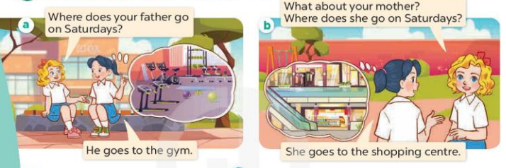  - Play the audio twice (sentence by sentence). Correct their pronunciation where necessary.  - Have Ss to practice the dialogue  - T invites a few pairs to the front of the class to practice.  - T checks pronunciation for ss.  Activity 3 Listen, point and say.  *Aims: Ss will be able to correctly say the words and use Where does he / she go on Saturdays?– He / She goes to the …... to ask and answer questions about where a family member goes at the weekend.  *Procedure:  * Model sentences:  - T asks Ss look at picture a and helps Ss know the structure from the dialogue.  - T introduces new structure for Ss.  - T explains, models and gives meaning.  -Have Ss repeat the model sentences.  A: Where does he / she go on Saturdays?  B: He’ She goes to the gym.  3.Practice: (7’)  *Drill pictures  - Elicit and check comprehension the name of the rooms.  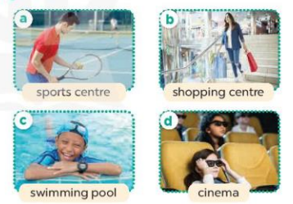  - Run through all the pictures.  - Run through model sentences.  + Run through the questions.  + Run through the answers  - Have Ss to practise:  + T says asks and Ss answer (change role).  + Ss – Ss (change role).  - Ask Ss to work in pairs.  - T controls and corrects.  - Invite a few pairs to come to the front of the classroom, point at the relevant character in each picture, and act out his/her role.  - Encourage Ss to practise speaking English.  - T gives feedbacks.  4.Production: (7’)  Activity 4. Let’s talk.  *Aims: Ss will be able to enhance the correct use of Where does he / she go on Saturdays? – He /She goes to the …….. to ask and answer questions about where a family member goes at the weekend in a freer context.  *Procedure:  - Ask questions to help them identify the context 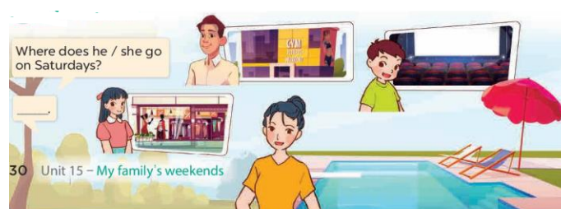  - T fills the gaps and writes the sentences on the board.  - T models  - T asks Ss to work in pairs to ask and answer  - Invite some pupils to the front of the class to present their exchanges.  - Give feedbacks  *Consolidation  *Aims: Ss will be able consolidate and wrap up the content of the lesson.  *Procedure:  - T asks ss to answer the following questions:  + What have you learnt from the lesson today?  - T review the vocabulary and model sentences.  - T praises some Ss who are hardworking / active/ good…. as well as encourage others to try more.  5. Homework. (2’)  - Prepare the new lesson: Unit 15, Lesson 1 (4,5,6). | - Ss listen  - Ss sing and dance  - Ss open their books  -Ss listen and answer  - - Ss listen and repeat  + Choral repetition (3 times).  + Individual repetition (3 ss)  - Ss take note  - Ss look, remember and write  -Look at the pictures and get to know the characters in the pictures.  + Picture a:  Mary: Where does your father go on Saturdays?  Mai: He goes to the gym.  + Picture b  Mary: What about your mother? Where does she go on Saturdays?  Mai: She goes to the shopping centre.  -Ss listen and repeat in chorus (twice)  -Ss work in pairs to practice  -Ss practice the dialogue  -Ss listen  -Ss look at the picture and answer.  -Ss listen  -Ss listen and repeat  -Ss repeat  - Ss look, listen and answer  + Picture a: father at the sports centre  + Picture b. a mother at the shopping centre  + Picture c. a brother at the swimming pool  + Picture d. a sister at the cinema  -Ss practice in chorus  -Ss practice in chorus  -Ss practice in chorus  -Ss work in pairs to practice  -Ss point and say  -Ss listen.  -Ss listen  -Ss look at the picture and answer  + a father at the gym, a brother at the cinema, a sister at the shopping centre, a mother at the swimming pool.  -Ss note  - Ss say the completed sentences.  -Ss work in pairs  -Ss perform in front of the class.  -Ss answer the questions  - Ss listen  -Ss listen and clap their hands  -Ss listen and take note
D. ADJUSTMENTS (if necessary):
………………………………………………………………………………………….…..……………………………………………………………………………...……………

