Week 21 Preparing date: January ……., 2024
Period 82 Teaching date: January …………, 2024
Unit 12: Jobs
Lesson 2 (4, 5, 6)
A. OBJECTIVES:
By the end of the lesson, Ss will be able to:
1. Knowledge:
- Use Where does he / she work? – He / She works …….. to ask and answer questions about places of work.
- Listen to and demonstrate understanding of simple communicative contexts in relation to the topic “Jobs”
- Vocabulary: Review
- Skills: speaking, listening, reading and writing.
2. Competences:
- Co-operation: ready to help friends in pair work/ group work.
- Self-control and independent learning: perform listening tasks.
3. Attitude/ Qualities:
- Kindness: Help partners to complete learning tasks.
- Diligence: complete learning tasks.
B. TEACHING AIDS:
- Teacher: Teacher’s guide Pages 176, 177; audio Tracks 17; website hoclieu.vn, posters, laptop, pictures, textbook, lesson plan, TV or projector.
- Students: Pupil’s book Page 15, notebooks, workbooks, school things.
C. PROCEDURES:
Teacher’s activities | Students’ activities | Notes
1.Warm- up: (5’)  Sing a song: “throw the ball”  *Aims: to create a friendly and active atmosphere in the class to beginning the lesson.  *Procedure:  - Divide the class into 2 teams.  - Stick the pictures of jobs on the board.  + T says a word, a pupil from each team has to point/throw the ball to the right picture and says the word three times.  + The one says faster will get points.  - Encourage Ss to take part in the game.  - Give points for Ss.  - Say “Open your book page 15” and look at “Unit 12, Lesson 2 (4,5,6)”.  2.Practice: (27’)  Activity 1. Listen and tick:  *Aims: Ss will be able to listen to and understand two communicative contexts in which pupils ask and answer questions about jobs and workplaces of family members and tick the correct pictures.  *Procedure:  - Elicit the names and jobs of the characters in the pictures.  - Point at the pictures respectively to explain the context.  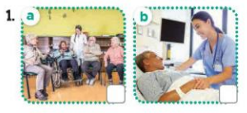  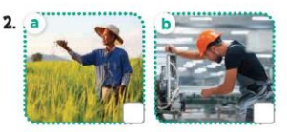  - T ask Ss to guess the answers.  + T writes Ss’guessing on the board.  - Listen to the tape:  + Play the recording  + Play the recording again and get Ss to swap books with their partners.  + Play the recording again to check answers together as a class.  + Write the answers on the board for Ss to correct their answers. Then checks Ss’ guessing.  - Play the recording, sentence by sentence, for the class to listen and repeat in chorus.  Key: 1.b 2. b  Activity 2. Look, complete and read.  *Aims: Ss will be able to complete two gapped exchanges with the help of picture cues. *Procedure:  - Have Ss look at the pictures and ask identify the jobs in the pictures.  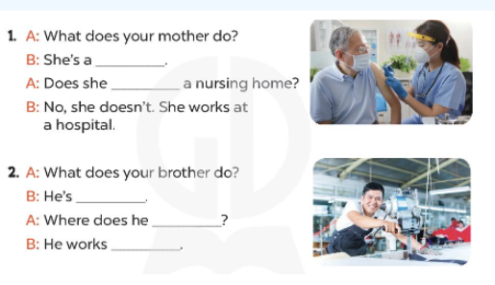  - T models with sentence 1.  + Have Ss look at the sentence.  + Ask them what is missing in the answer (nurse).  + Have Ss complete the gap.  + Have Ss read the completed sentence in chorus.  -Have Ss work in pairs and complete the sentences 2  - Invite pairs of pupils to stand up and read aloud the sentences.  -T gives feedbacks.  Key: 1. Nurse / work at  3. a worker/ work / at a factory.  Activity 3. Let’s play- Gussing game  *Aims: Ss will be able to revise the target vocabulary and sentence patterns by playing the game Gussing game.  *Procedure:  - Explain that they have to listen to the teacher’s sentences and reply the places where they work as quickly as possible.  - Invite two groups of pupils (three pupils in each group) to the front of the class.  -Then say (ex: He’s a farmer.) and ask the groups to reply (ex: He works on a farm.).  +The group that gives the correct answer more quickly gets one point / star.  +The group with more points / stars is the winner.  - When pupils feel confident with the game, call on one or two pupils to act as the teacher to say the sentences to the groups.  *Consolidation  *Aims: Ss will be able consolidate and wrap up the content of the lesson.  *Procedure:  - T asks ss to answer the following questions:  + What have you learnt from the lesson today?  - T praises some Ss who are hardworking / active/ good…. as well as encourage others to try more.  3. Homework. (3’)  - Prepare the new lesson: Unit 12, Lesson 3 (1,2,3). | - Ss listen and play the game  - Ss open their books  -Look at the pictures and say:  + Picture 1a: A nurse working at nursing home  + Picture 1b: A nurse working at a hospital  + Picture 2a: A man working on a farm  + Picture 2b: A man working at a factory  -Ss guess the answers  - Ss listen to the tape and tick  - Ss listen again, tick and swap books with their partners.  - Ss check their answers and guessing  -Ss wrirte the correct answer  -Ss listen and repeat.  -Ss look at the pictures and say  -Ss listen and answer  -Ss read and complete  -Ss compelet the gap  -Ss read the compeled sentence  -Ss work in pairs and do the task  -Ss read aloud the sentences.  - Ss listen  -Ss play the game  - Ss play the game  - Ss play the game  -Ss listen and answer  -Ss listen and take note
D. ADJUSTMENTS (if necessary):
………………………………………………………………………………………….…..……………………………………………………………………………...……………

