Week 15 Preparing date: December 19th, 2024
Period 60 Teaching date: December 20th, 2024

Unit 9: Our sports day
Lesson 3 (1, 2, 3)
A. OBJECTIVES:
By the end of the lesson, Ss will be able to:
1. Knowledge:
- correctly pronounce the sounds of the letter y in isolation, in the words February and July, and in the sentences Our sports day is in February. and My birthday is in July.
- use Is your sports day in ……. – Yes, it is. / No, it isn’t. It’s in ……. to ask and answer questions about sports days
- use When's your sports day? – It's in ……. to ask and answer questions about when a sport day is
- Vocabulary: Review
- Skills: speaking, listening, reading and writing.
2. Competences:
- Co-operation: ready to help friends in pair work/ group work.
- Sociability: Talk to each other, say good words to others.
3. Attitude/ Qualities:
- Kindness: Help partners to complete learning tasks.
- Honesty: tell the truth about feelings and emotions
B. TEACHING AIDS:
- Teacher: Teacher’s guide Pages 134, 135; audio Tracks 94, 95, 96; website hoclieu.vn, posters, laptop, pictures, textbook, lesson plan, TV or projector.
- Students: Pupil’s book Page 66, notebooks, workbooks, school things.
C. PROCEDURES:
Teacher’s activities | Students’ activities | Notes
1.Warm- up: (5’)  Game: Find and circle the words  *Aims: to create a friendly and active atmosphere in the class to beginning the lesson.  *Procedure:  - Divide class into 2 groups  - Ask Ss to find and circle the words that they learnt.  - Which groups find the best correct words is winner.  - Give Ss time to play the game.  Rows: February, cycling.  Columns: July, sky, January  -T checks who’s winner?  - Say “Open your book page 66” and look at “Unit 9, Lesson 3 (1,2,3)”.  2. Presentation (9’)  New lesson  Activity 1. Listen and repeat:  *Aims: Ss will be able to correctly repeat the sounds of the letter y in isolation, in the words July and February, and in the sentences Our sports day is in February. and My birthday is in July. with correct pronunciation and intonation.  *Procedure:  - T gives instruction to the letter y, the words February and July, and in the sentences Our sports day is in February. and My birthday is in July.  - Play the recording for the letter y.  - Encourage Ss to point at the letter/ word/ sentence while listening.  - Play the recording again and encourage Ss to listen and repeat.  - Do this several times until Ss feel confident.  - T calls some Ss to practice.  - T gives feedbacks.  3.Practice: (19’)  Activity 2. Listen and circle.  *Aims: Ss will be able to identify the target words July and February while listening.  *Procedure:  - Elicit the sentences and the gap-fill options.  - T ask Ss to guess the answers.  + T writes Ss’guessing on the board.  - Listen to the tape:  + Play the recording  + Play the recording again and get Ss to swap books with their partners.  + Play the recording again to check answers together as a class.  + Write the answers on the board for Ss to correct their answers. Then checks Ss’ guessing.  - Play the recording, sentence by sentence, for the class to listen and repeat in chorus.  - Invite one or two Ss to stand up and read the completed sentences.  Key: 1.a 2.b  Activity 3. Let’s chant  *Aims: Ss will be able to say the chant with the correct rhythm and pronunciation  *Procedure:  - Introduce the title and lyrics of the chant.  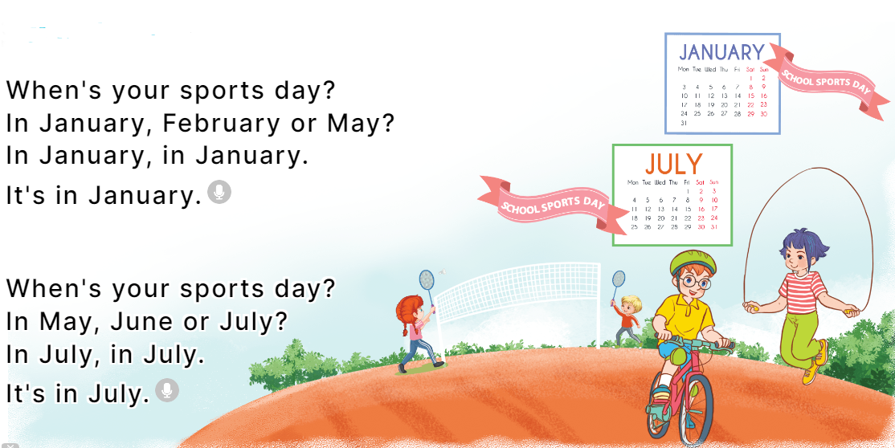  - Play the recording for Ss to listen to the whole chant.  + Have them repeat the title and lyrics line by line.  + Ask Ss to attend to the sounds of the letters y and the words February and July.  - Play the recording all the way through for Ss to listen to pronunciation and melody.  - Play the recording line by line for Ss to listen and repeat  - Play the recording for Ss to chant and clap along.  - Ask Ss to practice chant and clap along in pairs or groups.  - Invite groups to the front of the classroom to perform the chant  -T gives feedback.  *Consolidation  *Aims: Ss will be able consolidate and wrap up the content of the lesson.  *Procedure:  - T asks ss to answer the following questions:  + What have you learnt from the lesson today?  +What are the core values of the lesson? (if the teacher can take from the lesson).  - T praises some Ss who are hardworking / active/ good…. as well as encourage others to try more.  4. Homework. (2’)  - Practice the chant more.  - Collect three school things  - Prepare the new lesson: Unit 9, Lesson 3 (4, 5, 6). | - Ss listen  -Ss play game  - Ss open their books  - Ss recognize the differences about color of letter  - - Ss listen  - Ss listen and point  - Ss listen again and repeat  -Ss listen again and repeat  -Ss practice  -Ss listen  -Ss listen and say:  + Number 1: Is your sports day in July?  + Number 2: I like January.  -Ss guess the answers  - Ss listen to the tape and circle  - Ss listen again, circle and swap books with their partners.  - Ss check their answers and guessing  -Ss listen and repeat.  -Ss read the sentences  - Ss look and listen.  -Ss listen to the chant  - Ss listen and repeat line by line without clap their hands  -Ss note the sounds, words  -Ss listen to melody of the chant  - Ss listen and chant line by line.  - Ss chant and clap along.  - Ss work in groups (two groups) to chant  -Ss perform in front of the class.  -Ss listen  -Ss answer the questions  -Ss listen and clap their hands  -Ss listen and take note
  J | M | V | K | E | P | S | C | B | J
  U | C | T | H | N | E | K | C | L | A
  L | L | U | A | A | V | Y | O | U | N
  Y | E | L | N | N | N | A | S | U | U
  A | B | R | K | A | K | L | E | S | A
  S | C | D | K | O | K | K | I | Y | R
  S | R | F | E | B | R | U | A | R | Y
  L | C | Y | C | L | I | N | G | A | Y
  D | T | S | S | R | S | O | T | S | M
  A | C | E | B | F | Z | Z | Y | W

D. ADJUSTMENTS (if necessary):
………………………………………………………………………………………….…..……………………………………………………………………………...………………………………………….…..…………………………………………………………..............................................................................................................................................

