Week 3

Preparing date: September …..,
Teaching date: September ………….,
Period 9

Unit 1: Hello
Lesson 3 (1, 2, 3)
A. OBJECTIVES:
By the end of the lesson, Ss will be able to:
1. Knowledge:
- correctly repeat the sounds of the letters h and b in isolation, in the words hello and bye, and in the sentences Hello, Ben. and Bye, Ben. with the correct pronunciation and intonation.
- identify the target words hello and bye while listening.
- Vocabulary:Review
- Skills: speaking, listening, reading and writing.
2. Competences:
-Co-operation: ready to help friends in pair work/ group work.
- Sociability: Talk to each other, say good words to others.
3. Attitude/ Qualities:
-Kindness:Help partners to complete learning tasks.
- Honesty: tell the truth about feelings and emotions
B. TEACHING AIDS:
- Teacher: Teacher’s guide Pages 25, 26; audio Tracks 12,13, 14; website sachmem.vn, posters, laptop, pictures, textbook, lesson plan, TV or projector.
- Students: Pupil’s book Page 14, notebooks, workbooks, school things.
C. PROCEDURES:
Stages/Time | Teacher’s activities | Students’ activities
1.Warm- up:  (5’)  2.Presentation  (9’)  3.Practice: (19’)  4. Homework. (2’) | Game: Find a partner  *Aims: to create a friendly and active atmosphere in the class to beginning the lesson.  *Procedure:  - Divide the class into 2 teams: boys and girls. Prepare the name tags.  - Set the rules: Make a circle, then ask 1 Ss to come stand in the circle and choose a name tag.  The one whose name is called will come to the circle and practise speaking by saying Hi, I’m ___.  - Encourage students to join the game.  - Say “Open your book page 14” and look at “Unit 1, Lesson 3 (1,2,3)”.  Activity 1. Listen and repeat:  *Aims: Ss will be ableto correctly repeat the sounds of the letters h and b in isolation, the words hello and bye, and the sentences Hello, Ben. and Bye, Ben. with correct pronunciation and intonation.  *Procedure:  -T gives instruction to the letter h and b, the word hello andbye,the sentence Hello, Ben and Bye, Ben.  - Play the recording for the letter h,b  - Encourage Ss to point at the letter/ word/ sentence while listening.  - Play the recording again and encourage Ss to listen and repeat. - Do this several times until Ss feel confident.  - T calls some Ss to practice.  - T gives feedbacks.  Activity 2.Listen and circle.  *Aims: Ss will be ableto identify the target words hello and bye while listening.  *Procedure:  - Elicit the sentences and the gap-fill options.  - T ask Ss to guess the answers.  + T writes Ss’guessing on the board.  - Listen to the tape:  + Play the recording  + Play the recording again and get Ss to swap books with their partners.  + Play the recording again to check answers together as a class.  + Write the answers on the board for Ss to correct their answers. Then checks Ss’ guessing.  - Play the recording, sentence by sentence, for the class to listen and repeat in chorus.  -Invite one or two Ss to stand up and read the completed sentences.  Key: 1.c 2.a  Activity 3. Let’s chant  *Aims: Ss will be able to say the chant with the correct rhythm and pronunciation.  *Procedure:  - Introducethe title and lyrics of the chant.  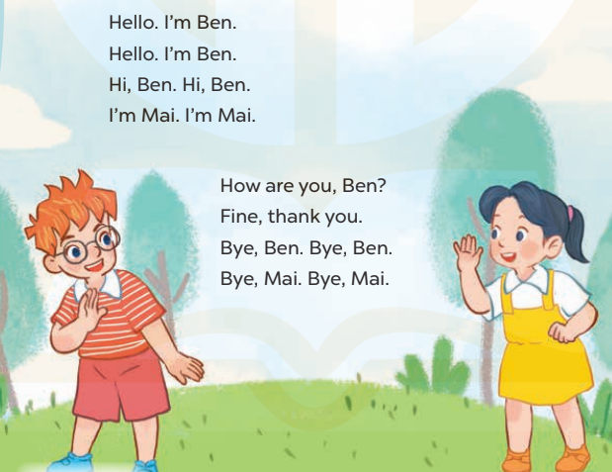  -Play the recording for Ss to listen to the whole chant.  +Have them repeat the title and lyrics line by line.  +Ask Ss to attend to the sounds of the letters h and b and the words Hello and Bye.  - Play the recording all the way through for Ss to listen to pronunciation and melody.  - Play the recording line by line for Ss to listen and repeat  - Play the recording for Ss to chant and clap along.  - Ask Ss to practice chant and clap along in pairs or groups.  -Invite groups to the front of the classroom to perform the chant  -T gives feedback.  *Consolidation  *Aims: Ss will be able consolidate and wrap up the content of the lesson.  *Procedure:  - T asks ss to answer the following questions:  + What have you learnt from the lesson today?  +What are the core values of the lesson? (if the teacher can take from the lesson).  - T review the vocabulary and model sentences.  - T praises some Ss who are hardworking / active/ good…. as well as encourage others to try more.  - Practice the chant more.  - Prepare the new lesson: Unit 1, Lesson 3 (4,5,6). | - Ss listen  -Ss listen the rules  - Ss play the game  - Ss open their books  -Ss recognize the differences about color of letter  - - Ss listen  - Ss listen and point  - Ss listen again and repeat  -Ss listen again and repeat  -Ss practice  -Ss listen  -Ss listen and say:  + Number 1: …..,Ben  + Number 2: …..,Ben.  -Ss guess the answers  - Ss listen to the tape and circle  - Ss listen again, circle and swap books with their partners.  - Ss check their answers and guessing  -Ss listen and repeat.  -Ss read the sentences  - Ss look and listen.  -Ss listen to the chant  -Ss listen and repeat line by line without clap their hands  -Ss note the sounds, words  -Ss listen to melody of the song  - Ss listen and chantline by line.  - Ss chant and clap along.  - Ss work in groups (two groups) to chant  -Ss performin front of the class.  -Ss listen  -Ss listen.  -Ss listen  -Ss answer the questions  - Ss listen  -Ss listen and clap their hands  -Ss listen and take note

D. ADJUSTMENTS (if necessary):
………………………………………………………………………………………….…..……………………………………………………………………………...………………………………………….…..……………………………………………………………………………….……………………………………………………………………...

Week 3 Preparing date: September …..,
Period 10 Teaching date: September …………,

Unit 1: Hello
Lesson 3 (4,5,6)
A. OBJECTIVES:
By the end of the lesson, Ss will be able to:
1. Knowledge:
- read four sentences and choose the correct responses about the topic “Greetings and goodbye”.
- read, understand and complete three exchanges with their personal information about the topic “Greetings and goodbye”.
- Vocabulary:Review
- Skills: speaking, listening, reading and writing.
2. Competences:
- Critical Thinking: self-introduce
-Co-operation: ready to help friends in pair work/ group work.
- Self-control and independent learning: perform listening tasks.
3. Attitude/ Qualities:
-Kindness:Help partners to complete learning tasks.
- Honesty: tell the truth about feelings and emotions.
- Diligence: complete learning tasks.
B. TEACHING AIDS:
- Teacher: Teacher’s guide Pages 26, 27; website sachmem.vn, posters, laptop, pictures, textbook, lesson plan, TV or projector.
- Students: Pupil’s book Page 15, notebooks, workbooks, school things.
C. PROCEDURES:
Stages/Time | Teacher’s activities | Students’ activities
1.Warm- up:  (5’)  2.Practice: (8’)  3.Production: (19’)  4. Homework. (3’) | Game: “Nought and crosses”  *Aims: to review the vocabulary and structure about greet and respond to greetings.  *Procedure:  - T helps ss to review the vocabulary and structure about greet and respond to greetings, using “How are you? and fine, thank you.  - T introduces how to play game.  - T reviews structure before play game.  - T guides Ss play game:  +Divide class into 2 groups.  + T gives Ss to watch the picture.  + Twill ask “How are you?”and Sswill answer  + Ss have correct answers, they will get a nought or cross and choose the way so that they win.  + The group has more correct answers that will be the winner and get a flower.  - T gives feedback.  - Say “Open your book page 15” and look at “Unit 1, Lesson 3 (4,5,6)”.  Activity 1. Readand circle:  *Aims: Ss will be abletoread four sentences and choose the correct responses.  *Procedure:  -Elicit the context and give feedback.  - T models with sentence 1.  + Get Ss to read Sentence 1  +Elicit the answer and give feedback. Circle the letter b.  -Have Ss work in pairs and circle the sentences 2, 3 and 4.  - Tell Ss to swap books with a partner, then check answers together as a class.  - Write the correct answers on the board for pupils to correct their answers.  - Invite pairs of Ss to stand up and role play  -T gives feedbacks.  Key: 1. b 2. a 3. a 4.b  Activity 2.Let’s write  *Aims: Ss will be ableto read, understand and complete three exchanges with their personal information.  *Procedure:  - Get Ss to look at the pictures and identify the characters  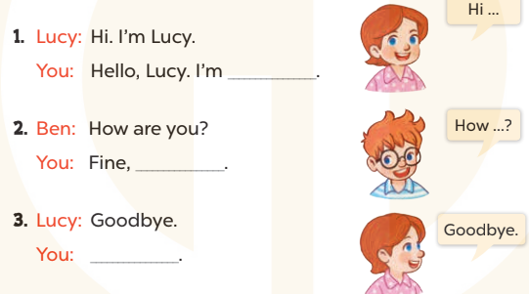  -Elicit the context and the missing words  - T models with sentence 1  + Ask Ss what is missing in the sentence.  + Have Ss complete the gap, then role-play the exchange.  -Have Ss work in groups and complete the sentences 2and 3.  - Get Ss to swap books with a partner, then check the answers together as a class.  - Ask a few Ss to stand up and role play the completed sentences aloud.  -T gives feedbacks.  Key:  1. Pupil’s answer  2. thank you/ thanks  3. Goodbye/ bye  Activity 3. Project.  *Aims: Ss will be able to make a pupil card for pupils to use, and use their work to practise talking to their classmates.  *Procedure:  - Stick the pupil card sample on the board and modelwith the name, class, school.  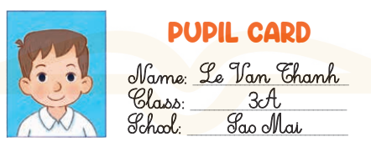  - T asks Ss to make their name cards and present them to their class.  - T asks ss to work in group and do the project in class.  - T calls some Ss to the front of the class to present their cards, using their name card and saying Hello.I’m + (name).  - Have Ss to stick their cards on the wall of the classroom  - Create a class display of pupil cards and vote for the best decorated one.  - T gives feedback.  *Consolidation  *Aims: Ss will be able consolidate and wrap up the content of the lesson.  *Procedure:  - T asks ss to answer the following questions:  + What have you learnt from the lesson today?  +What are the core values of the lesson? (if the teacher can take from the lesson).  - T praises some Ss who are hardworking / active/ good…. as well as encourage others to try more.  - Learn the number by heart  - Prepare the new lesson: Unit 1, Lesson 2 (1,2,3). | - Ss listen and answer  - Ss listen to the rules  -Ss play game  -Ss listen  - Ss open their books  - Ss look at the sentences and say  -Ss read and circle  -Ss work in pairs and circle  -Ss swap books and check  -Ss check the correct their answers  -Ss role play  -Ss listen  -Ss look at the picture and say:  + They’re Ben and Lucy  -Ss look and answer  -Ss answer: I’m…….  -Ss complete and role play  -Ss complete the sentences  -Ss swap books and check their answers  -Ss role play  -Ss listen  - Ss look and listen  -Ss prepare necessary school things to carry out the project (paper, pens, pencils, coloured pencils, scissors , glue,…..)  -Ssmake their name cards and present them to their class.  -Ss work in groups  -Ss present their cards  - Ss stick their cards on the wall of the classroom.  -Ss vote  -Ss listen  -Ss answer the questions  -Ss listen and clap their hands  -Ss listen and take note
D. ADJUSTMENTS (if necessary):
………………………………………………………………………………………….…..……………………………………………………………………………...…………
Week 3 Preparing date: September …….
Period 11 Teaching date: September ……,

Unit 2: Our names
Lesson 1 (1, 2, 3)
A. OBJECTIVES:
By the end of the lesson, Ss will be able to:
1. Knowledge:
- use the words what, your, name, my in relation to the topic “Our names”
- use What’s your name? – My name’s ………. to ask and answer questions about name
- listen to and demonstrate understanding of simple communicative contexts in relation to the topic "Our names"
- Vocabulary:what, your, name, my
- Skills: speaking and listening
2. Competences:
- Oral Communication: speak about names, ask and answer the questions
-Co-operation: ready to help friends in pair work/ group work.
- Sociability: Talk to each other, say good words to others.
3. Attitude/ Qualities:
-Kindness:Help partners to complete learning tasks.
- Honesty: tell the truth about feelings and emotions
- Diligence: complete learning tasks
B. TEACHING AIDS:
- Teacher: Teacher’s guide Pages 26, 27, audio Tracks 15,16, website sachmem.vn, posters, laptop, pictures, textbook, lesson plan, TV or projector.
- Students:Pupil’s book Page 16, notebooks, workbooks, school things.
C. PROCEDURES:
Stages/Time | Teacher’s activities | Students’ activities
1.Warm- up:  (3’)  2.Presentation  (16’)  3.Practice: (7’)  4.Production: (7’)  5. Homework. (2’) | Game: Who is faster?  *Aims: to create a friendly and active atmosphere in the class to beginning the lesson.  *Procedure:  - Divide the class into groups.  - Arrange the flashcards on the board.  - Invite a student from each group to go to the board.  - T says a word and the students run to tap the right card.  - The group has more cards that will be the winner.  - Say “Open your book page 16” and look at “Unit 2, Lesson 1 (1,2,3)”.  Activity 1. Vocabulary.  *Aims: Ss will be ableto know the vocabulary in front of starting the new lesson.  *Procedure:  -T elicitsthe new words  +what : gì, cái gì (translation)  +name: tên (situation)  + my : của tôi (translation)  + your : của bạn (translation)  - T models (3 times).  - T writes the words on the board.  - Checking: Rub out and remember  Activity 2. Listen, point and repeat:  *Aims: Ss will be ableto understand and correctly repeat the sentences in two communicative contexts (pictures) focusing on asking and answering questions about names.  *Procedure:  - Have pupils look at Pictures a and b and identify the characters in the pictures.  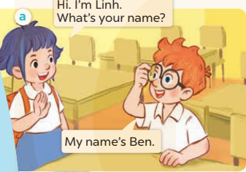  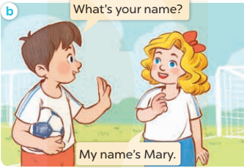  -Play the audio twice(sentence by sentence). Correct their pronunciation where necessary.  - Have Ss to practice the dialogue  -Tinvites a few pairs to the front of the class to practice.  - T checkspronunciation for ss.  Activity 3Listen, point and say.  *Aims: Ss will be ableto correctly say the character names and use What's your name? - My name's ….. to ask and answer questions about names.  *Procedure:  * Model sentences:  -T asks Ss look at picture a and helps Ss know the structure from the dialogue.  - T introduces new structure for Ss.  - T explains,models and gives meaning.  -Have Ss repeat the model sentences.  A: What’s your name?  B: My name’s Ben  *Note: What’s = what is  My name’s = my name is  *Drill pictures  - Elicit and check comprehension the name of each character.  - Run through all the pictures.  - Run through model sentences.  + Run through the questions.  + Run through the answers.  - Have Ss to practise:  + T asks the first – Ss answer(change role).  + Ss – Ss (change role).  - Ask Ss to work in pairs to ask and answer the question What’s your name? My name’s……  - T controls and corrects.  - Invite a few pairs to come to the front of the classroom,point at the relevant character in each picture, and act out his/her role.  - Encourage Ss to practise speaking English.  - T gives feedbacks.  Activity 4. Let’s talk.  *Aims: Ss will be able to enhance the correct use of What’s your name? and My name’s…. . to ask and answer questions about names.  *Procedure:  - T asks sslook at the second bubble andask  +What’s your name?  - Get Ss to repeat the question and the answer several times in pairs.  - T models: Go around the classroom, pointing to Ss and asking What’s your name?  - Ask Ss ask and answerabout their own names in pairs.  - Invite some groups to perform in front of the class.  - Give feedbacks  *Consolidation  *Aims: Ss will be able consolidate and wrap up the content of the lesson.  *Procedure:  - T asks ss to answer the following questions:  + What have you learnt from the lesson today?  +What are the core values of the lesson? (if the teacher can take from the lesson).  - T review the vocabulary and model sentences.  - T praises some Ss who are hardworking / active/ good…. as well as encourage others to try more.  - Learn the vocabulary and model sentences by heart  - Prepare the new lesson: Unit 2, Lesson 1 (4,5,6). | - Ss listen.  -Ss look at the board  - Ss play the game  - Ss listen and clap their hands  - Ss open their books  -Ss listen and answer  - - Ss listen and repeat  + Choral repetition (3 times).  + Individual repetition (3 ss)  - Ss take note  - Ss look, remember and write  -Look at the pictures and get to know the characters in the pictures.  + In picture a: Linh says:Hi. I’m Linh. What’s your name?And Ben answers:My name’s Ben.  + In pucture b: Minh asks:What’s your name?And Mary answers:My name’s Mary.  -Ss listenand repeat in chorus (twice)  -Ss work in pairs to practice  -Ss practice the dialogue  -Ss listen  -Ss look at the picture and answer.  -Ss listen  -Ss listen and repeat  -Ss repeat to the introduce and respond to greetings.  - Ss look, listen and repeat  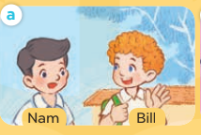  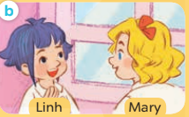  -Ss practice in chorus  -Ss work in pairs to practice  -Ss point and ask and answer  -Ss listen.  -Ss listen  -Ss look at the picture and answer  + My name’s Mai  -Ss ask and answer  - Ss answer  -Ss work in pairs  -Ss perform in front of the class.  -Ss answer the questions  - Ss listen  -Ss listen and clap their hands  -Ss listen and take note

D. ADJUSTMENTS (if necessary):
………………………………………………………………………………………….…..……………………………………………………………………………...………………………………………….…..……………………………………………………………………………….……………………………………………………………………...

Week 3 Preparing date: September ………,
Period 12 Teaching date: September ………..,

Unit 2: Our names
Lesson 1 (4,5,6)
A. OBJECTIVES:
By the end of the lesson, Ss will be able to:
1. Knowledge:
- use What’s your name? – My name’s…... to ask and answer questions about names
- listen to and demonstrate understanding of simple communicative contexts in relation to the topic "Our names"
- read and write about people’s names
- Vocabulary:Review
- Skills: speaking, listening, reading and writing.
2. Competences:
- Critical Thinking: self-introduce
-Co-operation: ready to help friends in pair work/ group work.
- Self-control and independent learning: perform listening tasks.
3. Attitude/ Qualities:
-Kindness:Help partners to complete learning tasks.
- Honesty: tell the truth about feelings and emotions.
- Diligence: complete learning tasks.
B. TEACHING AIDS:
- Teacher: Teacher’s guide Pages 28,29; audio Tracks 17; website sachmem.vn, posters, laptop, pictures, textbook, lesson plan, TV or projector.
- Students: Pupil’s book Page 17, notebooks, workbooks, school things.
C. PROCEDURES:
Stages/Time | Teacher’s activities | Students’ activities
1.Warm- up:  (5’)  2.Practice: (27’)  3. Homework. (3’) | Game: Interview your friend(s).  *Aims: to create a friendly and active atmosphere in the class to beginning the lesson.  *Procedure:  - Each Ss gets 1 sheet of paper from the teacher.  - Ask Ss fill in the information about themselves. Then they can move around the class to ask and answer the questions to know more about their friends’ family member.  -Have Ss perform in front of the class  - T gives feedback.  - Say “Open your book page 17” and look at “Unit 2, Lesson 1 (4,5,6)”.  Activity 1. Listenand tick:  *Aims: Ss will be abletolisten to and understand two dialogues in which pupils ask and answer questions about names.  *Procedure:  - Elicit the names of the characters in the pictures.  - Point at the pictures respectively to explain the context.  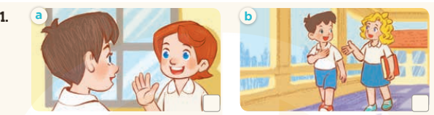  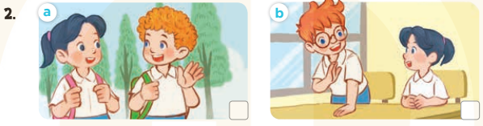  - T ask Ss to guess the answers.  + T writes Ss’guessing on the board.  - Listen to the tape:  + Play the recording  + Play the recording again and get Ss to swap books with their partners.  + Play the recording again to check answers together as a class.  + Write the answers on the board for Ss to correct their answers. Then checks Ss’ guessing.  - Play the recording, sentence by sentence, for the class to listen and repeat in chorus.  Key: 1.b 2.a  Activity 2.Look, complete and read.  *Aims: Ss will be ableto complete three target sentence patterns with the help of picture cues.  *Procedure:  - Get Ss to look at the pictures and identify the characters  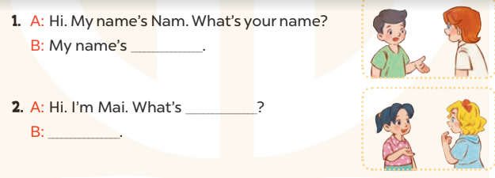  - Have Ss look at the three incomplete sentences and elicits the missing words in the sentences.  - T models with sentence 1  + Ask Ss what is missing in the sentence.  + Have Ss look at the picture and complete the gap, then read the completed sentence in chorus.  -Have Ss work in groups and complete the sentence 2.  - Ask a few Ss to stand up and read the completed sentences aloud.  -T gives feedbacks.  Key:  - Lucy 2. your name; Mary  Activity 3. Let’s play.  *Aims: Ss will be able to review the characters’ names by playing the game Slap the board.  *Procedure:  - Divide class into 2 groups  - How to play:  + Put the flash cards or write the words of the six pupils on the board.  + Each group chooses six Ss to play.  + Invite one Ss to the front of the class and ask What's your name? The class answers the question aloud with one of the names on the board (ex: My name's Bill).  + Look at the picture, listen and slap the picture you heard.  + Who faster will get 1 mark.  + Which group with higher mark is the winner.  - T gives feedback.  *Consolidation  *Aims: Ss will be able consolidate and wrap up the content of the lesson.  *Procedure:  - T asks ss to answer the following questions:  + What have you learnt from the lesson today?  +What are the core values of the lesson? (if the teacher can take from the lesson).  - T praises some Ss who are hardworking / active/ good…. as well as encourage others to try more.  - Ask and answer about the pictures on page 17.  - Prepare the new lesson: Unit 2, Lesson 2 (1,2,3). | - Ss listen  -Ss interview their friends and fill in their paper  -Ss perform  - Ss open their books  -Look at the pictures and say:  + Picture 1a:Minh greets Lucy and asks her name.  + Picture 1b:Minh greets Mary and asks her name.  + Picture 2a:Mai greets Bill and asks his name.  + Picture 2b:Mai greets Ben and asks his name.  -Ss guess the answers  - Ss listen to the tape and tick  - Ss listen again, tick and swap books with their partners.  - Ss check their answers and guessing  -Ss listen and repeat.  -Ss look at the picture and say:  + They’re Nam, Lucy in picture a  + They’re Mary and Mai in picture b  -Ss listen and answer  -Ss answer: My name’s Lucy  -Ss look, complete and read the completed sentence in chorus.  -Ss complete the sentence  -Ss read aloud  -Ss look and listen.  -Ss play game  -Ss listen to the teacher.  -Ss answer the questions  -Ss listen and clap their hands  -Ss listen and take note
D. ADJUSTMENTS (if necessary):
………………………………………………………………………………………….…..……………………………………………………………………………...………………………………………….…..……………………………………………………………………………….……………………………………………………………………...

