Week 5 Preparing date: October …..,
Period 17 Teaching date: October …..,

Unit 3: Our friends
Lesson 1 (1, 2, 3)
A. OBJECTIVES:
By the end of the lesson, Ss will be able to:
1. Knowledge:
- use the words this, that, it, yes, no, friend, teacher, Mr (Mr Long), Ms (Ms Hoa) in relation to the topic “Our friends”
- use This is / That’s ….. to introduce someone.
- Vocabulary:this, that, Mr, Ms.
- Skills: speaking and listening
2. Competences:
- Critical Thinking: self-introduce
-Co-operation: ready to help friends in pair work/ group work.
- Sociability: Talk to each other, say good words to others.
3. Attitude/ Qualities:
-Kindness:Help partners to complete learning tasks.
- Honesty: tell the truth about feelings and emotions
B. TEACHING AIDS:
- Teacher: Teacher’s guide Pages 39, 40, 41, audio Tracks 25, 26, website sachmem.vn, posters, laptop, pictures, textbook, lesson plan, TV or projector.
- Students:Pupil’s book Page 22, notebooks, workbooks, school things.
C. PROCEDURES:
Stages/Time | Teacher’s activities | Students’ activities
1.Warm- up:  (3’)  2.Presentation  (16’)  3.Practice: (7’)  4.Production: (7’)  5. Homework. (2’) | Sing: How old are you?  *Aims: to create a friendly and active atmosphere in the class to beginning the lesson.  *Procedure:  - Show the song on the screen.  https://www.youtube.com/watch?v=-2to7NkYMPk  - Ask pupils to listen, sing and dance the song.  - Say “Open your book page 22” and look at “Unit 3, Lesson 1 (1,2,3)”.  Activity 1. Vocabulary.  *Aims: Ss will be ableto know the vocabulary in front of starting the new lesson.  *Procedure:  -T elicitsthe new words  +this: đây, này  +that : đó, kia  + Mr :ông,thầy  + Ms : bà, cô  - T models (3 times).  - T writes the words on the board.  - Checking: Matching  Activity 2. 1. Listen, point and repeat:  *Aims: Ss will be ableto understand and correctly repeat the sentences in two communicative contexts (pictures) focusing on introducing someone.  *Procedure:  - Have Ss look at Pictures a and b and identify the characters in the pictures.  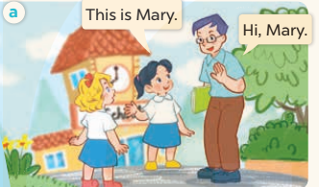  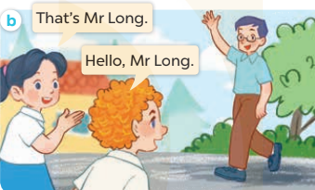  -Play the audio twice(sentence by sentence). Correct their pronunciation where necessary.  - Have Ss to practice the dialogue  -Tinvites a few pairs to the front of the class to practice.  - T checkspronunciation for ss.  Activity 32. Listen, point and say.  *Aims: Ss will be ableto correctly say the character names and use This is / That’s …….. to introduce someone.  *Procedure:  * Model sentences:  -T asks Ss look at picture a, b and helps Ss know the structure from the dialogue.  - T introduces new structure for Ss.  - T explains,models and gives meaning.  -Have Ss repeat the model sentences.  This is Mary.  That’s Mr Long.  *That’s = that is  *Drill pictures  - Elicit and check comprehension the name of each character.  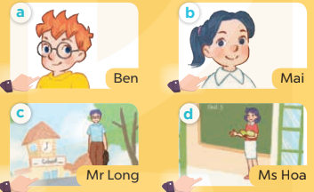  - Run through all the pictures.  - Run through model sentences.  - Have Ss to practise:  + T says the first picture  + Ss says the second picture  + Group A says the third picture  + Group B say the last picture.  - Ask Ss to work in pairs.  - T controls and corrects.  - Invite a few pairs to come to the front of the classroom,point at the relevant character in each picture, and act out his/her role.  - Encourage Ss to practise speaking English.  - T gives feedbacks.  Activity 4. Let’s talk.  *Aims: Ss will be able to enhance the correct use of This is / That’s ……... to introduce someone.  *Procedure:  - T asks ss to guess each character and what the children say.  + What can you see in the picture?  +Who are they?  +Where are they?  +What are they saying?  - T fills the gaps and writes the sentences on the board.  - T models  - T asks Ss to greet and introduce someone. (groups of four)  - Invite some groups to perform.  - Give feedbacks  *Consolidation  *Aims: Ss will be able consolidate and wrap up the content of the lesson.  *Procedure:  - T asks ss to answer the following questions:  + What have you learnt from the lesson today?  +What are the core values of the lesson? (if the teacher can take from the lesson).  - T review the vocabulary and model sentences.  - T praises some Ss who are hardworking / active/ good…. as well as encourage others to try more.  - Learn the vocabulary and model sentences by heart  - Prepare the new lesson: Unit 3, Lesson 1 (4,5,6). | -Ss sing and dance the song  - Ss open their books  -Ss listen and answer  - - Ss listen and repeat  + Choral repetition (3 times).  + Individual repetition (3 ss)  - Ss take note  - Ss look, remember and match  -Look at the pictures and get to know the characters in the pictures.  + In picture a: Mai says:This is Mary. And Mr Long says: Hi, Mary.  + In picture b: Mai says:That’s Mr Long. And Bill says:Hello, Mr Long.  -Ss listenand repeat in chorus (twice)  -Ss work in pairs to practice  -Ss practice the dialogue  -Ss listen  -Ss look at the picture and answer.  -Ss listen  -Ss listen and repeat  -Ss repeat to the introduce someone.  - Ss look, listen and answer  +Picture a: Ben, a British male pupil  + Picture b: Mai, a Vietnamese female pupil  + Picture c: Mr Long, a Vietnamese male teacher  + Picture d: Ms Hoa, a Vietnamese female teacher  -Ss listen and repeat  -Ss practice in chorus  -Ss work in pairs to practice  -Ss point and say  -Ss listen.  -Ss listen  -Ss look at the picture and answer  + Minh and Mai meet Bill and Mary in the school playground. Minh introduces Bill to Mai, then Minh introduces Mary to Mai. They greet and introduce themselves to each other.  -Ss note  - Ss say the completed sentences.  -Ss work in groups  -Ss perform in front of the class.  -Ss answer the questions  - Ss listen  -Ss listen and clap their hands  -Ss listen and take note

D. ADJUSTMENTS (if necessary):
………………………………………………………………………………………….…..……………………………………………………………………………...………………………………………….…..……………………………………………………………………………….……………………………………………………………………...

Week 5 Preparing date: October …..,
Period 18 Teaching date: October …..,

Unit 3: Our friends
Lesson 1 (4,5,6)
A. OBJECTIVES:
By the end of the lesson, Ss will be able to:
1. Knowledge:
- listen to and understand two communicative contexts in which pupils introduce someone and respond to the introduction.
- read and complete the sentences correctly.
- sing the song “This is Linh” with the correct pronunciation and melody.
- Vocabulary:Review
- Skills: speaking, listening, reading and writing.
2. Competences:
- Critical Thinking: self-introduce
-Co-operation: ready to help friends in pair work/ group work.
- Self-control and independent learning: perform listening tasks.
3. Attitude/ Qualities:
-Kindness:Help partners to complete learning tasks.
- Honesty: tell the truth about feelings and emotions.
- Diligence: complete learning tasks.
B. TEACHING AIDS:
- Teacher: Teacher’s guide Pages 23; audio Tracks 27; website sachmem.vn, posters, laptop, pictures, textbook, lesson plan, TV or projector.
- Students: Pupil’s book Page 23, notebooks, workbooks, school things.
C. PROCEDURES:
Stages/Time | Teacher’s activities | Students’ activities
1.Warm- up:  (5’)  2.Practice: (27’)  3. Homework. (3’) | Game: Sentence Puzzle  *Aims: to create a friendly and active atmosphere in the class to beginning the lesson.  *Procedure:  - Divide the class into groups of four.  - Give each group a sentence that is broken/cut into pieces.  - Ask them to arrange them to make a complete sentence, then read it aloud.  - The group that makes it first will be the winner.  - Say “Open your book page 11” and look at “Unit 3, Lesson 1 (4,5,6)”.  Activity 1. Listenand tick:  *Aims: Ss will be abletolisten to and understand two communicative contexts in which pupils introduce someone and respond to the introduction.  *Procedure:  - Elicit the names of the characters in the pictures.  - Point at the pictures respectively to explain the context.  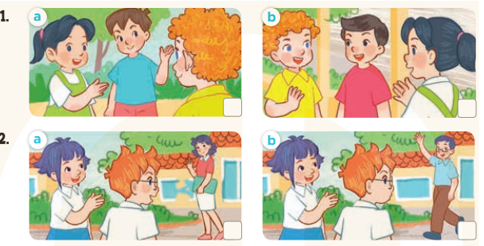  - T ask Ss to guess the answers.  + T writes Ss’guessing on the board.  - Listen to the tape:  + Play the recording  + Play the recording again and get Ss to swap books with their partners.  + Play the recording again to check answers together as a class.  + Write the answers on the board for Ss to correct their answers. Then checks Ss’ guessing.  - Play the recording, sentence by sentence, for the class to listen and repeat in chorus.  Key: 1.b 2.a  Activity 2.Look, complete and read.  *Aims: Ss will be ableto look, complete and read four target sentence patterns in two dialogues with the help of picture cues *Procedure:  - Get Ss to look at the pictures and identify the characters  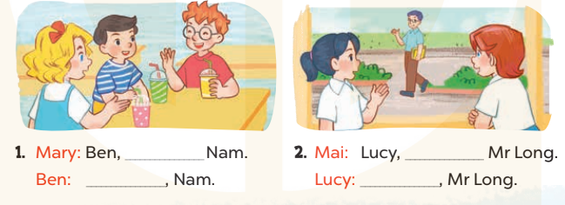  - Have Ss look at the two incomplete dialogue and elicits the missing words in the sentences.  - T models with picture 1  + Ask Ss what is missing in the sentence.  + Have Ss look at the picture and complete the gap, then read the completed sentence in chorus.  -Have Ss work in groups and complete the picture 2.  - Ask a few Ss to stand up and read the completed sentences aloud.  -T gives feedbacks.  Key:  1. this is – Hello / Hi  2. that’s – Hello  Activity 3. Let’s sing.  *Aims: Ss will be able to sing the song This is Linh with the correct pronunciation and melody.  *Procedure:  - Introducethe title and lyrics of the song:“This is Linh” song.  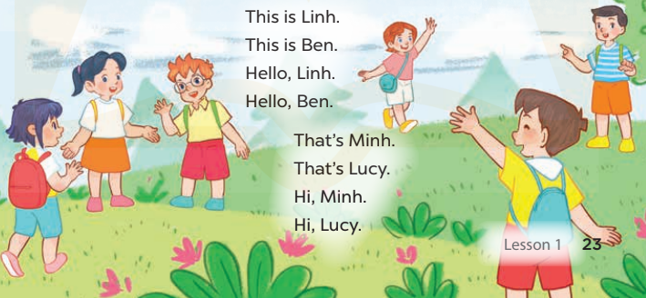  -Play the recording for Ss to listen to the whole song.  +Have them repeat the title and lyrics line by line.  +Tell Ss to point at the relevant character while singing his or her name.  - Play the recording all the way through for Ss to listen to pronunciation and melody of the song.  - Play the recording line by line for Ss to listen, repeat and point at the relevant character.  - Play the recording for Ss to sing and do actions.  - Ask Ss to practice singing and doing actions in pairs or groups.  -Invite groups to the front of the classroom to perform the song  -T gives feedback.  *Consolidation  *Aims: Ss will be able consolidate and wrap up the content of the lesson.  *Procedure:  - T asks ss to answer the following questions:  + What have you learnt from the lesson today?  +What are the core values of the lesson? (if the teacher can take from the lesson).  - T praises some Ss who are hardworking / active/ good…. as well as encourage others to try more.  - Practice part 5 again.  - Prepare the new lesson: Unit 3, Lesson 2 (1,2,3). | - Ss listen to the rule  - Ss play game  -Ss listen  - Ss open their books  -Look at the pictures and say:  + Picture 1a:Mai introduces Minh to Bill.  + Picture 1b:Mai introduces Nam to Bill.  + Picture 2a:Linh introduces Ms Hoa to Ben.  + Picture 2b:Linh introduces Mr Long to Ben.  -Ss guess the answers  - Ss listen to the tape and tick  - Ss listen again, tick and swap books with their partners.  - Ss check their answers and guessing  -Ss listen and repeat.  -Ss look at the picture and say:  + They’re Ben, Mary, Nam and Mai, Mr Long and Lucy.  -Ss look and answer  -Ss answer: This is Nam/ Hi, hello  -Ss look, complete and read the completed sentence in chorus.  -Ss complete the sentence  -Ss read aloud  -Ss look and listen.  -Ss listen to the song  -Ss listen and repeat line by line without the action.  -Ss point to the character while singing  -Ss listen to melody of the song  - Ss listen and sing line by line.  - Ss sing and do actions.  + Ss work in groups (two groups) to sing.  -Ss performin front of the class.  -Ss listen  -Ss answer the questions  -Ss listen and clap their hands  -Ss listen and take note

D. ADJUSTMENTS (if necessary):
………………………………………………………………………………………….…..……………………………………………………………………………...………………………………………….…..……………………………………………………………………………….……………………………………………………………………...

Week 5 Preparing date: October …..,
Period 19 Teaching date: October …..,

Unit 3: Our friends
Lesson 2 (1, 2, 3)
A. OBJECTIVES:
By the end of the lesson, Ss will be able to:
1. Knowledge:
-use the words this, that, it, yes, no, friend, teacher, Mr (Mr Long), Ms (Ms Hoa) in relation to the topic “Our friends”;
-use Is this / that ? – Yes, it is. / No, it isn’t. It’s….. to ask and answer questions about someone;
-ask and answer questions about someone in contexts.
- Vocabulary:yes, no, teacher friend
- Skills: speaking and listening
2. Competences:
- Critical Thinking: self-introduce
-Co-operation: ready to help friends in pair work/ group work.
- Sociability: Talk to each other, say good words to others.
3. Attitude/ Qualities:
-Kindness:Help partners to complete learning tasks.
- Honesty: tell the truth about feelings and emotions
B. TEACHING AIDS:
- Teacher: Teacher’s guide Pages 43, 44; audio Tracks 29,30, website sachmem.vn, posters, laptop, pictures, textbook, lesson plan, TV or projector.
- Students: Pupil’s book Page 24, notebooks, workbooks, school things.
C. PROCEDURES:
Stages/Time | Teacher’s activities | Students’ activities
1.Warm- up:  (3’)  2.Presentation  (16’)  3.Practice: (7’)  4.Production: (7’)  5. Homework. (2’) | Game: Roll the dice  *Aims: to create a friendly and active atmosphere in the class to beginning the lesson.  *Procedure:  - Divide the class into 2 teams.  - Each team choose a character on the slide (Nam or Mary) for their team.  - The 2 teams take turns to choose letters to go to the questions. For each correct answer, pupils can roll the dice and click the coloured stones to move their characters.  - The team who finishes first will be the winner.  - Say “Open your book page 24” and look at “Unit 3, Lesson 2 (1,2,3)”.  Activity 1. Vocabulary.  *Aims: Ss will be ableto know the vocabulary in front of starting the new lesson.  *Procedure:  -T elicits the new words  + friend : bạn bè  + teacher : giáo viên  + yes: vâng, có  + no : không  - T models (3 times).  - T writes the words on the board.  - Checking: What and where  Activity 2. Listen, point and repeat:  *Aims: Ss will be ableto understand and correctly repeat the sentences in two communicative contexts (pictures) focusing on asking and answering questions about someone.  *Procedure:  - Have Ss look at Pictures a and b and identify the characters in the pictures.  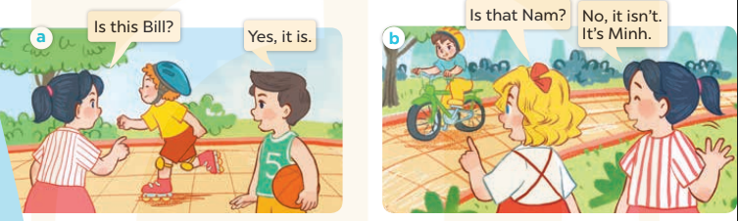  -Play the audio twice(sentence by sentence). Correct their pronunciation where necessary.  - Have Ss to practice the diaguage  -Tinvites a few pairs to the front of the class to practice.  - T checkspronunciation for ss.  Activity 3.Listen, point and say.  *Aims: Ss will be ableto correctly say the words and use Is this / that ……? and Yes, it is. / No, it isn’t. It’s…….. to ask and answer questions about the characters.  *Procedure:  * Model sentences:  - T asks Ss look at picture a, band helps Ss know the structure from the dialogue.  - T introduces new structure for Ss.  - T explains,models and gives meaning.  -Have Ss repeat the model sentences.  A: Is this Bill?  B: Yes, it is  A: Is that’s Nam?  B: No, it isn’t. It’s Minh.  *It’s = it is  *Drill pictures  - Elicit and check comprehension the name of each character.  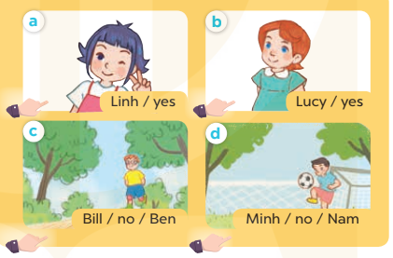  - Run through all the pictures.  - Run through model sentences.  + Run through the questions  + Run through the answers  - Have Ss to practise:  + T asks – Ss answer(change role).  + Ss – Ss (change role).  - Ask Ss to work in pairs.  - T controls and corrects.  - Invite a few pairs to come to the front of the classroom,point at the relevant character in each picture, and act out his/her role.  - Invite Ss to go to the board and role play. Encourage Ss to practise speaking English.  - T gives feedbacks.  Activity 4. Let’s talk.  *Aims: Ss will be able to enhance the correct use of Is this/ that…….? and Yes, it is. / No, it isn’t. It’s………. to ask and answer questions about someone  *Procedure:  - T asks ss to guess each character and what the children say.  + What can you see in the picture?  +Who are they?  +Where are they?  +What are they saying?  - T fills the gaps and writes the sentences on the board.  - T models  - T asks Ss use of Is this/ that…….?to ask , and answer (groups of four)  - Invite some groups to perform.  - Give feedbacks  *Consolidation  *Aims: Ss will be able consolidate and wrap up the content of the lesson.  *Procedure:  - T asks ss to answer the following questions:  + What have you learnt from the lesson today?  +What are the core values of the lesson? (if the teacher can take from the lesson).  - T review the vocabulary and model sentences.  - T praises some Ss who are hardworking / active/ good…. as well as encourage others to try more.  - Learn the vocabulary and model sentences by heart  - Prepare the new lesson: Unit 3, Lesson 2 (4,5,6). | - Ss listen  - Ss play the game  - Ss open their books  -Ss listen and answer  - - Ss listen and repeat  + Choral repetition (3 times).  + Individual repetition (3 ss)  - Ss take note  - Ss look, remember and slap  -Look at the pictures and get to know the characters in the pictures.  + In picture a: Mai asks:Is this Bill?And Nam answersYes, it is.  –In picture b: Mary asksIs that Nam?And Maianswers:No, it isn’t. It’s Minh  -Ss listen and repeat in chorus (twice)  -Ss work in pairs to practice  -Ss practice the diaguage  -Ss listen  -Ss look at the picture and answer.  -Ss listen  -Ss listen and repeat  -Ss repeat to the introduce someone  -Ss listen and answer  - Ss look, listen and repeat  - Ss practice in chorus  -Ss work in pairs to practice  -Ss listen  -Ss point and say  -Ss go to the board and rold play.  -Ss listen  -Ss look at the picture and answer  + A picture of Bill and Mai in the park. Bill asks Mai about Linh and Nam.  -Ss note  - Ss say the completed sentences.  -Ss work in groups  -Ss perform in front of the class.  -Ss answer the questions  - Ss listen  -Ss listen and clap their hands  -Ss listen and take note

D. ADJUSTMENTS (if necessary):
………………………………………………………………………………………….…..……………………………………………………………………………...………………………………………….…..……………………………………………………………………………….……………………………………………………………………...

Week 5 Preparing date: October …..,
Period 20 Teaching date: October …..,

Unit 3: Our friends
Lesson 2 (4,5,6)
A. OBJECTIVES:
By the end of the lesson, Ss will be able to:
1. Knowledge:
- listen to and understand communicative in contexts.
- look, complete and read the dialogues with the help of picture cues
- Vocabulary:Review
- Skills: speaking, listening, reading and writing.
2. Competences:
- Critical Thinking: self-introduce
-Co-operation: ready to help friends in pair work/ group work.
- Self-control and independent learning: perform listening tasks.
3. Attitude/ Qualities:
-Kindness:Help partners to complete learning tasks.
- Honesty: tell the truth about feelings and emotions.
- Diligence: complete learning tasks.
B. TEACHING AIDS:
- Teacher: Teacher’s guide Pages 45, 46; audio Tracks 31; website sachmem.vn, posters, laptop, pictures, textbook, lesson plan, TV or projector.
- Students: Pupil’s book Page 25, notebooks, workbooks, school things.
C. PROCEDURES:
Stages/Time | Teacher’s activities | Students’ activities
1.Warm- up:  (5’)  2.Practice: (27’)  3. Homework. (3’) | Sing a song: Hello  *Aims: to create a friendly and active atmosphere in the class to beginning the lesson.  *Procedure:  - Show the song on the screen.  https://www.youtube.com/watch?v=O13gITUS5t4  - Askpupils to listen, sing and dance the song.  - Say “Open your book page 13” and look at “Unit 3, Lesson 2 (4,5,6)”.  Activity 1. Listenand number:  *Aims: Ss will be abletolisten to and understand four communicative contexts in which pupils ask and answer questions about someone.  *Procedure:  - Elicit the names of the characters in the pictures.  - Point at the pictures respectively to explain the context.  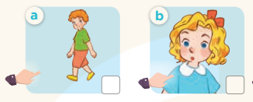  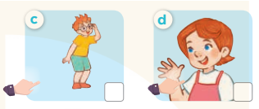  - T ask Ss to guess the answers.  + T writes Ss’guessing on the board.  - Listen to the tape:  + Play the recording  + Play the recording again and get Ss to swap books with their partners.  + Play the recording again to check answers together as a class.  + Write the answers on the board for Ss to correct their answers. Then checks Ss’ guessing.  - Play the recording, sentence by sentence, for the class to listen and repeat in chorus.  Key: 1. b 2. a 3. d 4. c  Activity 2.Look, complete and read  *Aims: Ss will be abletolook, complete and read four target sentence patterns in four dialogues with the help of picture cues.  *Procedure:  -Elicit the context and check comprehension  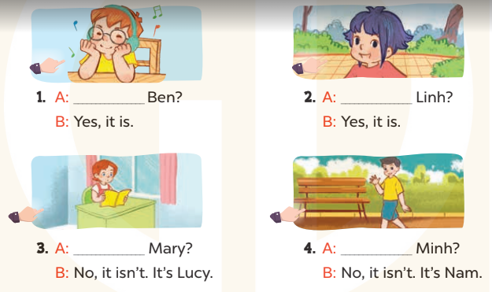  - Have Ss look at the four incomplete dialogue and elicits the missing words in the sentences.  - T models with picture 1  + Ask Ss what is missing in the sentence.  + Have Ss look at the picture and complete the gap, then read the completed sentence in chorus.  -Have Ss work in groups and complete the picture 2, 3 and 4.  - Ask a few Ss to stand up and read the completed sentences aloud.  -T gives feedbacks.  Key: 1. Is this 2. Is this 3. Is that 4. Is that  Activity 3. Let’s play.  *Aims: Ss will be able to recognise target words while looking at pictures of the characters and circle six names in a letter table and use them to ask and answer questions.  *Procedure:  - Tell pupils to work in pairs.  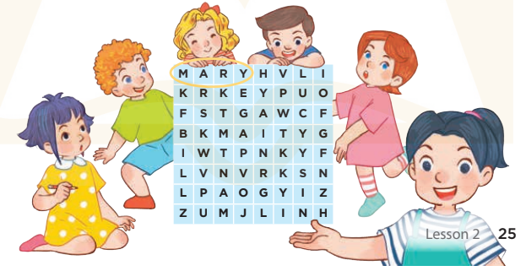  - Model the activity by identifying the picture of Mary first, draw Ss' attention to the word Mary in the table.  - Point to the picture of Mary and ask: “Is this Mary?” Ask a ss to answer the question: “Yes, it is.”  - Have pupils play the game. Explain that after identifying six characters in the pictures and circling  - Give Ss time to play the game.  - Invite a few pairs to perform the game in front of the class.  - Give feedbacks  Key:  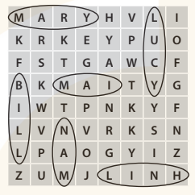  *Consolidation  *Aims: Ss will be able consolidate and wrap up the content of the lesson.  *Procedure:  - T asks ss to answer the following questions:  + What have you learnt from the lesson today?  +What are the core values of the lesson? (if the teacher can take from the lesson).  - T praises some Ss who are hardworking / active/ good…. as well as encourage others to try more.  - Practice part 5 again.  - Prepare the new lesson: Unit 3, Lesson 3 (1,2,3). | - Sing and dance the song in chorus.  - Ss open their books  -Look at the pictures and say:  + Picture a:Bill  + Picture b:Mary  + Picture c:Ben  + Picture d:Lucy  -Ss guess the answers  - Ss listen to the tape and write number  - Ss listen again, write number and swap books with their partners.  - Ss check their answers and guessing  -Ss listen and repeat.  -Ss look and answer  -Ss answer: Is this Ben?  -Ss look, complete and read the completed sentence in chorus.  -Ss complete the sentence  -Ss read aloud  - Ss listen  -Ss play game  -Ss answer the questions  - Ss listen  -Ss listen and clap their hands  -Ss listen

D. ADJUSTMENTS (if necessary):
………………………………………………………………………………………….…..……………………………………………………………………………...………………………………………….…..………………………………………………………….

