Week 8 Preparing date: October …..,
Period 29 Teaching date: October …..,

Unit 5: My hobbies
Lesson 1 (1, 2, 3)
A. OBJECTIVES:
By the end of the lesson, Ss will be able to:
1. Knowledge:
- understand and correctly repeat the sentences in two communicative contexts (pictures) focusing on asking and answering about hobbies.
- correctly say the words and use: What’s your hobby? – It’s ……... to ask and answer about hobbies.
- Vocabulary:sing, dance, draw, swim, hobby.
- Skills: speaking and listening
2. Competences:
- Critical Thinking: self-introduce
-Co-operation: ready to help friends in pair work/ group work.
- Sociability: Talk to each other, say good words to others.
3. Attitude/ Qualities:
-Kindness:Help partners to complete learning tasks.
- Honesty: tell the truth about feelings and emotions
B. TEACHING AIDS:
- Teacher: Teacher’s guide Pages 62, 63, 64, audio Tracks 45,46, website sachmem.vn, posters, laptop, pictures, textbook, lesson plan, TV or projector.
- Students:Pupil’s book Page 34, notebooks, workbooks, school things.
C. PROCEDURES:
Stages/Time | Teacher’s activities | Students’ activities
1.Warm- up:  (3’)  2.Presentation  (16’)  3.Practice: (7’)  4.Production: (7’)  5. Homework. (2’) | Sing: The hobby song  *Aims: to create a friendly and active atmosphere in the class to beginning the lesson.  *Procedure:  - Show the song on the screen.  https://www.youtube.com/watch?v=90LfcLAjLiI  - Ask Ss to listen, sing and dance the song.  - Say “Open your book page 34” and look at “Unit 5, Lesson 1 (1,2,3)”.  Activity 1. Vocabulary.  *Aims: Ss will be ableto know the vocabulary in front of starting the new lesson.  *Procedure:  -T elicitsthe new words  +sing-singing: hát (mime)  +draw-drawing: vẽ (mime)  + dance-dancing:nhảy/ múa(mime)  + swim- swimming :bơi (mime)  + hobby : sở thích (translation)  - T models (3 times).  - T writes the words on the board.  - Checking: Matching  Activity 2. Look, listen and repeat:  *Aims: Ss will be ableto understand and correctly repeat the sentences in two communicative contexts (pictures) focusing on asking and answering about hobbies.  *Procedure:  - Have Ss look at Pictures a and b and identify the characters in the pictures.  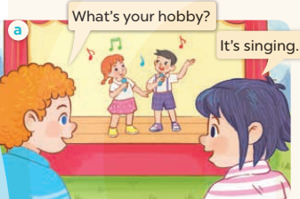  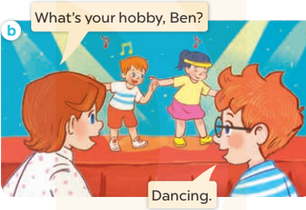  -Play the audio twice(sentence by sentence). Correct their pronunciation where necessary.  - Have Ss to practice the dialogue  -Tinvites a few pairs to the front of the class to practice.  - T checkspronunciation for ss.  Activity 32. Listen, point and say.  *Aims: Ss will be ableto correctly say the words and use: What's your hobby? - It's…… to ask and answer about hobbies.  *Procedure:  * Model sentences:  -T asks Ss look at picture aand helps Ss know the structure from the dialogue.  - T introduces new structure for Ss.  - T explains,models and gives meaning.  -Have Ss repeat the model sentences.  A: What’s your hobby?  B: It’s singing.  *Drill pictures  - Elicit and check comprehension the name of each character.  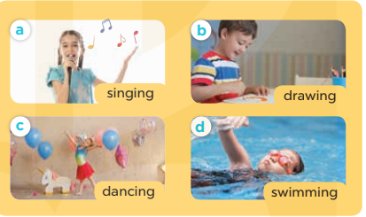  - Run through all the pictures.  - Run through model sentences.  - Have Ss to practise:  + T asks, Ss answer picture a  +Ss ask, T answers picture b  + Group A ask, group B answer picture c  + Group B ask, group A answer picture d  - Ask Ss to work in pairs.  - T controls and corrects.  - Invite a few pairs to come to the front of the classroom and point at the pictures and say the questions and answers in front of the class.  - T gives feedbacks.  Activity 4. Let’s talk.  *Aims: Ss will be able to enhance the correct use of What's your hobby? – It's …... to ask and answer questions about someone's hobby.  *Procedure:  - T asks ss to guess each character and what the children say.  + What can you see in the picture?  +Who are they?  +Where are they?  +What are they saying?  - T fills the gaps and writes the sentences on the board.  - T models  - T asks Ss to ask and answer questions using What's your hobby? –It's ………...  - Invite some pairs to perform.  - Give feedbacks  *Consolidation  *Aims: Ss will be able consolidate and wrap up the content of the lesson.  *Procedure:  - T asks ss to answer the following questions:  + What have you learnt from the lesson today?  +What are the core values of the lesson? (if the teacher can take from the lesson).  - T review the vocabulary and model sentences.  - T praises some Ss who are hardworking / active/ good…. as well as encourage others to try more.  - Learn the vocabulary and model sentences by heart  - Prepare the new lesson: Unit 5, Lesson 1 (4,5,6). | -Ss sing and dance the song  - Ss open their books  -Ss listen and answer  - - Ss listen and repeat  + Choral repetition (3 times).  + Individual repetition (3 ss)  - Ss take note  - Ss look, remember and match  -Look at the pictures and get to know the characters in the pictures.  + In picture a: Bill points to the activity on the stage and asks Linh: What’s your hobby? Linh says: It’s singing.  + In picture b: Lucy points to the activity on the stage and asks Ben: What’s your hobby, Ben? Ben says: Dancing.  -Ss listenand repeat in chorus (twice)  -Ss work in pairs to practice  -Ss practice the dialogue  -Ss listen  -Ss look at the picture and answer.  -Ss listen  -Ss listen and repeat  -Ss repeat to the hobbies.  - Ss look, listen and answer  +Picture a: a girl singing  + Picture b: a boy drawing  + Picture c: a girl dancing  + Picture d: a boy swimming  -Ss listen and repeat  -Ss practice in chorus  -Ss work in pairs to practice  -Ss point and say  -Ss listen.  -Ss look at the picture and answer  + They are on the beach/ by the sea  + A boy and a girl are drawing  + Three boys are swimming  -Ss note  - Ss say the completed sentences.  -Ss work in pairs  -Ss perform in front of the class.  -Ss answer the questions  - Ss listen  -Ss listen and clap their hands  -Ss listen and take note

D. ADJUSTMENTS (if necessary):
………………………………………………………………………………………….…..……………………………………………………………………………...………………………………………….…..……………………………………………………………………………….……………………………………………………………………...

Week 8 Preparing date: October …..,
Period 30 Teaching date: October …..,

Unit 5: My hobbies
Lesson 1 (4,5,6)
A. OBJECTIVES:
By the end of the lesson, Ss will be able to:
1. Knowledge:
- listen to and understand four communicative contexts in which pupils ask and answer questions about hobbies.
- read and match the target sentence patterns with pictures.
- review vocabulary related to the topic "Hobbies" by playing the game Find the hobby.
- Vocabulary:Review
- Skills: speaking, listening, reading and writing.
2. Competences:
- Critical Thinking: self-introduce
-Co-operation: ready to help friends in pair work/ group work.
- Self-control and independent learning: perform listening tasks.
3. Attitude/ Qualities:
-Kindness:Help partners to complete learning tasks.
- Honesty: tell the truth about feelings and emotions.
- Diligence: complete learning tasks.
B. TEACHING AIDS:
- Teacher: Teacher’s guide Pages 64, 65; audio Tracks 47; website sachmem.vn, posters, laptop, pictures, textbook, lesson plan, TV or projector.
- Students: Pupil’s book Page 35, notebooks, workbooks, school things.
C. PROCEDURES:
Stages/Time | Teacher’s activities | Students’ activities
1.Warm- up:  (5’)  2.Practice: (27’)  3. Homework. (3’) | Game: Matching game  *Aims: to create a friendly and active atmosphere in the class to beginning the lesson.  *Procedure:  - Write 4 new words on the board and asks Ss to read (whole class).  - Ask 4 Ss to come to the board and write their hobbies in the pieces of paper and keep them in secret.  - Ask 1 Ss to come to the board and guess their hobbies written in the paper (He has to write the answers in the small pieces of paper and stick to each 4 Ss.  - Ask the Ss on the board to ask the question to find out the answers and give him or her point if correct (repeat the activities depending the time).  - Say “Open your book page 35” and look at “Unit 5, Lesson 1 (4,5,6)”.  Activity 1. Listenand number:  *Aims: Ss will be abletolisten to and understand four communicative contexts in which pupils ask and answer questions about hobbies *Procedure:  - Elicit the names of the characters in the pictures.  - Point at the pictures respectively to explain the context.  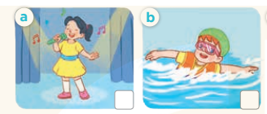  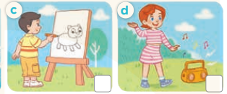  - T ask Ss to guess the answers.  + T writes Ss’guessing on the board.  - Listen to the tape:  + Play the recording  + Play the recording again and get Ss to swap books with their partners.  + Play the recording again to check answers together as a class.  + Write the answers on the board for Ss to correct their answers. Then checks Ss’ guessing.  - Play the recording, sentence by sentence, for the class to listen and repeat in chorus.  Key: 1. d 2. c 3. b 4. a  Activity 2.Read and match  *Aims: Ss will be ableto read and match the target sentence patterns with pictures.  *Procedure:  - Get Ss to look at the pictures and identify the characters’ hobbies.  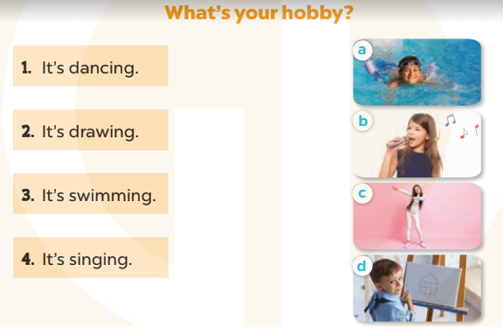  - Have Ss look atthe four sentences and the pictures. Elicit with picture 1  + Ask Ss to read the sentence 1 in chorus.  + Draw a line to match it with the picture of the girl dancing.  -Have Ss work in pairs and match sentences 2, 3, 4.  - Ask a few Ss to stand up and read the sentences aloud.  -T gives feedbacks.  Key:  1. c 2. d 3. a 4. b  Activity 3. Let’s play  *Aims: Ss will be able toreview vocabulary related to the topic "Hobbies" by playing the game Find the hobby.  *Procedure:  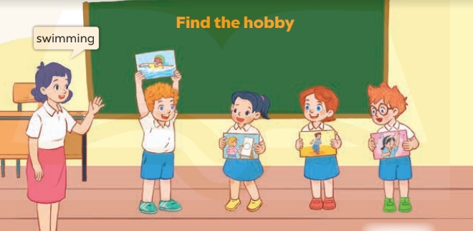  - Tell Ss the goal of the game and how to play it. Four Ss hold different flash cards  - Invite four Ss to the front of the class to demonstrate how to play the game.  - Tshouts out "swimming", the Ss with the swimming flash card steps up and shows his / her flash card to the whole class.  - Repeat the procedure with other flash cards. If a Ss fails to show up his / her flashcard or shows up the wrong flash card, he / she is "out" of the game.  *Consolidation  *Aims: Ss will be able consolidate and wrap up the content of the lesson.  *Procedure:  - T asks ss to answer the following questions:  + What have you learnt from the lesson today?  +What are the core values of the lesson? (if the teacher can take from the lesson).  - T praises some Ss who are hardworking / active/ good…. as well as encourage others to try more.  - Practice part 5 again.  - Prepare the new lesson: Unit 5, Lesson 2 (1,2,3). | - Ss read the words  - Ss play game  -Ss play game  - Ss open their books  -Look at the pictures and say:  + Picture a:a girl singing.+ Picture b:a boy swimming.+ Picture c:a boy drawing.  + Picture d:a girl dancing.  -Ss guess the answers  - Ss listen to the tape and write the number  - Ss listen again, write number and swap books with their partners.  - Ss check their answers and guessing  -Ss listen and repeat.  -Ss look at the picture and say  -Ss look and answer  -Ss match  -Ss work in pairs and match  -Ss read aloud  -Ss hold the flash cards  (flash card 1: swimming, flash card 2: drawing; flash card 3: dancing; flash card 4:singing).  -Ss play game  -Ss listen and play game  -Ss answer the questions  -Ss listen and clap their hands  -Ss listen and take note
D. ADJUSTMENTS (if necessary):
………………………………………………………………………………………….…..……………………………………………………………………………...………………………………………….…..……………………………………………………………………………….……………………………………………………………………...
Week 8 Preparing date: October …..,
Period 31 Teaching date: October …..,

Unit 5: My hobbies
Lesson 2 (1, 2, 3)
A. OBJECTIVES:
By the end of the lesson, Ss will be able to:
1. Knowledge:
-understand and correctly repeat the sentences in two communicative contexts (pictures) focusing on asking and answering about hobbies.
- correctly say the words and use What's your hobby? – I like………… to ask and answer questions about someone's hobby.
- enhance the correct use of What's your hobby? – I like ………... to ask and answer questions about someone's hobby.
- Vocabulary:run, paint, walk, cook, like
- Skills: speaking and listening
2. Competences:
- Critical Thinking: self-introduce
-Co-operation: ready to help friends in pair work/ group work.
- Sociability: Talk to each other, say good words to others.
3. Attitude/ Qualities:
-Kindness:Help partners to complete learning tasks.
- Honesty: tell the truth about feelings and emotions
B. TEACHING AIDS:
- Teacher: Teacher’s guide Pages 43, 44; audio Tracks 48, 49, website sachmem.vn, posters, laptop, pictures, textbook, lesson plan, TV or projector.
- Students: Pupil’s book Page 36, notebooks, workbooks, school things.
C. PROCEDURES:
Stages/Time | Teacher’s activities | Students’ activities
1.Warm- up:  (3’)  2.Presentation  (16’)  3.Practice: (7’)  4.Production: (7’)  5. Homework. (2’) | Game: Guessing and Choosing  *Aims: to create a friendly and active atmosphere in the class to beginning the lesson.  *Procedure:  - T shows 4 pictures of hobbies and calls 4 Ss to come to the board and choose.  - T asks 4 Ss to come to the board and choose 1 picture of hobby and keep them in secret by covering them.  - The others will write their hobbies in the board at their desks and keep their ides in secret.  - The Ss on the board will 1 by 1 show their pictures they chose.  - When the teacher says the word of the pictures 1 by 1 shown on the board, who has the same hobby will raise their board or raise their hands.  - The Ss on the board will get the same points as the numbers of Ss raising their hands.  - Say “Open your book page 36” and look at “Unit 5, Lesson 2 (1,2,3)”.  Activity 1. Vocabulary.  *Aims: Ss will be ableto know the vocabulary in front of starting the new lesson.  *Procedure:  -T elicits the new words  + run- running : chạy (mime)  + paint- painting: tô màu (mime)  + walk- walking : đi bộ (mime)  + cook- cooking : nấu ăn (mine)  + like : thích (situation)  - T models (3 times).  - T writes the words on the board.  - Checking: What and where  Activity 2. Look, listen and repeat:  *Aims: Ss will be abletounderstand and correctly repeat the sentences in two communicative contexts (pictures) focusing on asking and answering about hobbies.  *Procedure:  - Have Ss look at Pictures a and b and identify the characters in the pictures.  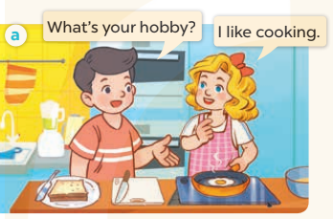  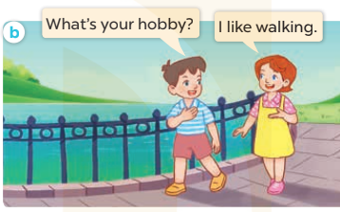  -Play the audio twice(sentence by sentence). Correct their pronunciation where necessary.  - Have Ss to practice the diaguage  -Tinvites a few pairs to the front of the class to practice.  - T checkspronunciation for ss.  Activity 3.Listen, point and say.  *Aims: Ss will be ableto correctly say the words and use What's your hobby? – I like ……. to ask and answer questions about someone's hobby.  *Procedure:  * Model sentences:  - T asks Ss look at picture aand helps Ss know the structure from the dialogue.  - T introduces new structure for Ss.  - T explains,models and gives meaning.  -Have Ss repeat the model sentences.  A: What’s your hobby?  B: I like cooking  *Drill pictures  - Have Ss look at the pictures and elicit the names of the hobbies.  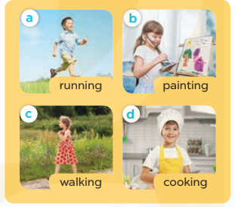  - Run through all the pictures.  - Run through model sentences.  + Run through the questions  + Run through the answers  - Have Ss to practise:  + T asks – Ss answer(change role).  + Ss – Ss (change role).  - Ask Ss to work in pairs.  - T controls and corrects.  - Invite a few pairs to come to the front of the classroom,point at the pictures and say the questions and answers in front of the class.  - T gives feedbacks.  Activity 4. Let’s talk.  *Aims: Ss will be able to enhance the correct use of What's your hobby? –I like…….to ask and answer questions about someone's hobby.  *Procedure:  - T asks ss to guess each character and what the children say.  + What can you see in the picture?  +Who are they?  +Where are they?  +What are they doing?  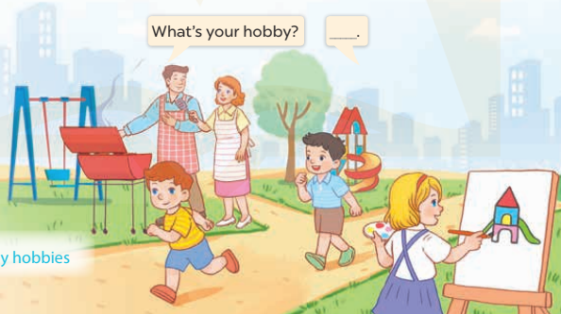  - Put Ss into pairs and encourage them to ask and answer questions using What’s your hobby? I like….  - Invite some pairs to stand up to perform their exchanges.  *Consolidation  *Aims: Ss will be able consolidate and wrap up the content of the lesson.  *Procedure:  - T asks ss to answer the following questions:  + What have you learnt from the lesson today?  +What are the core values of the lesson? (if the teacher can take from the lesson).  - T review the vocabulary and model sentences.  - T praises some Ss who are hardworking / active/ good…. as well as encourage others to try more.  - Learn the vocabulary and model sentences by heart  - Prepare the new lesson: Unit 5, Lesson 2 (4,5,6). | - Ss listen  - Ss play the game  -Ss play game  - Ss open their books  -Ss listen and answer  - - Ss listen and repeat  + Choral repetition (3 times).  + Individual repetition (3 ss)  - Ss take note  - Ss look, remember and slap  -Look at the pictures and get to know the characters in the pictures.  + In picture a: Nam asks:What's your hobby? And Mary answersI like cooking.  –In picture b: Minh asksWhat's your hobby? And Lucyanswers:I like walking  -Ss listen and repeat in chorus (twice)  -Ss work in pairs to practice  -Ss practice the diaguage  -Ss listen  -Ss look at the picture and answer.  -Ss listen  -Ss listen and repeat  -Ss repeat to the hobbies  -Ss listen and answer  +Picture a: a boy running  +Picture b. a girl painting  +Picture c. a girl walking  +Picture d. a boy cooking  - Ss look, listen and repeat  - Ss practice in chorus  -Ss work in pairs to practice  -Ss listen  -Ss go to the board and point and say  -Ss listen  -Ss look at the picture and answer  + There are several people doing different activities in the park.  -Ss work in pairs  -Ss ask and answer  -Ss answer the questions  - Ss listen  -Ss listen and clap their hands  -Ss listen and take note

D. ADJUSTMENTS (if necessary):
………………………………………………………………………………………….…..……………………………………………………………………………...………………………………………….…..……………………………………………………………………………….……………………………………………………………………...

Week 8 Preparing date: October …..,
Period 32 Teaching date: October …..,

Unit 5: My hobbies
Lesson 2 (4,5,6)
A. OBJECTIVES:
By the end of the lesson, Ss will be able to:
1. Knowledge:
- listen to and understand two communicative contexts in which pupils discuss different hobbies.
- complete four target sentences with the help of picture cues.
- sing the song My hobby with the correct pronunciation and melody
- Vocabulary:Review
- Skills: speaking, listening, reading and writing.
2. Competences:
- Critical Thinking: self-introduce
-Co-operation: ready to help friends in pair work/ group work.
- Self-control and independent learning: perform listening tasks.
3. Attitude/ Qualities:
-Kindness:Help partners to complete learning tasks.
- Honesty: tell the truth about feelings and emotions.
- Diligence: complete learning tasks.
B. TEACHING AIDS:
- Teacher: Teacher’s guide Pages 58, 59; audio Tracks 50, 51; website sachmem.vn, posters, laptop, pictures, textbook, lesson plan, TV or projector.
- Students: Pupil’s book Page 37, notebooks, workbooks, school things.
C. PROCEDURES:
Stages/Time | Teacher’s activities | Students’ activities
1.Warm- up:  (5’)  2.Practice: (27’)  3. Homework. (3’) | Sing a song: Slap the board  *Aims: to create a friendly and active atmosphere in the class to beginning the lesson.  *Procedure:  - Divide class into two teams. Have them stand in two lines.  - Place some cards on the board.  - Have four students come to the board to face off.  - Call out a word, ex:cooking, and have Ss run to the board then slap the picture and repeat the word.  - The winner is the student who  slaps the picture at first.  - Say “Open your book page 13” and look at “Unit 5, Lesson 2 (4,5,6)”.  Activity 1. Listenand tick:  *Aims: Ss will be abletolisten to and understand two communicative contexts in which pupils discuss different hobbies.  *Procedure:  - Elicit the hobby in each picture.  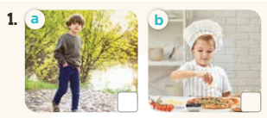  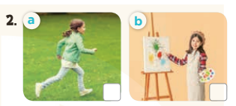  - T ask Ss to guess the answers.  + T writes Ss’guessing on the board.  - Listen to the tape:  + Play the recording  + Play the recording again and get Ss to swap books with their partners.  + Play the recording again to check answers together as a class.  + Write the answers on the board for Ss to correct their answers. Then checks Ss’ guessing.  - Play the recording, sentence by sentence, for the class to listen and repeat in chorus.  Key: 1. b 2. b  Activity 2.Look, complete and read  *Aims: Ss will be abletocomplete four target sentences with the help of picture cues.  *Procedure:  -Have Ss look at the pictures and identify the hobbies in the pictures.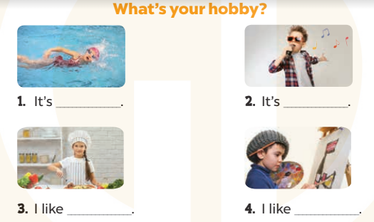  - Have Ss look at the four incomplete sentences and elicits the missing words in the sentences.  - T models with picture 1  + Ask Ss what is missing in the sentence.  + Have Ss look at the picture and complete the gap, then read the completed sentence in chorus.  -Have Ss work in groups and complete the picture 2, 3 and 4.  - Ask a few Ss to stand up and read the completed sentences aloud.  -T gives feedbacks.  Key: 1. swimming 2. singing  3. cooking 4. painting  Activity 3. Let’s sing.  *Aims: Ss will be able to sing the song My hobby with the correct pronunciation and melody.  *Procedure:  - Introducethe title and lyrics of the song:“My hobby”  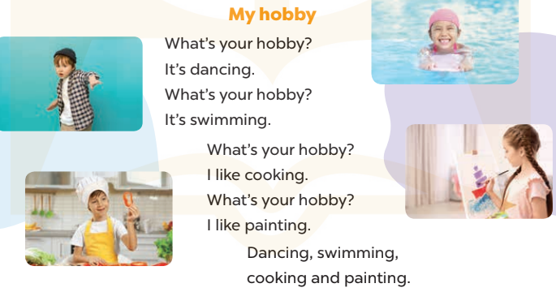  -Play the recording for Ss to listen to the whole song.  +Have them repeat the title and lyrics line by line.  +Tell Ss to point at the pictures while singing.  - Play the recording all the way through for Ss to listen to pronunciation and melody of the song.  - Play the recording line by line for Ss to listen, repeat and point to the pictures  - Play the recording for Ss to sing and do actions.  - Ask Ss to practice singing and doing actions in pairs or groups.  -Invite groups to the front of the classroom to perform the song  -T gives feedback.  *Consolidation  *Aims: Ss will be able consolidate and wrap up the content of the lesson.  *Procedure:  - T asks ss to answer the following questions:  + What have you learnt from the lesson today?  +What are the core values of the lesson? (if the teacher can take from the lesson).  - T praises some Ss who are hardworking / active/ good…. as well as encourage others to try more.  - Practice part 5 again.  - Prepare the new lesson: Unit 5, Lesson 3 (1,2,3). | - Ss listen  - Ss play game  - Ss open their books  -Look at the pictures and say:  + Picture 1a. a boy walking + Picture 1b. a boy cooking  + Picture 2a. a girl running + Picture 2b. a girl painting  -Ss guess the answers  - Ss listen to the tape and tick  - Ss listen again, tick and swap books with their partners.  - Ss check their answers and guessing  -Ss listen and repeat.  -Ss look at the picture and say  -Ss answer: It’s….  I like………  -Ss look, complete and read the completed sentence in chorus.  -Ss complete the sentence  -Ss read aloud  - Ss listen  -Ss listen to the song  -Ss listen and repeat line by line without the action.  -Ss point to the pictures while singing  -Ss listen to melody of the song  - Ss listen and sing line by line.  - Ss sing and do actions.  + Ss work in groups (two groups) to sing.  -Ss performin front of the class.  -Ss listen  -Ss answer the questions  - Ss listen  -Ss listen and clap their hands  -Ss listen

D. ADJUSTMENTS (if necessary):
………………………………………………………………………………………….…..……………………………………………………………………………...………………………………………….…..………………………………………………………….

