Week 10 Preparing date: November …….,
Period 37 Teaching date: November ………,

Fun time 1
A. OBJECTIVES:
By the end of the lesson, Ss will be able to:
1. Knowledge:
- take part in three fun activities relating to their language knowledge and competences.
- Vocabulary:Review
- Skills: speaking,writing and listening
2. Competences:
-Co-operation: ready to help friends in pair work/ group work.
- Sociability: Talk to each other, say good words to others.
3. Attitude/ Qualities:
-Kindness:Help partners to complete learning tasks.
- Honesty: tell the truth about feelings and emotions
B. TEACHING AIDS:
- Teacher: Teacher’s guide Pages 76, 77, 78; website sachmem.vn, posters, laptop, pictures, textbook, lesson plan, TV or projector.
- Students: Pupil’s book Page 42, 43, notebooks, workbooks, school things.
C. PROCEDURES:
Stages/Time | Teacher’s activities | Students’ activities
1.Warm- up:  (3’)  2.Practice  (30’)  3. Homework. (2’) | Sing: Head, shoulders, knees and toes  *Aims: to create a friendly and active atmosphere in the class to beginning the lesson.  *Procedure:  - Show the song on the screen.  https://www.youtube.com/watch?v=WX8HmogNyCY  - Ask Ss to listen, sing and dance the song.  - Say “Open your book page 42, 43” and look at “Fun time”.  Activity 1. Find, circle and match:  *Aims: Ss will be abletorevise learnt vocabulary by doing the word search.  *Procedure:  - Have Ss look at the pictures and ask +What’s this?  + What do you see in the pictures?  - Write the words or stick the flash cards of the words, one by one, on the board.  - Point at each word on the board and have Ss say the word as a class.  - Point at the picture of an ear, and match the word “ear” that has been circled as an example.  - Tell Ss to find the rest of the words in the word search.  - Have Ss match the words in the word search with the pictures.  - Have Ss check and correct their answers in pairs  - Have Ss work in pairs, one points at the pictures and the other points at the circled words in the word search and say them aloud.  Key:  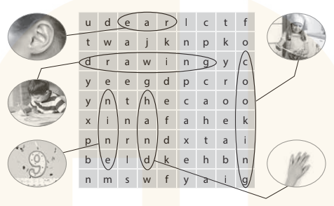  Activity 2.Quiz time  *Aims: Ss will be abletorevise vocabulary and sentence patterns learnt in Units 1–5.  *Procedure:  - Put Ss into two teams, Team 1 and Team 2.  - Have one representative of each team stand next to their boxes, Box 1 and Box 2.  - Explain the rules: Two quiz masters will read different dialogues for each pair of Ss.  Example:  Quiz master 1 (showing a flash card): What’s this?  Quiz master 2: It’s a hand.  - After listening to the dialogue, each representative has to find the right flash card and put it in their team’s box.  - The quicker representative earns one point for his / her team. Then, other pairs take turns to compete. The quiz continues until the end of the time limit (5 – 10 dialogues are recommended).  - The team with most points wins.  Activity 3. Look and match  *Aims: Ss will be able to learn the five senses and how they relate to our bodies.  *Procedure:  - T elicits the names of the body parts: eye, ear,nose, hand, mouth.  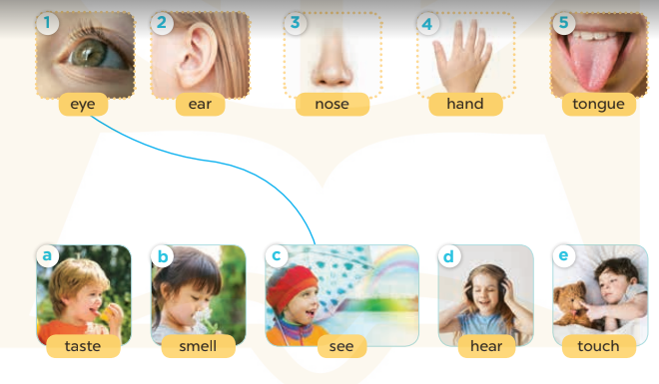  - Point to your eyes and ask Ss what they do with their eyes  - Write see on the board and model it  for Ss to repeat.  - Have Ss complete the activity by drawing lines to match the body parts to the senses.  - Check answers together as a class.  Key: 1-c 2-d 3-b 4-e 5-a  *Consolidation  *Aims: Ss will be able consolidate and wrap up the content of the lesson.  *Procedure:  - T asks ss to answer the following questions:  + What have you learnt from the lesson today?  +What are the core values of the lesson? (if the teacher can take from the lesson).  - T praises some Ss who are hardworking / active/ good…. as well as encourage others to try more.  - Prepare the new lesson: Unit 6, Lesson 1 (1,2,3). | - Ss listen  - Ss sing a song  -Ss look at the picture and answer  - - Ss note  - Ss say the word  - Ss look and match  -Ss find the words  -SS match the words with pictures  -Ss check their answer  -Ss say aloud  -Ss listen  -Ss listen and play game  -Ss play game  - Ss look, listen and answer  - Ss answer  -Ss listen and repeat  -Ss work in pairs to practice  -Ss check their answer.  -Ss answer the questions  -Ss listen and clap their hands  -Ss listen and take note

D. ADJUSTMENTS (if necessary):
………………………………………………………………………………………….…..……………………………………………………………………………...………………………………………….…..……………………………………………………………………………….……………………………………………………………………...

Week 10 Preparing date: November …..,
Period 38 Teaching date: November …..,

Unit 6: Our school
Lesson 1 (1, 2, 3)
A. OBJECTIVES:
By the end of the lesson, Ss will be able to:
1. Knowledge:
- use the words school, classroom, library, playground in the sentence pattern: Is this our ……………? – Yes, it is. / No, it isn’t.
- use Is this our………… ? – Yes, it is. / No, it isn’t. to ask and answer questions about their school.
- Vocabulary:school, classroom, library, playground
- Skills: speaking and listening
2. Competences:
-Co-operation: ready to help friends in pair work/ group work.
- Sociability: Talk to each other, say good words to others.
3. Attitude/ Qualities:
-Kindness:Help partners to complete learning tasks.
- Honesty: tell the truth about feelings and emotions
B. TEACHING AIDS:
- Teacher: Teacher’s guide Pages 79, 80, 81, audio Tracks 57,58, website sachmem.vn, posters, laptop, pictures, textbook, lesson plan, TV or projector.
- Students:Pupil’s book Page 44, notebooks, workbooks, school things.
C. PROCEDURES:
Stages/Time | Teacher’s activities | Students’ activities
1.Warm- up:  (3’)  2.Presentation  (16’)  3.Practice: (7’)  4.Production: (7’)  5. Homework. (2’) | Sing:Jigsaw puzzle  *Aims: to create a friendly and active atmosphere in the class to beginning the lesson.  *Procedure:  - Divide class into 4 groups: Tom, Jerry, Miu and Chit.  - Ask Ss look at the pieces of picture.    - Ask Ss go to the board and jigsaw puzzle into the correct picture.  -T checks who’s the winner?  - Say “Open your book page 44” and look at “Unit 6, Lesson 1 (1,2,3)”.  Activity 1. Vocabulary.  *Aims: Ss will be ableto know the vocabulary in front of starting the new lesson.  *Procedure:  -T elicitsthe new words  +school: trường học (picture)  +library: thư viện(picture)  + classroom:phòng học (picture)  + playground :sân chơi (picture)  - T models (3 times).  - T writes the words on the board.  - Checking: Matching  Activity 2. Look, listen and repeat:  *Aims: Ss will be ableto understand and correctly repeat the sentences in two communicative contexts (pictures) to ask and answer questions about their school.  *Procedure:  - Have Ss look at Pictures a and b and identify names of the speakers in the pictures.  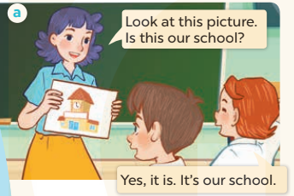  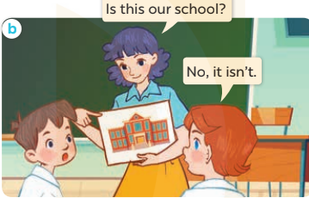  -Play the audio twice(sentence by sentence). Correct their pronunciation where necessary.  - Have Ss to practice the dialogue  -Tinvites a few pairs to the front of the class to practice.  - T checkspronunciation for ss.  Activity 3Listen, point and say.  *Aims: Ss will be ableto correctly say the words and use Is this our …….? – Yes, it is. / No, it isn't. to ask and answer questions about their school.  *Procedure:  * Model sentences:  -T asks Ss look at picture aand helps Ss know the structure from the dialogue.  - T introduces new structure for Ss.  - T explains,models and gives meaning.  -Have Ss repeat the model sentences.  A: Is this our school?  B: Yes, it is. / No, it isn't.  *Drill pictures  - Elicit and check comprehension the places of school  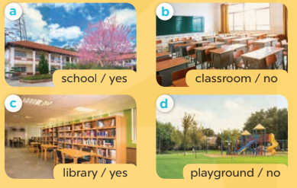  - Run through all the pictures.  - Run through model sentences.  +Run through the question sentences  +Run through the answer sentences  - Have Ss to practise:  + T asks, Ss answer picture a  +Ss ask, T answers picture b  + Group A ask, group B answer picture c  + Group B ask, group A answer picture d  - Ask Ss to work in pairs.  - T controls and corrects.  - Invite a few pairs to come to the front of the classroom and point at the pictures and say the questions and answers in front of the class.  - T gives feedbacks.  Activity 4. Let’s talk.  *Aims: Ss will be able to enhance the correct use of Is this our ……..? – Yes, it is. / No, it isn't. to ask and answer questions about their school.  *Procedure:  - Have Ss look at the picture and elicit the question and the answer in context.  +What can you see in the picture?  +How many pictures are there?  - Stick the flash cards for school, classroom, library and playground on the wall at various places around the classroom and point at a certain flash card to elicit the question and answer.  - Give Ss time to practise in pairs.  - Invite some pairs of Ss to the front of the class to perform their conversations.  *Consolidation  *Aims: Ss will be able consolidate and wrap up the content of the lesson.  *Procedure:  - T asks ss to answer the following questions:  + What have you learnt from the lesson today?  +What are the core values of the lesson? (if the teacher can take from the lesson).  - T review the vocabulary and model sentences.  - T praises some Ss who are hardworking / active/ good…. as well as encourage others to try more.  - Learn the vocabulary and model sentences by heart  - Prepare the new lesson: Unit 6, Lesson 1 (4,5,6). | -Ss listen  -Ss look at the pieces of the picture  -Ss put into the correct picture  -Ss check  - Ss open their books  -Ss listen and answer  - - Ss listen and repeat  + Choral repetition (3 times).  + Individual repetition (3 ss)  - Ss take note  - Ss look, remember and match  -Look at the pictures and say  + In picture a: Ms Hoa says: Look at this picture. Is this our school? Lucy answers: Yes, it is. It’s our school.  + In picture b: Ms Hoa asks: Is this our school?Lucy answers: No, it isn’t.  -Ss listenand repeat in chorus (twice)  -Ss work in pairs to practice  -Ss practice the dialogue  -Ss listen  -Ss look at the picture and answer.  -Ss listen  -Ss listen and repeat  -Ss repeat to the place  - Ss look, listen and answer  +Picture a: a school  + Picture b: a classroom  + Picture c: a library  + Picture d: a playground  -Ss listen and repeat  -Ss practice in chorus  -Ss work in pairs to practice  -Ss point and say  -Ss listen.  -Ss look at the picture and answer  + I can see 4 places…  + There are 4 pictures  -Ss look and answer  -Ss work in pairs  -Ss perform in front of the class.  -Ss answer the questions  - Ss listen  -Ss listen and clap their hands  -Ss listen and take note
D. ADJUSTMENTS (if necessary):
………………………………………………………………………………………….…..……………………………………………………………………………...………………………………………….…..……………………………………………………………………………….……………………………………………………………………...

Week 10 Preparing date: November …..,
Period 39 Teaching date: November …..,

Unit 6: Our school
Lesson 1 (4,5,6)
A. OBJECTIVES:
By the end of the lesson, Ss will be able to:
1. Knowledge:
- listen to and understand four communicative contexts in which pupils ask and answer questions about their school
- read and complete three target sentence patterns with the help of picture cues.
- sing the song Our school with the correct pronunciation and melody.
- Vocabulary:Review
- Skills: speaking, listening, reading and writing.
2. Competences:
- Critical Thinking: self-introduce
-Co-operation: ready to help friends in pair work/ group work.
- Self-control and independent learning: perform listening tasks.
3. Attitude/ Qualities:
-Kindness:Help partners to complete learning tasks.
- Honesty: tell the truth about feelings and emotions.
- Diligence: complete learning tasks.
B. TEACHING AIDS:
- Teacher: Teacher’s guide Pages 81,82,83; audio Tracks 59,60; website sachmem.vn, posters, laptop, pictures, textbook, lesson plan, TV or projector.
- Students: Pupil’s book Page 45, notebooks, workbooks, school things.
C. PROCEDURES:
Stages/Time | Teacher’s activities | Students’ activities
1.Warm- up:  (5’)  2.Practice: (27’)  3. Homework. (3’) | Game: Matching game  *Aims: to create a friendly and active atmosphere in the class to beginning the lesson.  *Procedure:  - Write 4 new words on the board and asks Ss to read (whole class).  - Ask 4 Ss to come to the board and write their school in the pieces of paper and keep them in secret.  - Ask 1 Ss to come to the board and guess their school written in the paper (He has to write the answers in the small pieces of paper and stick to each 4 Ss.  - Ask the Ss on the board to ask the question to find out the answers and give him or her point if correct (repeat the activities depending the time).  - Say “Open your book page 45” and look at “Unit 6, Lesson 1 (4,5,6)”.  Activity 1. Listenand tick:  *Aims: Ss will be abletolisten to and understand two communicative contexts to ask and answer questions about a school.  *Procedure:  - Elicit the word for the place in each picture  - Point at the pictures respectively to explain the context.  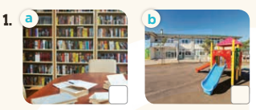  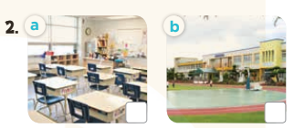  - T ask Ss to guess the answers.  + T writes Ss’guessing on the board.  - Listen to the tape:  + Play the recording  + Play the recording again and get Ss to swap books with their partners.  + Play the recording again to check answers together as a class.  + Write the answers on the board for Ss to correct their answers. Then checks Ss’ guessing.  - Play the recording, sentence by sentence, for the class to listen and repeat in chorus.  Key: 1. b 2. a  Activity 2.Look, complete and read  *Aims: Ss will be abletocomplete three target sentence patterns with the help of picture cues.  *Procedure:  - Get Ss to look at the pictures andidentify the places in the pictures.  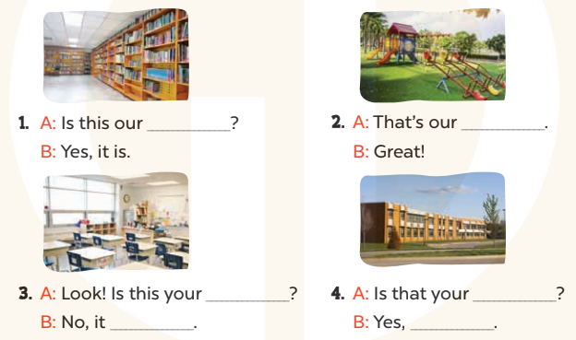  - Have Ss look atthe four dialogue and the pictures. Elicit and modelwith picture 1  + Ask Ss to read the sentence 1 in chorus.  + Ask them what is missing in the question (library). Then have them complete the gap (Is this our library?).  -Have Ss work in pairs and complete the dialogue2, 3, 4.  - Ask a few Ss to stand up and read the sentences aloud.  -T gives feedbacks.  Key:  1. library 2. playground  3. classroom; isn’t  4. school; it is  Activity 3. Let’s sing  *Aims: Ss will be able tosing the song Our school with the correct pronunciation and melody.  *Procedure:  - Introducethe title and lyrics of the song:“Our school”  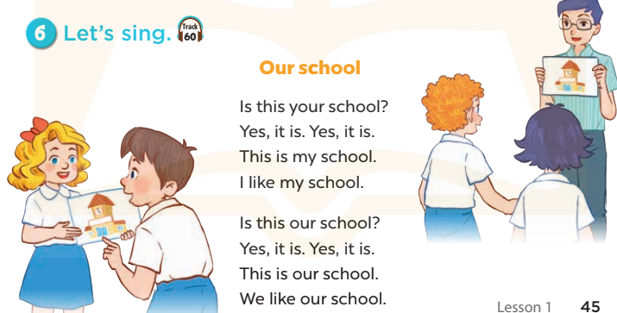  -Play the recording for Ss to listen to the whole song.  +Have them repeat the title and lyrics line by line.  +Tell Ss to point at the pictures while singing.  - Play the recording all the way through for Ss to listen to pronunciation and melody of the song.  - Play the recording line by line for Ss to listen, repeat and point to the pictures  - Play the recording for Ss to sing and do actions.  - Ask Ss to practice singing and doing actions in pairs or groups.  -Invite groups to the front of the classroom to perform the song  -T gives feedback.  *Consolidation  *Aims: Ss will be able consolidate and wrap up the content of the lesson.  *Procedure:  - T asks ss to answer the following questions:  + What have you learnt from the lesson today?  +What are the core values of the lesson? (if the teacher can take from the lesson).  - T praises some Ss who are hardworking / active/ good…. as well as encourage others to try more.  - Practice part 5 again.  - Prepare the new lesson: Unit 6, Lesson 2 (1,2,3). | - Ss read the words  - Ss play game  -Ss play game  - Ss open their books  -Look at the pictures and say:  + Picture 1a:a library + Picture 1b:a playground  + Picture 2a:a classroom  + Picture 2b:a school  -Ss guess the answers  - Ss listen to the tape and tick  - Ss listen again, tick and swap books with their partners.  - Ss check their answers and guessing  -Ss listen and repeat.  -Ss look at the picture and say  -Ss look and answer  -Ss read  -Ss say and complete  -Ss work in pairs and complete  -Ss read aloud  - Ss listen  -Ss listen to the song  -Ss listen and repeat line by line without the action.  -Ss point to the pictures while singing  -Ss listen to melody of the song  - Ss listen and sing line by line.  - Ss sing and do actions.  + Ss work in groups (two groups) to sing.  -Ss performin front of the class.  -Ss listen  -Ss answer the questions  -Ss listen and clap their hands  -Ss listen and take note
D. ADJUSTMENTS (if necessary):
………………………………………………………………………………………….…..……………………………………………………………………………...………………………………………….…..……………………………………………………………………………….……………………………………………………………………...

Week 10 Preparing date: November …..,
Period 40 Teaching date: November …..,

Unit 6: Our school
Lesson 2 (1, 2, 3)
A. OBJECTIVES:
By the end of the lesson, Ss will be able to:
1. Knowledge:
- use the words school, classroom, library, playground, computer room, art room, music room and gym in the sentence pattern Let’s go to the ……….
- use Let’s go to the ……. – OK, let’s go. to make suggestions to go to a place at school and express agreement;
- Vocabulary:computer room, art room, music room and gym
- Skills: speaking and listening
2. Competences:
-Co-operation: ready to help friends in pair work/ group work.
- Sociability: Talk to each other, say good words to others.
3. Attitude/ Qualities:
-Kindness:Help partners to complete learning tasks.
- Honesty: tell the truth about feelings and emotions
B. TEACHING AIDS:
- Teacher: Teacher’s guide Pages 83, 84; audio Tracks 61,62, website sachmem.vn, posters, laptop, pictures, textbook, lesson plan, TV or projector.
- Students: Pupil’s book Page 46, notebooks, workbooks, school things.
C. PROCEDURES:
Stages/Time | Teacher’s activities | Students’ activities
1.Warm- up:  (3’)  2.Presentation  (16’)  3.Practice: (7’)  4.Production: (7’)  5. Homework. (2’) | Game: Guessing and Choosing  *Aims: to create a friendly and active atmosphere in the class to beginning the lesson.  *Procedure:  - T shows 4 pictures of places and calls 4 Ss to come to the board and choose.  - T asks 4 Ss to come to the board and choose 1 picture of place and keep them in secret by covering them.  - The others will write their place in the board at their desks and keep their ides in secret.  - The Ss on the board will 1 by 1 show their pictures they chose.  - When the teacher says the word of the pictures 1 by 1 shown on the board, who has the same places will raise their board or raise their hands.  - The Ss on the board will get the same points as the numbers of Ss raising their hands.  - Say “Open your book page 46” and look at “Unit 6, Lesson 2 (1,2,3)”.  Activity 1. Vocabulary.  *Aims: Ss will be ableto know the vocabulary in front of starting the new lesson.  *Procedure:  -T elicits the new words  + art room: phòng mĩ thuật  (picture)  + computer room: phòng tin học  (picture)  + music room: phòng âm nhạc  (picture)  + gym :nhà thể chất  (picture)  - T models (3 times).  - T writes the words on the board.  - Checking: What and where  Activity 2. Look, listen and repeat:  *Aims: Ss will be abletounderstand and correctly repeat the sentences in two communicative contexts (pictures) to make suggestions to go to a place at school and express agreement.  *Procedure:  - Have Ss look at Pictures a and b and identify the characters in the pictures.  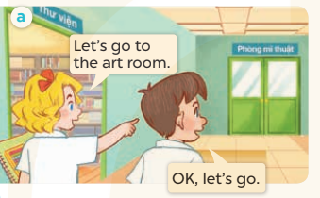  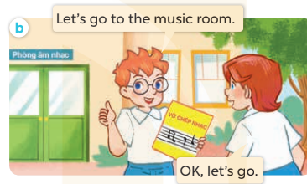  -Play the audio twice(sentence by sentence). Correct their pronunciation where necessary.  - Have Ss to practice the diaguage  -Tinvites a few pairs to the front of the class to practice.  - T checkspronunciation for ss.  Activity 3.Listen, point and say.  *Aims: Ss will be ableto correctly say the words and use Let's go to the …… .- OK, let’s go. to make suggestions to go to a place at school and express agreement.  *Procedure:  * Model sentences:  - T asks Ss look at picture aand helps Ss know the structure from the dialogue.  - T introduces new structure for Ss.  - T explains,models and gives meaning.  -Have Ss repeat the model sentences.  A: Let’s go to the art room.  B: OK, let’s go.  *Drill pictures  - Have Ss look at the pictures and elicit the names of the places  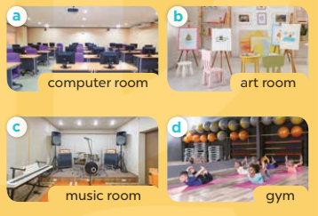  - Run through all the pictures.  - Run through model sentences.  - Have Ss to practise:  + T say – Ss respond(change role).  + Ss – Ss (change role).  - Ask Ss to work in pairs.  - T controls and corrects.  - Invite a few pairs to come to the front of the classroom,point at the pictures and say the questions and answers in front of the class.  - T gives feedbacks.  Activity 4. Let’s talk.  *Aims: Ss will be able toenhance the correct use of Let's go to the …... – OK, let's go. to make suggestions to go to a place at school and express agreement.  *Procedure:  - T asks ss to guess each character and what the children say.  + What can you see in the picture?  +Who are they?  +Where are they?  +What are they doing?  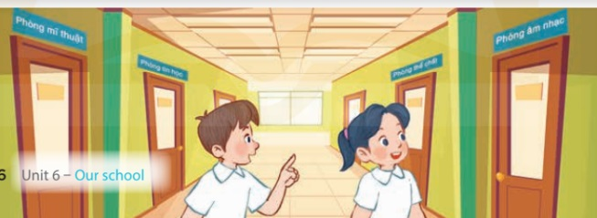  - Put Ss into pairs and encourage them to make suggestions to go to a place at school and express agreementusing Let’s go to the..… -Ok, let’s go.  - Invite some pairs to stand up to perform their exchanges.  *Consolidation  *Aims: Ss will be able consolidate and wrap up the content of the lesson.  *Procedure:  - T asks ss to answer the following questions:  + What have you learnt from the lesson today?  - T review the vocabulary and model sentences.  - T praises some Ss who are hardworking / active/ good…. as well as encourage others to try more.  - Learn the vocabulary and model sentences by heart  - Prepare the new lesson: Unit 6, Lesson 2 (4,5,6). | - Ss listen  - Ss play the game  -Ss play game  - Ss open their books  -Ss listen and answer  - - Ss listen and repeat  + Choral repetition (3 times).  + Individual repetition (3 ss)  - Ss take note  - Ss look, remember and slap  -Look at the pictures and get to know the characters in the pictures.  + In picture a: Mary says:Let’s go to the art room. And Minh says:OK, let’s go.  –In picture b: Ben says:Let’s go to the music room. And Lucysays:OK, let’s go.  -Ss listen and repeat in chorus (twice)  -Ss work in pairs to practice  -Ss practice the diaguage  -Ss listen  -Ss look at the picture and answer.  -Ss listen  -Ss listen and repeat  -Ss repeat to the hobbies  -Ss listen and answer  +Picture a: a computer room  +Picture b. an art room  +Picture c. a music room  +Picture d. a gym  - Ss look, listen and repeat  - Ss practice in chorus  -Ss work in pairs to practice  -Ss listen  -Ss go to the board and point and say  -Ss listen  -Ss look at the picture and answer  + Two Ssare standing in the hall and pointing to the four school rooms.  -Ss work in pairs  -Ss ask and answer  -Ss answer the questions  - Ss listen  -Ss listen and clap their hands  -Ss listen and take note
D. ADJUSTMENTS (if necessary):
………………………………………………………………………………………….…..……………………………………………………………………………...……………

