Week 11 Preparing date: November …..,
Period 41 Teaching date: November …..,

Unit 6: Our school
Lesson 2 (4, 5, 6)
A. OBJECTIVES:
By the end of the lesson, Ss will be able to:
1. Knowledge:
- listen to and understand simple exchanges in relation to the topic “Our school”
- read some sentences and match them with the correct pictures.
- practise the target sentence pattern by playing the game Guess the place.
- Vocabulary:Review
- Skills: speaking, listening, reading and writing.
2. Competences:
- Critical Thinking: self-introduce
-Co-operation: ready to help friends in pair work/ group work.
- Self-control and independent learning: perform listening tasks.
3. Attitude/ Qualities:
-Kindness:Help partners to complete learning tasks.
- Honesty: tell the truth about feelings and emotions.
- Diligence: complete learning tasks.
B. TEACHING AIDS:
- Teacher: Teacher’s guide Pages 85, 86; audio Tracks 63; website sachmem.vn, posters, laptop, pictures, textbook, lesson plan, TV or projector.
- Students: Pupil’s book Page 47, notebooks, workbooks, school things.
C. PROCEDURES:
Stages/Time | Teacher’s activities | Students’ activities
1.Warm- up:  (5’)  2.Practice: (27’)  3. Homework. (3’) | Game: Slap the board  *Aims: to create a friendly and active atmosphere in the class to beginning the lesson.  *Procedure:  - Divide class into 2 groups  - How to play:  + Each group chooses five Ss to play.  + Class will read aloud.  + Look at the picture, listen and slap the picture you heard.  + Who faster will get 1 mark.  + Which group with higher mark is the winner.  - T gives feedback.  - Say “Open your book page 47” and look at “Unit 6, Lesson 2 (4,5,6)”.  Activity 1. Listenand number:  *Aims: Ss will be ableto listen and understand four communicative contexts in which pupils make suggestions to go to different places at school  *Procedure:  - Elicit the word for the place in each picture  - Point at the pictures respectively to explain the context.  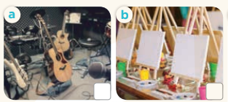    - T ask Ss to guess the answers.  + T writes Ss’guessing on the board.  - Listen to the tape:  + Play the recording  + Play the recording again and get Ss to swap books with their partners.  + Play the recording again to check answers together as a class.  + Write the answers on the board for Ss to correct their answers. Then checks Ss’ guessing.  - Play the recording, sentence by sentence, for the class to listen and repeat in chorus.  Key: 1. c 2. b 3. d 4. a  Activity 2.Read and match  *Aims: Ss will be abletoread some sentences and match them with the correct pictures.  *Procedure:  - Get Ss to look at the pictures andidentify the places in the pictures.  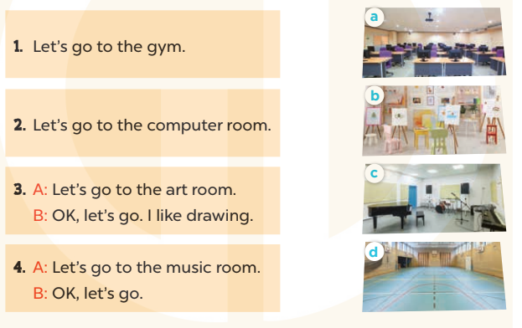  - Have Ss look at the four dialoguesand the pictures. Elicit and model with picture 1  + Ask Ss to read the sentence 1 in chorus.  +Ask Ss to match sentence 1 with the correct picture  -Have Ss work in pairs and complete the sentences2, 3, 4.  - Ask a few Ss to stand up and read the sentences aloud.  -T gives feedbacks.  Key:  1. d 2. a 3. b 4. c  Activity 3. Let’s play  *Aims: Ss will be able topractise the target sentence pattern by playing the game Guess the place.  *Procedure:  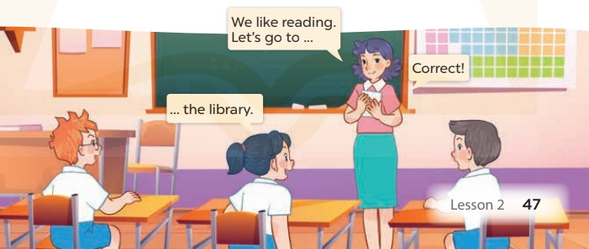  - Hold up a flash card for library and say: We like reading. Let's go to ....  - Elicit the school room to complete the sentence.  - Show Ss the flash card and have them repeat the word and the sentence.  - Hold up another flash card and continue with the game.  - Divide the class into two teams.  + Each team in turn plays the game. If Ss in a team can guess the correct picture, they get a star.  + After three or four rounds, the team with the most stars is the winner.  + Give the team a fun prize.  *Consolidation  *Aims: Ss will be able consolidate and wrap up the content of the lesson.  *Procedure:  - T asks ss to answer the following questions:  + What have you learnt from the lesson today?  +What are the core values of the lesson? (if the teacher can take from the lesson).  - T praises some Ss who are hardworking / active/ good…. as well as encourage others to try more.  - Practice part 5 again.  - Prepare the new lesson: Unit 6, Lesson 3 (1,2,3). | - Ss read the words  - Ss play game  -Ss play game  - Ss open their books  -Look at the pictures and say:  + Picture a:a music room + Picture b:an art room  + Picture c:a gym  + Picture d:a computer room  -Ss guess the answers  - Ss listen to the tape and write  - Ss listen again, write and swap books with their partners.  - Ss check their answers and guessing  -Ss listen and repeat.  -Ss look at the picture and say  -Ss look and answer  -Ss read  -Ss say and match  -Ss work in pairs and macth  -Ss read aloud  - Ss listen  -Ss play game  -Ss play game  -Ss answer the questions  -Ss listen and clap their hands  -Ss listen and take note
D. ADJUSTMENTS (if necessary):
………………………………………………………………………………………….…..……………………………………………………………………………...………………………………………….…..……………………………………………………………………………….……………………………………………………………………...

Week 11 Preparing date: November …..,
Period 42 Teaching date: November …..,

Unit 6: Our school
Lesson 3 (1, 2, 3)
A. OBJECTIVES:
By the end of the lesson, Ss will be able to:
1. Knowledge:
- correctly pronounce the sounds of the letters pl and cl in isolation, in the words playground and classroom, and in the sentences Let's go to the playground. and Is that your classroom
- listen and circle the correct words.
- Vocabulary:Review
- Skills: speaking, listening, reading and writing.
2. Competences:
-Co-operation: ready to help friends in pair work/ group work.
- Sociability: Talk to each other, say good words to others.
3. Attitude/ Qualities:
-Kindness:Help partners to complete learning tasks.
- Honesty: tell the truth about feelings and emotions
B. TEACHING AIDS:
- Teacher: Teacher’s guide Pages 88, 89; audio Tracks 64, 65, 66; website sachmem.vn, posters, laptop, pictures, textbook, lesson plan, TV or projector.
- Students: Pupil’s book Page 48, notebooks, workbooks, school things.
C. PROCEDURES:
Stages/Time | Teacher’s activities | Students’ activities
1.Warm- up:  (5’)  2.Presentation  (9’)  3.Practice: (19’)  4. Homework. (2’) | Game: Pass the ball  *Aims: to create a friendly and active atmosphere in the class to beginning the lesson.  *Procedure:  - Divide the class into 3 teams.  - Each team has 1 sticky ball.  - Play the music, Ss in each team take turns to pass the ball.  + After the music ends, 3 Ss have the ball – stand up and say the name, using the sentence model.  - Say “Open your book page 48” and look at “Unit 6, Lesson 3 (1,2,3)”.  Activity 1. Listen and repeat:  *Aims: Ss will be ableto correctly pronounce the sounds of the letters pl and cl in isolation, in the words playground and classroom, and in the sentences Let's go to the playground. and Is that your classroom?  *Procedure:  -T gives instruction to the letter pland cl,playgroundand classroom, and in the sentences Let's go to the playground. and Is that your classroom?  - Play the recording for the letter cl, pl.  - Encourage Ss to point at the letter/ word/ sentence while listening.  - Play the recording again and encourage Ss to listen and repeat. - Do this several times until Ss feel confident.  - T calls some Ss to practice.  - T gives feedbacks.  Activity 2.Listen and circle.  *Aims: Ss will be ableto identify the target words playground and classroom while listening.  *Procedure:  - Elicit the sentences and the gap-fill options.  - T ask Ss to guess the answers.  + T writes Ss’guessing on the board.  - Listen to the tape:  + Play the recording  + Play the recording again and get Ss to swap books with their partners.  + Play the recording again to check answers together as a class.  + Write the answers on the board for Ss to correct their answers. Then checks Ss’ guessing.  - Play the recording, sentence by sentence, for the class to listen and repeat in chorus.  -Invite one or two Ss to stand up and read the completed sentences.  Key: 1.b 2.c  Activity 3. Let’s chant  *Aims: Ss will be able to say the chant with the correct rhythm and pronunciation.  *Procedure:  - Introducethe title and lyrics of the chant.  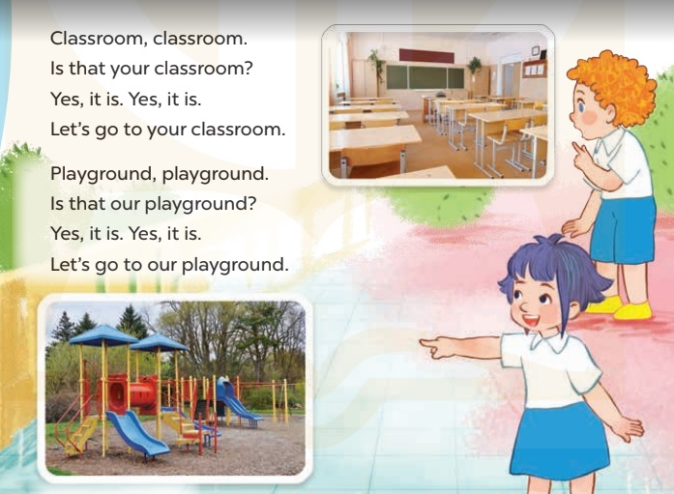  -Play the recording for Ss to listen to the whole chant.  +Have them repeat the title and lyrics line by line.  +Ask Ss to attend to the sounds of the letters pland cland the words playground and classroom.  - Play the recording all the way through for Ss to listen to pronunciation and melody.  - Play the recording line by line for Ss to listen and repeat  - Play the recording for Ss to chant and clap along.  - Ask Ss to practice chant and clap along in pairs or groups.  -Invite groups to the front of the classroom to perform the chant  -T gives feedback.  *Consolidation  *Aims: Ss will be able consolidate and wrap up the content of the lesson.  *Procedure:  - T asks ss to answer the following questions:  + What have you learnt from the lesson today?  +What are the core values of the lesson? (if the teacher can take from the lesson).  - T praises some Ss who are hardworking / active/ good…. as well as encourage others to try more.  - Practice the chant more.  - Prepare a poster about their school in order to introduce their school to a new pupil.  - Prepare the new lesson: Unit 6, Lesson 3 (4,5,6). | - Ss listen  -Ss play game  - Ss open their books  -Ss recognize the differences about color of letter  - - Ss listen  - Ss listen and point  - Ss listen again and repeat  -Ss listen again and repeat  -Ss practice  -Ss listen  -Ss listen and say:  + Number 1: Let’s go to the …....  + Number 2: Is that our ……?  -Ss guess the answers  - Ss listen to the tape and circle  - Ss listen again, circle and swap books with their partners.  - Ss check their answers and guessing  -Ss listen and repeat.  -Ss read the sentences  - Ss look and listen.  -Ss listen to the chant  -Ss listen and repeat line by line without clap their hands  -Ss note the sounds, words  -Ss listen to melody of the chant  - Ss listen and chantline by line.  - Ss chant andclap along.  - Ss work in groups (two groups) to chant  -Ss performin front of the class.  -Ss listen  -Ss listen.  -Ss answer the questions  -Ss listen and clap their hands  -Ss listen and take note

D. ADJUSTMENTS (if necessary):
………………………………………………………………………………………….…..……………………………………………………………………………...………………………………………….…..……………………………………………………………………………….……………………………………………………………………...

Week 11 Preparing date: November …..,
Period 43 Teaching date: November …..,

Unit 6: Our school
Lesson 3 (4, 5, 6)
A. OBJECTIVES:
By the end of the lesson, Ss will be able to:
1. Knowledge:
- read and write about a school;
- make a poster to introduce their school to a new pupil.
- Vocabulary:Review
- Skills: speaking, listening, reading and writing.
2. Competences:
- Critical Thinking: self-introduce
-Co-operation: ready to help friends in pair work/ group work.
- Self-control and independent learning: perform listening tasks.
3. Attitude/ Qualities:
-Kindness:Help partners to complete learning tasks.
- Honesty: tell the truth about feelings and emotions.
- Diligence: complete learning tasks.
B. TEACHING AIDS:
- Teacher: Teacher’s guide Pages 88, 89; website sachmem.vn, posters, laptop, pictures, textbook, lesson plan, TV or projector.
- Students: Pupil’s book Page 49, notebooks, workbooks, school things.
C. PROCEDURES:
Stages/Time | Teacher’s activities | Students’ activities
1.Warm- up:  (5’)  2.Practice: (8’)  3.Production: (19’)  4. Homework. (3’) | Game: “Chant”  *Aims: to review the vocabulary and structure about greet and respond to greetings.  *Procedure:  - Ask Ss chant and do the actions in Unit 6, Lesson 3 page 48 in groups.  - Give point for the groups and encourage them.  - Say “Open your book page 49” and look at “Unit 6, Lesson 3 (4,5,6)”.  Activity 1. Read and complete:  *Aims: Ss will be abletoread and choose the words to complete the text.  *Procedure:  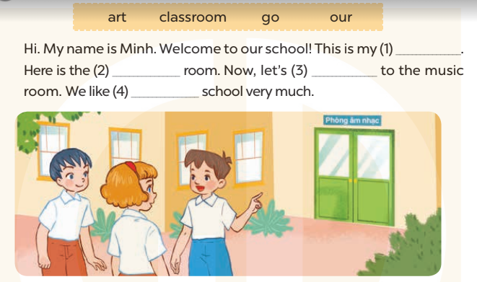  - Elicit and introduce the context.  + Minh is introducing his school to his friends.  - Have Ss read aloud the words to fill in.  - Model the first blank with Ss to make sure that they know how to do the task.  - Give Ss enough time to complete the text.  - Check the answers as a class.  - Have Ss read the text aloud.  Key: 1. classroom 2. art  3. go 4. our  Activity 2.Let’s write  *Aims: Ss will be ableto read and complete a gapped paragraph to introduce their school.  *Procedure:  -Model the first gap and ask Ss what the missing word is.  - Have Ss write their answers.  - Give Ss time to write the answers.  -Have some Ss read their completed paragraph aloud.  Key: Pupils’ answer  Activity 3. Project.  *Aims: Ss will be able to introduce the school to a new pupil.  *Procedure:  - Point at the sample poster and explain that the Ss is going to introduce his school to some friends.  - Have Ss show the photos or pictures that they have prepared for the project.  - Revise some structures and vocabulary that Ss need for their presentations.  +Hello/ Hi, class. Im’……  +Welcome to my school. This is….  +This is….and that’s……  + Now, let’s go to the…..  - Give Ss time to practise their presentations by themselves.  - Give Ss time to use their posters to practise presenting within their groups.  - Select a few pupils to give their presentations in front of the class.  - Have Ss go around their school to introduce some school rooms to their friends. One group introduces the school, and others act as new pupils.  *Consolidation  *Aims: Ss will be able consolidate and wrap up the content of the lesson.  *Procedure:  - T asks ss to answer the following questions:  + What have you learnt from the lesson today?  +What are the core values of the lesson? (if the teacher can take from the lesson).  - T praises some Ss who are hardworking / active/ good…. as well as encourage others to try more.  - Prepare the new lesson: Unit 7, Lesson 1 (1, 2, 3). | - Ss listen and chant  - Ss open their books  - Ss look at the pictures and answer  -Ss read the words  -Ss fill in the gap  -Ss complete the text  -Ss check their answer  -Ss read aloud  -Ss listen and answer  -Ss write the first gap  -Ss write  -SS read aloud  -Ss listen  -Ss show the picture  -Ss listen and note  -Ss practise  -Ss present the poster  -Ss present in front of the class  -Ss go around their school to introduce some school rooms to their friends.  -Ss answer the questions  -Ss listen and clap their hands  -Ss listen and take note
D. ADJUSTMENTS (if necessary):
………………………………………………………………………………………….…..……………………………………………………………………………...…………

Week 11 Preparing date: November …..,
Period 44 Teaching date: November …..,

Unit 7: Classroom instructions
Lesson 1 (1, 2, 3)
A. OBJECTIVES:
By the end of the lesson, Ss will be able to:
1. Knowledge:
-use the words open, close, stand up, sit down and please in relation to the topic “Classroom instructions”
-use …………. please! to give instructions;
- Vocabulary:open, close, stand up, sit down, please
- Skills: speaking and listening
2. Competences:
- Critical Thinking: self-introduce
-Co-operation: ready to help friends in pair work/ group work.
- Sociability: Talk to each other, say good words to others.
3. Attitude/ Qualities:
-Kindness:Help partners to complete learning tasks.
- Honesty: tell the truth about feelings and emotions
B. TEACHING AIDS:
- Teacher: Teacher’s guide Pages 90, audio Tracks 67,68, website sachmem.vn, posters, laptop, pictures, textbook, lesson plan, TV or projector.
- Students:Pupil’s book Page 50, notebooks, workbooks, school things.
C. PROCEDURES:
Stages/Time | Teacher’s activities | Students’ activities
1.Warm- up:  (3’)  2.Presentation  (16’)  3.Practice: (7’)  4.Production: (7’)  5. Homework. (2’) | Sing:Baby shark  *Aims: to create a friendly and active atmosphere in the class to beginning the lesson.  *Procedure:  - Show the song on the screen.  https://www.youtube.com/watch?v=XqZsoesa55w  - Ask Ss to listen, sing and dance the song.  - Say “Open your book page 50” and look at “Unit 7, Lesson 1 (1,2,3)”.  Activity 1. Vocabulary.  *Aims: Ss will be ableto know the vocabulary in front of starting the new lesson.  *Procedure:  -T elicitsthe new words  +open: mở(mime)  +close: đóng(mime)  + stand up:đứng lên(mime)  + sit down :ngồi xuống(mime)  + please : xin mời (translation)  - T models (3 times).  - T writes the words on the board.  - Checking: Rub out and remember  Activity 2. Look, listen and repeat:  *Aims: Ss will be ableto understand and correctly repeat the sentences in two communicative contexts (pictures) focusing on classroom instructions.  *Procedure:  - Have Ss look at Pictures a and b and identify names of the speakers in the pictures.  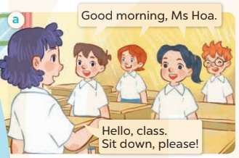  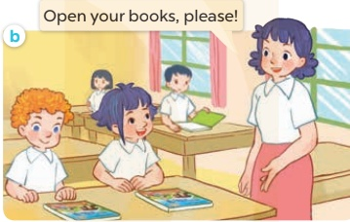  -Play the audio twice(sentence by sentence). Correct their pronunciation where necessary.  - Have Ss to practice the dialogue  -Tinvites a few pairs to the front of the class to practice.  - T checkspronunciation for ss.  Activity 32. Listen, point and say.  *Aims: Ss will be ableto correctly say the words and use ……. , please!to give instructions  *Procedure:  * Model sentences:  -T asks Ss look at picture aand helps Ss know the structure from the dialogue.  - T introduces new structure for Ss.  - T explains,models and gives meaning.  -Have Ss repeat the model sentences.  Sit down, please!  *Drill pictures  - Elicit the school thing and the character in each picture.  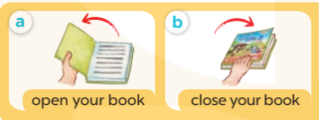  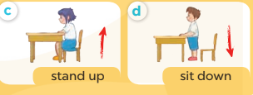  - Have S point at Picture a, listen to the recording and repeat the phrase  (open your book).  - Follow the same procedure with the other three pictures.  - Point at the bubble and Picture a and have S listen and repeat after the  recording (Open your book, please!).  - Have pairs practise saying ______, please! with Pictures b, c and d.  - Invite a few pairs to point at the pictures and give instructions for the class to act out  Activity 4. Let’s talk.  *Aims: Ss will be able to enhance the correct use of ………., please! to give instructions  *Procedure:  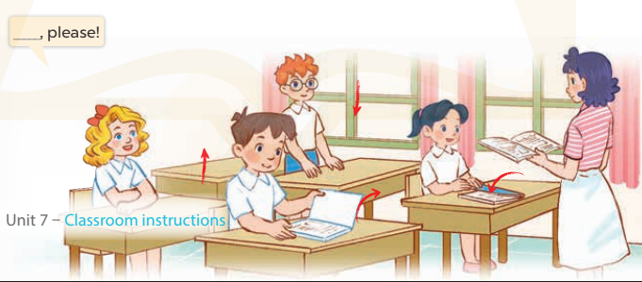  - Have Ss look at the picture and elicit the question and the answer in context.  +A picture of a classroom in which pupils are asking the teacher for her permission to  (open the book / close the book / stand up / sit down)  - Put Ss work in pairs to give and respond to instructions. Go around the classroom to offer support while they are acting out the instructions.  - Invite some pairs of Ss to the front of the class to act out the instructions.  *Consolidation  *Aims: Ss will be able consolidate and wrap up the content of the lesson.  *Procedure:  - T asks ss to answer the following questions:  + What have you learnt from the lesson today?  +What are the core values of the lesson? (if the teacher can take from the lesson).  - T review the vocabulary and model sentences.  - T praises some Ss who are hardworking / active/ good…. as well as encourage others to try more.  - Learn the vocabulary and model sentences by heart  - Prepare the new lesson: Unit 7, Lesson 1 (4,5,6). | - Ss sing and dance the song  - Ss open their books  -Ss listen and answer  - - Ss listen and repeat  + Choral repetition (3 times).  + Individual repetition (3 ss)  - Ss take note  - Ss look, remember and write  -Look at the pictures and say  + In picture a: Class says: Good morning, Ms Hoa. Lucy answers: Hello, class. Sit down, please!  + In picture b: Ms Hoa says: Open your books, please!  -Ss listenand repeat in chorus (twice)  -Ss work in pairs to practice  -Ss practice the dialogue  -Ss listen  -Ss look at the picture and answer.  -Ss listen  -Ss listen and repeat  -Ss repeat to the place  - Ss look, listen and answer  +Picture a: a book opening  + Picture b: a book closing  + Picture c: a girl about to stand up  + Picture d: a boy about to sit down  -Ss listen and repeat  -Ss practice  -Ss listen and repeat  -Ss practice  -Ss point, say nd do action  -Ss look at the picture and answer  -Ss work in pairs  -Ss act out the instructions.  -Ss answer the questions  - Ss listen  -Ss listen and clap their hands  -Ss listen and take note
D. ADJUSTMENTS (if necessary):
………………………………………………………………………………………….…..……………………………………………………………………………...………………………………………….…..……………………………………………………………………………….……………………………………………………………………...

