Week 13 Preparing date: December …..,
Period 49 Teaching date: December …..,

Unit 7: Classroom instructions
Lesson 3 (4, 5, 6)
A. OBJECTIVES:
By the end of the lesson, Ss will be able to:
1. Knowledge:
-read and match two sentences and two dialogues with four pictures.
-read, understand and complete the incomplete sentences by writing the correct words in the gaps.
-make classroom instructions, choose one from the box and read it to the classmates to act out.
- Vocabulary:Review
- Skills: speaking, listening, reading and writing.
2. Competences:
- Critical Thinking: self-introduce
-Co-operation: ready to help friends in pair work/ group work.
- Self-control and independent learning: perform listening tasks.
3. Attitude/ Qualities:
-Kindness:Help partners to complete learning tasks.
- Honesty: tell the truth about feelings and emotions.
- Diligence: complete learning tasks.
B. TEACHING AIDS:
- Teacher: Teacher’s guide Pages 98, 99; website sachmem.vn, posters, laptop, pictures, textbook, lesson plan, TV or projector.
- Students: Pupil’s book Page 55, notebooks, workbooks, school things.
C. PROCEDURES:
Stages/Time | Teacher’s activities | Students’ activities
1.Warm- up:  (5’)  2.Practice: (8’)  3.Production: (19’)  4. Homework. (3’) | Game: “Chant”  *Aims: to review the vocabulary and structure about greet and respond to greetings.  *Procedure:  - Ask Ss chant and do the actions in Unit 7, Lesson 3 page 54in groups.  - Give point for the groups and encourage them.  - Say “Open your book page 55” and look at “Unit 7, Lesson 3 (4,5,6)”.  Activity 1. Read and match:  *Aims: Ss will be abletoread and match two sentences and two dialogues with four pictures *Procedure:  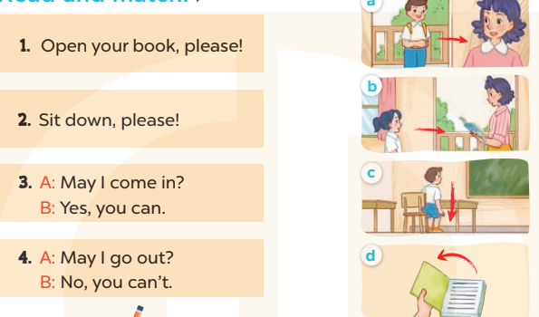  - Elicit and introduce four picture cues, two sentences and two dialogues to match  - Have Ss read the first sentence in chorus  - Model by drawing a line to match it with Picture dand make sure that Ss know how to do the task.  - Give Ss enough time to complete the text.  - Check the answers as a class.  - Have Ss read the text aloud.  Key: 1. d 2. c 3. a 4. b  Activity 2.Let’s write  *Aims: Ss will be ableto read, understand and complete the incomplete sentences by writing the correct words in the gaps.  *Procedure:  -Write the first incomplete sentence on the board: 1. Open your.., please!  - Read the incomplete sentence as a class.  + Elicit the word Ss have to write in the first gap and encourage them to say it.  - Give Ss time to write down the answer 2, 3, 4.  - Invite one or two Ss to stand up, listen and repeat the sentences  Key: 1. book(s) 2. Stand  3. come; Yes 4. speak; can’t  Activity 3. Project.  *Aims: Ss will be able to make classroom instructions, choose one from the box and read it to the classmates to act out.  *Procedure:  - Put Ss into groups or ask the whole class to work together.  - Tell Ss to write instructions on their sheets of paper, then fold and put them in a box (each pupil writes just one instruction).  - Get each Ss to choose one instruction in the box then read it to the group/ whole class to act out.  - Give Ss enough time to complete each step.  - Create a class display using the pictures and vote for the most creative.  *Consolidation  *Aims: Ss will be able consolidate and wrap up the content of the lesson.  *Procedure:  - T asks ss to answer the following questions:  + What have you learnt from the lesson today?  +What are the core values of the lesson? (if the teacher can take from the lesson).  - T praises some Ss who are hardworking / active/ good…. as well as encourage others to try more.  - Prepare the new lesson: Unit 8, Lesson 1 (1, 2, 3). | - Ss listen and chant  - Ss open their books  - Ss look at the pictures and answer  -Ss read the first dentence  -Ss match  -Ss match  -Ss check their answer  -Ss read aloud  -Ss look and listen  -Ss read  -Ss write  -Ss do the task  -Ss listen and repeat  -Ss listen  -Ss write instructions  + Example: Stand up / Sit down, please!  Close / Open your book(s), please!  Go to the board, please! Go there / Come here, please!  Tell me / Spell your name, please! …)  -Ss choose instruction and read it  -Ss do the task  -Ss vote for the most creative  -Ss answer the questions  -Ss listen and clap their hands  -Ss listen and take note
D. ADJUSTMENTS (if necessary):
………………………………………………………………………………………….…..……………………………………………………………………………...…………

Week 13 Preparing date: December …..,
Period 50 Teaching date: December …..,

Unit 8: My school things
Lesson 1 (1, 2, 3)
A. OBJECTIVES:
By the end of the lesson, Ss will be able to:
1. Knowledge:
- use the words pen, ruler, book, school bag, have in relation to the topic “School things”
- use I have ……….. to talk about having a school thing
- understand and correctly repeat the sentences in two communicative contexts (pictures) to talk about having a school thing.
- Vocabulary:pen, ruler, book, school bag, have
- Skills: speaking and listening
2. Competences:
- Self-control and independent learning: perform listening tasks.
- Communication and collaboration: work in pairs or groups.
- Sociability: talk to each other, say good words to others.
3. Attitude/ Qualities:
-Kindness:Help partners to complete learning tasks.
- Honesty: tell the truth about feelings and emotions
B. TEACHING AIDS:
- Teacher: Teacher’s guide Pages 100, 101, audio Tracks 77, 78, website sachmem.vn, posters, laptop, pictures, textbook, lesson plan, TV or projector.
- Students: Pupil’s book Page 56, notebooks, workbooks, school things.
C. PROCEDURES:
Stages/Time | Teacher’s activities | Students’ activities
1.Warm- up:  (3’)  2.Presentation  (16’)  3.Practice: (7’)  4.Production: (7’)  5. Homework. (2’) | Jigsaw puzzle  *Aims: to create a friendly and active atmosphere in the class to beginning the lesson.  *Procedure:  - Divide class into 4 groups: Tom, Jerry, Miu and Chit.  - Ask Ss look at the pieces of picture.    - Ask Ss go to the board and jigsaw puzzle into the correct picture.  -T checks who’s the winner? - Say “Open your book page 56” and look at “Unit 8, Lesson 1 (1,2,3)”.  Activity 1. Vocabulary.  *Aims: Ss will be ableto know the vocabulary in front of starting the new lesson.  *Procedure:  -T elicits the new words  + pen: bút mực(realia)  + ruler: thước kẻ(realia)  + book:quyển sách(realia)  + school bag: cặp sách(realia)  + have : có(translation)  - T models (3 times).  - T writes the words on the board.  - Checking: Rub out and remember  Activity 2. Look, listen and repeat:  *Aims: Ss will be ableto understand and correctly repeat the sentences in two communicative contexts (pictures) to talk about having a school thing.  *Procedure:  - Have Ss look at Pictures a and b and identify the characters(Linh and Ben) in the pictures.  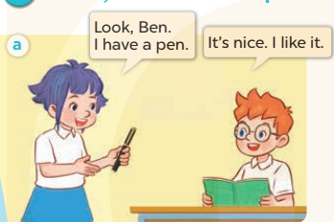  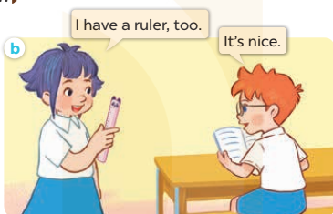  -Play the audio twice(sentence by sentence). Correct their pronunciation where necessary.  - Have Ss to practice the dialogue  -Tinvites a few pairs to the front of the class to practice.  - T checkspronunciation for ss.  Activity 32. Listen, point and say.  *Aims: Ss will be ableto correctly say the words and use: I have …….  to talk about having a school thing.  *Procedure:  * Model sentences:  - T asks Ss look at picture aand helps Ss know the structure from the dialogue.  - T introduces new structure for Ss.  - T explains,models and gives meaning.  -Have Ss repeat the model sentences.  I have a pen.  *Drill pictures  - Have Ss look at the pictures and identify the school things in the pictures  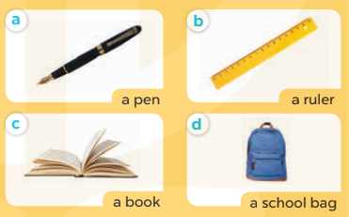  - Run through all the pictures.  - Run through model sentences.  - Have Ss to practise:  +Tell Ss to point at the relevant school thing in the picture when they are repeating the sentence  - T controls and corrects.  - Invite a few pupils to stand up, point at each school thing in the picture and say he sentence aloud.  - T gives feedbacks.  Activity 4. Let’s talk.  *Aims: Ss will be able enhance the correct use of I have ……. to talk about having a school thing.  *Procedure:  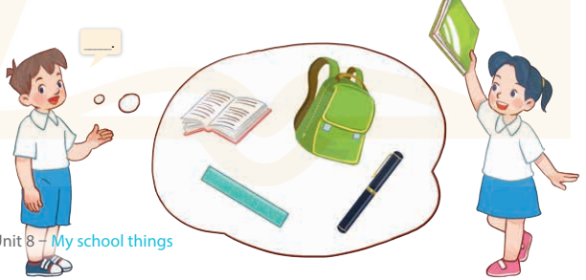  - Have Ss look at the picture and elicit the question and the answer in context.  +Who are they?  + Where are they?  + What are they talking about?  - Point at each school thing, elicit the missing words in the bubble (I have a book /ruler / …).  - Get Ss to say the completed sentence.  - Put Ss into pairs point at the school things in the picture and in the classroom respectively to say the sentence I have……….  *Consolidation  *Aims: Ss will be able consolidate and wrap up the content of the lesson.  *Procedure:  - T asks ss to answer the following questions:  + What have you learnt from the lesson today?  +What are the core values of the lesson? (if the teacher can take from the lesson).  - T review the vocabulary and model sentences.  - T praises some Ss who are hardworking / active/ good…. as well as encourage others to try more.  - Learn the vocabulary and model sentences by heart  - Prepare the new lesson: Unit 8, Lesson 2 (4,5,6). | - Ss listen  -Ss look at the pieces of the picture  -Ss put into the correct picture  -Ss check  -Ss listen and answer  - - Ss listen and repeat  + Choral repetition (3 times).  + Individual repetition (3 ss)  - Ss take note  - Ss look, remember and write  -Look at the pictures and say  + In picture a: Linh shows Ben her new pen and says: Look, Ben. I have a pen. Ben expresses his surprise and says: It's nice. I like it.  + In picture b: Linh shows Ben a ruler and says: I have a ruler, too. Ben says: It's nice.  -Ss listen and repeat in chorus (twice)  -Ss work in pairs to practice  -Ss practice the dialogue  -Ss listen  -Ss look at the picture and answer.  -Ss listen  -Ss listen and repeat  -Ss repeat  - Ss look, listen and answer  +Picture a: a pen  + Picture b:a ruler  + Picture c:a book  + Picture d: a school bag  -Ss listen and repeat  -Ss practice in chorus, individuals.  -Ss point and say  -Ss listen.  -Ss look at the picture and answer  +Two pupils talk about having a school thing (a book, a school bag, a pen and a ruler).  -Ss point and say  -Ss say the sentence  -Ss work in pairs, point and say  -Ss answer the questions  - Ss listen  -Ss listen and clap their hands  -Ss listen and take note
D. ADJUSTMENTS (if necessary):
………………………………………………………………………………………….…..……………………………………………………………………………...………………………………………….…..……………………………………………………………………………….……………………………………………………………………...
Week 13 Preparing date: December …..,
Period 51 Teaching date: December …..,

Unit 8: My school things
Lesson 1(4, 5, 6)
A. OBJECTIVES:
By the end of the lesson, Ss will be able to:
1. Knowledge:
- listen to and understand two communicative contexts in which pupils talk about the school things they have.
- read and complete the four gapped sentences with the help of the picture cues.
- sing the song School things with the correct pronunciation and melody.
- Vocabulary:Review
- Skills: speaking, listening, reading and writing.
2. Competences:
- Oral Communication: sing the song – Let’s sing.
- Written Communication: complete the sentences.
- Self-control and independent learning: perform listening tasks.
- Communication and collaboration: work in pairs or groups.
3. Attitude/ Qualities:
-Kindness:Help partners to complete learning tasks.
- Honesty: tell the truth about feelings and emotions.
- Diligence: complete learning tasks.
B. TEACHING AIDS:
- Teacher: Teacher’s guide Pages 102, 103; audio Tracks 79, 80; website sachmem.vn, posters, laptop, pictures, textbook, lesson plan, TV or projector.
- Students: Pupil’s book Page 57, notebooks, workbooks, school things.
C. PROCEDURES:
Stages/Time | Teacher’s activities | Students’ activities
1.Warm- up:  (5’)  2.Practice: (27’)  3. Homework. (3’) | Sentence Puzzle  *Aims: to create a friendly and active atmosphere in the class to beginning the lesson.  *Procedure:  - Divide the class into groups of four.  - Give each group a sentence that is broken/cut in to pieces.  - Ask Ss to arrange them to make a complete sentence, then read it aloud.  - The group makes it first will be the winner.  - Say “Open your book page 57” and look at “Unit 8, Lesson 1 (4,5,6)”.  Activity 1. Listenand tick:  *Aims: Ss will be abletolisten to and understand two communicative contexts in which pupils talk about the school things they have.  *Procedure:  - Elicit the name of the school thing in each picture.  - Point at the pictures respectively to explain the context.  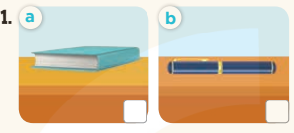  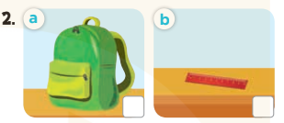  - T ask Ss to guess the answers.  + T writes Ss’guessing on the board.  - Listen to the tape:  + Play the recording  + Play the recording again and get Ss to swap books with their partners.  + Play the recording again to check answers together as a class.  + Write the answers on the board for Ss to correct their answers. Then checks Ss’ guessing.  - Play the recording, sentence by sentence, for the class to listen and repeat in chorus.  Key: 1. b2. a  Activity 2.Look, complete and read  *Aims: Ss will be abletoread and complete the four gapped sentences with the help of the picture cues.  *Procedure:  - Have Ss look at the picture cues and identify the school things (a pen, a book, a ruler and a school bag) 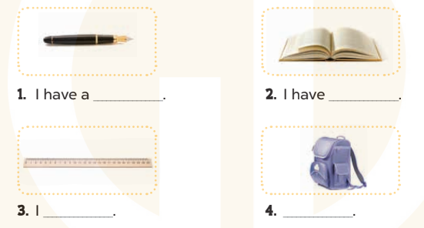  - Have Ss look at the four incomplete sentences. Elicit and model with picture 1  + Ask Ss to read the sentence 1 in chorus.  +Ask Ss what word is missing in the gap (pen). Then have them complete the sentence (I have a pen).  -Have Ss work in pairs and complete the sentences2, 3, 4.  - Ask a few Ss to stand up and read the sentences aloud.  -T gives feedbacks.  Key:  1. pen 2. a book  3. have a ruler  4. I have a school bag  Activity 3. Let’s sing  *Aims: Ss will be able tosing the song School things with the correct pronunciation and melody.  *Procedure:  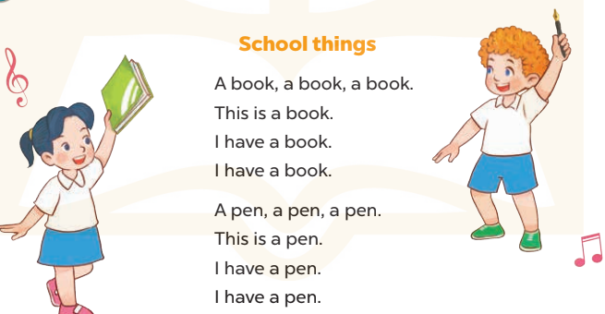  -Play the recording for Ss to listen to the whole song.  +Have them repeat the title and lyrics line by line.  +Tell Ss to point at the pictures while singing.  - Play the recording all the way through for Ss to listen to pronunciation and melody of the song.  - Play the recording line by line for Ss to listen, repeat and point to the pictures  - Play the recording for Ss to sing and do actions.  - Ask Ss to practice singing and doing actions in pairs or groups.  -Invite groups to the front of the classroom to perform the song  -T gives feedback.  *Consolidation  *Aims: Ss will be able consolidate and wrap up the content of the lesson.  *Procedure:  - T asks ss to answer the following questions:  + What have you learnt from the lesson today?  +What are the core values of the lesson? (if the teacher can take from the lesson).  - T praises some Ss who are hardworking / active/ good…. as well as encourage others to try more.  - Practice part 5 again.  - Prepare the new lesson: Unit 8, Lesson 2 (1,2,3). | - Ss listen  -Ss listen  - Ss arrange and read aloud  -Ss congratuate the winner  - Ss open their books  -Look at the pictures and say:  + Picture 1a:a book  + Picture1b:a pen  + Picture 2a:a school bag  + Picture 2b:a ruler  -Ss guess the answers  - Ss listen to the tape and tick  - Ss listen again, tick and swap books with their partners.  - Ss check their answers and guessing  -Ss listen and repeat.  -Ss look at the picture and say  -Ss look and answer  -Ss read  -Ss say and write  -Ss work in pairs and complete  -Ss read aloud  -Ss listen to the song  -Ss listen and repeat line by line without the action.  -Ss point to the pictures while singing  -Ss listen to melody of the song  - Ss listen and sing line by line.  - Ss sing and do actions.  + Ss work in groups (two groups) to sing.  -Ss performin front of the class.  -Ss listen  -Ss answer the questions  -Ss listen and clap their hands  -Ss listen and take note
D. ADJUSTMENTS (if necessary):
………………………………………………………………………………………….…..……………………………………………………………………………...………………………………………….…..……………………………………………………………………………….……………………………………………………………………...

Week 13 Preparing date: December …..,
Period 52 Teaching date: December …..,

Unit 8: My school things
Lesson 2 (1, 2, 3)
A. OBJECTIVES:
By the end of the lesson, Ss will be able to:
1. Knowledge:
- understand and correctly repeat the sentences in two communicative contexts (pictures) focusing on the questions and answers about having a school thing.
- correctly say the words and use Do you have ……..? − Yes, I do. / No, I don’t. to ask and answer questions about having a school thing.
- enhance the correct use of Do you have …………..? − Yes, I do. / No, I don’t. to ask and answer questions about having a school thing.
- Vocabulary:pencil, pencil case, notebook, eraser
- Skills: speaking and listening
2. Competences:
- Critical Thinking: self-introduce
-Co-operation: ready to help friends in pair work/ group work.
- Sociability: Talk to each other, say good words to others.
3. Attitude/ Qualities:
-Kindness:Help partners to complete learning tasks.
- Honesty: tell the truth about feelings and emotions
B. TEACHING AIDS:
- Teacher: Teacher’s guide Pages 103, 104, 105, audio Tracks 81,82, website sachmem.vn, posters, laptop, pictures, textbook, lesson plan, TV or projector.
- Students: Pupil’s book Page 58, notebooks, workbooks, school things.
C. PROCEDURES:
Stages/Time | Teacher’s activities | Students’ activities
1.Warm- up:  (3’)  2.Presentation  (16’)  3.Practice: (7’)  4.Production: (7’)  5. Homework. (2’) | Pass the school things.  *Aims: to create a friendly and active atmosphere in the class to beginning the lesson.  *Procedure:  - Review the previous lesson by having the class pass the school things with the music.  - When the music stops, those who have school things have to say the sentence: I have a …  - Say “Open your book page 52” and look at “Unit 8, Lesson 2 (1,2,3)”.  Activity 1. Vocabulary.  *Aims: Ss will be ableto know the vocabulary in front of starting the new lesson.  *Procedure:  -T elicits the new words  + pencil: bút chì (realia)  + pencil case: hộp bút(realia)  + notebook :quyển vở (realia)  + eraser : cục tẩy(realia)  - T models (3 times).  - T writes the words on the board.  - Checking: Rub out and remember  Activity 2. Look, listen and repeat:  *Aims: Ss will be ableto understand and correctly repeat the sentences in two communicative contexts (pictures) focusing on the questions and answers about having a school thing.  *Procedure:  - Have Ss look at Pictures a and b and identify names of the speakers in the pictures.  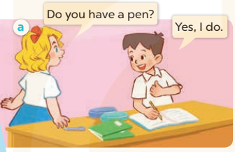  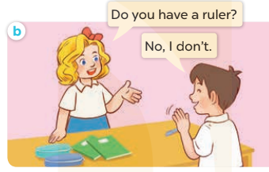  -Play the audio twice(sentence by sentence). Correct their pronunciation where necessary.  - Have Ss to practice the dialogue  -Tinvites a few pairs to the front of the class to practice.  - T checkspronunciation for ss.  Activity 32. Listen, point and say.  *Aims: Ss will be ableto correctly say the words and use Do you have ……….? − Yes, I do. / No, I don’t. to ask and answer questions about having a school thing.  *Procedure:  * Model sentences:  - T asks Ss look at picture a, band helps Ss know the structure from the dialogue.  - T introduces new structure for Ss.  - T explains,models and gives meaning.  -Have Ss repeat the model sentences.  A: Do you have a pen?  B: Yes, I do. / No, I don’t  *Drill pictures  - Have Ss look at the pictures and identify the school things.  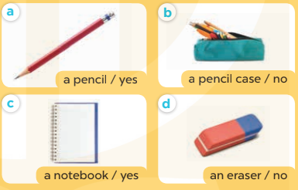  - Run through all the pictures.  - Run through model sentences.  +Run through question sentence  +Run through answer sentence  - Have Ss to practise:  + T asks, Ss answer picture a  +Ss asks, T answers picture b  + Group A ask, group B answer picture c  + Group B ask, group A answer picture d  - Ask Ss to work in pairs.  - T controls and corrects.  - Invite a few pairs to come to the front of the classroom and point at the pictures and say the questions and answers in front of the class.  - T gives feedbacks.  Activity 4. Let’s talk.  *Aims: Ss will be able to enhance the correct use of Do you have …….? − Yes, I do. / No, I don’t. to ask and answer questions about having a school thing.  *Procedure:  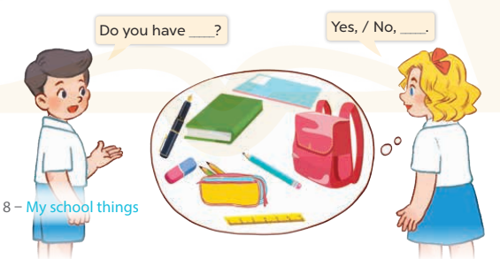  - Have Ss look at the picture and elicit the question and the answer in context.  +Who are they?  + What are they talking about?  - Put Ss work in pairs to ask and answer with with yes/ no  -Invite some pairs to the front of the classroom to take turns to hold up a school thing in their classroom.  *Consolidation  *Aims: Ss will be able consolidate and wrap up the content of the lesson.  *Procedure:  - T asks ss to answer the following questions:  + What have you learnt from the lesson today?  +What are the core values of the lesson? (if the teacher can take from the lesson).  - T review the vocabulary and model sentences.  - T praises some Ss who are hardworking / active/ good…. as well as encourage others to try more.  - Learn the vocabulary and model sentences by heart  - Prepare the new lesson: Unit 8, Lesson 2 (4,5,6). | - Ss listen  - Ss play game  -Ss open their books  -Ss listen and answer  - - Ss listen and repeat  + Choral repetition (3 times).  + Individual repetition (3 ss)  - Ss take note  - Ss look, remember and write  -Look at the pictures and say  + In picture a: Mary asks Minh if he has a pen: Do you have a pen? and he answers: Yes, I do.  + In picture b: Mary asks Minh if he has a ruler: Do you have a ruler? and he answers: No, I don’t.  -Ss listen and repeat in chorus (twice)  -Ss work in pairs to practice  -Ss practice the dialogue  -Ss listen  -Ss look at the picture and answer.  -Ss listen  -Ss listen and repeat  -Ss repeat  - Ss look, listen and answer  +Picture a: a pencil + Picture b: a pencil case  + Picture c: a notebook  + Picture d: an eraser  -Ss listen and repeat  -Ss practice in chorus  -Ss work in pairs to practice  -Ss point and say  -Ss listen.  -Ss look at the picture and answer  +Two pupils ask and answer the question about having a school thing (a book, a notebook, a school bag, an eraser, a pen, a pencil, a pencil case and a ruler.  -Ss work in pairs  -Ss ask and answer.  -Ss answer the questions  - Ss listen  -Ss listen and clap their hands  -Ss listen and take note
D. ADJUSTMENTS (if necessary):
………………………………………………………………………………………….…..……………………………………………………………………………...………………………………………….…..……………………………………………………………………………….……………………………………………………………………...

