Week 14 Preparing date: December …..,
Period 53 Teaching date: December …..,

Unit 8: My school things
Lesson 2(4, 5, 6)
A. OBJECTIVES:
By the end of the lesson, Ss will be able to:
1. Knowledge:
- listen to and understand four communicative contexts in which pupils ask and answer questions about having a school thing.
- read and match four simple exchanges with the correct pictures
- review vocabulary words for school things and use them in the sentence patterns Do you have ………...? and Yes, I do. / No, I don’t. by playing the matching game or Pelmanism.
- Vocabulary:Review
- Skills: speaking, listening, reading and writing.
2. Competences:
- Critical Thinking: self-introduce
-Co-operation: ready to help friends in pair work/ group work.
- Self-control and independent learning: perform listening tasks.
3. Attitude/ Qualities:
-Kindness:Help partners to complete learning tasks.
- Honesty: tell the truth about feelings and emotions.
- Diligence: complete learning tasks.
B. TEACHING AIDS:
- Teacher: Teacher’s guide Pages 105, 106, 107; audio Tracks 83; website sachmem.vn, posters, laptop, pictures, textbook, lesson plan, TV or projector.
- Students: Pupil’s book Page 59, notebooks, workbooks, school things.
C. PROCEDURES:
Stages/Time | Teacher’s activities | Students’ activities
1.Warm- up:  (5’)  2.Practice: (27’)  3. Homework. (3’) | Game: Who says fast?  *Aims: to create a friendly and active atmosphere in the class to beginning the lesson.  *Procedure:  - Hold a school thing card, then reveal it slowly.  - Ask What is it?  - Ask the Ss guess the answer as fast as possible.  - Then have Ss do the same with the rest.  - This can be played in groups to make it more interesting.  - Say “Open your book page 59” and look at “Unit 8, Lesson 2 (4,5,6)”.  Activity 1. Listenand number:  *Aims: Ss will be able tolisten to and understand four communicative contexts in which pupils ask and answer questions about having a school thing.  *Procedure:  - Elicit the words for the school thing in each picture.  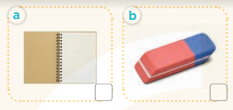  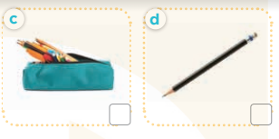  - T ask Ss to guess the answers.  + T writes Ss’guessing on the board.  - Listen to the tape:  + Play the recording  + Play the recording again and get Ss to swap books with their partners.  + Play the recording again to check answers together as a class.  + Write the answers on the board for Ss to correct their answers. Then checks Ss’ guessing.  - Play the recording, sentence by sentence, for the class to listen and repeat in chorus.  Key: 1. c 2. d 3. a 4. b  Activity 2.Read and match  *Aims: Ss will be abletoread and match four simple exchanges with the correct pictures.  *Procedure:  - Get Ss to look at the pictures andidentify the school things.  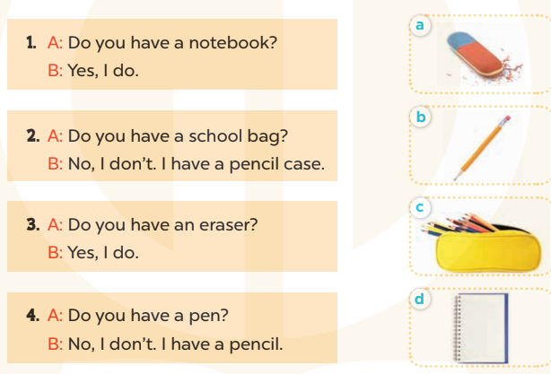  - Have Ss look at the four dialogues and the pictures. Elicit and model with number 1  + Get Ss to read number 1 in chorus. + Ask them what A and B are talking about.  + Write the word notebook on the board.  + Tell Ss to identify the picture of a notebook (Picture d).  + Then match number 1 with Picture d.  -Have Ss work in pairs and match the sentences2, 3, 4.  - Ask a few Ss to stand up and read the sentences aloud.  -T gives feedbacks.  Key:  1. d 2. c 3. a 4. b  - Activity 3. Let’s play  *Aims: Ss will be able toreview vocabulary words for school things and use them in the sentence patterns Do you have ………..? and Yes, I do. / No, I don’t. by playing the matching game or Pelmanism.  *Procedure:  - Explain how to play the game:  + Players take turns to flip over two matching cards.  + A picture matches with the name of the object in the picture.  For example,a picture of a pen matches with the word pen.  + If two cards match, they are left turned face up and the player scores one point.  + If they do not match, they are returned to their face down layout and play passes to the next player.  + Players that successfully match cards get to take another turn and try to match two more cards.  + This continues until that player fails to match a pair.  + The player with the most points is the winner.  - Set a time limit for Ss to play the game in pairs.  - When time runs out, show the cards one by one and invite a few pairs to ask and answer questions using the sentence patterns Do you have ………? And Yes, I do. / No, I don’t.  *Consolidation  *Aims: Ss will be able consolidate and wrap up the content of the lesson.  *Procedure:  - T asks ss to answer the following questions:  + What have you learnt from the lesson today?  +What are the core values of the lesson? (if the teacher can take from the lesson).  - T praises some Ss who are hardworking / active/ good…. as well as encourage others to try more.  - Practice part 5 again.  - Prepare the new lesson: Unit 8, Lesson 3 (1,2,3). | - Ss listen  - Ss play game  -Ss play game  - Ss open their books  -Look at the pictures and say:  + Picture a:a notebook  + Picture b:an esaser  + Picture c:a pencil case  + Picture d:a pencil.  -Ss guess the answers  - Ss listen to the tape and write  - Ss listen again, write and swap books with their partners.  - Ss check their answers and guessing  -Ss listen and repeat.  -Ss look at the picture and say  -Ss look and answer  -Ss read  -Ss answer  -Ss write  -Ss listen and match  -Ss work in pairs and complete  -Ss read aloud  - Ss listen  - Ss play game  -Ss ask and answer the questions  -Ss answer the questions  -Ss listen and clap their hands  -Ss listen and take note
D. ADJUSTMENTS (if necessary):
………………………………………………………………………………………….…..……………………………………………………………………………...………………………………………….…..……………………………………………………………………………….……………………………………………………………………...

Week 14 Preparing date: December …..,
Period 54 Teaching date: December …..,

Unit 8: My school things
Lesson 3 (1, 2, 3)
A. OBJECTIVES:
By the end of the lesson, Ss will be able to:
1. Knowledge:
- correctly repeat the sounds of the letter cluster oo and letter a in isolation, in the words book and eraser, and in the sentences I have a book. and Do you have an eraser? with correct pronunciation and intonation.
- identify the target words book and eraser while listening.
- say the chant with the correct rhythm and pronunciation.
- Vocabulary:Review
- Skills: speaking, listening, reading and writing.
2. Competences:
-Co-operation: ready to help friends in pair work/ group work.
- Sociability: Talk to each other, say good words to others.
3. Attitude/ Qualities:
-Kindness:Help partners to complete learning tasks.
- Honesty: tell the truth about feelings and emotions
B. TEACHING AIDS:
- Teacher: Teacher’s guide Pages 107, 108; audio Tracks 84, 85, 86; website sachmem.vn, posters, laptop, pictures, textbook, lesson plan, TV or projector.
- Students: Pupil’s book Page 60, notebooks, workbooks, school things.
C. PROCEDURES:
Stages/Time | Teacher’s activities | Students’ activities
1.Warm- up:  (5’)  2.Presentation  (9’)  3.Practice: (19’)  4. Homework. (2’) | Game: Find and circle the words  *Aims: to create a friendly and active atmosphere in the class to beginning the lesson.  *Procedure:  B O O K E P S C E T  H C T H N E H C R H  C L U A A N A O A I  L E L N N C T S S N  A A W K E I O E E K  S C H O O L I I R B  S R O E E C V C A H  L O O K I A S D A Y  D T S S R S O T S M  A C E B F E Z Y W  - Divide class into 2 groups  - Ask Ss to find and circle the words that they learnt.  - Which groups find the best correct words is winner.  - Give Ss time to play the game.  Rows: book, school, look  Columns: pencil case, eraser  -T checks who’s winner?  - Say “Open your book page 60” and look at “Unit 8, Lesson 3 (1,2,3)”.  Activity 1. Listen and repeat:  *Aims: Ss will be ableto correctly repeat the sounds of the letter cluster oo and letter a in isolation, in the words book and eraser, and in the sentences I have a book. and Do you have an eraser? with correct pronunciation and intonation.  *Procedure:  -T gives instruction to the letter ooand a, bookand erase, and in the sentences I have a book. and Do you have an eraser?  - Play the recording for the letter oo, a.  - Encourage Ss to point at the letter/ word/ sentence while listening.  - Play the recording again and encourage Ss to listen and repeat. - Do this several times until Ss feel confident.  - T calls some Ss to practice.  - T gives feedbacks.  Activity 2.Listen and circle.  *Aims: Ss will be ableto identify the target words book and eraser while listening.  *Procedure:  - Elicit the sentences and the gap-fill options.  - T ask Ss to guess the answers.  + T writes Ss’guessing on the board.  - Listen to the tape:  + Play the recording  + Play the recording again and get Ss to swap books with their partners.  + Play the recording again to check answers together as a class.  + Write the answers on the board for Ss to correct their answers. Then checks Ss’ guessing.  - Play the recording, sentence by sentence, for the class to listen and repeat in chorus.  -Invite one or two Ss to stand up and read the completed sentences.  Key: 1.b 2.c  Activity 3. Let’s chant  *Aims: Ss will be able to say the chant with the correct rhythm and pronunciation  *Procedure:  - Introducethe title and lyrics of the chant.  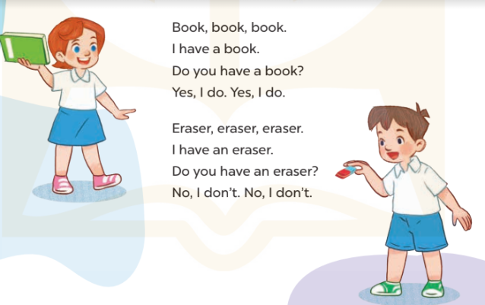  -Play the recording for Ss to listen to the whole chant.  +Have them repeat the title and lyrics line by line.  +Ask Ss to attend to the sounds of the letters ooand a and the words bookand eraser.  - Play the recording all the way through for Ss to listen to pronunciation and melody.  - Play the recording line by line for Ss to listen and repeat  - Play the recording for Ss to chant and clap along.  - Ask Ss to practice chant and clap along in pairs or groups.  -Invite groups to the front of the classroom to perform the chant  -T gives feedback.  *Consolidation  *Aims: Ss will be able consolidate and wrap up the content of the lesson.  *Procedure:  - T asks ss to answer the following questions:  + What have you learnt from the lesson today?  +What are the core values of the lesson? (if the teacher can take from the lesson).  - T praises some Ss who are hardworking / active/ good…. as well as encourage others to try more.  - Practice the chant more.  - Collect three school things  - Prepare the new lesson: Unit 8, Lesson 3 (4,5,6). | - Ss listen  -Ss play game  - Ss open their books  -Ss recognize the differences about color of letter  - - Ss listen  - Ss listen and point  - Ss listen again and repeat  -Ss listen again and repeat  -Ss practice  -Ss listen  -Ss listen and say:  + Number 1: I have .…….  + Number 2: Do you have …?  -Ss guess the answers  - Ss listen to the tape and circle  - Ss listen again, circle and swap books with their partners.  - Ss check their answers and guessing  -Ss listen and repeat.  -Ss read the sentences  - Ss look and listen.  -Ss listen to the chant  -Ss listen and repeat line by line without clap their hands  -Ss note the sounds, words  -Ss listen to melody of the chant  - Ss listen and chantline by line.  - Ss chant andclap along.  - Ss work in groups (two groups) to chant  -Ss performin front of the class.  -Ss listen  -Ss listen.  -Ss answer the questions  -Ss listen and clap their hands  -Ss listen and take note

D. ADJUSTMENTS (if necessary):
………………………………………………………………………………………….…..……………………………………………………………………………...………………………………………….…..……………………………………………………………………………….……………………………………………………………………...

Week 14 Preparing date: December …..,
Period 55 Teaching date: December …..,

Unit 8: My school things
Lesson 3 (4, 5, 6)
A. OBJECTIVES:
By the end of the lesson, Ss will be able to:
1. Knowledge:
-read and complete a gapped paragraph with the words provided.
- read, understand and complete the writing frame with Ss’ information.
- collect three school things from home and bring them to the classroom to present to their classmates
- Vocabulary:Review
- Skills: speaking, listening, reading and writing.
2. Competences:
- Listening: Listen to the teacher and classmates in communicating.
- Critical Thinking: complete a task in reading a text.
-Co-operation: ready to help friends in pair work/ group work.
- Self-control and independent learning: perform listening tasks.
3. Attitude/ Qualities:
-Kindness:Help partners to complete learning tasks.
- Honesty: tell the truth about feelings and emotions.
- Diligence: complete learning tasks.
B. TEACHING AIDS:
- Teacher: Teacher’s guide Pages 109, 110; website sachmem.vn, posters, laptop, pictures, textbook, lesson plan, TV or projector.
- Students: Pupil’s book Page 61, notebooks, workbooks, school things.
C. PROCEDURES:
Stages/Time | Teacher’s activities | Students’ activities
1.Warm- up:  (5’)  2.Practice: (8’)  3.Production: (19’)  4. Homework. (3’) | Game: “Chant”  *Aims: to review the vocabulary and structure about greet and respond to greetings.  *Procedure:  - Ask Ss chant and do the actions in Unit 8, Lesson 3 page 60in groups.  - Give point for the groups and encourage them.  - Say “Open your book page 61” and look at “Unit 8, Lesson 3 (4,5,6)”.  Activity 1. Read and complete:  *Aims: Ss will be abletoread and complete a gapped paragraph with the words provided.  *Procedure:  - Elicit and introduce the paragraph to complete  - Elicit the missing word for the first gap (have)  - Then tell Ss to pay attention to the article a / an to select appropriate nouns in the box for the next two gaps  - Give Ss time to do the rest individually or in pairs.  - Tell Ss to swap their answers with a partner.  - Check answers as a class. Write the correct answers on the board for Ss to correct their answers.  - Have Ss read the text aloud.  Key: 1. have 2. pen 3. eraser 4. my  Activity 2.Let’s write  *Aims: Ss will be ableto read, understand and complete the writing frame with pupils’ information *Procedure:  - Write the writing frame on the board.  - Have Ss read the sentences in chorus.  - When you reach the first gap, point to it and tell Ss to complete it with their name.  - Then read the next line and tell them to complete each gap with the school things they have.  - Give Ss time to do the task.  - Invite a few Ss to stand up and read their writing aloud.  Key: Pupils’ answer  Activity 3. Project.  *Aims: Ss will be able to collect three school things from home and bring them to the classroom to present to their classmates.  *Procedure:  - Tell Ss about the activity.  - Check their school things.  - Draw a school thing on the board and write the presentation language under it.  - Check comprehension and give feedback.  - Have Ss repeat the sentences until they can say them by themselves.  - Invite a pupil to the front of the class to model the presentation.  -Watch and offer your support with the language.  - Put Ss into groups to rehearse their presentation.  - Invite a few Ss from different groups to show and talk about their school things in front of the class.  - Create a class display of school things and vote for the best presentation.  *Consolidation  *Aims: Ss will be able consolidate and wrap up the content of the lesson.  *Procedure:  - T asks ss to answer the following questions:  + What have you learnt from the lesson today?  +What are the core values of the lesson? (if the teacher can take from the lesson).  - T praises some Ss who are hardworking / active/ good…. as well as encourage others to try more.  - Prepare the new lesson: Unit 9, Lesson 1 (1, 2, 3). | - Ss listen and chant  - Ss open their books  - Ss look at the pictures and answer  -Ss read and complete the first sentence  -Ss listen and answer  -Ss do the task  -Ss swap their answers  -Ss check their answer  -Ss read aloud  -Ss look and listen  -Ss read  -Ss write  -Ss do the task  My name is…….Look at my school things. I have……..  and……….  -Ss listen and repeat  - Ss listen  -Ss listen  - Ss look and note  -Ss listen and answer  -Ss repeat the sentences  -Ss present  -Ss listen  -Ss present into groups  -Ss talk about their school things  -Ss vote for the best presentation  -Ss answer the questions  -Ss listen and clap their hands  -Ss listen and take note
D. ADJUSTMENTS (if necessary):
………………………………………………………………………………………….…..……………………………………………………………………………...…………

Week 14 Preparing date: December …..,
Period 56 Teaching date: December …..,

Unit 9: Colours
Lesson 1 (1, 2, 3)
A. OBJECTIVES:
By the end of the lesson, Ss will be able to:
1. Knowledge:
- use the words blue, brown, red, yellow related to the topic “colours”
- use What colour is it? – It’s ………to ask and answer questions about colours of school things
- Vocabulary:blue, brown, red, yellow, colour
- Skills: speaking and listening
2. Competences:
- Self-control and independent learning: perform listening tasks.
- Communication and collaboration: work in pairs or groups.
- Sociability: talk to each other, say good words to others.
3. Attitude/ Qualities:
-Kindness:Help partners to complete learning tasks.
- Honesty: tell the truth about feelings and emotions
B. TEACHING AIDS:
- Teacher: Teacher’s guide Pages 111, 112, audio Tracks 87,88, website sachmem.vn, posters, laptop, pictures, textbook, lesson plan, TV or projector.
- Students: Pupil’s book Page 62, notebooks, workbooks, school things.
C. PROCEDURES:
Stages/Time | Teacher’s activities | Students’ activities
1.Warm- up:  (3’)  2.Presentation  (16’)  3.Practice: (7’)  4.Production: (7’)  5. Homework. (2’) | Jigsaw puzzle  *Aims: to create a friendly and active atmosphere in the class to beginning the lesson.  *Procedure:  - Divide class into 4 groups: Tom, Jerry, Miu and Chit.  - Ask Ss look at the pieces of picture.    - Ask Ss go to the board and jigsaw puzzle into the correct picture.  -T checks who’s the winner?  - Say “Open your book page 62” and look at “Unit 9, Lesson 1 (1,2,3)”.  Activity 1. Vocabulary.  *Aims: Ss will be ableto know the vocabulary in front of starting the new lesson.  *Procedure:  -T elicits the new words  + blue : màu xanh da trời  (visual)  + brown: màu nâu(visual)  + red:màu đỏ(visual)  + yellow : màu vàng(visual)  + colour: màu sắc (translation)  - T models (3 times).  - T writes the words on the board.  - Checking: Rub out and remember  Activity 2. Look, listen and repeat:  *Aims: Ss will be ableto understand and correctly repeat the sentences in two communicative contexts (pictures) to talk about colours.  *Procedure:  - Have Ss look at Pictures a and b and identify the characters(Minh and Mary) in the pictures.  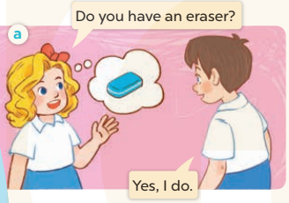  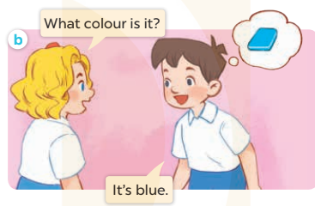  -Play the audio twice(sentence by sentence). Correct their pronunciation where necessary.  - Have Ss to practice the dialogue  -Tinvites a few pairs to the front of the class to practice.  - T checkspronunciation for ss.  Activity 32. Listen, point and say.  *Aims: Ss will be ableto correctly use What colour is it? It’s ……. for asking and answering questions about the colours of school things.  *Procedure:  * Model sentences:  - T asks Ss look at picture band helps Ss know the structure from the dialogue.  - T introduces new structure for Ss.  - T explains,models and gives meaning.  -Have Ss repeat the model sentences.  A: What colours is it?  B: It’sblue.  *Drill pictures  - Have Ss look at the pictures and identify the names of the school things in the pictures  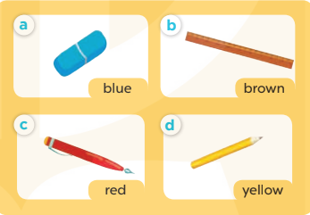  - Run through all the pictures.  - Run through model sentences.  +Run through question sentence  +Run through answer sentence  - Have Ss to practise:  + T asks, Ss answer picture a  +Ss asks, T answers picture b  + Group A ask, group B answer picture c  + Group B ask, group A answer picture d  - Ask Ss to work in pairs.  - T controls and corrects.  - Invite a few pupils to stand up, point at each school thing in the picture and say the sentence aloud.  - T gives feedbacks.  Activity 4. Let’s talk.  *Aims: Ss will be ableto enhance the correct use of What colour is it? – It’s …….. for asking and answering questions about the colour of a school thing.  *Procedure:  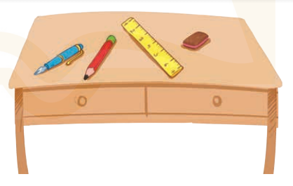  - Have Ss look at the picture and elicit the question and the answer in context.  +What are they?  + Where are they?  + What colours is it?  - Have Ss look at the school things on the desk and say their names, and then their colours.  - Have Ss look at the first speech bubble and read What colour are they?  - Then have them point at the school bags and complete the gapped answer in the second bubble (Ex:They’re black.). After that, let them say the question and the answer.  - Give Ss time to practise asking and answering the question What colour are they? – ……. in pairs.  - Invite a few pairs to practise asking and answering questions about the colours of the school things on the desk in front of the class.  - If time allows, let Ss point at the school things around them, ask and answer questions about their colours.  *Consolidation  *Aims: Ss will be able consolidate and wrap up the content of the lesson.  *Procedure:  - T asks ss to answer the following questions:  + What have you learnt from the lesson today?  +What are the core values of the lesson? (if the teacher can take from the lesson).  - T review the vocabulary and model sentences.  - T praises some Ss who are hardworking / active/ good…. as well as encourage others to try more.  - Learn the vocabulary and model sentences by heart  - Prepare the new lesson: Unit 9, Lesson 1 (4,5,6). | - Ss listen  -Ss look at the pieces of the picture  -Ss put into the correct picture  -Ss check  -Ss open their books  -Ss listen and answer  - - Ss listen and repeat  + Choral repetition (3 times).  + Individual repetition (3 ss)  - Ss take note  - Ss look, remember and write  -Look at the pictures and say  + In picture a: Mary asks Minh: Do you have an eraser?  Minh replies: Yes, I do.  + In picture b: Mary asks Minh: What colour is it?  Minh replies: It’s blue.  -Ss listen and repeat in chorus (twice)  -Ss work in pairs to practice  -Ss practice the dialogue  -Ss listen  -Ss look at the picture and answer.  -Ss listen  -Ss listen and repeat  -Ss repeat  - Ss look, listen and answer  +Picture a: a blue eraser + Picture b:a brown ruler  + Picture c:a red pen  + Picture d: a yellow pencil  -Ss listen and repeat  -Ss practice in chorus, individuals.  -Ss work in pairs  -Ss point and say  -Ss listen.  -Ss look at the picture and answer  +a blue pen, a red pencil, a yellow ruler, and a brown eraser on a desk.  -Ss point and say  -Ss read the sentence  -Ss point and complete  -Ss ask and answer  -Ss work in pairs, point and ask and answer  -SS practice to ask amd amswer  -Ss ask and answer about their colours  -Ss answer the questions  - Ss listen  -Ss listen and clap their hands  -Ss listen and take note
D. ADJUSTMENTS (if necessary):
………………………………………………………………………………………….…..……………………………………………………………………………...………………………………………….…..……………………………………………………………………………….……………………………………………………………………...

