Week 15 Preparing date: December …..,
Period 57 Teaching date: December …..,

Unit 9: Colours
Lesson 1 (4, 5, 6)
A. OBJECTIVES:
By the end of the lesson, Ss will be able to:
1. Knowledge:
- listen to and demonstrate understanding of simple exchanges related to the topic “Colours”
- read and write about colours of school things.
- Vocabulary:Review
- Skills: speaking, listening, reading and writing.
2. Competences:
- Written Communication: complete the sentences.
- Self-control and independent learning: perform listening tasks.
- Communication and collaboration: work in pairs or groups.
3. Attitude/ Qualities:
-Kindness:Help partners to complete learning tasks.
- Honesty: tell the truth about feelings and emotions.
- Diligence: complete learning tasks.
B. TEACHING AIDS:
- Teacher: Teacher’s guide Pages 113, 114; audio Tracks 89; website sachmem.vn, posters, laptop, pictures, textbook, lesson plan, TV or projector.
- Students: Pupil’s book Page 63, notebooks, workbooks, school things.
C. PROCEDURES:
Stages/Time | Teacher’s activities | Students’ activities
1.Warm- up:  (5’)  2.Practice: (27’)  3. Homework. (3’) | Slap the board  *Aims: to create a friendly and active atmosphere in the class to beginning the lesson.  *Procedure:  - Divide class into 2 groups: Tom and Jerry.  - How to play:  + Each group chooses five Ss to play.  + Class will read aloud.  + Look at the picture, listen and slap the picture you heard.  + Who faster will get 1 mark.  + Which group with higher mark is the winner.  - T gives feedback.  - Say “Open your book page 63” and look at “Unit 9, Lesson 1 (4,5,6)”.  Activity 1. Listenand tick:  *Aims: Ss will be abletolisten to and understand two communicative contexts in which pupils ask and answer questions about colours of school things and tick the correct pictures.  *Procedure:  - Elicit the name of the school thing in each picture.  - Check comprehensionthe difference between the two pictures.  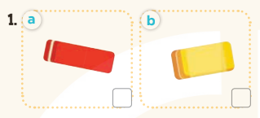  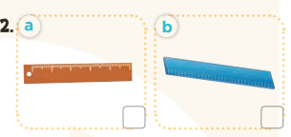  - T ask Ss to guess the answers.  + T writes Ss’guessing on the board.  - Listen to the tape:  + Play the recording  + Play the recording again and get Ss to swap books with their partners.  + Play the recording again to check answers together as a class.  + Write the answers on the board for Ss to correct their answers. Then checks Ss’ guessing.  - Play the recording, sentence by sentence, for the class to listen and repeat in chorus.  Key: 1. b2. a  Activity 2.Look, complete and read  *Aims: Ss will be abletocomplete the four gapped dialogues with the help of the picture cues  *Procedure:  - Have Ss look at the picture cues and identify the school things and their colours 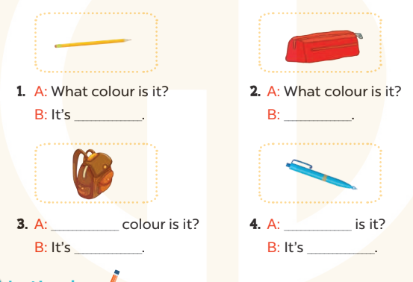  - Have Ss look at the four incomplete sentences. Elicit and model with picture 1  + Ask Ss to read the sentence 1 in chorus.  +Ask Ss what word is missing in the gap (yellow). Then have them complete the sentence (It’s yellow).  -Have Ss work in pairs and complete the sentences2, 3, 4.  - Ask a few Ss to stand up and read the sentences aloud.  -T gives feedbacks.  Key:  1. yellow 2. It’s red.  3. What; brown  4. What colour; blue  Activity 3. Let’s play  *Aims: Ss will be able torevise the target vocabulary items through the puzzle, then ask and answer questions about the colours of school things.  *Procedure:  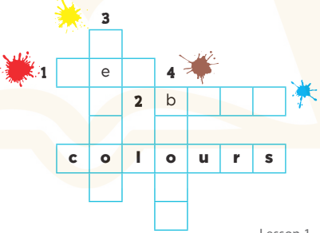  -Tell Ss the goal of the game and how to play it.  - Then have them look at the word colours and the colour clues to find appropriate letters to complete the words.  - Give Ss a time limit to do the puzzle individually.  - Have Ss work in pairs. One points and asks What colour is it?It’s ….  -T gives feedback.  Key: 1. red 2. blue  3. yellow 4. brown  *Consolidation  *Aims: Ss will be able consolidate and wrap up the content of the lesson.  *Procedure:  - T asks ss to answer the following questions:  + What have you learnt from the lesson today?  +What are the core values of the lesson? (if the teacher can take from the lesson).  - T praises some Ss who are hardworking / active/ good…. as well as encourage others to try more.  - Practice part 5 again.  - Prepare the new lesson: Unit 9, Lesson 2 (1,2,3). | - Ss listen  -Ss listen  - Ss play game  -Ss congratuate the winner  - Ss open their books  -Look at the pictures and say:  + Picture 1a:a red eraser  + Picture1 b:an yellow eraser  + Picture 2a:a brown ruler  + Picture 2b:a blue ruler  -Ss guess the answers  - Ss listen to the tape and tick  - Ss listen again, tick and swap books with their partners.  - Ss check their answers and guessing  -Ss listen and repeat.  -Ss look at the picture and say  + a yellow pencil, a red pencil case, a brown school bag and a blue pen.  -Ss look and answer  -Ss read  -Ss say and write  -Ss work in pairs and complete  -Ss read aloud  -Ss listen  -Ss look and find the letter to complete  - Ss do the puzzle  - Ss work in pairs to ask and answer  -Ss listen  -Ss answer the questions  -Ss listen and clap their hands  -Ss listen and take note
D. ADJUSTMENTS (if necessary):
………………………………………………………………………………………….…..……………………………………………………………………………...………………………………………….…..……………………………………………………………………………….……………………………………………………………………...

Week 15 Preparing date: December …..,
Period 58 Teaching date: December …..,

Unit 9: Colours
Lesson 2 (1, 2, 3)
A. OBJECTIVES:
By the end of the lesson, Ss will be able to:
1. Knowledge:
- use the words orange, green, white and black related to the topic “colours”
- use What colour are they? – They’re ……… to ask and answer questions about colours of school things
- Vocabulary:orange, green, white and black
- Skills: speaking and listening
2. Competences:
- Self-control and independent learning: perform listening tasks.
- Communication and collaboration: work in pairs or groups.
- Sociability: talk to each other, say good words to others.
3. Attitude/ Qualities:
-Kindness:Help partners to complete learning tasks.
- Honesty: tell the truth about feelings and emotions
B. TEACHING AIDS:
- Teacher: Teacher’s guide Pages 115, 116, audio Tracks 90, 91, website sachmem.vn, posters, laptop, pictures, textbook, lesson plan, TV or projector.
- Students: Pupil’s book Page 64, notebooks, workbooks, school things.
C. PROCEDURES:
Stages/Time | Teacher’s activities | Students’ activities
1.Warm- up:  (3’)  2.Presentation  (16’)  3.Practice: (7’)  4.Production: (7’)  5. Homework. (2’) | Lucky number  *Aims: to create a friendly and active atmosphere in the class to beginning the lesson.  *Procedure:  - Divide the class into 2 teams (boys and girls).  - Each team takes turns to choose a number.  - They need to ask and answer with the picture corresponding to that number to get points.  - The group with more points at the end of the game will be the winner.  - Praise the winner, encourage the other team.  - Say “Open your book page 64” and look at “Unit 9, Lesson 2 (1,2,3)”.  Activity 1. Vocabulary.  *Aims: Ss will be ableto know the vocabulary in front of starting the new lesson.  *Procedure:  -T elicits the new words  + orange: màu xanh da trời  (visual)  + green: màu nâu (visual)  + white:màu đỏ (visual)  + black : màu vàng (visual)  - T models (3 times).  - T writes the words on the board.  - Checking: Rub out and remember  Activity 2. Look, listen and repeat:  *Aims: Ss will be ableto understand and correctly repeat the sentences in two communicative contexts (pictures) to talk about colours.  *Procedure:  - Have Ss look at Pictures a and b and identify the characters(Minh and Lucy) in the pictures.  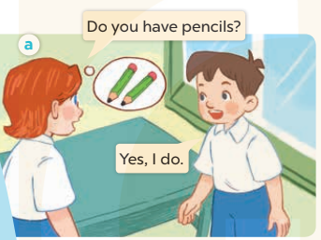  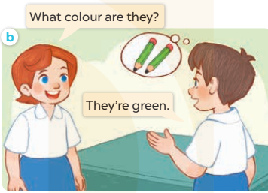  -Play the audio twice(sentence by sentence). Correct their pronunciation where necessary.  - Have Ss to practice the dialogue  -Tinvites a few pairs to the front of the class to practice.  - T checkspronunciation for ss.  Activity 32. Listen, point and say.  *Aims: Ss will be ableto correctly use What colour are they? They’re …….. for asking and answering questions about the colours of school things.  *Procedure:  * Model sentences:  - T asks Ss look at picture band helps Ss know the structure from the dialogue.  - T introduces new structure for Ss.  - T explains,models and gives meaning.  -Have Ss repeat the model sentences.  A: What colours are they?  B: They’reorange.  *Drill pictures  - Have Ss look at the pictures and identify the names and colours of the school things in the pictures  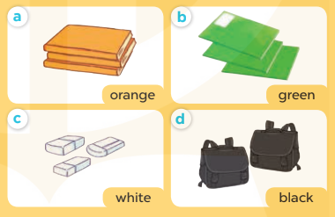  - Run through all the pictures.  - Run through model sentences.  +Run through question sentence  +Run through answer sentence  - Have Ss to practise:  + T asks, Ss answer picture a  +Ss asks, T answers picture b  + Group A ask, group B answer picture c  + Group B ask, group A answer picture d  - Ask Ss to work in pairs.  - T controls and corrects.  - Invite a few pupils to stand up, point at each school thing in the picture and say the sentence aloud.  - T gives feedbacks  Activity 4. Let’s talk.  *Aims: Ss will be abletocorrectly use What colour are they? They’re …... for asking and answering questions about the colours of school things.  *Procedure:  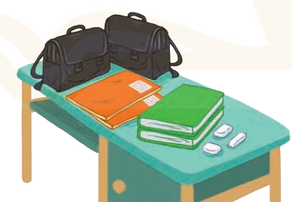  - Have Ss look at the picture and elicit the question and the answer in context.  +What are they?  + Where are they?  + What colours are they?  - Have Ss look at the school things on the desk and say their names, and then their colours.  - Have Ss look at the first speech bubble and read What colour are they?  - Then have them point at the school bags and complete the gapped answer in the second bubble (Ex:They’re black.). After that, let them say the question and the answer.  - Give Ss time to practise asking and answering the question What colour are they? – ……. in pairs.  - Invite a few pairs to practise asking and answering questions about the colours of the school things on the desk in front of the class.  - If time allows, let Ss point at the school things around them, ask and answer questions about their colours.  *Consolidation  *Aims: Ss will be able consolidate and wrap up the content of the lesson.  *Procedure:  - T asks ss to answer the following questions:  + What have you learnt from the lesson today?  +What are the core values of the lesson? (if the teacher can take from the lesson).  - T review the vocabulary and model sentences.  - T praises some Ss who are hardworking / active/ good…. as well as encourage others to try more.  - Learn the vocabulary and model sentences by heart  - Prepare the new lesson: Unit 9, Lesson 2 (4,5,6). | - Ss listen  -Ss play game  -Ss clap the hands  -Ss open their books  -Ss listen and answer  - - Ss listen and repeat  + Choral repetition (3 times).  + Individual repetition (3 ss)  - Ss take note  - Ss look, remember and write  -Look at the pictures and say  + In picture a: Lucy asks Minh if he has pencils. Minh says that he does.  + In picture b: Lucy asks Minh: What colour are they?  Minh answers: They’re green.  -Ss listen and repeat in chorus (twice)  -Ss work in pairs to practice  -Ss practice the dialogue  -Ss listen  -Ss look at the picture and answer.  -Ss listen  -Ss listen and repeat  -Ss repeat  - Ss look, listen and answer  +Picture a: some orange books  + Picture b:some green notebooks  + Picture c:three white pencil cases  + Picture d: two black school bags  -Ss listen and repeat  -Ss practice in chorus, individuals.  -Ss work in pairs  -Ss point and say  -Ss listen.  -Ss look at the picture and answer  +two black school bags, two orange notebooks, two green books and three white erasers on a desk.  -Ss point and say  -Ss read the sentence  -Ss point and complete  -Ss ask and answer  -Ss work in pairs, point and ask and answer  -SS practice to ask amd amswer  -Ss ask and answer about their colours  -Ss answer the questions  - Ss listen  -Ss listen and clap their hands  -Ss listen and take note
D. ADJUSTMENTS (if necessary):
………………………………………………………………………………………….…..……………………………………………………………………………...………………………………………….…..……………………………………………………………………………….……………………………………………………………………...

Week 15 Preparing date: December …..,
Period 59 Teaching date: December …..,

Unit 9: Colours
Lesson 2(4, 5, 6)
A. OBJECTIVES:
By the end of the lesson, Ss will be able to:
1. Knowledge:
- listen to and demonstrate understanding of simple exchanges related to the topic “Colours”
- read and write about colours of school things.
- Vocabulary:Review
- Skills: speaking, listening, reading and writing.
2. Competences:
- Critical Thinking: look, complete and read
-Co-operation: ready to help friends in pair work/ group work.
- Self-control and independent learning: perform listening tasks.
3. Attitude/ Qualities:
-Kindness:Help partners to complete learning tasks.
- Honesty: tell the truth about feelings and emotions.
- Diligence: complete learning tasks.
B. TEACHING AIDS:
- Teacher: Teacher’s guide Pages 116, 117; audio Tracks 92, 93; website sachmem.vn, posters, laptop, pictures, textbook, lesson plan, TV or projector.
- Students: Pupil’s book Page 65, notebooks, workbooks, school things.
C. PROCEDURES:
Stages/Time | Teacher’s activities | Students’ activities
1.Warm- up:  (5’)  2.Practice: (27’)  3. Homework. (3’) | Game: Who says fast?  *Aims: to create a friendly and active atmosphere in the class to beginning the lesson.  *Procedure:  - Hold a school thing card, then reveal it slowly.  - Ask What is it?  - Ask the Ss guess the answer as fast as possible.  - Then have Ss do the same with the rest.  - This can be played in groups to make it more interesting.  - Say “Open your book page 59” and look at “Unit 9, Lesson 2 (4,5,6)”.  Activity 1. Listenand number:  *Aims: Ss will be able tolisten to and understand four communicative contexts in which the characters ask and answer questions about the colours of school things and number the correct pictures.  *Procedure:  - Elicit the names and cloursof the school thing in each picture.  +What is this?  + What colour is it?  + What are these?  + What colour are they?  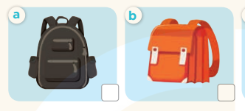  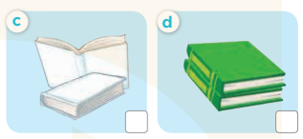  - T ask Ss to guess the answers.  + T writes Ss’guessing on the board.  - Listen to the tape:  + Play the recording  + Play the recording again and get Ss to swap books with their partners.  + Play the recording again to check answers together as a class.  + Write the answers on the board for Ss to correct their answers. Then checks Ss’ guessing.  - Play the recording, sentence by sentence, for the class to listen and repeat in chorus.  Key: 1. b 2. d 3. c 4. a  Activity 2.Look, complete and read  *Aims: Ss will be able to complete the four gapped dialogues with the help of the picture cues  *Procedure:  - Get Ss to look at the pictures andidentify the names and colours of theschool things.  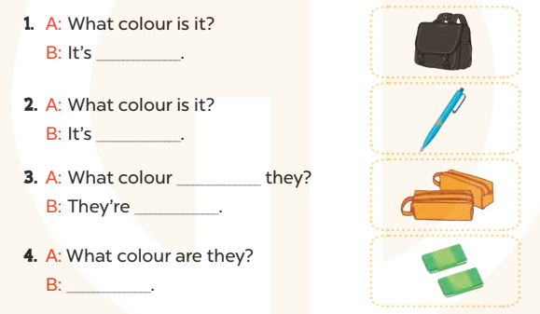  - Have Ss look at the four dialogues and the pictures. Elicit and model with number 1  + Get Ss to read number 1 in chorus. + Ask them what A and B are talking about.  + Write the word notebook on the board.  + Tell Ss to identify the picture of a notebook (black).  + Then writenumber 1 with black  -Have Ss work in pairs and match the sentences2, 3, 4.  - Ask a few Ss to stand up and read the sentences aloud.  -T gives feedbacks.  Key:  1. black 2. blue  3. are; orange 4. They’re green.  Activity 3. Let’s sing  *Aims: Ss will be able tosing the song Colours with the correct pronunciation, rhythm, and melody.  *Procedure:  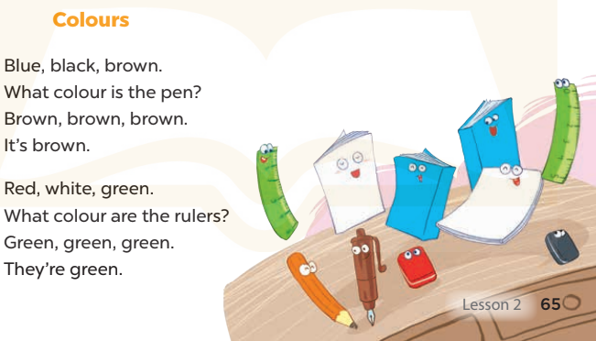  - Introducethe title and lyrics of the song and check comprehension.  + What is the song about?  + What colour is the pen?  + What colour are the rulers?  -Play the recording for Ss to listen to the whole song.  +Have them repeat the title and lyrics line by line.  +Tell Ss to point at the pictures while singing.  - Play the recording all the way through for Ss to listen to pronunciation and melody of the song.  - Play the recording line by line for Ss to listen, repeat and point to the pictures  - Play the recording for Ss to sing and do actions.  - Ask Ss to practice singing and doing actions in pairs or groups.  -Invite groups to the front of the classroom to perform the song  -T gives feedback.  *Consolidation  *Aims: Ss will be able consolidate and wrap up the content of the lesson.  *Procedure:  - T asks ss to answer the following questions:  + What have you learnt from the lesson today?  +What are the core values of the lesson? (if the teacher can take from the lesson).  - T praises some Ss who are hardworking / active/ good…. as well as encourage others to try more.  - Practice part 5 again.  - Prepare the new lesson: Unit 9, Lesson 3 (1,2,3). | - Ss listen  - Ss play game  -Ss play game  - Ss open their books  -Look at the pictures and say:  + Picture a:a black school bag  + Picture b:an orange school bag  + Picture c:two white books  + Picture d:two green books  -Ss guess the answers  - Ss listen to the tape and write  - Ss listen again, write and swap books with their partners.  - Ss check their answers and guessing  -Ss listen and repeat.  -Ss look at the picture and say  -Ss look and answer  -Ss read  -Ss answer  -Ss write  -Ss listen and match  -Ss work in pairs and complete  -Ss read aloud  -Ss listen and answer  -Ss listen to the song  -Ss listen and repeat line by line without the action.  -Ss point to the pictures while singing  -Ss listen to melody of the song  - Ss listen and sing line by line.  - Ss sing and do actions.  + Ss work in groups (two groups) to sing.  -Ss performin front of the class.  -Ss listen  -Ss answer the questions  -Ss listen and clap their hands  -Ss listen and take note
D. ADJUSTMENTS (if necessary):
………………………………………………………………………………………….…..……………………………………………………………………………...………………………………………….…..……………………………………………………………………………….……………………………………………………………………...

Week 15 Preparing date: December …..,
Period 60 Teaching date: December …..,

Unit 9: Colours
Lesson 3 (1, 2, 3)
A. OBJECTIVES:
By the end of the lesson, Ss will be able to:
1. Knowledge:
- correctly repeat the sounds of the letterbl and letter br in isolation, in the words blue and brown, and in the sentences My school bag is blue. and The pencil cases are brown. with correct pronunciation and intonation.
- listen to two sentences and circle the correct options to complete the gaps in two gapped sentences.
- say the chant with the correct rhythm and pronunciation.
- Vocabulary:Review
- Skills: speaking, listening, reading and writing.
2. Competences:
-Co-operation: ready to help friends in pair work/ group work.
- Sociability: Talk to each other, say good words to others.
3. Attitude/ Qualities:
-Kindness:Help partners to complete learning tasks.
- Honesty: tell the truth about feelings and emotions
B. TEACHING AIDS:
- Teacher: Teacher’s guide Pages 118, 119; audio Tracks 94, 95, 96; website sachmem.vn, posters, laptop, pictures, textbook, lesson plan, TV or projector.
- Students: Pupil’s book Page 66, notebooks, workbooks, school things.
C. PROCEDURES:
Stages/Time | Teacher’s activities | Students’ activities
1.Warm- up:  (5’)  2.Presentation  (9’)  3.Practice: (19’)  4. Homework. (2’) | Game: Find and circle the words  *Aims: to create a friendly and active atmosphere in the class to beginning the lesson.  *Procedure:  *Procedure:  B M V K E P S C B T  L C T H N E B C L H  U L U A A V L O O I  E E L N N N A S U N  A B R E A K C E S K  S C D K O K K I E B  S R O E E C V C A H  L H B R O W N D A Y  D T S S R S O T S M  A C E B F Z Z Y W  - Divide class into 2 groups  - Ask Ss to find and circle the words that they learnt.  - Which groups find the best correct words is winner.  - Give Ss time to play the game.  Rows: brown, break  Columns: blue, brown, blouse  -T checks who’s winner?  - Say “Open your book page 66” and look at “Unit 9, Lesson 3 (1,2,3)”.  Activity 1. Listen and repeat:  *Aims: Ss will be ableto correctly repeat the sounds of the letterbl and letter br in isolation, in the words blue and brown, and in the sentences My school bag is blue. and The pencil cases are brown. with correct pronunciation and intonation.  *Procedure:  -T gives instruction to the letter bland br, blueandbrown , and in the sentences My school bag is blue. and The pencil cases are brown.  - Play the recording for the letter bl, br.  - Encourage Ss to point at the letter/ word/ sentence while listening.  - Play the recording again and encourage Ss to listen and repeat. - Do this several times until Ss feel confident.  - T calls some Ss to practice.  - T gives feedbacks.  Activity 2.Listen and circle.  *Aims: Ss will be ableto identify the target words blue and brown while listening.  *Procedure:  - Elicit the sentences and the gap-fill options.  - T ask Ss to guess the answers.  + T writes Ss’guessing on the board.  - Listen to the tape:  + Play the recording  + Play the recording again and get Ss to swap books with their partners.  + Play the recording again to check answers together as a class.  + Write the answers on the board for Ss to correct their answers. Then checks Ss’ guessing.  - Play the recording, sentence by sentence, for the class to listen and repeat in chorus.  -Invite one or two Ss to stand up and read the completed sentences.  Key: 1.b 2.b  Activity 3. Let’s chant  *Aims: Ss will be able to say the chant with the correct rhythm and pronunciation  *Procedure:  - Introducethe title and lyrics of the chant.  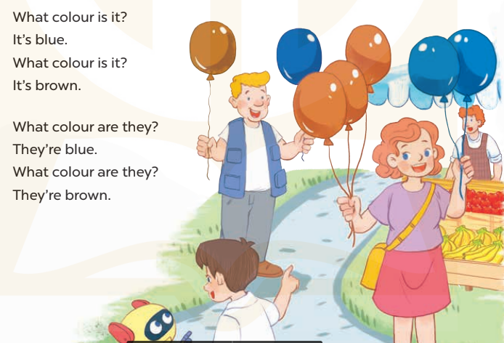  -Play the recording for Ss to listen to the whole chant.  +Have them repeat the title and lyrics line by line.  +Ask Ss to attend to the sounds of the letters bland brand the words blueand brown.  - Play the recording all the way through for Ss to listen to pronunciation and melody.  - Play the recording line by line for Ss to listen and repeat  - Play the recording for Ss to chant and clap along.  - Ask Ss to practice chant and clap along in pairs or groups.  -Invite groups to the front of the classroom to perform the chant  -T gives feedback.  *Consolidation  *Aims: Ss will be able consolidate and wrap up the content of the lesson.  *Procedure:  - T asks ss to answer the following questions:  + What have you learnt from the lesson today?  +What are the core values of the lesson? (if the teacher can take from the lesson).  - T praises some Ss who are hardworking / active/ good…. as well as encourage others to try more.  - Practice the chant more.  - Collect three school things  - Prepare the new lesson: Unit 9, Lesson 3 (4,5,6). | - Ss listen  -Ss play game  - Ss open their books  -Ss recognize the differences about color of letter  - - Ss listen  - Ss listen and point  - Ss listen again and repeat  -Ss listen again and repeat  -Ss practice  -Ss listen  -Ss listen and say:  + Number 1: My school bag is.…….  + Number 2: The pencils are  -Ss guess the answers  - Ss listen to the tape and circle  - Ss listen again, circle and swap books with their partners.  - Ss check their answers and guessing  -Ss listen and repeat.  -Ss read the sentences  - Ss look and listen.  -Ss listen to the chant  -Ss listen and repeat line by line without clap their hands  -Ss note the sounds, words  -Ss listen to melody of the chant  - Ss listen and chantline by line.  - Ss chant andclap along.  - Ss work in groups (two groups) to chant  -Ss performin front of the class.  -Ss listen  -Ss listen.  -Ss answer the questions  -Ss listen and clap their hands  -Ss listen and take note

D. ADJUSTMENTS (if necessary):
………………………………………………………………………………………….…..……………………………………………………………………………...………………………………………….…..……………………………………………………………………………….……………………………………………………………………...

