Week 16 Preparing date: December …..,
Period 61 Teaching date: December …..,

Unit 9: Colours
Lesson 3 (4, 5, 6)
A. OBJECTIVES:
By the end of the lesson, Ss will be able to:
1. Knowledge:
- read a short text and tick the colours of some school things.
- use the target language in a real context by writing a short paragraph about the colours of some of their school things.
- revise the target vocabulary items they have learnt in a real context.
- do a project on how to draw, colour and say the colours of school things.
- Vocabulary:Review
- Skills: speaking, listening, reading and writing.
2. Competences:
- Written communication: write about the colours of school things
- Critical thinking: complete a task in reading a text.
-Co-operation: ready to help friends in pair work/ group work.
- Self-control and independent learning: perform listening tasks.
3. Attitude/ Qualities:
-Kindness:Help partners to complete learning tasks.
- Honesty: tell the truth about feelings and emotions.
- Diligence: complete learning tasks.
B. TEACHING AIDS:
- Teacher: Teacher’s guide Pages 120, 121; website sachmem.vn, posters, laptop, pictures, textbook, lesson plan, TV or projector.
- Students: Pupil’s book Page 67, notebooks, workbooks, school things.
C. PROCEDURES:
Stages/Time | Teacher’s activities | Students’ activities
1.Warm- up:  (5’)  2.Practice: (8’)  3.Production: (19’)  4. Homework. (3’) | Game: “Chant”  *Aims: to review the vocabulary and structure about greet and respond to greetings.  *Procedure:  - Ask Ss chant and do the actions in Unit 9 , Lesson 3 page 66 in groups.  - Give point for the groups and encourage them.  - Say “Open your book page 67” and look at “Unit 9, Lesson 3 (4,5,6)”.  Activity 1. Read and tick:  *Aims: Ss will be abletoread and understand a short text and tick the colours of some school things.  *Procedure:  - Explain how to complete the task: read the text and tick the correct colours of the school things in the table.  - Ask Ss to read the list of the school things in the first column of the table.  - Ask Ss look at the colours on the right side of the table.  - Ask Ss read the text and tick the correct colours.  - Let Ss swap and check answers.  - Check the answers  - Ask some Ss to read the text aloud.  Key:  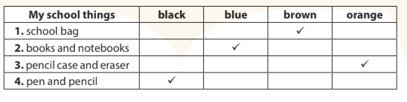  Activity 2.Let’s write  *Aims: Ss will be ableto use the target language in a real context by completing a gapped text about the colours of school things.  *Procedure:  - Check comprehension and elicit toSs read the gapped text and fill in the gaps with the colours of their school things.  - Let Ss read the gapped text and fill in the gaps with the colours of their school things.  - Have Ss complete the first gap together as an example.  - Ask Ss to look at the gap and ask them what is missing. Then let them identify the colour of their school bag. After that, let them write down the suitable word in the gap.  - Give Ss time to complete the text independently.  - In pairs or groups, ask Ss to swap their complete texts before checking as a class.  - Invite some Ss to come to the board and read the answer.  Key: Pupils’ answer  Activity 3. Project.  *Aims: Ss will be able to do a project on how to draw, colour and say the colours of school things.  *Procedure:  - Explain that Ss are going to draw, colour, then show four school things that they have drawn and coloured and tell the class about the colours.  - Have Ss work in groups. Each member shows the piece of paper or notebook in which four school things are drawn and coloured at home and introduce them, Ex: This is a school bag. It’s brown. These are the pens. They’re green.  - Invite one or two Ss to show their pictures of school things and tell what colour they are to the class.  - Tell the Ss to make a poster of school things and how to use your school things carefully.  *Consolidation  *Aims: Ss will be able consolidate and wrap up the content of the lesson.  *Procedure:  - T asks ss to answer the following questions:  + What have you learnt from the lesson today?  +What are the core values of the lesson? (if the teacher can take from the lesson).  - T praises some Ss who are hardworking / active/ good…. as well as encourage others to try more.  - Prepare the new lesson: Unit 10, Lesson 1 (1, 2, 3). | - Ss listen and chant  - Ss open their books  -Ss read and answer  -Ss listen and read  -Ss listen  -Ss read and tick  -Ss swap their answers  -Ss check their answer  -Ss read aloud  -Ss listen and read  -Ss read in chorus  -Ss write  -Ss do the task  I have a school bag. It is brown. I have a pen. It is…….I have ……………They are……  -Ss swap the book and check  -Ss listen and repeat  - Ss listen  -Ss work in groups and say the picture  -Ss show the picture and tell to the class  -Ss listen and do the task  -Ss answer the questions  -Ss listen and clap their hands  -Ss listen and take note
D. ADJUSTMENTS (if necessary):
………………………………………………………………………………………….…..……………………………………………………………………………...…………

Week 16 Preparing date: December …..,
Period 62 Teaching date: December …..,

Unit 10: Break time activities
Lesson 1 (1, 2, 3)
A. OBJECTIVES:
By the end of the lesson, Ss will be able to:
1. Knowledge:
- understand and correctly repeat the sentences in two communicative contexts about school break time activities.
- correctly say the words and use I …………..at break time. to identify school break time activities.
- enhance the correct use of I ………… at break time. to identify school break time activities.
- Vocabulary:chess, volleyball, basketball, badminton, play, break time
- Skills: speaking and listening
2. Competences:
- Self-control and independent learning: perform listening tasks.
- Communication and collaboration: work in pairs or groups.
- Sociability: talk to each other, say good words to others.
3. Attitude/ Qualities:
-Kindness:Help partners to complete learning tasks.
- Honesty: tell the truth about feelings and emotions
B. TEACHING AIDS:
- Teacher: Teacher’s guide Pages 122, 123, audio Tracks 97,98, website sachmem.vn, posters, laptop, pictures, textbook, lesson plan, TV or projector.
- Students: Pupil’s book Page 68, notebooks, workbooks, school things.
C. PROCEDURES:
Stages/Time | Teacher’s activities | Students’ activities
1.Warm- up:  (3’)  2.Presentation  (16’)  3.Practice: (7’)  4.Production: (7’)  5. Homework. (2’) | Jigsaw puzzle  *Aims: to create a friendly and active atmosphere in the class to beginning the lesson.  *Procedure:  - Divide class into 4 groups: Tom, Jerry, Miu and Chit.  - Ask Ss look at the pieces of picture.  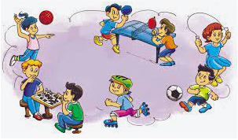  - Ask Ss go to the board and jigsaw puzzle into the correct picture.  -T checks who’s the winner?  - Say “Open your book page 68” and look at “Unit 10, Lesson 1 (1,2,3)”.  Activity 1. Vocabulary.  *Aims: Ss will be ableto know the vocabulary in front of starting the new lesson.  *Procedure:  -T elicits the new words  + chess: cờ (visual)  + volleyball : bóng chuyền (picture)  + basketball :bóng rổ(picture)  + badminton : cầu lông(visual)  + play: chơi(translation)  + break time: giờ giải lao(situation)  - T models (3 times).  - T writes the words on the board.  - Checking: Rub out and remember  Activity 2. Look, listen and repeat:  *Aims: Ss will be ableto understand and correctly repeat the sentences in two communicative contexts about school break time activities.  *Procedure:  - Have Ss look at Pictures a and b and identify the characters(Ben Minh and Lucy) in the pictures.  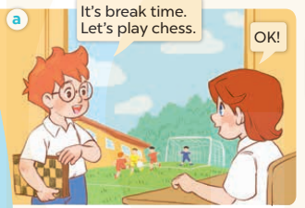  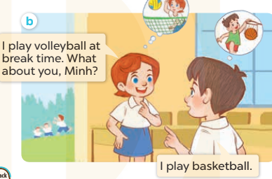  -Play the audio twice(sentence by sentence). Correct their pronunciation where necessary.  - Have Ss to practice the dialogue  -Tinvites a few pairs to the front of the class to practice.  - T checkspronunciation for ss.  Activity 32. Listen, point and say.  *Aims: Ss will be ableto correctly say the words and use I…… at break time.to identify school break time activities.  *Procedure:  * Model sentences:  - T asks Ss look at picture band helps Ss know the structure from the dialogue.  - T introduces new structure for Ss.  - T explains,models and gives meaning.  -Have Ss repeat the model sentences.  I play volleyball at break time.  *Drill pictures  - Elicit and check comprehension about the name of each break time activity.  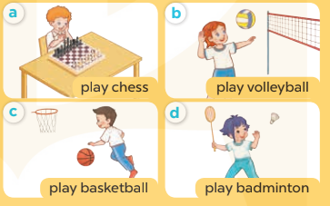  - Run through all the pictures.  - Run through model sentences.  +Run through question sentence  +Run through answer sentence  - Have Ss to practise:  + T asks, Ss answer picture a  +Ss asks, T answers picture b  + Group A ask, group B answer picture c  + Group B ask, group A answer picture d  - Ask Ss to work in pairs.  - T controls and corrects.  - Invite a few pupils to stand up, point at each school thing in the picture and say the sentence aloud.  - T gives feedbacks.  Activity 4. Let’s talk.  *Aims: Ss will be abletoenhance the correct use of I …… break time. to identify school break time activities.  *Procedure:  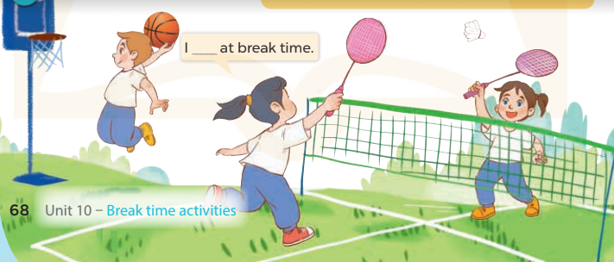  - Have Ss look at the picture and elicit the question and the answer in context.  +Who are they?  + Where are they?  + What are they doing?  - Have Ss look at the picture and say the activities  - Have Ss look at the first speech bubble and read I play badminton at break time.  - Then have them point to the pupils playing badmintonand complete the gapped answer in the second bubble (Ex:I play badminton at break time) After that, let them say aloud.  - Give Ss time to practise say the sentenceI play……at break time.  -Invite some Ss to practise talking about school break time activities in front of the class.  *Consolidation  *Aims: Ss will be able consolidate and wrap up the content of the lesson.  *Procedure:  - T asks ss to answer the following questions:  + What have you learnt from the lesson today?  +What are the core values of the lesson? (if the teacher can take from the lesson).  - T review the vocabulary and model sentences.  - T praises some Ss who are hardworking / active/ good…. as well as encourage others to try more.  - Learn the vocabulary and model sentences by heart  - Prepare the new lesson: Unit 10, Lesson 1 (4,5,6). | - Ss listen  -Ss look at the pieces of the picture  -Ss put into the correct picture  -Ss check  -Ss open their books  -Ss listen and answer  - - Ss listen and repeat  + Choral repetition (3 times).  + Individual repetition (3 ss)  - Ss take note  - Ss look, remember and write  -Look at the pictures and say  + In picture a: Ben says: It’s break time. Let’s play chess. Lucy says: OK!  + In picture b: Lucy says: I play volleyball at break time.What about you, Minh? Minh  answers: I play basketball.  -Ss listen and repeat in chorus (twice)  -Ss work in pairs to practice  -Ss practice the dialogue  -Ss listen  -Ss look at the picture and answer.  -Ss listen  -Ss listen and repeat  -Ss repeat  - Ss look, listen and answer  +Picture a: a boy playing chess  + Picture b:a girl playing volleyball  + Picture c:a boy playing basketball  + Picture d: a girl playing badminton  -Ss listen and repeat  -Ss practice in chorus, individuals.  -Ss work in pairs  -Ss point and say  -Ss listen.  -Ss look at the picture and answer  +pupils doing different activities at break time  -Ss point and say  -Ss read the sentence  -Ss point and complete  -Ss say aloud  -Ss say the sentence  -Sspractice  -Ss answer the questions  - Ss listen  -Ss listen and clap their hands  -Ss listen and take note
D. ADJUSTMENTS (if necessary):
………………………………………………………………………………………….…..……………………………………………………………………………...………………………………………….…..……………………………………………………………………………….……………………………………………………………………...

Week 16 Preparing date: December …..,
Period 63 Teaching date: December …..,

Unit 10: Break time activities
Lesson 1 (4, 5, 6)
A. OBJECTIVES:
By the end of the lesson, Ss will be able to:
1. Knowledge:
- listen to and understand two communicative contexts in which pupils talk about what they do at break time.
- complete four target sentence patterns with the help of the picture cues.
- sing the song “It’s break time” with the correct pronunciation and melody.
- Vocabulary:Review
- Skills: speaking, listening, reading and writing.
2. Competences:
- Written Communication: complete the sentences.
- Self-control and independent learning: perform listening tasks.
- Communication and collaboration: work in pairs or groups.
3. Attitude/ Qualities:
-Kindness:Help partners to complete learning tasks.
- Honesty: tell the truth about feelings and emotions.
- Diligence: complete learning tasks.
B. TEACHING AIDS:
- Teacher: Teacher’s guide Pages 124, 125; audio Tracks 99,100, website sachmem.vn, posters, laptop, pictures, textbook, lesson plan, TV or projector.
- Students: Pupil’s book Page 69, notebooks, workbooks, school things.
C. PROCEDURES:
Stages/Time | Teacher’s activities | Students’ activities
1.Warm- up:  (5’)  2.Practice: (27’)  3. Homework. (3’) | Slap the board  *Aims: to create a friendly and active atmosphere in the class to beginning the lesson.  *Procedure:  - Divide class into 2 groups: Tom and Jerry.  - How to play:  + Each group chooses five Ss to play.  + Class will read aloud.  + Look at the picture, listen and slap the picture you heard.  + Who faster will get 1 mark.  + Which group with higher mark is the winner.  - T gives feedback.  - Say “Open your book page 69” and look at “Unit 10, Lesson 1 (4,5,6)”.  Activity 1. Listenand tick:  *Aims: Ss will be abletolisten to and understand two communicative contexts in which pupils talk about what they do at break time.  *Procedure:  - Elicit the name of the activities in each picture.  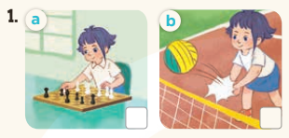  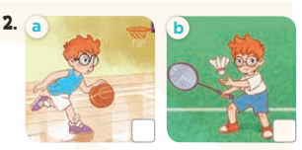  - T ask Ss to guess the answers.  + T writes Ss’guessing on the board.  - Listen to the tape:  + Play the recording  + Play the recording again and get Ss to swap books with their partners.  + Play the recording again to check answers together as a class.  + Write the answers on the board for Ss to correct their answers. Then checks Ss’ guessing.  - Play the recording, sentence by sentence, for the class to listen and repeat in chorus.  Key: 1. b2. a  Activity 2.Look, complete and read  *Aims: Ss will be abletocomplete four target sentence patterns with the help of the picture cues.  *Procedure:  - Have Ss look at the picture cues and identifythe activity of the character.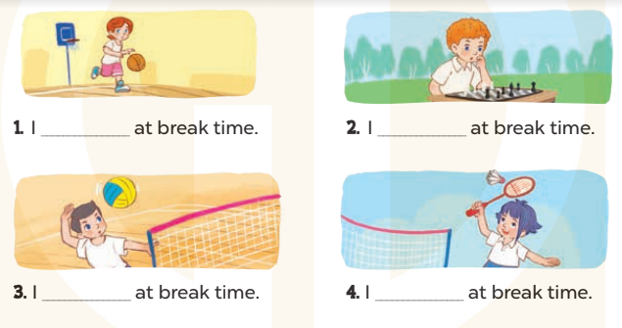  - Have Ss look at the four incomplete sentences. Elicit and model with picture 1  + Ask Ss to read the sentence 1 in chorus.  +Ask Ss what word is missing in the gap (play volleyball). Then have them complete the sentence (I play volleyball at break time).  -Have Ss work in pairs and complete the sentences2, 3, 4.  - Ask a few Ss to stand up and read the sentences aloud.  -T gives feedbacks.  Key:  1.play basketball  2. play chess  3. play volleyball  4. Play badminton  Activity 3. Let’s sing  *Aims: Ss will be able tosing the song “It’s break time” with the correct pronunciation and melody.  *Procedure:  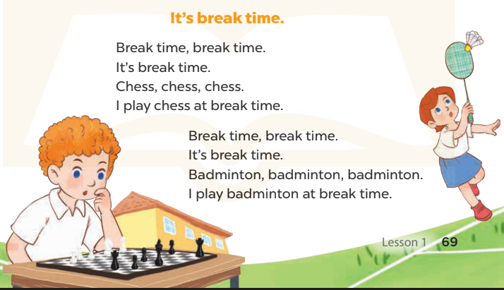  - Introducethe title and lyrics of the song and check comprehension.  + What is the song about?  + What are they doing?  -Play the recording for Ss to listen to the whole song.  +Have them repeat the title and lyrics line by line.  +Tell Ss to point at the pictures while singing.  - Play the recording all the way through for Ss to listen to pronunciation and melody of the song.  - Play the recording line by line for Ss to listen, repeat and point to the pictures  - Play the recording for Ss to sing and do actions.  - Ask Ss to practice singing and doing actions in pairs or groups.  -Invite groups to the front of the classroom to perform the song  -T gives feedback.  *Consolidation  *Aims: Ss will be able consolidate and wrap up the content of the lesson.  *Procedure:  - T asks ss to answer the following questions:  + What have you learnt from the lesson today?  +What are the core values of the lesson? (if the teacher can take from the lesson).  - T praises some Ss who are hardworking / active/ good…. as well as encourage others to try more.  - Practice part 5 again.  - Prepare the new lesson: Unit 10, Lesson 2 (1,2,3). | - Ss listen  -Ss listen  - Ss play game  -Ss congratuate the winner  - Ss open their books  -Look at the pictures and say:  + Picture 1a:Linh is playing chess.  + Picture1 b:Linh is playing volleyball.  + Picture 2a:Ben is playing basketball.  + Picture 2b:Ben is playing badminton.  -Ss guess the answers  - Ss listen to the tape and tick  - Ss listen again, tick and swap books with their partners.  - Ss check their answers and guessing  -Ss listen and repeat.  -Ss look at the picture and say  -Ss look and answer  -Ss read  -Ss say and write  -Ss work in pairs and complete  -Ss read aloud  -Ss listen and answer  -Ss listen to the song  -Ss listen and repeat line by line without the action.  -Ss point to the pictures while singing  -Ss listen to melody of the song  - Ss listen and sing line by line.  - Ss sing and do actions.  + Ss work in groups (two groups) to sing.  -Ss performin front of the class.  -Ss listen  -Ss answer the questions  -Ss listen and clap their hands  -Ss listen and take note
D. ADJUSTMENTS (if necessary):
………………………………………………………………………………………….…..……………………………………………………………………………...………………………………………….…..……………………………………………………………………………….……………………………………………………………………...

Week 16 Preparing date: December …..,
Period 64 Teaching date: December …..,

Unit 10: Break time activities
Lesson 2 (1, 2, 3)
A. OBJECTIVES:
By the end of the lesson, Ss will be able to:
1. Knowledge:
- use the words football, table tennis, chat, word puzzle related to the topic school break time activities
- use What do you do at break time? – I……… to ask and answer questions about school break time activites.
- Vocabulary:football, table tennis, chat, word puzzle
- Skills: speaking and listening
2. Competences:
- Self-control and independent learning: perform listening tasks.
- Communication and collaboration: work in pairs or groups.
- Sociability: talk to each other, say good words to others.
3. Attitude/ Qualities:
-Kindness:Help partners to complete learning tasks.
- Honesty: tell the truth about feelings and emotions
B. TEACHING AIDS:
- Teacher: Teacher’s guide Pages 126, 127, audio Tracks 101, 102, website sachmem.vn, posters, laptop, pictures, textbook, lesson plan, TV or projector.
- Students: Pupil’s book Page 70, notebooks, workbooks, school things.
C. PROCEDURES:
Stages/Time | Teacher’s activities | Students’ activities
1.Warm- up:  (3’)  2.Presentation  (16’)  3.Practice: (7’)  4.Production: (7’)  5. Homework. (2’) | Game:Act and Guess  *Aims: to create a friendly and active atmosphere in the class to beginning the lesson.  *Procedure:  - T divides class into 2 Teams (Boys and Girls)  -1 pupil of each team comes to the board and does actions for their team to guess the names of break time activities and sticks the right pictures.  -The first Team to stick 4 correct pictures with right order is the winner.  - Say “Open your book page 70” and look at “Unit 10, Lesson 2 (1,2,3)”.  Activity 1. Vocabulary.  *Aims: Ss will be ableto know the vocabulary in front of starting the new lesson.  *Procedure:  -T elicits the new words  + football: bóng đá (visual)  + word puzzle : trò chơi ô chữ  (visual)  + chat:trò chuyện(translation)  + table tennis : bóng bàn (visual)  - T models (3 times).  - T writes the words on the board.  - Checking: Rub out and remember  Activity 2. Look, listen and repeat:  *Aims: Ss will be ableto understand and correctly repeat the sentences in two communicative contexts (pictures) to talk about school brek time activities.  *Procedure:  - Have Ss look at Pictures a and b and identify the characters(Bill and Mai) in the pictures.  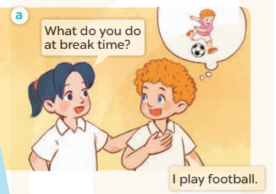  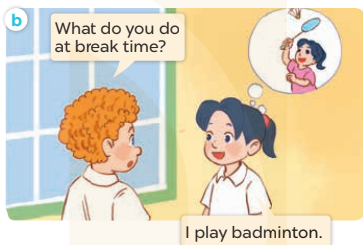  -Play the audio twice(sentence by sentence). Correct their pronunciation where necessary.  - Have Ss to practice the dialogue  -Tinvites a few pairs to the front of the class to practice.  - T checkspronunciation for ss.  Activity 32. Listen, point and say.  *Aims: Ss will be ableto correctly use What do you do at break time?  I…….. for asking and answering questions about school break time activities.  *Procedure:  * Model sentences:  - T asks Ss look at picture aand helps Ss know the structure from the dialogue.  - T introduces new structure for Ss.  - T explains,models and gives meaning.  -Have Ss repeat the model sentences.  A: What do you do at break time?  B: Iplay football.  *Drill pictures  - Elicit the action of the characters in the pictures.  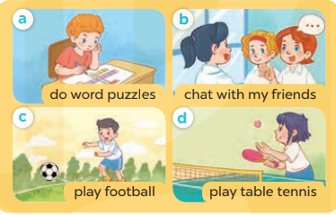  - Run through all the pictures.  - Run through model sentences.  +Run through question sentence  +Run through answer sentence  - Have Ss to practise:  + T asks, Ss answer picture a  +Ss asks, T answers picture b  + Group A ask, group B answer picture c  + Group B ask, group A answer picture d  - Ask Ss to work in pairs.  - T controls and corrects.  - Invite a few pupils to stand up, point at each school thing in the picture and say the sentence aloud.  - T gives feedbacks  Activity 4. Let’s talk.  *Aims: Ss will be abletocorrectly use What do you do at break time? I…... for asking and answering questions about school break time activities.  *Procedure:  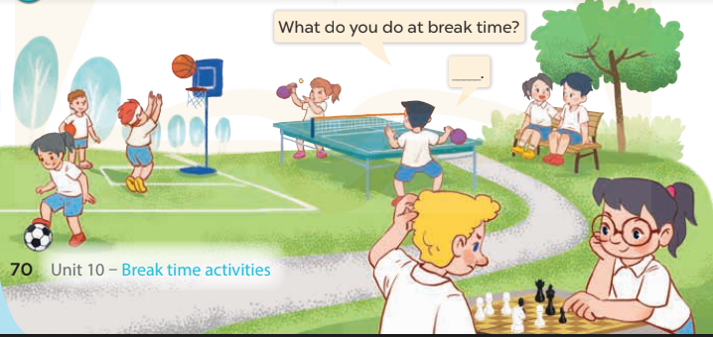  - Have Ss look at the picture and elicit the question and the answer in context.  +Who are they?  + Where are they?  + What are they doing?  - Have Ss look at the picture and say the break time activites.  - Have Ss look at the first speech bubble and read What do you do at break time?  - Have Ss point the activities, ask and answer the questions about break time activities  - Give Ss time to practise asking and answering the question What do you do at break time? – ……. in pairs.  - Invite a few pairs to practise asking and answering questions about break time activites in front of the class.  *Consolidation  *Aims: Ss will be able consolidate and wrap up the content of the lesson.  *Procedure:  - T asks ss to answer the following questions:  + What have you learnt from the lesson today?  +What are the core values of the lesson? (if the teacher can take from the lesson).  - T review the vocabulary and model sentences.  - T praises some Ss who are hardworking / active/ good…. as well as encourage others to try more.  - Learn the vocabulary and model sentences by heart  - Prepare the new lesson: Unit 10, Lesson 2 (4,5,6). | - Ss listen  -Ss play game  -Ss open their books  -Ss listen and answer  - - Ss listen and repeat  + Choral repetition (3 times).  + Individual repetition (3 ss)  - Ss take note  - Ss look, remember and write  -Look at the pictures and say  + In picture a: Mai asks Bill if What do you do at break time? Bill says that I play football.  + In picture b: Bill asks Mai: What do you do at break time?  Mai answers: I play badminton.  -Ss listen and repeat in chorus (twice)  -Ss work in pairs to practice  -Ss practice the dialogue  -Ss listen  -Ss look at the picture and answer.  -Ss listen  -Ss listen and repeat  -Ss repeat  - Ss look, listen and answer  +Picture a: a boy doing word puzzle.  + Picture b:a girl chatting with her friends  + Picture c:a boy playing football  + Picture d: a girl playing table tennis  -Ss listen and repeat  -Ss practice in chorus, individuals.  -Ss work in pairs  -Ss point and say  -Ss listen.  -Ss look at the picture and answer  +pupils playing different games and sports at break time.  -Ss point and say  -Ss read the sentence  -Ss point,ask and answer  -Ss ask and answer  -Ss work in pairs, point and ask and answer  -Ss answer the questions  - Ss listen  -Ss listen and clap their hands  -Ss listen and take note
D. ADJUSTMENTS (if necessary):
………………………………………………………………………………………….…..……………………………………………………………………………...………………………………………….…..……………………………………………………………………………….……………………………………………………………………...

