Week 18 Preparing date: December …..,
Period 69 Teaching date: December …..,
Review 2
Parts 3, 4, 5
A. OBJECTIVES:
By the end of the lesson, Ss will be able to:
1. Knowledge:
- correctly use the following sentence patterns:
correctly use the following sentence patterns:
+ Is this our ………..? – Yes, it is. / No, it isn’t.
+ Let’s go to the………….. – OK, let’s go.
+…………. , please.
+ May I…………..? − Yes, you can. / No, you can’t.
+ I have………..
+ Do you have………….? − Yes, I do. / No, I don’t.
+ What colour is it? − It’s……………..
+ What colour are they? − They’re ……………..
+I………….. at break time.
+ What do you do at break t time? − I ………….
- Vocabulary:Review
- Skills: speaking, listening, reading and writing.
2. Competences:
- Critical Thinking: self-introduce
-Co-operation: ready to help friends in pair work/ group work.
- Self-control and independent learning: perform listening tasks.
3. Attitude/ Qualities:
-Kindness:Help partners to complete learning tasks.
- Honesty: tell the truth about feelings and emotions.
- Diligence: complete learning tasks.
B. TEACHING AIDS:
- Teacher: Teacher’s guide Pages 136, 137; website sachmem.vn, posters, laptop, pictures, textbook, lesson plan, TV or projector.
- Students: Pupil’s book Page 75, notebooks, workbooks, school things.
C. PROCEDURES:
Stages/Time | Teacher’s activities | Students’ activities
1.Warm- up:  (5’)  2.Practice: (27’)  3. Homework. (3’) | Game: Whispering  *Aims: to review the vocabulary and structure about greet and respond to greetings.  *Procedure:  - Divide class into 2 groups.  -Ask 5Ss in each group stand in a straight line.  - T says a word or phrase to the first pupil in this line.  - Then, the first pupil whispers what she/ he hear to the second person in line; the second one whispers what he/ she hears to the third one and so on until the last pupil in group hears the word or phrase.  - The last pupil says the word or phrase out loud.  - The faster group has correct word or phrase is the winner.  - Say “Open your book page 75” and look at Review 2.  Activity 1. Read and match  *Aims: Ss will be able toread and match pairs of target sentence patterns  *Procedure:  - Tell Ss about this activity. Point at sentence 1, elicit the answer and models.  - Give Sswork in pairs to do the sentence 2,3,4,5.  - Tell Ss to swap their books with their partners, then check answers together as a class.  - Write the correct answers on the board for Ss to correct their answers.  - Invite some pairs to stand up and read the matched exchanges aloud.  Key:  1. e 2. d 3. b 4. c 5. a  Activity 2. Look, complete and read.  *Aims: Ss will be able tounderstand and complete two incomplete sentence patterns and two exchanges.  *Procedure:  - Elicit the missing words and the conversation.  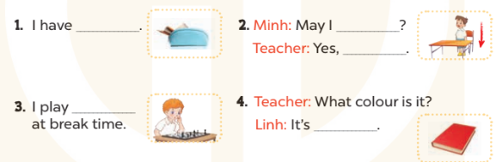  - Tell Ss about this activity. Point at number 1, elicit the answer and models.  - Give Sswork in pairs to do the task  - Tell Ss to swap their books with their partners, then check answers together as a class.  - Write the correct answers on the board for Ss to correct their answers.  - Invite some pairs to stand up and read the matched exchanges aloud.  Key:  1. a pencil case  2. stand up, you can  3. chess  4. red  Activity 3. Ask and answer  *Aims: Ss will be able toread and understand five question patterns, then take it in turns to ask and answer the questions.  *Procedure:  - Ask Ss to read the question and elicit the answer  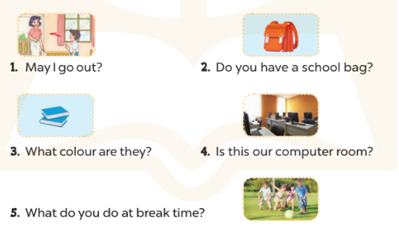  - Get Ss to role-play the exchange with sentence 1  - Give Ss time to take it in turns to role-play the fivequestion.  - Invite some pairs to stand up and role-play.  Key:  1. Yes, you can. / No, you can’t.  2. Yes, I do.  3. They’re blue.  4. Yes, it is.  5. I play football.  * Game: Pass the ball  - Divide class into 3 teams.  - Each team has 1 sticky ball.  - Play the music, students in each team take turn to pass the ball. After the music ends, 3 students have the ball – stand up and say the name, using the sentence model.  *Consolidation  *Aims: Ss will be able consolidate and wrap up the content of the lesson.  *Procedure:  - T asks ss to answer the following questions:  + What have you learnt from the lesson today?  +What are the core values of the lesson?  - T praises some Ss who are hardworking / active/ good…. as well as encourage others to try more.  - Prepare Fun time 2. | - Ss listen  -Ss play game  - Ss open their books  -Ss look at the sentence 1 and say  -Ss work in pairs and match  -Ss swap their books and match  -Ss check  -Ss read aloud  -Ss listen and answer  -Ss look at the dialogue and say number 1  -Ss work in pairs and complete  -Ss swap their books and match  -Ss check  -Ss read aloud  -Ss listen and answer  -Ss role play sentence 1  -Ss work in paris  -Ss role play  -Ss listen and play game  -Ss listen and answer  -Ss listen and clap their hands  -Ss listen and take note
D. ADJUSTMENTS (if necessary):
………………………………………………………………………………………….…..……………………………………………………………………………...…………

Week 18 Preparing date: December …..,
Period 70 Teaching date: December …..,

Fun time 2
A. OBJECTIVES:
By the end of the lesson, Ss will be able to:
1. Knowledge:
- take part in three fun activities relating to their language knowledge and competences.
- Vocabulary:Review
- Skills: speaking, writing and listening
2. Competences:
- Critical Thinking: self-introduce
-Co-operation: ready to help friends in pair work/ group work.
- Sociability: Talk to each other, say good words to others.
3. Attitude/ Qualities:
-Kindness:Help partners to complete learning tasks.
- Honesty: tell the truth about feelings and emotions
B. TEACHING AIDS:
- Teacher: Teacher’s guide Pages 137, 138, 139; website sachmem.vn, posters, laptop, pictures, textbook, lesson plan, TV or projector.
- Students: Pupil’s book Page 76, 77, notebooks, workbooks, school things.
C. PROCEDURES:
Stages/Time | Teacher’s activities | Students’ activities
1.Warm- up:  (3’)  2.Practice  (30’)  3. Homework. (2’) | Sing: Head, shoulders, knees and toes  *Aims: to create a friendly and active atmosphere in the class to beginning the lesson.  *Procedure:  - Show the song on the screen.  https://www.youtube.com/watch?v=WX8HmogNyCY  - Ask Ss to listen, sing and dance the song.  - Say “Open your book page 76, 77” and look at “Fun time”.  Activity 1. Find and circle  *Aims: Ss will be abletorevise learnt vocabulary by doing the word search.  *Procedure:  - Have Ss look at the pictures and ask +What’s this?  + What can you see in the pictures?  + What colour is it?  - Write the words or stick the flash cards of the words, one by one, on the board.  - Point at each word on the board and have Ss say the word as a class.  - Point at the picture of the school, and circle it in the word search as an example.  - Tell Ss to find the rest of the words in the word search.  - Have Ss check and correct their answers in pairs  - Have Ss work in pairs, one points at the pictures and the other points at the circled words in the word search and say them aloud.  Key:  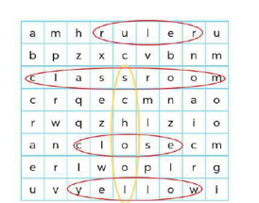  Activity 2.Quiz time  *Aims: Ss will be abletorevise vocabulary and sentence patterns related to asking and answering questions that help to identify school things and their colours.  *Procedure:  - Elicit the words and stick the flash cards on the board one by one as Ss say the corresponding words.  - Point at each flash card and have Ss say the word as a class.  - Point at a flash card and elicit the answers to the questions  +Do you have…….?  +What colour is it?  + What colour are they?  -Hold up a textbook, point at a picture of a school thing and ask these questions again.  - Show the class how to complete the task: Point at a picture of a school thing and ask the questions in pairs.  - Have Ss work in pair to as and answer about their school things  - Invite a few pairs to the front of the class to interact with each other.  Activity 3. Look and write  *Aims: Ss will be able tounderstand how mixing two colours makes a third colour  *Procedure:  - T elicits the names of the three colours: red, blue, yellow.  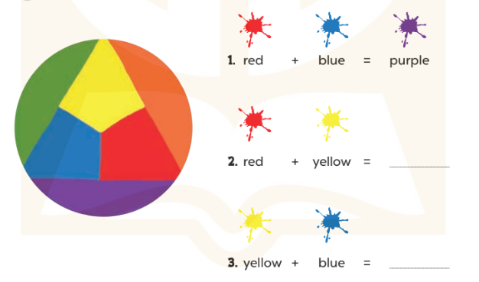  - Use crayons or paints to show pupils what happens when you mix red and blue.  - Explain that this third colour is called purple. Write purple on the  board and model it for pupils to repeat.  - Repeat for red and yellow (orange),yellow and blue (green).  - Have Ss complete the colour sums.  - Check answers together as a class.  Key: 1. purple 2. orange 3. green  *Consolidation  *Aims: Ss will be able consolidate and wrap up the content of the lesson.  *Procedure:  - T asks ss to answer the following questions:  + What have you learnt from the lesson today?  +What are the core values of the lesson? (if the teacher can take from the lesson).  - T praises some Ss who are hardworking / active/ good…. as well as encourage others to try more.  - Prepare the first test. | - Ss listen  - Ss sing a song  -Ss look at the picture and answer  - - Ss note  - Ss say the word  - Ss point and circle  -Ss find the words  -Ss check their answer  -Ss say aloud  -Ss listen  -Ss listen and say the word  -Ss point and say  -Ss point, ask and answer  -Ss listen  -Ss work in pairs  -Ss present  - Ss look, listen and answer  - Ss look and answer  -Ss listen and write  -Ss do the task  -Ss write their answer.  -Ss check  -Ss answer the questions  -Ss listen and clap their hands  -Ss listen and take note

D. ADJUSTMENTS (if necessary):
………………………………………………………………………………………….…..……………………………………………………………………………...………………………………………….…..……………………………………………………………………………….……………………………………………………………………...

Week 18 Preparing date: January 4^{h}, 2023
Period 71, 72 Teaching date: January 6th, 2023

The first term test

A. OBJECTIVES:
By the end of the lesson, Ss will be able to:
1. Knowledge:
- Check Ss’ comprehension about this theme and get marks.
- Vocabulary: Review
- Model sentences:Review
- Skills: speaking, writing and listening
2. Competences:
-Co-operation: ready to help friends in pair work/ group work.
- Sociability: Talk to each other, say good words to others.
3. Attitude/ Qualities:
-Kindness:Help partners to complete learning tasks.
- Honesty: tell the truth about feelings and emotions
B. TEACHING AIDS:
- Teacher:- Teacher: Textbook, lesson plan, TV or projector, wordsheets.
- Students:School things.
C. PROCEDURES:
Stages/Time | Teacher’s activities | Students’ activities
70’ | Give the students papers test to do  - T recommends  - Prepare Unit 11: Lesson 1 (1, 2, 3). | Whole class to do the test.  -Ss listen
D. ADJUSTMENTS (if necessary):
………………………………………………………………………………………….…..……………………………………………………………………………...………………………………………….…..……………………………………………………………………………….……………………………………………………………………...

