Week 19 Preparing date: January20th,
Period 73 Teaching date: January23rd,

Unit 11: My family
Lesson 1 (1, 2, 3)
A. OBJECTIVES:
By the end of the lesson, Ss will be able to:
1. Knowledge:
-use the words mother, father, brother, sister related to the topic “My family”
-use Who’s this / that? – It’s my ………. to ask and answer questions about a family member
- Vocabulary:mother, father, brother, sister, family
- Model sentences:
A: Who’s this/ that?
B: It’s my father
- Skills: speaking and listening
2. Competences:
- Critical Thinking: talk about family
-Co-operation: ready to help friends in pair work/ group work.
- Sociability: Talk to each other, say good words to others.
3. Attitude/ Qualities:
-Kindness:Help partners to complete learning tasks.
- Honesty: tell the truth about feelings and emotions
B. TEACHING AIDS:
- Teacher: Teacher’s guide Pages 140, 141, audio Tracks 2, 3, website sachmem.vn, posters, laptop, pictures, textbook, lesson plan, TV or projector.
- Students:Pupil’s book Page 6, notebooks, workbooks, school things.
C. PROCEDURES:
Stages/Time | Teacher’s activities | Students’ activities
1.Warm- up:  (3’)  2.Presentation  (16’)  3.Practice: (7’)  4.Production: (7’)  5. Homework. (2’) | Game: jigsaw puzzle  *Aims: to create a friendly and active atmosphere in the class to beginning the lesson.  *Procedure:  -Divide class into 4 groups: Doreamon, Nobita, Xuka and Xeko.  - Ask Ss look at the pieces of picture.  - Ask Ss go to the board and jigsaw puzzle into the correct picture    -T checks who’s the winner?  - Ask Ss look at the pieces of picture  - Say “Open your book page 6” and look at “Unit 11, Lesson 1 (1,2,3)”.  Activity 1. Vocabulary.  *Aims: Ss will be ableto know the vocabulary in front of starting the new lesson.  *Procedure:  -T elicitsthe new words  +father : bố, ba(situation)  +mother: mẹ, má (situation)  + brother: (anh) em trai (picture)  + sister: chị (em) gái (picture)  + family : gia đình (translation)  - T models (3 times).  - T writes the words on the board.  - Checking: Rub out and remember  Activity 2. Listen, point and repeat:  *Aims: Ss will be ableto understand and correctly repeat the sentences in two communicative contexts (pictures) to ask and answer questions about a family member *Procedure:  - Have Ss look at Pictures a and b and identify the characters in the pictures.  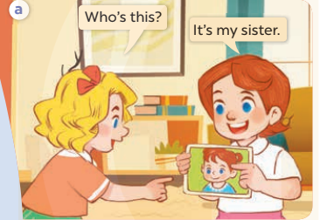  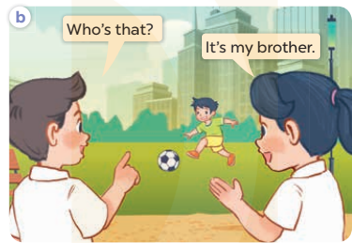  -Play the audio twice(sentence by sentence). Correct their pronunciation where necessary.  - Have Ss to practice the dialogue  -Tinvites a few pairs to the front of the class to practice.  - T checkspronunciation for ss.  Activity 3Listen, point and say.  *Aims: Ss will be ableto correctly say the words and use Who’s this / that? – It’s my……….. to ask and answer questions about a family member.  *Procedure:  * Model sentences:  -T asks Ss look at picture a , band helps Ss know the structure from the dialogue.  - T introduces new structure for Ss.  - T explains,models and gives meaning.  -Have Ss repeat the model sentences.  A: Who’s this/ that?  B: It’s my sister.  *Drill pictures  - Elicit and check comprehension the name of each character.  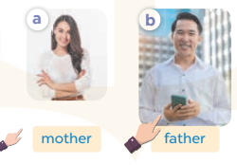  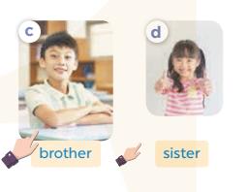  - Run through all the pictures.  - Run through model sentences.  + Run through the questions.  + Run through the answers  - Have Ss to practise:  + T says asks and Ss answer(change role).  + Ss – Ss (change role).  - Ask Ss to work in pairs.  - T controls and corrects.  - Invite a few pairs to come to the front of the classroom,point at the relevant character in each picture, and act out his/her role.  - Encourage Ss to practise speaking English.  - T gives feedbacks.  Activity 4. Let’s talk.  *Aims: Ss will be able toenhance the correct use of Who’s this /that? – It’s my ……... to ask and answer questions about a family member.  *Procedure:  - T asks ss to guess each character and what the children say.  + What can you see in the picture?  +Who’s this/ that?  +Where are they?  +What are they saying?  - T fills the gaps and writes the sentences on the board.  - T models  - T asks Ss to work in pairs to ask and answer  - Invite some pupils to the front of the class to present their exchanges.  - Give feedbacks  *Consolidation  *Aims: Ss will be able consolidate and wrap up the content of the lesson.  *Procedure:  - T asks ss to answer the following questions:  + What have you learnt from the lesson today?  - T review the vocabulary and model sentences.  - T praises some Ss who are hardworking / active/ good…. as well as encourage others to try more.  - Learn the number by heart  - Prepare the new lesson: Unit 11, Lesson 1 (4,5,6). | - Ss listen  -Ss play the game  - Ss open their books  -Ss listen and answer  - - Ss listen and repeat  + Choral repetition (3 times).  + Individual repetition (3 ss)  - Ss take note  - Ss look, remember and write  -Look at the pictures and get to know the characters in the pictures.  + Mary asks Who’s this? Lucy answers It’s my sisterin picture a.  + Nam asksWho’s that? Mai answers It’s my brotherin picture b.  -Ss listenand repeat in chorus (twice)  -Ss work in pairs to practice  -Ss practice the dialogue  -Ss listen  -Ss look at the picture and answer.  -Ss listen  -Ss listen and repeat  -Ss repeat  - Ss look, listen and repeat  -Ss practice in chorus  -Ss work in pairs to practice  -Ss point and say  -Ss listen.  -Ss listen  -Ss look at the picture and answer  + a brother and a sister are playing badminton and their parents are sitting on a bench nearby.  -Ss note  - Ss say the completed sentences.  -Ss work in pairs  -Ss perform in front of the class.  -Ss answer the questions  - Ss listen  -Ss listen and clap their hands  -Ss listen and take note

D. ADJUSTMENTS (if necessary):
………………………………………………………………………………………….…..……………………………………………………………………………...………………………………………….…..……………………………………………………………………………….……………………………………………………………………...

Week 19 Preparing date: January20th,
Period 74 Teaching date: January23rd,

Unit 11: My family
Lesson 1 (4,5,6)
A. OBJECTIVES:
By the end of the lesson, Ss will be able to:
1. Knowledge:
- listen to and demonstrate understanding of simple communicative contexts in relation to the topic “My family”
- read and write about family members and their ages
- Vocabulary:Review
- Skills: speaking, listening, reading and writing.
2. Competences:
-Co-operation: ready to help friends in pair work/ group work.
- Self-control and independent learning: perform listening tasks.
3. Attitude/ Qualities:
-Kindness:Help partners to complete learning tasks.
- Honesty: tell the truth about feelings and emotions.
- Diligence: complete learning tasks.
B. TEACHING AIDS:
- Teacher: Teacher’s guide Pages 142, 143; audio Tracks 4,5; website sachmem.vn, posters, laptop, pictures, textbook, lesson plan, TV or projector.
- Students: Pupil’s book Page 7, notebooks, workbooks, school things.
C. PROCEDURES:
Stages/Time | Teacher’s activities | Students’ activities
1.Warm- up:  (5’)  2.Practice: (27’)  3. Homework. (3’) | Game: “Passing the puppet”  *Aims: to create a friendly and active atmosphere in the class to beginning the lesson.  *Procedure:  - T gives Ss a puppet.  - T asks Ss to listen to music and transfer a puppet around the class.  - When the music stops, Ss who keep a puppet have to practice with partner using: It’s my……..  - T gives feedback.  - Say “Open your book page 7” and look at “Unit 11, Lesson 1 (4,5,6)”.  Activity 1. Listenand tick:  *Aims: Ss will be abletolisten to and understand two communicative context to ask and answer questions about a family member.  *Procedure:  - Elicit the word for each family member 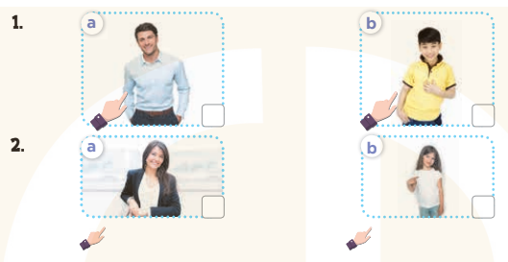  - T ask Ss to guess the answers.  + T writes Ss’guessing on the board.  - Listen to the tape:  + Play the recording  + Play the recording again and get Ss to swap books with their partners.  + Play the recording again to check answers together as a class.  + Write the answers on the board for Ss to correct their answers. Then checks Ss’ guessing.  - Play the recording, sentence by sentence, for the class to listen and repeat in chorus.  Key: 1.a 2.b  Activity 2.Look, complete and read.  *Aims: Ss will be ableto complete two sentences and two gapped dialogues with the help of the relevant picture cues.  *Procedure:  -Have Ss look at the pictures and identify the people in the pictures.  - Have Ss look at the four incomplete sentences and elicits the missing words in the sentences.  - T models with sentence 1  + Ask Ss what is missing in the sentence.  + Have Ss look at the picture and complete the gap, then read the completed sentence in chorus.  -Have Ss work in groups and complete the sentences 2,3 and 4.  - Ask a few Ss to stand up and read the completed sentences aloud.  -T gives feedbacks.  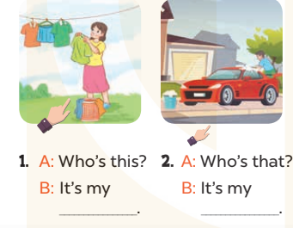  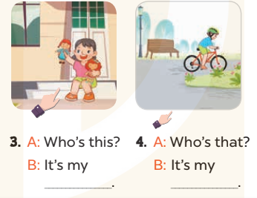  Key:  1. mother 2. brother  3. sister 4. father  Activity 3. Let’s sing.  *Aims: Ss will be able to sing the song My family with the correct pronunciation and melody. *Procedure:  - Introducethe title and lyrics of the song:“My family” song.  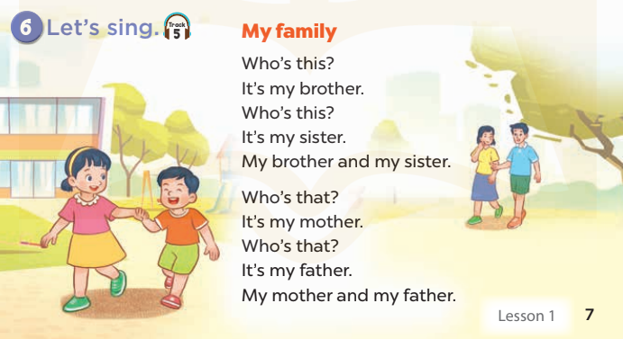  -Play the recording for Ss to listen to the whole song.  +Have them repeat the title and lyrics line by line.  +Tell Ss to point at the relevant character while singing his or her name.  - Play the recording all the way through for Ss to listen to pronunciation and melody of the song.  - Play the recording line by line for Ss to listen, repeat and point at the relevant character.  - Play the recording for Ss to sing and do actions.  - Ask Ss to practice singing and doing actions in pairs or groups.  -Invite groups to the front of the classroom to perform the song  -T gives feedback.  *Consolidation  *Aims: Ss will be able consolidate and wrap up the content of the lesson.  *Procedure:  - T asks ss to answer the following questions:  + What have you learnt from the lesson today?  +What are the core values of the lesson? (if the teacher can take from the lesson).  - T praises some Ss who are hardworking / active/ good…. as well as encourage others to try more.  - Learn the number by heart  - Prepare the new lesson: Unit 11, Lesson 2 (1,2,3). | - Ss listen and keep the puppet  - Ss listen to music and play the game  -Ss listen  - Ss open their books  -Look at the pictures and say:  + Picture 1a:father.  + Picture 1b:brother.  + Picture 2a:mother.  + Picture 2b:sister  -Ss guess the answers  - Ss listen to the tape and tick  - Ss listen again, tick and swap books with their partners.  - Ss check their answers and guessing  -Ss listen and repeat.  -Ss look at the picture and say:  -Ss look and answer  -Ss answer: mother  -Ss look, complete and read the completed sentence in chorus.  -Ss complete the sentence  -Ss read aloud  -Ss look and listen.  -Ss listen to the song  -Ss listen and repeat line by line without the action.  -Ss point to the character while singing  -Ss listen to melody of the song  - Ss listen and sing line by line.  - Ss sing and do actions.  + Ss work in groups (two groups) to sing.  -Ss performin front of the class.  -Ss listen  -Ss answer the questions  -Ss listen and clap their hands  -Ss listen and take note

D. ADJUSTMENTS (if necessary):
………………………………………………………………………………………….…..……………………………………………………………………………...………………………………………….…..……………………………………………………………………………….……………………………………………………………………...

Week 19 Preparing date: January20th,
Period 75 Teaching date: January23rd,

Unit 11: My family
Lesson 2 (1, 2, 3)
A. OBJECTIVES:
By the end of the lesson, Ss will be able to:
1. Knowledge:
- correctly pronounce the sounds of the letters o and ure in isolation, in the words old and sure and in the sentences How old is your brother?and Are you sure?
-use the numbers from 11 – 20 related to the topic “My family”
-use How old is he / she? – He’s / She’s………….. to ask and answer questions about the age of a family member
- Vocabulary:eleven, tweleve, thirteen, fourteen, fifteen, sixteen, seventeen, eighteen, nineteen, twenty.
- Model sentences:
A: How old is she/ he?
B: She’s/ He’seighteen years old.
- Skills: speaking and listening
2. Competences:
- Critical Thinking: talk about family
-Co-operation: ready to help friends in pair work/ group work.
- Oral Communication: speak about someone, ask and answer the questions
3. Attitude/ Qualities:
-Kindness:Help partners to complete learning tasks.
- Honesty: tell the truth about feelings and emotions
B. TEACHING AIDS:
- Teacher: Teacher’s guide Pages 143, 144; audio Tracks 6,7, website sachmem.vn, posters, laptop, pictures, textbook, lesson plan, TV or projector.
- Students: Pupil’s book Page 8, notebooks, workbooks, school things.
C. PROCEDURES:
Stages/Time | Teacher’s activities | Students’ activities
1.Warm- up:  (3’)  2.Presentation  (16’)  3.Practice: (7’)  4.Production: (7’)  5. Homework. (2’) | Game: Pass the ball  *Aims: to create a friendly and active atmosphere in the class to beginning the lesson.  *Procedure:  - T gives Ss a ball.  - T asks Ss to listen to music and transfer a ball around the class.  - When the music stops, Ss who keep a ball have to practice with partner using: Who’s this/ that?andIt’s my……..  - T gives feedback.  - Say “Open your book page 8” and look at “Unit 11, Lesson 2 (1,2,3)”.  Activity 1. Vocabulary.  *Aims: Ss will be ableto know the vocabulary in front of starting the new lesson.  *Procedure:  -T elicits the new words  + eleven : số 11 (picture)  + twelve : số 12 (picture)  + thirteen : số 13(picture)  + fourteen : số 14 (picture)  + fifteen : số 15(picture)  + sixteen : số 16 (picture)  + seventeen: số 17 (picture)  + eighteen : số 18 (picture)  + nineteen : số 19 (picture)  + twenty : số 20 (picture)  - T models (3 times).  - T writes the words on the board.  - Checking: Rub out and remember  Activity 2. Listen, point and repeat:  *Aims: Ss will be ableto understand and correctly repeat the sentences in two communicative contexts (pictures) to to ask and answer questions about the age of a family member.  *Procedure:  - Have Ss look at Pictures a and b and identify the characters in the pictures.  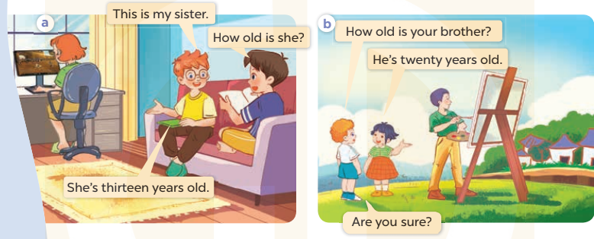  -Play the audio twice(sentence by sentence). Correct their pronunciation where necessary.  - Have Ss to practice the diaguage  -Tinvites a few pairs to the front of the class to practice.  - T checkspronunciation for ss.  Activity 3.Listen, point and say.  *Aims: Ss will be ableto correctly say the words and use the question and answer How old is he / she? – He’s / She’s …………. to ask and answer questions about the age of a family member  *Procedure:  * Model sentences:  - T asks Ss look at picture a, band helps Ss know the structure from the dialogue.  - T introduces new structure for Ss.  - T explains,models and gives meaning.  -Have Ss repeat the model sentences.  A: How old is she/ he?  B: She’s/ He’s thirteen years old.  *Drill pictures  - Elicit and check comprehension the name of each character.  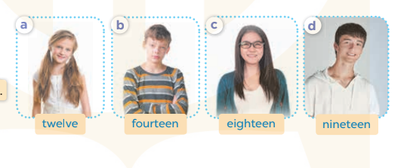  - Run through all the pictures.  - Run through model sentences.  +Run through the question sentences  +Run through the answer sentences  - Have Ss to practise:  + T asks, Ss answer picture a  +Ss ask, T answers picture b  + Group A ask, group B answer picture c  + Group B ask, group A answer picture d  - Ask Ss to work in pairs.  - T controls and corrects.  - Invite a few pairs to come to the front of the classroom,point at the relevant character in each picture, and act out his/her role.  - T gives feedbacks.  Activity 4. Let’s talk.  *Aims: Ss will be able to enhance the correct use of How old is he / she? – He's / She's …….. to ask and answer questions about the age of a family member.  *Procedure:  - T asks ss to guess each character and what the children say.  + What can you see in the picture?  +Who are they?  +Where are they?  +What are they saying?  - T fills the gaps and writes the sentences on the board.  - T models  - T asks Ss use of How old is your brother/…..? andHe’s/ she’s …….to ask and answer (groups of four)  - Invite some groups to perform.  - Give feedbacks  *Consolidation  *Aims: Ss will be able consolidate and wrap up the content of the lesson.  *Procedure:  - T asks ss to answer the following questions:  + What have you learnt from the lesson today?  +What are the core values of the lesson? (if the teacher can take from the lesson).  - T review the vocabulary and model sentences.  - T praises some Ss who are hardworking / active/ good…. as well as encourage others to try more.  - Learn the number by heart  - Prepare the new lesson: Unit 11, Lesson 2 (4,5,6). | - Ss listen and keep the ball  - Ss listen to music and play the game  - Ss open their books  -Ss listen and answer  - - Ss listen and repeat  + Choral repetition (3 times).  + Individual repetition (3 ss)  - Ss take note  - Ss look, remember and write  -Look at the pictures and get to know the characters in the pictures.  + In picture a: Ben saysThis is my sister And Minh asks: How old is she?, Ben answers She’s thirteen years old.  –In picture b: Bill asksHow old is your brther?. And Linh answersHe is twenty years old. Bill says Are you sure?  -Ss listen and repeat in chorus (twice)  -Ss work in pairs to practice  -Ss practice the diaguage  -Ss listen  -Ss look at the picture and answer.  -Ss listen  -Ss listen and repeat  -Ss repeat  - Ss look, listen and answer  +Picture a: a 12-year-old girl  + Picture b: a 14-year-old boy  + Picture c: an 18-year-old girl  + Picture d: a 19-year-old man  -Ss practice in chorus  - Ss practice in chorus  -Ss work in pairs to practice  -Ss listen  -Ss go to the board and role play.  -Ss listen  -Ss look at the picture and answer  + Ben and his sister, Linh and her brother are playing in the playground.  -Ss note  - Ss say the completed sentences.  -Ss work in groups  -Ss perform in front of the class.  -Ss answer the questions  - Ss listen  -Ss listen and clap their hands  -Ss listen and take note

D. ADJUSTMENTS (if necessary):
………………………………………………………………………………………….…..……………………………………………………………………………...………………………………………….…..……………………………………………………………………………….……………………………………………………………………...

Week 19 Preparing date: January20th,
Period 76 Teaching date: January23rd,

Unit 11: My family
Lesson 2 (4,5,6)
A. OBJECTIVES:
By the end of the lesson, Ss will be able to:
1. Knowledge:
- listen to and demonstrate understanding of simple communicative contexts in relation to the topic “My family”
- read and write about family members and their ages
- Vocabulary:Review
- Skills: speaking, listening, reading and writing.
2. Competences:
- Critical Thinking: talk about someone
-Co-operation: ready to help friends in pair work/ group work.
- Self-control and independent learning: perform listening tasks.
3. Attitude/ Qualities:
-Kindness:Help partners to complete learning tasks.
- Honesty: tell the truth about feelings and emotions.
- Diligence: complete learning tasks.
B. TEACHING AIDS:
- Teacher: Teacher’s guide Pages 145, 146; audio Tracks 8; website sachmem.vn, posters, laptop, pictures, textbook, lesson plan, TV or projector.
- Students: Pupil’s book Page 9, notebooks, workbooks, school things.
C. PROCEDURES:
Stages/Time | Teacher’s activities | Students’ activities
1.Warm- up:  (5’)  2.Practice: (27’)  3. Homework. (3’) | Sing a song: “how are you”  *Aims: to create a friendly and active atmosphere in the class to beginning the lesson.  *Procedure:  - Show the song on the screen.  https://www.youtube.com/watch?v=O13gITUS5t4  - Askpupils to listen, sing and dance the song.  - Say “Open your book page 9” and look at “Unit 11, Lesson 2 (4,5,6)”.  Activity 1. Listenand number:  *Aims: Ss will be abletolisten to and understand four communicative contexts in which pupils ask their teachers for permission *Procedure:  - Elicit the names and ages of the characters in the pictures.      - T ask Ss to guess the answers.  + T writes Ss’guessing on the board.  - Listen to the tape:  + Play the recording  + Play the recording again and get Ss to swap books with their partners.  + Play the recording again to check answers together as a class.  + Write the answers on the board for Ss to correct their answers. Then checks Ss’ guessing.  - Play the recording, sentence by sentence, for the class to listen and repeat in chorus.  Key: 1.a 2. d 3. b 4. c  Activity 2.Look, complete and read.  *Aims: Ss will be abletocomplete four gapped dialogues with the help of picture cues.  *Procedure:  -Have Ss look at the pictures and ask them pay attention to the cakes with candles or numbers  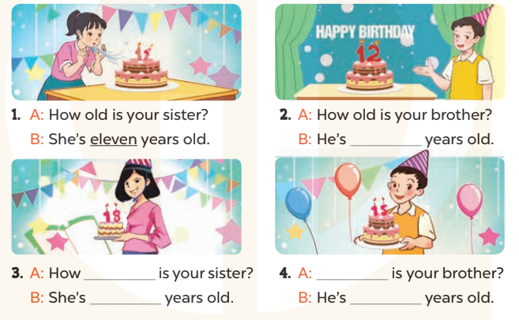  - T models with sentence 1.  + Have Ss look at the sentence.  + Ask them what is missing in the answer (eleven).  + Have Ss complete the gap.  + Have Ss read the completed sentence in chorus.  -Have Ss work in pairs and complete the sentences 2, 3 and 4.  - Invite pairs of pupils to stand up and read aloud the sentences.  -T gives feedbacks.  Key: 1. eleven 2. twelve  3.old; eighteen  4. How old; fifteen  Activity 3. Let’s play.  *Aims: Ss will be able to review vocabulary related to the topic “My family” by playing the game Board race.  *Procedure:  - Tell the Ss the goal of the game and how to play it. Ask them to revise all vocabulary learnt in Unit 11.  - Invite two groups of four pupils to the front of the class to demonstrate the game.  - Two Ss play in each round, one from each group.  - Give the Ss time to play the game in two groups of four.  - Circulate round the class during the activity and offer help where necessary  - Give Ss time to play the game.  - Give feedbacks  *Consolidation  *Aims: Ss will be able consolidate and wrap up the content of the lesson.  *Procedure:  - T asks ss to answer the following questions:  + What have you learnt from the lesson today?  +What are the core values of the lesson? (if the teacher can take from the lesson).  - T praises some Ss who are hardworking / active/ good…. as well as encourage others to try more.  - Prepare the new lesson: Unit 11, Lesson 3 (1,2,3). | - Sing and dance the song in chorus.  - Ss open their books  -Look at the pictures and say:  + Picture a:a 13-year-old girl  + Picture b:an 18-year-old girl  + Picture c:a 14-year-old boy  + Picture d:a 20-year-old man.  -Ss guess the answers  - Ss listen to the tape and write number  - Ss listen again, write number and swap books with their partners.  - Ss check their answers and guessing  -Ss listen and repeat.  -Ss look at the pictures and say  -Ss listen and answer  -Ss read and complete  -Ss work in pairs  -Ss read  - Ss listen  -Ss play the game  -Ss play the game  -Ss listen and answer  -Ss listen and take note

D. ADJUSTMENTS (if necessary):
………………………………………………………………………………………….…..……………………………………………………………………………...………………………………………….…..……………………………………………………………………………….……………………………………………………………………...

