Week: 24 Preparing date: 22/02/2025
Period :96 Teaching date: 28/02/2025
Class 4B
Unit 14: Daily activities
Lesson 3 (4, 5, 6)
A. OBJECTIVES:
By the end of the lesson, Ss will be able to:
1. Knowledge:
- use the phrases wash the clothes, clean the ﬂoor, help with the cooking and wash the dishes in relation to the topic “Daily activities”
- read and write about someone’s daily activities.
- draw pictures or take notes of what daily activities pupils do at home and present the results to the class at Project time.
- Vocabulary: Review
- Skills: speaking, listening, reading and writing.
2. Competences:
- Co-operation: ready to help friends in pair work/ group work.
- Self-control and independent learning: perform reading tasks.
3. Attitude/ Qualities:
- Kindness: Help partners to complete learning tasks.
- Diligence: complete learning tasks.
B. TEACHING AIDS:
- Teacher: Teacher’s guide Pages 207, 208, website hoclieu.vn, posters, laptop, pictures, textbook, lesson plan, TV or projector.
- Students: Pupil’s book Page 29, notebooks, workbooks, school things.
C. PROCEDURES:
Teacher’s activities | Students’ activities | Notes
1.Warm- up: (5’)  Game: Brainstorming  *Aims: to review the vocabulary and structure about greet and respond to greetings.  *Procedure:  - Hold a activity card, then reveal it slowly.  - Ask What’s activity?  - Ask the Ss guess the answer as fast as possible.  - Then have Ss do the same with the rest.  - This can be played in groups to make it more interesting.  - Say “Open your book page 29” and look at “Unit 14, Lesson 3 (4, 5, 6)”.  2.Practice: (8’)  Activity 1. Read and match:  *Aims: Ss will be able to read a paragraph and show understanding of it by matching time phrases with the appropriate activities  *Procedure:  - Have Ss read all the phrases under the paragraph. Tell them to read Phrase 1: in the morning.  - Ask Ss scan the paragraph for the appropriate activity related to the phrase.  -Have Ss to do the activity independently.  - Get Ss to swap books with their partners and check their answers before checking as a class.  - Invite some Ss to stand up and read the paragraph aloud.  Key: 1.a 2. a, d 3. b  3.Production: (19’)  Activity 2. Let’s write  *Aims: Ss will be able to complete a paragraph about pupils’ activities on Sundays.  *Procedure:  - Explain to the class the goal of this activity.  - Ask Ss to read each gapped sentence, look at the picture and fill in the gap.  - Give Ss time to write their answers  - Ask Ss to swap and correct their answers in pairs.  - Check the answers as a class.  Example: I do a lot of housework on Sundays. In the morning, I wake up and have breakfast. In the afternoon, I watch TV and play games. In the evening, I have dinner with my family.  Activity 3. Project.  *Aims: Ss will be able to draw pictures or take notes of what daily activities pupils do on Sundays and present the results to the class, using the target language *Procedure:  - Explain that they have to look at the pictures or notes they have prepared at home and present the results to the class.  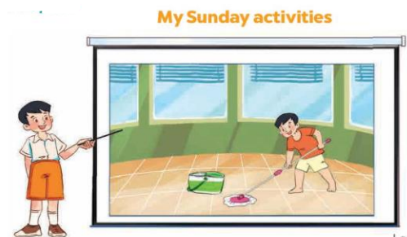  - Have Ss work in groups of five.  + Each pupil looks at their pictures or notes and tells the group about what daily activities he / she does on Sundays.  - Invite a few Ss to look at their pictures or notes and tell the class about them  - Have the rest of class applaud if pupils perform well  +Example: Hello, everyone. My name’s Huong. I’m nine years old. This is my picture. I do a lot of housework on Sundays. In the morning, I wake up and have breakfast. In the afternoon, I watch TV and play games. In the evening, I have dinner with my family.  4. Homework. (3’)  *Consolidation  *Aims: Ss will be able consolidate and wrap up the content of the lesson.  *Procedure:  - T asks ss to answer the following questions:  + What have you learnt from the lesson today?  +What are the core values of the lesson?  - T praises some Ss who are hardworking / active/ good…. as well as encourage others to try more.  - Prepare the new lesson: Unit 15: Lesson 1 (1,2,3). | - Ss listen  -Ss play game  - Ss open their books  - Ss read and answer  -Ss scan the paragraph  -Ss do the task  -Ss swap books and check  -Ss read the paragraph aloud  -Ss listen  -Ss read and answer  -Ss write  -Ss swap books and check their answers  -Ss check the answer  -Ss listen  -Ss work in groups  -Ss show the picture and say.  -Ss perform in front of the class.  -Ss answer the questions  -Ss listen and clap their hands  -Ss listen and take note
D. ADJUSTMENTS (if necessary):

