Week: 23 Preparing date: 15/02/2025
Period : 92 Teaching date: 21/02/2025
Class 4B
Unit 14: Daily activities
Lesson 1 (4, 5, 6)
A. OBJECTIVES:
By the end of the lesson, Ss will be able to:
1. Knowledge:
- use the phrases in the morning, at noon, in the afternoon, in the evening in relation to the topic “Daily activities”.
- listen to and demonstrate understanding of simple communicative contexts in relation to the topic “Daily activities”.
- Vocabulary: Review
- Skills: speaking, listening, reading and writing.
2. Competences:
- Co-operation: ready to help friends in pair work/ group work.
- Self-control and independent learning: perform listening tasks.
3. Attitude/ Qualities:
- Kindness: Help partners to complete learning tasks.
- Honesty: tell the truth about feelings and emotions.
B. TEACHING AIDS:
- Teacher: Teacher’s guide Pages 199, 200; audio Tracks 33, 34; website hoclieu.vn, posters, laptop, pictures, textbook, lesson plan, TV or projector.
- Students: Pupil’s book Page 25, notebooks, workbooks, school things.
C. PROCEDURES:
Teacher’s activities | Students’ activities | Notes
1.Warm- up: (5’)  Game: “pass the ball”  *Aims: to create a friendly and active atmosphere in the class to beginning the lesson.  *Procedure:  - T gives Ss a ball.  - T asks Ss to listen to music and transfer a ball around the class.  - When the music stops, Ss who keep a ball have to answer the question using: When do you watch TV? and I watch TV…….  - Say “Open your book page 25” and look at “Unit 14, Lesson 1 (4,5,6)”.  2.Practice: (27’)  Activity 1. Listen and tick or cross:  *Aims: Ss will be able to listen to and understand four communicative contexts in which pupils ask and answer questions about when someone does an activity, and tick or cross the pictures  *Procedure:  - Elicit and identify the activities and the time of the day by looking at the clocks and the sun or moon.  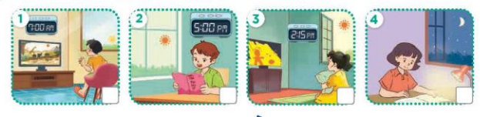  - T ask Ss to guess the answers.  + T writes Ss’guessing on the board.  - Listen to the tape:  + Play the recording  + Play the recording again and get Ss to swap books with their partners.  + Play the recording again to check answers together as a class.  + Write the answers on the board for Ss to correct their answers. Then checks Ss’ guessing.  - Play the recording, sentence by sentence, for the class to listen and repeat in chorus.  Key: 1.x 2.v 3.x 4.x  Activity 2. Look, complete and read.  *Aims: Ss will be able to complete four gapped exchanges about when someone does an activity with the help of picture cues *Procedure:  - Ask Ss to look at the pictures and identify the activities and time of the day.  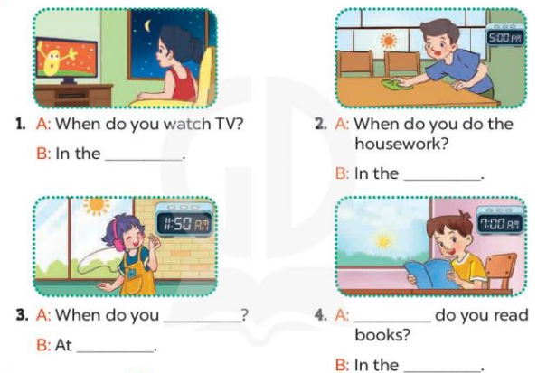  - Have Ss look at the four incomplete sentnces and elicits the missing words in the sentences.  - T models with sentence 1  + Ask Ss what is missing in the sentence.  + Have Ss look at the picture and complete the gap, then read the completed sentence in chorus.  -Have Ss work in groups and complete the sentences 2,3 and 4.  - Ask a few Ss to stand up and read the completed sentences aloud.  -T gives feedbacks.  Key:  1. evening 2. afternoon  3. listen to music; room  4. When; morning  Activity 3. Let’s sing  *Aims: Ss will be able to sing the song When do you watch TV and read books? with the correct pronunciation, rhythm and melody  *Procedure:  - Have pupils read the lyrics to familiarise themselves with the questions and answers.  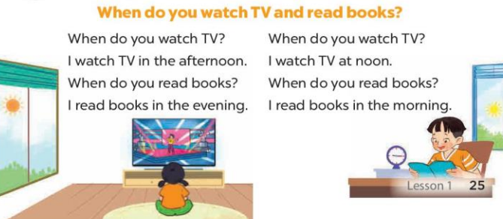  - Encourage them to identify two activities (watch TV; read books) and time of the day in the pictures.  - Have Ss listen to the whole song, drawing their attention to the pronunciation and tune.  - Play the recording of the song once or twice for pupils to listen and repeat, line after line, and do related actions.  - Ask Ss to sing the whole song while doing actions or clapping hands.  - Invite a few groups to the front of the class to sing the song.  *Consolidation  *Aims: Ss will be able consolidate and wrap up the content of the lesson.  *Procedure:  - T asks ss to answer the following questions:  + What have you learnt from the lesson today?  +What are the core values of the lesson? (if the teacher can take from the lesson).  - T praises some Ss who are hardworking / active/ good…. as well as encourage others to try more.  3. Homework. (3’)  - Prepare the new lesson: Unit 14, Lesson 2 (1,2,3). | - Ss listen and pay attention  -Ss play the game.  - Ss open their books  -Look at the pictures and say:  + Picture 1. a boy watching TV in the morning  + Picture 2. a boy reading a book in the afternoon  + Picture 3. a girl watching TV in the afternoon  + Picture 4. a girl reading a book in the evening  -Ss guess the answers  - Ss listen to the tape and tick/ cross  - Ss listen again, tick/ cross and swap books with their partners.  - Ss check their answers and guessing  -Ss write the correct answer  -Ss listen and repeat.  -Ss look at the picture and answer  -Ss look and answer  -Ss answer: evening  -Ss look, complete and read the completed sentence in chorus.  -Ss complete the sentence  -Ss read the completed sentences aloud  - Ss look and listen.  - Ss pay attention and say  -Ss listen the whole song  -Ss listen and repeat, line by line  -Ss sing the whole song  -Ss sing the song in front of the class  -Ss answer the questions  -Ss listen and clap their hands  -Ss listen and take note

D. ADJUSTMENTS (if necessary):
………………………………………………………………………………………….…..……………………………………………………………………………...………

