Week: 23 Preparing date: 15/02/2025
Period :46 Teaching date: 18/02/2025
Class 2A

UNIT 11: IN THE PLAYGROUND
Lesson 3

I. OBJECTIVES:
By the end of the lesson, students will be able to:
- Use : They’re ________(V-ing) to say what other people are doing.
- Sing a song about what other people are doing in the playground
1. Knowledge/ Language focus:
- Vocabulary: review
- Sentence pattern: They’re ________(V-ing)
2. Skills:
- Listening and speaking.
3. Quality /Attitude:
-Actively participate in activities with their classmates in pairs, groups or class. Educate Ss to become studious and obedient students; love something relates the playground.
4. Competences:
SS can develop some competences:
-Comunicative and collaborative competence:work in pairs/groups, role play
-Problem-solving competence: observing, collecting and analyzing information
-Self studying and self - control competence: remembering, recalling and guessing words/phrases.
-Creative competence, linguistic competence: giving ideas, changing information, giving comments, critical thinking.
II. TEACHING AIDS / MATERIALS:
- Pictures, textbook, computer, projector, pictures, recording…
III. METHODS:
- Communicative language teaching, contextual teaching and learning, total physical response, games activities teaching, Model-Action-Talk, teaching methods by visual, direction method, audiolingual method.
IV. PROCEDURE:

Teacher’s activities | Students’ activities | Notes
1. Warm- up (5’)  Game: Slap the board  *Aims: to help ss review some vocabulary that they learnt.  *Teaching techniques  - grouping, miming, ask and answer.  *Procedure:  -Write the words on the board  - Call 2 Ss to go to the board and ask them to slap the word when T says one word aloud.  - After finishing the game, the student slaps more correct words will be the winner.  - Say “Open your book page 50 and look at lesson 3”  2. Practice(25’)  New lesson  Activity 1. 6. Listen and repeat:  *Aims: to use : They’re ________(V-ing) to say what other people are doing.  *Context: The picture shows a playground. Three boys are driving cars, A girl are watching them and say: They’re driving cars.  *Teaching techniques  - techniques in teaching listening and speaking, individual, pairworks, ask and answer…  - using flashcardas, recording, pictures…  *Procedure:  - Have Ss look at the first picture. Play the recording for ss to listen and repeat,  - Have ss look at the sentence: They’re ________(V-ing. )Explain the meaning of the sentence and how it is used. Check comprehension.  -Play the recording several times for ss to listen and repeat the sentence. Give more support to those ss who find it difficult to do the task.  - Invite some ss to say the sentences in front of the class.  - T checks and corrects.  *Outcome: Ss can use : They’re ________(V-ing) to say what other people are doing.  Activity 2 7. Let’s talk:  *Aims: to use : They’re ________(V-ing) to say what other people are doing.  *Context:Threre are three picture showing: sliding, riding, driving and sentence pattern They’re ________(V-ing)  *Teaching techniques  - techniques in teaching listening and speaking,  -individual, pairworks, ask and answer…  - using flashcardas, recording, pictures…  *Procedure:  - Have ss look at the first picture.  Point to the pictures and ask them What are they doing? Tell them about actions in progress.  - Ask ss to work in pairs to practise saying what other people are doing. Offer help, if necessary.  - Have ss look at the second picture. And practise in pairs.  - Ask a few pairs of ss to practise in front of the class. Offer help, if necessary.  - T gets feedback.  *Outcome: Ss can use: They’re ________(V-ing) to say what other people are doing.  Activity 3. 8. Let’s sing:  *Aims: to Sing a song about what other people are doing in the playground  *Context: The picture shows the children playing in the playground  *Teaching techniques  - techniques in teaching listening and speaking,  -individual, groupworks, …  - using recording, pictures…  *Procedure:  -Have ss read the lyrics to familiarize themselves with the first verse of the song. Explain the meanings of the verse, if necessary. Check comprehension.  -Play the recording several times for ss to repeat line after line to make sure that they can sing the verse correctly.  - Do the same with the second verse of the lyrics. Play the recording several times for ss to repeat to make sure that they can sing the verse correctly. Check comprehension.  -Have time for ss practise singing the song. Help them sing the song sentence by sentence first. Then help them to sing the whole song.  - Call one or two groups to sing the song in front of the class.  *Outcome: Ss can sing a song about what other people are doing in the playground  3. Consolidation (4’)  *Aims: to consolidate and wrap up the content of the lesson.  - T tells ss about the main content of the lesson.  -T tells ss about the educational Aimss of the lessons.  4. Homework (1’)  - Practice more at home.  - Prepare for Unit 12 lesson 1. | - SS listen and play game.  -SS open their book.  -Look at the picture and listen and repeat.  -Ss listen.  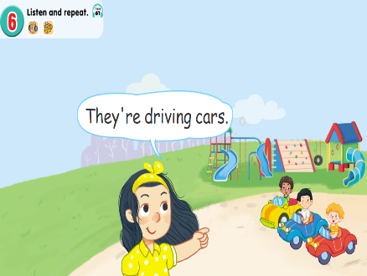  -Ss listen and repeat.  -SS say.  -Look at the picture and discribe.  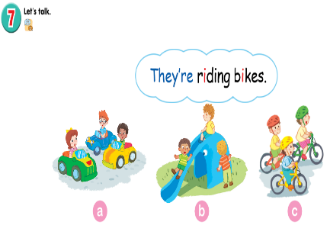  -Point and say  -SS practice in pairs.  -SS practice in front of the class.  -Ss look and listen.  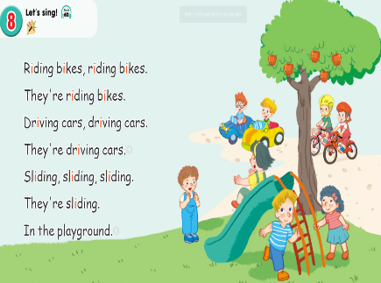  -Ss listen and repeat.  -SS do the task.  -SS sing the song.  -Ss sing in front of the class.  -SS listen.  SS listen.
ADJUSTMENTS (if necessary):
……………………………………………………………………………………………………………………………………………………………………………………………………………………

