Week: 22 Preparing date: 9/02/2025
Period : 87 Teaching date: 14/02/2025
Class 4B
Unit 13: Appearance
Lesson 2 (1, 2, 3)
A. OBJECTIVES:
By the end of the lesson, Ss will be able to:
1. Knowledge:
- use the words and phrases a round face, big eyes, long hair, and short hair in relation to the topic "Appearance"
- use What does he / she look like? –He / She has …… to ask and answer questions about someone’s appearances
- Vocabulary: long, round
- Model sentences:
A: What does he / she look like?
B: He/ She has a round face.
- Skills: speaking and listening
2. Competences:
- Co-operation: ready to help friends in pair work/ group work.
- Oral Communication: speak about someone, ask and answer the questions
3. Attitude/ Qualities:
- Kindness: Help partners to complete learning tasks.
- Honesty: tell the truth about feelings and emotions
B. TEACHING AIDS:
- Teacher: Teacher’s guide Pages 188, 189; audio Tracks 25, 26, website hoclieu.vn, posters, laptop, pictures, textbook, lesson plan, TV or projector.
- Students: Pupil’s book Page 20, notebooks, workbooks, school things.
C. PROCEDURES:
Teacher’s activities | Students’ activities | Notes
1.Warm- up: (3’)  Game: Teacher says  *Aims: to create a friendly and active atmosphere in the class to beginning the lesson.  2. Presentation(16’)  *Procedure:  - Teachers quickly review body parts, focusing on Face features.  -Teacher plays "Teacher says": Touch your ears/nose/face/eyes/hair .... to review face features.  - Say “Open your book page 20” and look at “Unit 13, Lesson 2 (1,2,3)”.  Activity 1. Vocabulary.  *Aims: Ss will be able to know the vocabulary in the new lesson.  *Procedure:  -T elicits the new words  + round : tròn (realia)  + long : dài (realia)  - T models (3 times).  - T writes the words on the board.  - Checking: Rub out and remember  Activity 2. Look, listen and repeat:  *Aims: Ss will be able to understand and correctly repeat the sentences in two communicative contexts focusing on asking and answering questions about someone’s appearance, using the verb to have  *Procedure:  - Have Ss look at Pictures a and b and identify the characters in the pictures.  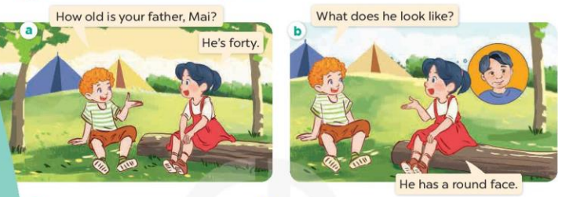  - Play the audio twice (sentence by sentence). Correct their pronunciation where necessary.  - Have Ss to practice the diaguage  - T invites a few pairs to the front of the class to practice.  - T checks pronunciation for ss.  Activity 3. Listen, point and say.  *Aims: Ss will be able to correctly say the phrases and use What does he / she look like? – He / She has …... to ask and answer questions about someone’s appearance.  *Procedure:  * Model sentences:  - T asks Ss look at picture b and helps Ss know the structure from the dialogue.  - T introduces new structure for Ss.  - T explains, models and gives meaning.  - Have Ss repeat the model sentences.  A: What does he / she look like?  B: He/ She has a round face.  3.Practice: (7’)  *Drill pictures  - Elicit and check comprehension the name of each character.  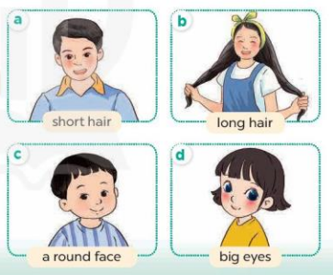  - Run through all the pictures.  - Run through model sentences.  +Run through the question sentences  +Run through the answer sentences  - Have Ss to practise:  + T asks, Ss answer picture a  + Ss ask, T answers picture b  + Group A ask, group B answer picture c  + Group B ask, group A answer picture d  - Ask Ss to work in pairs.  - T controls and corrects.  - Invite a few pairs to come to the front of the classroom, point at the relevant character in each picture, and act out his/her role.  - T gives feedbacks.  4.Production: (7’)  Activity 4. Let’s talk.  *Aims: Ss will be able to enhance the correct use of What does he / she look like? – He / She has ………. to ask and answer questions about someone’s appearance in a freer context.  *Procedure:  - T asks ss to attend to the picture.  + What can you see in the picture?  +Where are they?  + What do they look like?  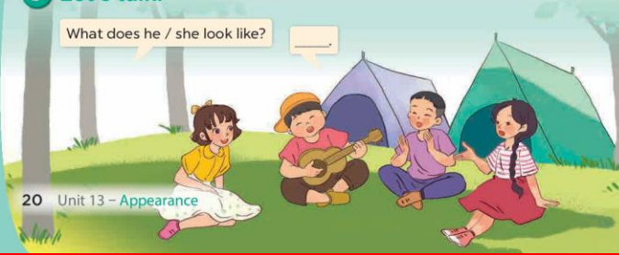  - T fills the gaps and writes the sentences on the board.  - T models  - T asks Ss use of What does he/ she look like? and He has/ She has……. to ask and answer (pairs work)  - Invite some groups to perform.  - Give feedbacks  5. Homework. (2’)  *Consolidation  *Aims: Ss will be able consolidate and wrap up the content of the lesson.  *Procedure:  - T asks ss to answer the following questions:  + What have you learnt from the lesson today?  - T review the vocabulary and model sentences.  - Learn the number by heart  - Prepare the new lesson: Unit 13, Lesson 2 (4,5,6). | - Ss listen  - Ss play the game  - Ss open their books  -Ss listen and answer  - - Ss listen and repeat  + Choral repetition (3 times).  + Individual repetition (3 ss)  - Ss take note  - Ss look, remember and write  -Look at the pictures and get to know the characters in the pictures.  + In picture a:  Bill: How old is your brother, Mai? Mai: He’s four  – In picture b:  Bill: What does he look like?  Mai: He has a round face.  -Ss listen and repeat in chorus (twice)  -Ss work in pairs to practice  -Ss practice the diaguage  -Ss listen  -Ss look at the picture and answer.  -Ss listen  -Ss listen and repeat  -Ss repeat  - Ss look, listen and answer  + Picture a: a boy with short hair + Picture b: a girl with long hair  + Picture c: a boy with a round face  + Picture d: a girl with big eyes  -Ss practice in chorus  - Ss practice in chorus  -Ss practice in chorus  -Ss work in pairs to practice  -Ss listen  -Ss go to the board and role play.  -Ss listen  -Ss look at the picture and answer  + a group of four pupils with different appearance  -Ss note  - Ss say the completed sentences.  -Ss work in pairs and ask and answer  -Ss perform in front of the class.  -Ss answer the questions  - Ss listen  -Ss listen and take note
D. ADJUSTMENTS (if necessary):

