Week: 22 Preparing date: 9/02/2025
Period :43 Teaching date: 11/02/2025
Class 2B

FUN TIME 3
Part 1- 4

I. OBJECTIVES:
By the end of the lesson, students will be able to:
- Correctly pronounce and spell the words :yams, yo-yos, yogurt, zoo, zebra
1. Knowledge/ Language focus:
- Vocabulary: review
2. Skills:
- Listening and speaking.
3. Quality /Attitude:
-Actively participate in activities with their classmates in pairs, groups or class. Educate Ss to become studious and obedient students; love learning English.
4. Competences:
SS can develop some competences:
-Comunicative and collaborative competence:work in pairs/groups, role play
-Problem-solving competence: observing, collecting and analyzing information
-Self studying and self - control competence: remembering, recalling and guessing words/phrases.
-Creative competence, linguistic competence: giving ideas, changing information, giving comments, critical thinking.
II. TEACHING AIDS / MATERIALS:
- Pictures, textbook, computer, projector, pictures, recording…
III. METHODS:
- Communicative language teaching, contextual teaching and learning, total physical response, games activities teaching, Model-Action-Talk, teaching methods by visual, direction method, audiolingual method.
IV. PROCEDURE:

Teacher’s activities | Students’ activities | Notes
1. Warm- up (5’)  Game: Guessing game  *Aims: to help ss review some vocabulary that they learnt.  *Teaching techniques  - grouping, miming, ask and answer.  *Procedure:  -Have ss to look through 4 pictures( which is closed). T opens each piece of each picture for ss to guess about the pets and then read alous name of the food.T checks and have ss read all the words.  - Say “Open your book page 46 and look at Funtime 3 – Part 1, 2”  2. Practice(25’)  New lesson  Activity 1. 1. Circle and match Then say.  *Aims: to correctly pronounce the words : yams, yo-yos, yogurt, zoo, zebra  *Context: Five pictures and a set of letters under each picture.  *Teaching techniques  - techniques in teaching writing  - individual, pairworks, ask and answer…  - using flashcardas, recording, pictures…  *Procedure:  -Have ss look at the pictures and say the words, saying Look and say, please  -Ask ss to look at the word search, find and circle the correct words in it individually. Then say the words  -T models with the first word if necessary. Give further support to those Ss who find it difficult to do the task.  - Have time for ss to do the task.  -After the ss find the words and pronounce them, organize a short game. Divide the class into two teams. Call on one student from each team to go to the board. Call out a word and the two ss have to write them on the board. Give a point to each correct word. Ss from the teams take turns to write the words.  Activity 2. 2. Let’s play:What and where :  *Aims: to identify and pronounce the words: yams, yo-yos, yogurt, zoo, zebra  *Context: A board with five target words: yams, yo-yos, yogurt, zoo, zebra  *Teaching techniques  - techniques in teaching listening and speaking, groupworks, ask and answer…  - using flashcardas, pictures…  *Procedure:  -Write five target words on the board. Draw a circle around each word. Tell ss to look at the remember the word.Explain that when eraser one of the words, ss must try to remember it.When you erase a second word , ss must try to remember both words. Countinue untill all the words have been erasered and ss cay say all five from memmory.  -Have time for ss to play game.  *Outcome: Ss can identify and pronounce the words: yams, yo-yos, yogurt, zoo, zebra.  3. Consolidation (4’)  *Aims: to consolidate and wrap up the content of the lesson.  - T tells ss about the main content of the lesson.  - T tells ss about the educational Aimss of the lessons.  4. Homework (1’)  - Practice more at home.  - Prepare for the next lesson. | - SS listen and play game.  -SS open their book.  -Look at the picture and say.  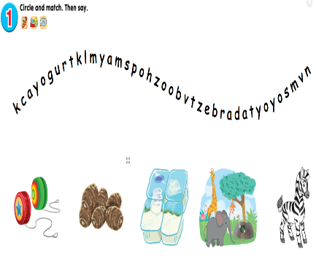  -SS look and say.  -Ss do the task.  -SS play game.  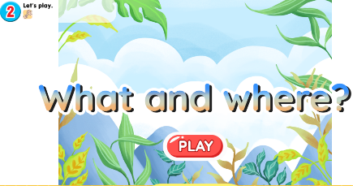  -Ss look and listen.  -SS play game.  -Ss listen.  -Ss listen.
ADJUSTMENTS (if necessary):
……………………………………………………………………………………………………………………………………………………………………………………………………………………

