Week: 19 Preparing date:11/01/2025
Period :76 Teaching date: 17/01/2025

Unit 11: My home
Lesson 2 (4, 5, 6)
A. OBJECTIVES:
By the end of the lesson, Ss will be able to:
1. Knowledge:
- Identify the specific information by listening 2 conversations about my school to tick the correct pictures.
- Using clue pictures to complete the gaps.
- Perform the song “my house” in interesting ways, using appropriate and meaningful gestures.
- Vocabulary: Review
- Skills: speaking, listening, reading and writing.
2. Competences:
- Co-operation: ready to help friends in pair work/ group work.
- Self-control and independent learning: perform listening tasks.
3. Attitude/ Qualities:
- Show their pride about their places/ address.
- Honesty: tell the truth about feelings and emotions.
- Diligence: complete learning tasks.
B. TEACHING AIDS:
- Teacher: Teacher’s guide Pages 164, 165; audio Tracks 6, 7; website hoclieu.vn, posters, laptop, pictures, textbook, lesson plan, TV or projector.
- Students: Pupil’s book Page 9, notebooks, workbooks, school things.
C. PROCEDURES:
Teacher’s activities | Students’ activities | Notes
1.Warm- up: (5’)  Sing a song: “how are you”  *Aims: to create a friendly and active atmosphere in the class to beginning the lesson.  *Procedure:  - Show the song on the screen.  - Ask pupils to listen, sing and dance the song.  - Say “Open your book page 9” and look at “Unit 11, Lesson 2 (4,5,6)”.  2.Practice: (27’)New lesson  Activity 1. Listen and tick:  *Aims: Ss will be able to listen to and understand two communicative contexts in which characters ask and answer questions about what a place is like and tick the correct pictures.  *Procedure:  - Elicit the words and phrases to describe the pictures.  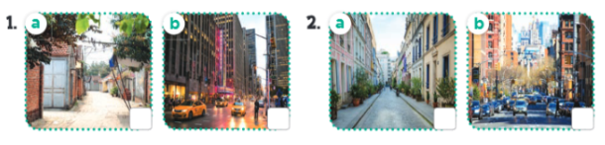  - T ask Ss to guess the answers.  + T writes Ss’guessing on the board.  - Listen to the tape:  + Play the recording  + Play the recording again and get Ss to swap books with their partners.  + Play the recording again to check answers together as a class.  + Write the answers on the board for Ss to correct their answers. Then checks Ss’ guessing.  - Play the recording, sentence by sentence, for the class to listen and repeat in chorus.  Key: 1.b 2. a  Activity 2. Look, complete and read.  *Aims: Ss will be able to complete two gapped exchanges with the help of picture cues.  *Procedure:  - Have pupils read the sentence and guess the missing words.  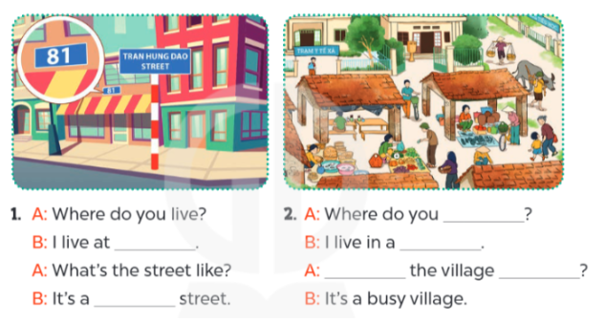  - T models with sentence 1.  + Have Ss look at the sentence.  + Ask them what is missing in the answer (81 Tran Hung Dao Street).  + Have Ss complete the gap.  + Have Ss read the completed sentence in chorus.  -Have Ss work in pairs and complete the sentences 2.  - Invite pairs of pupils to stand up and read aloud the sentences.  -T gives feedbacks.  Key: 1. 81 Tran Hung Dao Street; quiet  2. live; village; What’s; like  Activity 3. Let’s sing.  *Aims: Ss will be able to sing the song My house with the correct pronunciation, rhythm and melody.  *Procedure:  - Tell the Ss the title and the lyrics of the song.  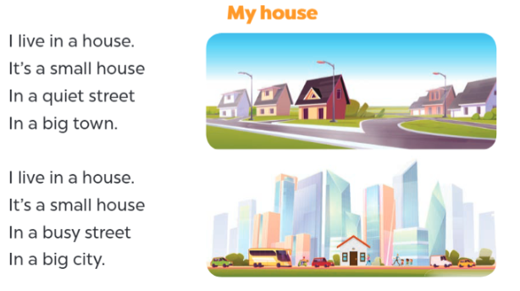  - Have Ss read the first verse of the lyrics.  + Explain that the first verse is about a house in a town.  + Have Ss listen to the first verse, drawing their attention to the pronunciation, rhythm and melody.  +Have Ss listen to and practise singing it, line by line, while making gestures for small, quiet and big  - Explain that it is about a house in a city.  - Ask pupils to listen to and sing the whole song while making gestures.  - Invite a few groups to the front of the class to sing the song.  + The class may sing along and clap to reinforce the activity.  *Consolidation  *Aims: Ss will be able consolidate and wrap up the content of the lesson.  *Procedure:  - T asks ss to answer the following questions:  + What have you learnt from the lesson today?  +What are the core values of the lesson? (if the teacher can take from the lesson).  - T praises some Ss who are hardworking / active/ good…. as well as encourage others to try more.  3. Homework. (3’)  - Prepare the new lesson: Unit 11, Lesson 3 (1,2,3). | - Sing and dance the song in chorus.  - Ss open their books  -Look at the pictures and say:  + Picture a: a small village  + Picture b: a big city  + Picture c: a quiet street  + Picture d: a busy street.  -Ss guess the answers  - Ss listen to the tape and tick  - Ss listen again, tick and swap books with their partners.  - Ss check their answers and guessing  -Ss write the correct answer  -Ss listen and repeat.  -Ss look at the pictures and say  -Ss look at the sentence  -Ss listen and answer  -Ss read and complete  -Ss complete the gap  -Ss work in pairs  -Ss read aloud the sentences.  -SS listen  - Ss listen  -Ss read the song  - Ss listen and pay attention the pronunciation, rhythm and melody.  -Ss listen and sing, sentence by sentence  -Ss listen  -Ss listen and sing the whole song  -Ss sing a song in front of the class  -Ss sing and clap  -Ss listen and answer  -Ss listen and take note

D. ADJUSTMENTS (if necessary):
………………………………………………………………………………………….…..……………………………………………………………………………...………………………………………….…..……………………………………………………………………………….………………………………………………………………

