Week: 19 Preparing date:11/01/2025
Period :75 Teaching date: 17/01/2025
Unit 11: My home
Lesson 2 (1, 2, 3)
A. OBJECTIVES:
By the end of the lesson, Ss will be able to:
1. Knowledge:
- Identify the situation between Nam and Bill.
- use the phrases a big city, a noisy road, a busy street, a quiet village in relation to the topic “My home”
- use What’s the ……….like? – It’s …….. to ask and answer questions about what a place is like
- Vocabulary: busy, noisy, quiet
- Model sentences:
A: What’s the street like?
B: It’s a busy street.
- Skills: speaking and listening
2. Competences:
- Co-operation: ready to help friends in pair work/ group work.
- Oral Communication: speak about someone, ask and answer the questions
3. Attitude/ Qualities:
- Kindness: Help partners to complete learning tasks.
- Honesty: tell the truth about feelings and emotions
B. TEACHING AIDS:
- Teacher: Teacher’s guide Pages 162,163,164; audio Tracks 4, 5, website hoclieu.vn, posters, laptop, pictures, textbook, lesson plan, TV or projector.
- Students: Pupil’s book Page 8, notebooks, workbooks, school things.
C. PROCEDURES:
Teacher’s activities | Students’ activities | Notes
1.Warm- up: (3’)  Game: Pass the ball  *Aims: to create a friendly and active atmosphere in the class to beginning the lesson.  *Procedure:  - T gives Ss a ball.  - T asks Ss to listen to music and transfer a ball around the class.  - When the music stops, Ss who keep a ball have to practice with partner using: Where do you live? and I live……..  - T gives feedback.  - Say “Open your book page 8” and look at “Unit 11, Lesson 2 (1,2,3)”.  2. Presentation (16’)  New lesson  Activity 1. Vocabulary.  *Aims: Ss will be able to know the vocabulary in the new lesson.  *Procedure:  -T elicits the new words  + busy : nhộn nhịp (situation)  + quiet : yên tĩnh (situation)  + noisy : ồn ào (situation)  - T models (3 times).  - T writes the words on the board.  - Checking: Rub out and remember  Activity 2. Look, listen and repeat:  *Aims: Ss will be able to understand and correctly repeat the sentences in two communicative contexts (pictures) in which characters ask and answer the question about what a place is like.  *Procedure:  - Have Ss look at Pictures a and b and identify the characters and predict  what they are talking about in the pictures.  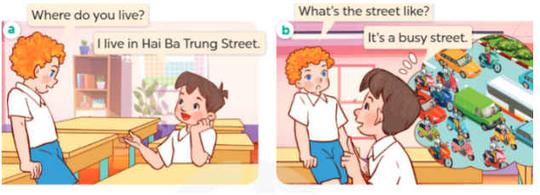  - Play the audio twice (sentence by sentence). Correct their pronunciation where necessary.  - Have Ss to practice the diaguage  - T invites a few pairs to the front of the class to practice.  - T checks pronunciation for ss.  Activity 3. Listen, point and say.  *Aims: Ss will be able to correctly say the phrases and use What’s the …. like? – It’s …… to ask and answer questions about what a place is like.  *Procedure:3.Practice: (7’)  * Model sentences:  - T asks Ss look at picture b and helps Ss know the structure from the dialogue.  - T introduces new structure for Ss.  - T explains, models and gives meaning.  - Have Ss repeat the model sentences.  A: What’s the street like?  B: It’s a busy street.  *Drill pictures  - Elicit and identify the places in the pictures.  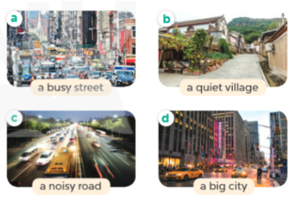  - Run through all the pictures.  - Run through model sentences.  +Run through the question sentences  +Run through the answer sentences  - Have Ss to practise:  + T asks, Ss answer picture a  + Ss ask, T answers picture b  + Group A ask, group B answer picture c  + Group B ask, group A answer picture d  - Ask Ss to work in pairs.  - T controls and corrects.- Invite a few pairs to come to the front of the classroom, point at the relevant character in each picture, and act out his/her role.  - T gives feedbacks.  Activity 4. Let’s talk.  *Aims: Ss will be able to enhance the correct use of What’s the …. like? – It’s ….. to ask and answer  questions about what a place is like in a freer context.  *Procedure:4.Production: (7’)  - Ask Ss to look at the pictures and elicit the phrase to describe the place in each picture.  + What can you see in the picture?  +How many places are there?  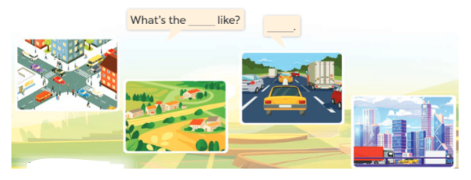  - T fills the gaps and writes the sentences on the board.  - T models  - T asks Ss use of What’s the …….like? and It’s ……. to ask and answer (groups of four)  - Invite some groups to perform.  - Give feedbacks  *Consolidation  *Aims: Ss will be able consolidate and wrap up the content of the lesson.  *Procedure:  - T asks ss to answer the following questions:  + What have you learnt from the lesson today?  +What are the core values of the lesson? (if the teacher can take from the lesson).  - T review the vocabulary and model sentences.  - T praises some Ss who are hardworking / active/ good…. as well as encourage others to try more.  5. Homework. (2’)  - Learn the number by heart  - Prepare the new lesson: Unit 11, Lesson 2 (4,5,6). | - Ss listen and keep the ball  - Ss listen to music and play the game  - Ss open their books  -Ss listen and answer  - - Ss listen and repeat  + Choral repetition (3 times).  + Individual repetition (3 ss)  - Ss take note  - Ss look, remember and write  -Look at the pictures and get to know the characters in the pictures.  + In picture a:  Bill: Where do you live?  Minh: I live in Hai Ba Trung Street  – In picture b:  Bill: What’s the street like?  Minh: It’s a busy street.  -Ss listen and repeat in chorus (twice)  -Ss work in pairs to practice  -Ss practice the diaguage  -Ss practice in front of the class  -Ss listen  -Ss look at the picture and answer.  -Ss listen  -Ss listen and repeat  -Ss repeat  - Ss look, listen and answer  + Picture a: a busy street  + Picture b: a quiet village  + Picture c: a noisy road  + Picture d: a big city  -Ss practice in chorus  -Ss practice in chorus  - Ss practice in chorus and individual  -Ss work in pairs to practice  -Ss listen  -Ss go to the board and role play.  -Ss listen  -Ss look at the picture and answer  + a busy street, a quiet village, a noisy road, a big city  -Ss note  - Ss say the completed sentences.  -Ss work in groups  -Ss perform in front of the class.  -Ss answer the questions  - Ss listen  -Ss listen and clap their hands  -Ss listen and take note
D. ADJUSTMENTS (if necessary):

……………………………………………………………………………………………………

