Thứ Ba ngày 19 tháng 11 năm 2024
Week: 11 Preparing date:16/11/2024
Period :21 Teaching date: 19/11/2024

UNIT 5: IN THE CLASSROOM
Lesson 3 (6,7,8)

I. OBJECTIVES:
By the end of the lesson, students will be able to:
- Use : What’s he/she doing? – He’s/ She’s doing a quiz to ask and answer question about what someone is doing .
- Sing a song about playing in the classroom
1. Knowledge/ Language focus:
- Vocabulary: review
- Sentence pattern: What’s he/she doing? – He’s/ She’s doing a quiz
2. Skills:
- Listening and speaking.
3. Quality /Attitude:
-Actively participate in activities with their classmates in pairs, groups or class. Educate Ss to become studious and obedient students; love something relates the classroom.
4. Competences:
SS can develop some competences:
-Comunicative and collaborative competence:work in pairs/groups, role play
-Problem-solving competence: observing, collecting and analyzing information
-Self studying and self - control competence: remembering, recalling and guessing words/phrases.
-Creative competence, linguistic competence: giving ideas, changing information, giving comments, critical thinking.
II. TEACHING AIDS / MATERIALS:
- Pictures, textbook, computer, projector, pictures, recording…
III. METHODS:
- Communicative language teaching, contextual teaching and learning, total physical response, games activities teaching, Model-Action-Talk, teaching methods by visual, direction method, audiolingual method.
IV. PROCEDURE:

Teacher’s activities | Students’ activities | Notes
1. Warm- up (5’)  Game: Slap the board  *Aims: to help ss review some vocabulary that they learnt.  *Teaching techniques  - grouping, miming, ask and answer.  *Procedure:  -Write the words on the board  - Call 2 Ss to go to the board and ask them to slap the word when T says one word aloud.  - After finishing the game, the student slaps more correct words will be the winner.  - Say “Open your book page 25 and look at lesson 3”  2. New lesson Practice(25’)  Activity 1. 6. Listen and repeat  *Aims: to use : What’s he/she doing? – He’s/ She’s doing a quiz. to ask and answer question about what someone is doing .  *Context: The picture shows a girl and a boy in the classroom , they ask and answer What’s he/she doing? – He’s/ She’s doing a quiz.  *Teaching techniques  - techniques in teaching listening and speaking, individual, pairworks, ask and answer…  - using flashcardas, recording, pictures…  *Procedure:  - Have Ss look at the first picture.  Play the recording for ss to listen and repeat  - Have ss look at the sentence: What’s he/she doing? – >He’s/ She’s doing a quiz .Explain the meaning of the sentence and how it is used. Check comprehension.  -Play the recording several times for ss to listen and repeat the sentence. Give more support to those ss who find it difficult to do the task.  - Invite some ss to say the sentences in front of the class.  - T checks and corrects.  *Outcome: Ss can use : What’s he/she doing? – He’s/ She’s doing a quiz. to ask and answer question about what someone is doing .  Activity 2 7. Let’s talk  *Aims: to use :What’s he/she doing? – He’s/ She’s doing a quiz. to ask and answer question about what someone is doing .  *Context:Threre are three picture showing:question, square, quiz and sentence pattern :  Is she/he_______?-> Yes, she /he is. / No, she/he isn’t.  *Teaching techniques  - techniques in teaching listening and speaking,  -individual, pairworks, ask and answer…  - using flashcardas, recording, pictures…  *Procedure:  - Have ss look at the first picture.  Point to the pictures and ask them What are they doing? Tell them about what someone is doing .  - Ask ss to work in pairs to practise asking and answering about what someone is doing .Offer help, if necessary.  - Have ss look at the second picture. And practise in pairs.  - Ask a few pairs of ss to practise in front of the class. Offer help, if necessary.  - T gets feedback.  *Outcome: Ss can use: What’s he/she doing? – He’s/ She’s doing a quiz. to ask and answer question about what someone is doing .  Activity 3. 8. Let’s sing  *Aims: to Sing a song about doing something in the classroom.  *Context: The picture shows the children doing something in the classroom.  *Teaching techniques  - techniques in teaching listening and speaking,  -individual, groupworks, …  - using recording, pictures…  *Procedure:  -Have ss read the lyrics to familiarize themselves with the first verse of the song. Explain the meanings of the verse, if necessary. Check comprehension.  -Play the recording several times for ss to repeat line after line to make sure that they can sing the verse correctly.  - Do the same with the second verse of the lyrics. Play the recording several times for ss to repeat to make sure that they can sing the verse correctly. Check comprehension.  -Have time for ss practise singing the song. Help them sing the song sentence by sentence first. Then help them to sing the whole song.  - Call one or two groups to sing the song in front of the class.  *Outcome: Ss can sing a song about doing something in the classroom.  3. Consolidation (4’)  *Aims: to consolidate and wrap up the content of the lesson.  - T tells ss about the main content of the lesson.  -T tells ss about the educational Aimss of the lessons.  4. Homework (1’)  - Practice more at home.  - Prepare for Unit 6 lesson 1. | - SS listen and play game.  -SS open their book.  -Look at the picture and listen and repeat.  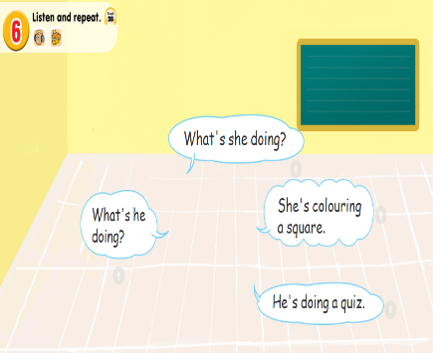  -Ss listen.  -Ss listen and repeat.  -SS say.  -Look at the picture and discribe.  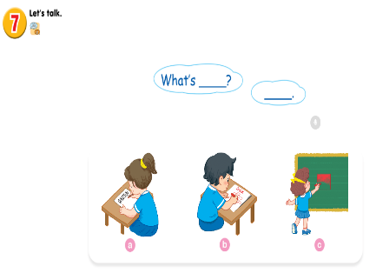  -Point and say  -SS practice in pairs.  -SS practice in front of the class.  -Ss look and listen.  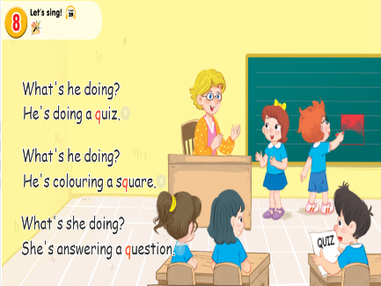  -Ss listen and repeat.  -SS do the task.  -SS sing the song.  -Ss sing in front of the class.  -SS listen.  -SS listen.

ADJUSTMENTS (if necessary):
………………………………………………………………………………………………………………………………………………………………………………

