Week: 10 Preparing date:10/11/2024
Period :20 Teaching date: 15/11/2024

UNIT 5: IN THE CLASSROOM
Lesson 2(3,4,5)

I. OBJECTIVES:
By the end of the lesson, students will be able to:
- Correctly pronounce the words question, square, quiz and say the sentence pattern: He’s/ She’s ________(V-ing) in a chant.
1. Knowledge/ Language focus:
- Sound /q/
- Vocabulary: review
- Sentence pattern: He’s/ She’s ________(V-ing)
2. Skills:
- Listening, writing and speaking.
3. Quality /Attitude:
-Actively participate in activities with their classmates in pairs, groups or class. Educate Ss to become studious and obedient students; love something relates the classroom.
4. Competences:
SS can develop some competences:
-Comunicative and collaborative competence:work in pairs/groups, role play
-Problem-solving competence: observing, collecting and analyzing information
-Self studying and self - control competence: remembering, recalling and guessing words/phrases.
-Creative competence, linguistic competence: giving ideas, changing information, giving comments, critical thinking.
II. TEACHING AIDS / MATERIALS:
- Pictures, textbook, computer, projector, pictures, recording…
III. METHODS:
- Communicative language teaching, contextual teaching and learning, total physical response, games activities teaching, Model-Action-Talk, teaching methods by visual, direction method, audiolingual method.
IV. PROCEDURE:

Teacher’s activities | Students’ activities | Notes
1. Check-up: Warm- up (5’)  *Aims: to help ss remember the words that they have learn in lesson 1.  *Teaching techniques  - grouping, miming, ask and answer.  *Procedure:  -T asks ss to say the letter and the sound they learnt in lesson 1(Q/q ,/q/)  Say “Open your book page 24 and look at lesson 2”  2. Practice(25’)  New lesson  Activity 1. 3. Listen and chant  *Aims: to correctly pronounce the words question, square, quiz and say the sentence pattern: He’s/ She’s ________(V-ing) in a chant.  *Context: The picture shows some children are doing in the classroom.  *Teaching techniques  - techniques in teaching listening and speaking, individual, pairworks,groupworks, ask and answer…  - using flashcardas, recording, pictures, worksheets…  *Procedure:  - Have ss look at the chant on p. 24 in their books and draw ss’ attention to the first line and explain its meaning. Ask them to pay attention to the letter Q/q and the words: question, square, quiz . Check comprehension.  - Play the recording of the first verse for Ss to listen and to get familiarized with the tune.  - Play the recording again, ask ss to listen and repeat the first line. Then play the recording for them to listen and repeat until they feel confident.  - Follow the same Procedure: with the other verse. Show ss how to chant and clap their hands. Correct pronunciation, if necessary.  - Play the recording all the way through. Ask ss to listen and repeat the chant individually and in chorus. Give further support to those ss who find it difficult to do the task.  - Select some ss to the front of the class to chant and clap their hands. The rest of the class may sing the chant along and clap their hands.  *Outcome: Ss can correctly pronounce the words question, square, quiz and say the sentence pattern: He’s/ She’s ________(V-ing) in a chant.  Activity 2 4. Listen and tick  *Aims: to recognize the words question, square, quiz and the sentence pattern: He’s/ She’s _____  (V-ing)  *Context:Sentence 1: square, circle./ Sentence 2: question, quiz  *Teaching techniques  - techniques in teaching listening  - pairworks, ask and answer…  - using recording, pictures…  *Procedure:  -Have Ss look at two pictures and say what they can see. Draw ss’ attention to the boxes next to the letters a and b. Check comprehension.  -Encourage some ss to point to the pictures and say the words in front of the class . E.g. 1a: square, 1b: circle  - Play the recording for ss to listen and tick the box.  - Let ss to listen again and check .  -T gets feedback.  *Keys: 1.b / 2.a  *Outcome: Ss can to recognize the words question, square, quiz and the sentence pattern: He’s/ She’s ________(V-ing)  Activity 3. 5. Look and write  *Aims: to write the letter Q/q and complete the words: question, square, quiz  *Context: Pictures of: question, square, quiz  Writing grids for Q(upper case) and q( lower case)  *Teaching techniques  - techniques in teaching writing  - individual, groupworks, ask and answer…  - using flashcardas, pictures…  *Procedure:  - Have Ss look at the letter Q (upper case) and q (lower case). Ask ss to make sure if they recognize the two forms of the letter.  - Tell ss to trace the letter Q/q .T can demonstrate by air tracing or tracing the broken lines of the letter Q/q on the board.  -Then let ss write the letter. Then find out the missing letter to complete the correct word. Give further support to those Ss who find it difficult to do the task.  - Check the results of ss’ tracing and give feedback. Ask ss to work in pairs and swap their answers. Give ss time to work. Go around and offer help, if necessary.  - Ask some ss to show what they have done.  *Outcome: Ss can write the letter Q/q and complete the words: question, square, quiz  3. Consolidation (4’)  *Aims: to consolidate and wrap up the content of the lesson.  - T tells ss about the main content of the lesson.  - T tells ss about the educational Aimss of the lessons.  4. Homework (1’)  - Practice more at home.  - Prepare for the next lesson. | - SS say the letter and the sound.  -SS open their book.  -Look at the picture and listen.  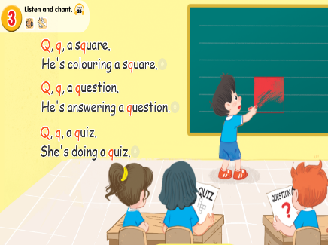  -Ss listen.  -Ss listen and repeat.  -SS listen and chant.  -SS chant.  -SS chant in front of the class.  -Look at the picture and discribe.  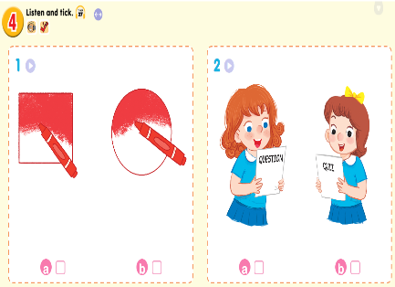  -Point and say  -SS listen and do the task.  -Ss look and listen.  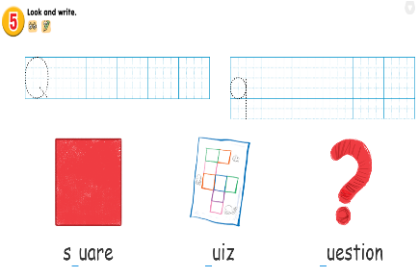  -SS do the task.  -Check in pairs.  -Ss show their work.  -SS listen.
ADJUSTMENTS (if necessary):
……………………………………………………………………………………………………………………………………………………………………………………………………………………

