Week: 10 Preparing date:10/11/2024
Period :19 Teaching date: 13/11/2024

UNIT 5: IN THE CLASSROOM
Lesson 2

I. OBJECTIVES:
By the end of the lesson, students will be able to:
- Correctly pronounce the name of letter Q/q and the sound /q/ in
isolation.
- Say correctly the words : question, square, quiz
1. Knowledge/ Language focus:
- Sound /q/
- Vocabulary: question, square, quiz
2. Skills:
- Listening and speaking.
3. Quality /Attitude:
-Actively participate in activities with their classmates in pairs, groups or class. Educate Ss to become studious and obedient students; love something relates the classroom.
4. Competences:
SS can develop some competences:
-Comunicative and collaborative competence:work in pairs/groups, role play
-Problem-solving competence: observing, collecting and analyzing information
-Self studying and self - control competence: remembering, recalling and guessing words/phrases.
-Creative competence, linguistic competence: giving ideas, changing information, giving comments, critical thinking.
II. TEACHING AIDS / MATERIALS:
- Pictures, textbook, computer, projector, pictures, recording…
III. METHODS:
- Communicative language teaching, contextual teaching and learning, total physical response, games activities teaching, Model-Action-Talk, teaching methods by visual, direction method, audiolingual method.
IV. PROCEDURE:

Teacher’s activities | Students’ activities | Notes
1. Warm- up (5’)  Game: Guessing game  *Aims: to help ss review some vocabulary that they learnt.  *Teaching techniques  - grouping, miming, ask and answer.  *Procedure:  -Have ss to look through 3 pictures( which is closed). T opens each piece of each picture for ss to guess about the pets and then read alous name of the food.T checks and have ss read all the words.  - Say “Open your book page 23 and look at Unit 5, Lesson 1”  2. New lesson Practice(25’)  Activity 1. 1. Listen and repeat:  *Aims: to correctly pronounce the name of letter Q/q and the sound / q / both in isolation and in the words question, square, quiz  *Context: The picture shows classroom.with thw worsd: question, square, quiz  *Teaching techniques  - techniques in teaching listening and speaking, individual, pairworks, ask and answer…  - using flashcardas, recording, pictures…  *Procedure:  - Have ss look at the picture and draw ss’ attention to the letter Q/q, the words next to the things and the colour of the letter Q/q.  -Ask ss to point to the letter Q/q Have them listen and repeat the sound of the letter Q/q more than once, if necessary.  -Tell ss to point to question . Ask them to listen and repeat the word.  -Repeat the same Procedure: with the words: square, quiz, Give further support to those ss who find it difficult to do the task.  -Play the recording again and have them listen, point to the letter Q/q and the question, square, quiz and repeat until they feel confident. Correct pronunciation, if necessary.  -Play the recording again and call some ss to say the letter Q/q and the words question, square, quiz in front of the class.  *Outcome: Ss can correctly pronounce the name of letter Q/q and the sound /q/ both in isolation and in the words question, square, quiz  Activity 2 2. Point and say  *Aims: to correctly identify and pronounce the name the words question, square, quiz  *Context: The picture shows classroom.with thw worsd: question, square, quiz  *Teaching techniques  - techniques in teaching listening and speaking, pairworks, ask and answer…  - using flashcardas, recording, pictures…  *Procedure:  - Have ss look at the picture again and ask them to describe the picture again (in Vietnamese). Draw their attention to the letter Q/q, question, square, quiz if necessary.  - Get them to point to the letter Q/q and say it. Let them point to the word and say,  - Give further support to those ss who find it difficult to do the task.  - Follow the same Procedure: with other things. Give further support to those Ss who find it difficult to do the task.  - Ask ss to work in pairs or in groups to point to the picture and say the sound of the letter Q/q and the words. Go around and offer help or correct pronunciation, if necessary.  -Invite two or three ss to point to the picture and say the sound of the letter and the words in front of the class.  - T gets feedback.  *Outcome: Ss can correctly identify and pronounce the name the words question, square, quiz  Activity 3. *Play game:Pass the word.  *Aims: to correctly pronounce the target words: question, square, quiz  *Context: Using flashcards that contain sounds ss have learnt.  *Teaching techniques  - techniques in teaching listening and speaking, groupworks, ask and answer…  - using flashcardas, pictures…  *Procedure:  - Devide the class into 2 teams to play game.Tell team to form a line  - Explain that when you whisper a word to the first student in each line.He/ she must turn whisper it to the second student in the line , and the turn whisper to other students in the line. When the word reaches the last student in the line he/ she should call it out. A correct word scores one point.  - Have time for ss to play game.  -Count the points for eaxch team and announce the winner.The team with the most points wins  *Outcome: Ss can correctly pronounce the target words: question, square, quiz  3. Consolidation (4’)  *Aims: to consolidate and wrap up the content of the lesson.  - T tells ss about the main content of the lesson.  - T tells ss about the educational Aimss of the lessons.  4. Homework (1’)  - Practice more at home.  - Prepare for the next lesson. | - SS listen and play game.  -SS open their book.  -Look at the picture and listen.  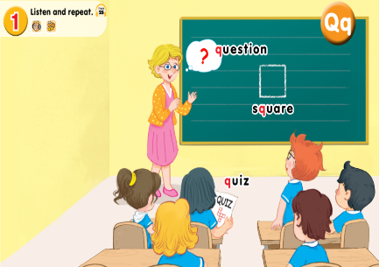  -Point, listen and repeat.  -Ss repeat.  -Ss listen and repeat.  -SS listen, point and repeat.  -SS say in front of the class.  -Look at the picture and discribe.  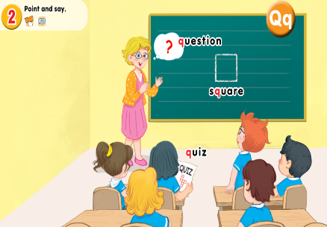  -Point and say  -Work in pairs or in groups.  -Point and say  -Ss look and listen.  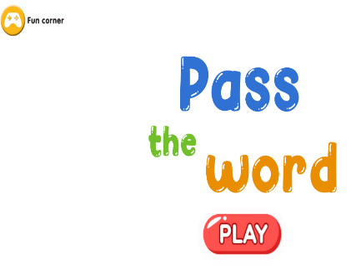  -Ss play game.  -Ss listen.  -Ss listen.

ADJUSTMENTS (if necessary):

