Week 2 Preparing date: 15/9/ 2024
Period 6 Teaching date: 16/9/ 2024
Unit 1: All about me!
Lesson 1 (4, 5, 6)
A. OBJECTIVES: By the end of the lesson, Ss will be able to:
1. Knowledge:
- listen to and understand two communicative contexts in which pupils ask and answer questions about personal information and tick the correct pictures.
- complete four gapped exchanges with the help of picture cues.
- sing the song All about me! with the correct pronunciation, rhythm and melody.
- Vocabulary: Review
- Skills: speaking, listening, reading and writing.
2. Competences:
- Communication and collaboration: work in pairs and groups to complete the learning tasks.
- Self-control and independent learning: perform pronunciation and intonation, listening and reading tasks.
3. Attitude/ Qualities:
- Show their pride in their personal information and where they live.
B. TEACHING AIDS:
- Teacher: Teacher’s guide Pages 21, 22, 23; audio Tracks 7, 8; website hoclieu.vn, posters, laptop, pictures, textbook, lesson plan, TV or projector.
- Students: Student’s book Page 11, notebooks, workbooks, school things.
C. PROCEDURES:
Stages/ Time | Teacher’s activities | Students’ activities
1.Warm- up and review: (5’)  2.Practice: (25’)  3. Fun corner and wrap- up (5’) | Game: “Spin the wheel”  *Aims: to revise the learned sentence structures.  *Procedure:  - Ask Ss if they remember the previous sentence structures to ask and answer questions about personal information.  - Write the question and answers on the board.  - Prepare the numbers on the wheels to match with Ss’ numbers in the class.  - Spin the wheel to choose two numbers. Invite two Ss with those numbers, one pupil asks the question Can you tell me about yourself? and one pupil answers the question.  - Ask their friends to check their pronunciation.  - Continue spinning the wheel for pupils to practice sentence structures.  - Say “Open your book page 11” and look at “Unit 1, Lesson 1 (4,5,6)”.  Activity 1. Listen and tick:  *Aims: Ss will be able to listen to and understand two communicative contexts in which pupils ask and answer questions about personal information and tick the correct pictures.  *Procedure:  - Elicit the personal information of the character (name, grade, place of living) in each picture.  +What’s his/ her name?  +What class is he/ she in?  +Where does he/ she live?  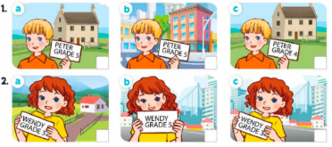  - T ask Ss to guess the answers.  + T writes Ss’guessing on the board.  - Listen to the tape:  + Play the recording  + Play the recording again for pupils to do the task.  + Play the recording a third time for pupils to check their answers.  - Get Ss to swap books with their partner, then check answers as a class.  + Write the answers on the board for Ss to correct their answers. Then checks Ss’ guessing.  - Ask Ss to look at the picture, say the information about Peter and Wendy.  ex: Peter is a pupil. He’s in Grade 5. He lives in the countryside.  Key: 1. a 2. c  Activity 2. Read and complete.  *Aims: Ss will be able to complete four gapped exchanges with the help of picture cues.  *Procedure:  - Get Ss to look at the pictures and identify the characters  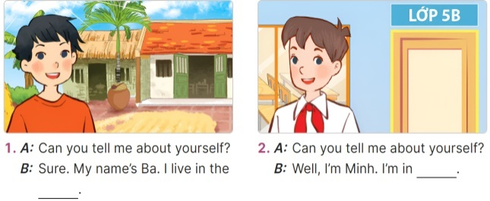  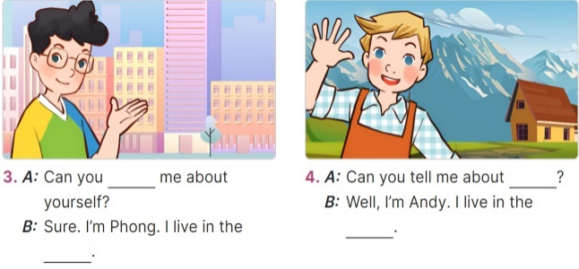  - Have Ss look at the four incomplete exchanges and elicits the missing words in the sentences.  - T models with sentence 1  + Ask Ss what is missing in the sentence (a place of living)  + Have Ss look at the picture and identify the needed information (countryside).  - Have Ss work in groups and complete the sentences 2, 3 and 4.  - Get Ss to swap books with a partner and check their answers before checking as a class.  -T gives feedbacks.  Key:  1. countryside / village  2. Class 5B 3. tell; city  4. yourself; mountains  Activity 3. Let’s sing.  *Aims: Ss will be able to sing the song All about me! with the correct pronunciation, rhythm and melody. *Procedure:  - Introduce the title and lyrics of the song: “All about you!” song.  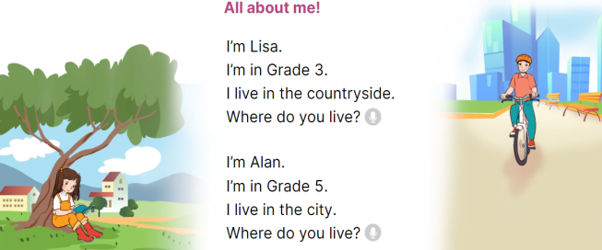  - Play the recording for Ss to listen to the whole song.  + Have them repeat the title and lyrics line by line.  - Play the recording all the way through for Ss to listen to pronunciation and melody of the song.  - Play the recording line by line for Ss to listen, repeat.  - Play the recording for Ss to sing and do actions.  - Ask Ss to practice singing and doing actions in pairs or groups.  - Invite groups to the front of the classroom to perform the song  Game: Roll the dice  - Divide the class into groups of six. Have each student count the numbers from one to six.  - Ask a student from each group to roll the dice to choose a pupil asking the question.  - Ask that student to ask the question and invite another pupil of the group to answer the question about his / her personal information.  - The Ss giving the correct answer will continue rolling the dice.  - The Ss giving the incorrect answer will lose their turns. | - Give the sentence structures.  - Look at the question and answers on the board.  - Ask and answer the question Can you tell me about yourself?  - Check their friends’ pronunciation  - Continue playing the game.  - Ss open their books  -Look at the pictures and say:  + Picture 1a: His name is Peter, he’s in grade 5, he lives in the countryside.  + Picture 1b: His name is Peter, he’s in grade 5, he lives in the city.  + Picture 1c: His name is Peter, he’s in grade 4, he lives in the countryside.  + Picture 2a: Her name is Wendy, she’s in grade 3, she lives in the countryside.  + Picture 2b: Her name is Wendy, she’s in grade 5, she lives in the city.  + Picture 2c: Her name is Wendy, she’s in grade 3, she lives in the city.  -Ss guess the answers  - Ss listen to the tape  - Ss listen again and do the task.  - Ss listen and check their answers  - Ss swap books with their partner, then check answers as a class and guessing  -Ss listen and read aloud  -Ss look at the picture, say the information about Peter and Wendy.  -Ss look at the picture and identify personal information of the character in each picture.  -Ss look and follow the teacher demonstrating the exchange 1.  -Ss listen and pay attention  -Ss answer: (I live in the countryside.)  -Ss complete the sentences  -Ss swap books with a partner and check their answers before checking as a class.  -Ss listen  - Ss listen and pay attention  -Ss listen to the song  - Ss listen and repeat line by line without the action.  -Ss listen to melody of the song  - Ss listen and sing line by line.  - Ss sing and do actions.  + Ss work in groups (two groups) to sing.  -Ss perform in front of the class.  -Ss listen  - Ss listen  -Ss listen and play the game  Ex:  A: Can you tell me about yourself?  B: I’m in Class 5B. I live in the countryside.  - Ss continute playing the game
Week 2

