Week 2 Preparing date: 15/9/ 2024
Period 5 Teaching date: 16/9/ 2024
Unit 1: All about me!
Lesson 1 (1, 2, 3)
A. OBJECTIVES: By the end of the lesson, Ss will be able to:
1. Knowledge:
- understand and correctly repeat the sentences in two communicative contexts focusing on asking and answering questions about personal information.
- correctly say the words and use Can you tell me about yourself? - I’m in ………...; I live in the……………. to ask and answer questions about personal information.
- use Can you tell me about yourself? - I’m in ……; I live in the…in freer contexts.
- Vocabulary: city, class, countryside
- Structures: A: Can you tell me about yourself?
B: I’m in class 5D. I live in the countryside.
- Skills: speaking and listening
2. Competences:
- Communication and collaboration: work in pairs and groups to complete the learning tasks.
- Self-control and independent learning: perform pronunciation and speaking tasks.
3. Attitude/ Qualities:
- Show their pride in their personal information and where they live.
B. TEACHING AIDS:
- Teacher: Teacher’s guide Pages 18, 19, 20, 21, audio Tracks 5,6, website hoclieu.vn, posters, laptop, pictures, textbook, lesson plan, TV or projector.
- Students: Students’ book Page 10, notebooks, workbooks, school things.
C. PROCEDURES:
Stages/Time | Teacher’s activities | Students’ activities
1.Warm- up: (3’)  2. Presentation (15’)  3.Practice: (7’)  4. Production: (6’)  5. Fun corner and wrap- up (4’) | Sing a song: Hello, nice to meet you  *Aims: to create a friendly and active atmosphere in the class to beginning the lesson.  *Procedure:  - Show the song on the screen.  https://www.youtube.com/watch?v=ANrSdZq8sCk  - Ask Ss to listen, sing and dance the song  - Say “Open your book page 10” and look at “Unit 1, Lesson 1 (1,2,3)”.  Activity 1. Vocabulary.  *Aims: Ss will be able to know the vocabulary in the new lesson.  *Procedure:  -T elicits the new words  + city : thành phố (picture)  + class : lớp học (picture)  + countryside:nông thôn (picture)  - T models (3 times).  - T writes the words on the board.  - Checking: Rub out and remember  Activity 2. Look, listen and repeat:  *Aims: Ss will be able to understand and correctly repeat the sentences in two communicative contexts focusing on asking and answering questions about personal information.  *Procedure:  - Have Ss look at Pictures a and b and identify the characters in the pictures.  + Who is he/ she?  + Where is he/ she?  + What are they talking about?  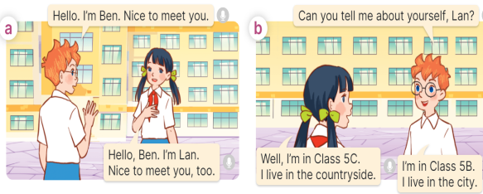  - Play the audio twice (sentence by sentence). Correct their pronunciation where necessary.  - Have Ss to practice the dialogue  - T invites a few pairs to the front of the class to practice.  - T checks pronunciation for ss.  Activity 3 Listen, point and say.  *Aims: Ss will be able to correctly say the words and use Can you tell me about yourself? - I’m in ……..; I live in the ….. to ask and answer questions about personal information.  *Procedure:  * Structures:  - T asks Ss look at picture b in activity 1 and helps Ss know the structure from the dialogue.  - T introduces new structures for Ss.  - T explains, models and gives meaning.  - Have Ss repeat the model sentences.  A: Can you tell me about yourself?  B: I’m in class 5D. I live in the countryside.  *Drill pictures  - Elicit and check comprehension the personal information of each character.  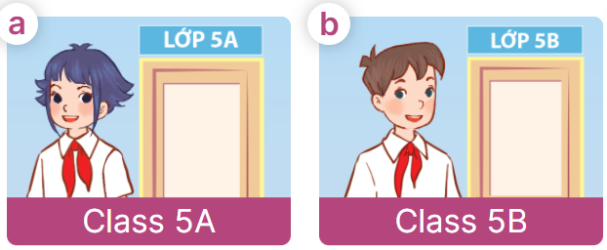  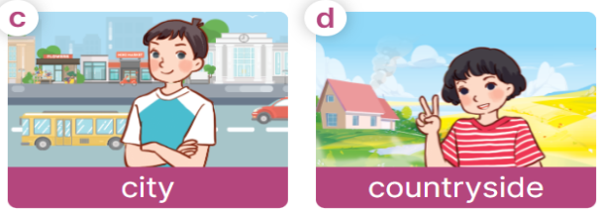  - Have Ss point at pictures, listen and run through all the pictures.  - Have Ss point at the bubbles, listen and run through model sentences.  - Have Ss to practise:  + T asks the first picture, Ss answer  + Ss asks the second picture, T answers  + Group A asks the third picture, group B answers  + Group B asks the last picture, group A  - Ask Ss to work in pairs to practise asking and answering the question Can you tell me about yourself? - I’m in ……….; I live in the…….  - T controls and corrects.  - Invite a few pairs to point at the pictures and say the questions and answers in front of the class.  Activity 4. Let’s talk.  *Aims: Ss will be able to use Can you tell me about yourself? - I’m in …….; I live in the ……… in a freer context.  *Procedure:  - T asks ss to identify the character’s information in each picture  +What can you see in the picture?  +Who are they?  +Where does he/ she live?  +What class is he/ she in?  +When’s her/ his birthday?  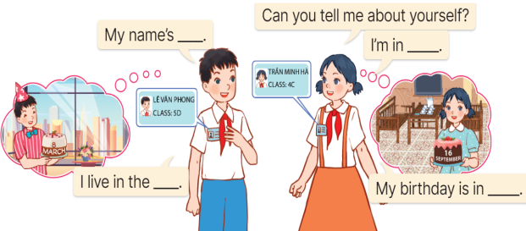  - Elicit the answer in the speech bubble and write it on the board. Get Ss to say the completed sentences.  - Have Ss role-play to practise asking the questions and giving their answers in pairs, using the picture cue.  - Invite a few pairs to point at the pictures and ask and answer questions.  Game: Pass the teddy bears  - Give two different coloured teddy bears to two Ss, a black teddy bear (ask the question) and a white teddy bear (answer the question).  - Ask Ss to listen to music and pass the teddy bears.  - Stop music suddenly. Have the student with a black teddy bear make a question. Have the student with a white teddy bear answer the question.  - Repeat the game several times. | - Sing and dance the song together.  - Ss listen and open their books  -Ss listen and answer  - - Ss listen and repeat  + Choral repetition  (3 times).  + Individual repetition  (3 ss)  - Ss take note  - Ss look, remember and write  -Look at the pictures and get to know the characters in the pictures.  +In picture a:  Ben: Hello, I’m Ben. Nice to meet you.  Lan: Hello, Ben. I’m Lan. Nice to meet you, too.  + In picture b:  Ben: Can you tell me about yourself, Lan?  Lan: Well, I’m in Class 5C. I live in the countryside.  Ben: I’m in Class 5B. I live in the city  -Ss listen and repeat in chorus (twice)  -Ss work in pairs to practice  -Ss come to the front of the classroom to practice.  -Ss listen  - Ss look at the picture and answer.  -Ss listen  -Ss listen and repeat  -Ss repeat to the structures  - Ss look, listen and repeat  +Picture a: a girl standing at the door of Class 5A.  + Picture b: a boy standing at the door of Class 5B.  + Picture c: high buildings in the city.  + Picture d: a girl standing in front of a house in the countryside.  -Ss point at pictures, listen and repeat  -Ss point at the bubbles, listen and repeat  -Ss practice in chorus  -Ss practice in chorus  -Ss work in pairs to practise asking and answering the question  - Pairs of Ss point at the pictures and say in front of the class  -Ss look at the picture and answer  + a picture of two pupils showing their personal information (classes they are in and places they live in).  - Ss say the completed sentences.  -Ss work in pairs to ask and answer  Can you tell me about yourself?  - My name’s ……. I’m in ………….I live in the …… My birthday is in ……  -Ss perform in front of the class.  - Ss listen  -Ss listen and play the game  Ex:  A: Can you tell me about yourself?  B: I’m in Class 5A. I live in the city.  -Ss continute to play the game.

