TRƯỜNG TIỂU HỌC HÒA AN 2
Tổ 5

KẾ HOẠCH BÀI DẠY
MÔN TIẾNG ANH LỚP 5
Tuần 1


Giáo viên: Lê Thị Nhơn

Năm học: 2024-2025

Week 1 Preparing date: 08/09/2024
Period 1 Teaching date: 09/09/2024
INTRODUCTION THE ENGLISH 5 PROGRAME AND TEXTBOOK
A. OBJECTIVES: By the end of the lesson, Ss will be able to:
1. Knowledge:
- use the allocation in their study (at school + at home) and basic classroom language.
- Skills: speaking and listening
2. Competences:
- Be self-study, communicative and interative skill.
- Co-operation: ready to help friends in pair work/ group work.
3. Attitude/ Qualities:
-Actively participate in activities with their classmates in pairs, groups or class. Educate Ss to become studious and obedient students, love learning English.
- Honesty, patience and friendliness.
B. TEACHING AIDS:
- Teacher: Posters, laptop, pictures, textbook, lesson plan, TV or projector.
- Students: Textbooks, notebooks, workbooks, school things.
C. PROCEDURES:
Stages/Time | Teacher’s activities | Students’ activities
1. Warm- up: (5’)  2.Presentation: (15’)  3. Fun corner and wrap up: (15’) | *Aims: to create a friendly and active atmosphere in the class to beginning the lesson.  *Procedure:  - Greet the class and introduce yourself,  - Encourage Ss to say their names  - Sing a song  Activity 1.  *Aims: Ss will be able to know about the English 5 progamme and textbook.  *Procedure:  - Introduce about subject  +“English 5” has 3 books. (two student books and one exercise book)  - Introduce the student’s book and workbook.  - Say the main contents  There are 20 Units, each Unit has 3 lessons  Activity 2.  *Aims: Ss will be able to know and do action about classroom languages.  *Procedure:  - Say and model some classroom languages  + Open/ close your books, please!  + Stand up/ Sit down, please!  + Be quiet/ Don’t talk, please!  + ….  - Sing and model the “If you’re happy and you know it” song  https://www.youtube.com/watch?v=zyMWcWqmhRc  Activity 4 Game: Pass the ball.  - Give a ball to a Ss and turn on the music.  - Have that pupil pass the ball until the music stops.  - The one who is keeping the ball will introduce themselves to his/ her friends  Ex: My name’s Huong.My birthday is in October. I live in Nghia Lam Village. I study at Nghia Lam Primary Schol… | - Greet and introduce  - Ss greet and say their names  - Listen, sing and dance the song in chorus.  - Listen to the teacher  - Listen to the teacher  - Listen to the teacher  - Look and do action  - Listen to the song through the tape.  - Listen and repeat sentence by sentence link the action.  - Sing all the text link the action in the chorus.  - Work in groups (two groups) to sing  - Listen and play games.

Week 1 Preparing date: 8/9/2024
Period 2 Teaching date: 9/9/2024
STARTERA. Back to school
A. OBJECTIVES: By the end of the lesson, Ss will be able to:
1. Knowledge:
- sing the song Back to school with correct pronunciation, rhythm and melody.
- review the vocabulary and structure items related to months of the year and someone’s birthday.
- complete three gapped sentences in My goal tree about their learning goals and share them with their friends.
- Vocabulary: Review
- Skills: speaking, listening and writing.
2. Competences:
- Critical thinking and creativity: learn how to ask and answer questions about personal information correctly and fluently.
- Communication and collaboration: work in pairs and groups to complete the learning tasks.
- Self-control and independent learning: perform speaking and writing tasks.
3. Attitude/ Qualities:
- Show pride in the time back to school.
- Show their love and interest in learning and playing.
B. TEACHING AIDS:
- Teacher: Teacher’s guide Pages 12-13, audio Tracks 1, website hoclieu.vn, posters, pictures, computer, textbook, lesson plan, TV or projector.
C. PROCEDURES:
Stages/Time | Teacher’s activities | Students’ activities
1.Warm- up: (5’)  2. Practice (25’)  3. Fun corner and wrap- up (5’) | Sing a song: Hello song  *Aims: to create a friendly and lively atmosphere in the classroom.  *Procedure:  - Show the song on the screen.  https://www.youtube.com/watch?v=tVlcKp3bWH8  - Ask Ss to listen, sing and dance the song.  - Say “Open your book page 7” and look at “Starter, Back to school”  Activity 1. Let’s sing  *Aims: Ss will be able to sing the song Back to school with correct pronunciation, rhythm and melody.  *Procedure:  - Draw Ss’ attention to the lyric of the song.  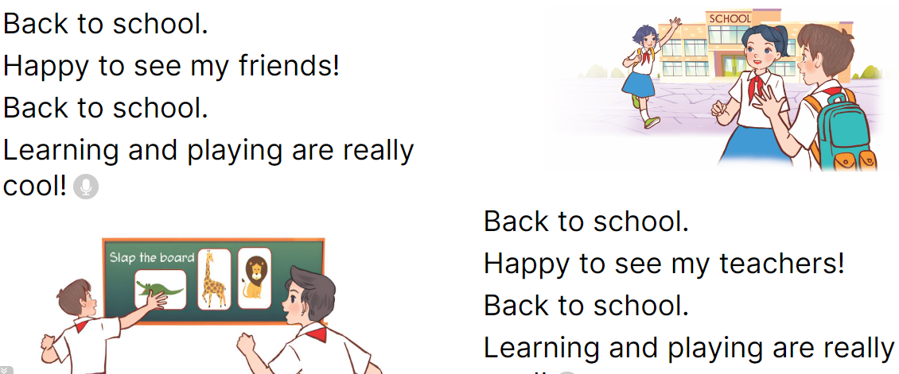  - Have Ss read and listen to the song, drawing their attention to the pronunciation, rhythm and melody.  - Play the recording again and let them listen to and practise singing the song, line by line, while doing actions or clapping their hands.  - Ask Ss to listen to and sing the whole song while doing actions or clapping their hands.  - Invite a few groups to the front of the class to sing the song.  Activity 2. Let’s play  *Aims: Ss will be able to review the vocabulary and structure items related to months of the year and someone’s birthday.  *Procedure:  - Invite two teams of six pupils to play. Tell Ss how to play the game. Ss say their birthday months and line up, starting with January.  - The faster team will win the game.  - Invite other teams to play the game.  Activity 3. Write and share.  *Aims: Ss will be able to complete three gapped sentences in My goal tree about their learning goals and share them with their friends.  *Procedure:  - Tell the class the goal of the activity and explain that they should write three sentences about their learning goals. Check comprehension. 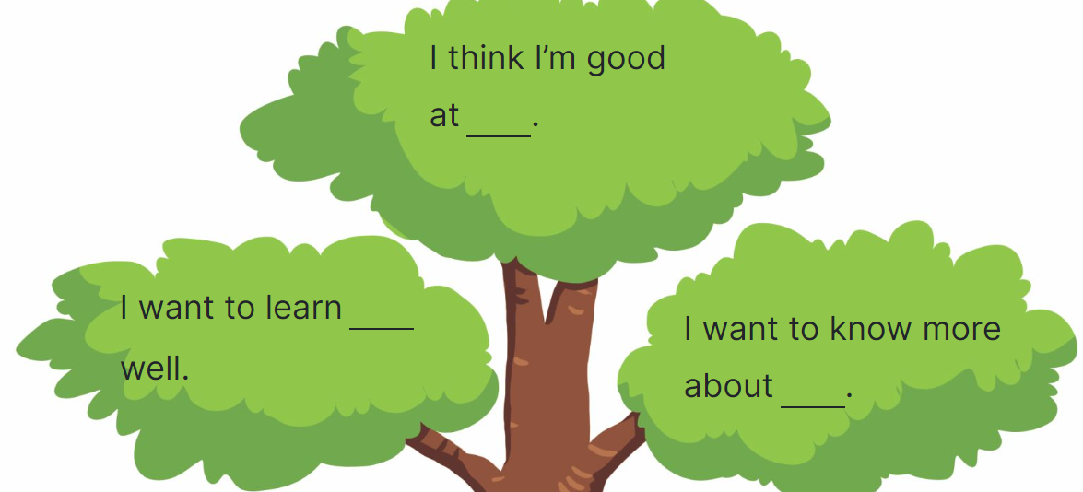  - Ask Ss to read the sentence and elicit possible answers. Then have them write their answers in the gap.  - Give Ss time to complete the sentences independently.  - Get pupils to work in pairs to share their learning goals  - Invite one or two Ss to read their learning goals aloud.  Game: Bingo (ppt)  - Prepare word cards about months of the year.  - Ask Ss to choose four words and write in a bingo grid.  - Explain that when you call out a word, Ss should search for that word on their bingo card. If they have the word, they should cross it out. The first pupil to cross out all their words wins.  - Play the game. Praise the winner. | - Sing and dance the song in chorus.  - Ss listen and open their books.  - Ss pay attention to the title and lyrics of the song.  - Ss read and listen to the song.  - Ss listen to the recording and practise singing the song, line by line, while doing actions or clapping their hands.  - Ss listen to and sing the whole song while doing actions or clapping their hands.  - Ss come to the front of the class to sing the song.  - Ss work in two teams of six. Ss listen to the instructions and play the game.  - Ss praise the winner.  - Ss play the game.  - Ss listen to the teacher’s explanation.  - Ss read the sentence and elicit possible answers and write their answers in the gap.  - Ss complete the sentences  - Ss work in pairs to share their learning goals.  - Ss read their learning goals aloud.  - Ss listen  - Ss play the game  -Ss praise the winner

Week 1 Preparing date: 8/9/202
Period 3 Teaching date: 12/9/2024
STARTER B. Last summer
A. OBJECTIVES:By the end of the lesson, Ss will be able to:
1. Knowledge:
- review the vocabulary and structure items related to the topic Last summer by playing Guessing game.
- listen to and understand four communicative contexts in which speakers ask and answer questions about the places they were last summer and match the speakers with the right pictures.
- correctly use key structures to ask and answer questions about someone’s last summer in a freer context.
- Vocabulary: Review
- Skills: speaking and listening
2. Competences:
- Oral communication: work in pairs and groups to complete the learning tasks.
- Self-control and independent learning: perform listening and speaking tasks.
3. Attitude/ Qualities:
- Show pride in where they went last summer.
- Show their love and interest in the places they went to last summer.
B. TEACHING AIDS:
- Teacher: Teacher’s guide Page 14,15, 16 audio Track 2, website hoclieu.vn, posters, laptop, pictures, textbook, lesson plan, TV or projector.
- Students: Student’s book Page 8, notebooks, workbooks, school things.
C. PROCEDURES:
Stages/  Time | Teacher’s activities | Students’ activities
1.Warm- up and review: (4’)  2. Practice (27’)  3. Fun corner and wrap- up (4’) | Sing a song: Hello summer  *Aims: to create a friendly and active atmosphere in the class to beginning the lesson.  *Procedure:  - Show the song on the screen.  https://www.youtube.com/watch?v=J8DftSKKXGE  - Ask Ss to listen, sing and dance the song.  - Say “Open your book page 8” and look at “Starter, Last summer”.  Activity 1. Let’s play:  *Aims: Ss will be able to review the vocabulary and structure items related to the topic Last summer by playing Guessing game.  *Procedure:  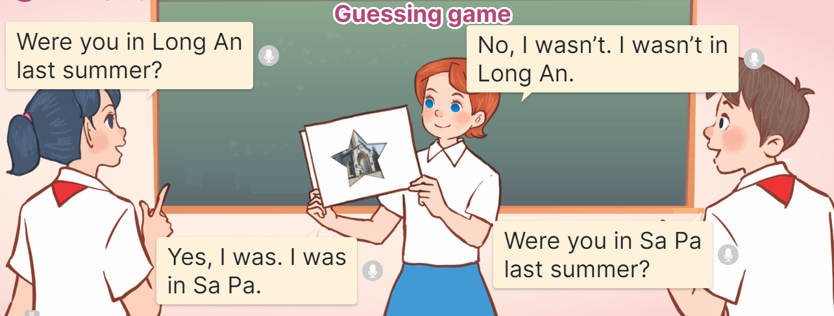  - Ss prepare pictures of the places they went to last summer.  - Divide the class into two teams.  + A student from one team holds up a picture covered by another piece of paper so everyone can only see one part of it.  + The other team guesses what place it is by asking Yes / No questions.  - If the team can guess the correct place with fewer than three questions, the team gets one star.  - Continue the game. The team with more stars will be the winner.  Activity 2: Listen and match  *Aims: Ss will be able to listen to and understand four communicative contexts in which speakers ask and answer questions about the places they were last summer and match the speakers with the right pictures  *Procedure:  - Draw Ss’ attention to the pictures of the four characters, the places and the weather and ask the questions:  +Who are they?  +What’s the weather like in….?  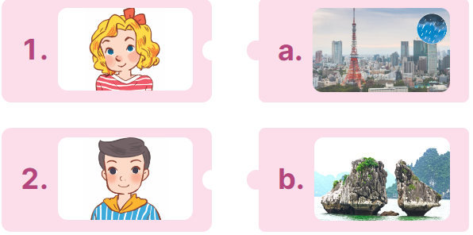  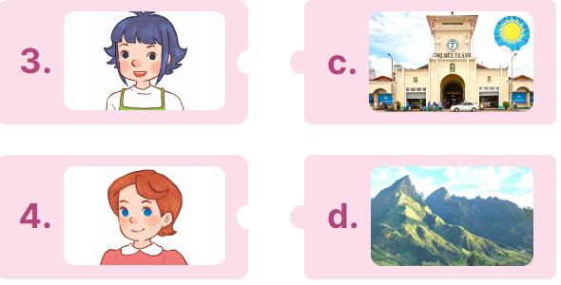  - Play the recording all the way through for Ss to listen and familiarise themslves with the speaker’s voice.  - Play the recording again for Ss to listen and number the pictures.  - Get pupils to swap books with a partner to check their answers before checking as a class.  - Check the correct answer and give feedback.  - Play the recording, sentence by sentence, for pupils to listen and repeat in chorus.  Key: 1.b 2.a 3.d 4.c  Activity 3. Let’s talk  *Aims: Ss will be able to correctly use key structures to ask and answer questions about someone’s last summer in a freer context.  *Procedure:  - Draw Ss’ attention to the picture and ask the questions:  +Where were you last summer?  +What was the weather like there?  +Was it fun?  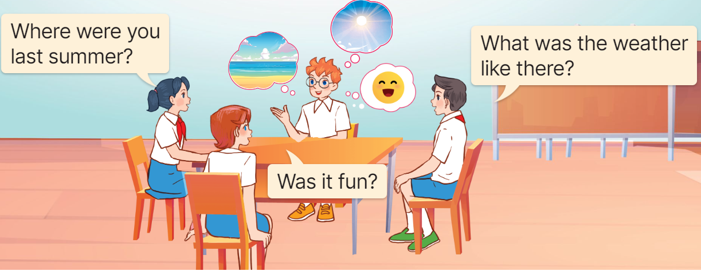  - Get Ss to read the speech bubbles and elicit possible answers.  - Put Ss into groups of four to ask and answer questions about their last summers.  - Invite a few groups to the front of the classroom to ask and answer questions about their last summers.  Game: Pass the ball  - Choose a song Back to school (Track 1) and 2 balls: 1 red and 1 green.  - While the music plays, Ss pass the balls around the class.  - When the music stops, the student with the red ball asks a question: Where were you last summer?  - The student with the green ball answers the question: I was on the beach.  - Continue the game with other students. | - Sing and dance the song in chorus.  - Ss listen and open their books.  - Ss prepare pictures of the places they went to last summer.  - Ss play the game  - Ss get one star for one correct place.  - Ss continue playing the game.  -Look at the pictures and answer  -Ss listen to the tape  - Ss listen again and match  -Ss swap books with the partner and check.  -Ss check the answer together.  - Ss listen and repeat, sentence by sentence.  -Ss listen and answer  - Ss read the speech bubbles and elicit possible answers.  - Ss work into groups of four to ask and answer questions.  - Groups of Ss come to the front of the classroom to ask and answer questions.  - Ss listen  - Ss play the game  - Ss continue to play the game

Week 1 Preparing date: 8/9/2024
Period 4 Teaching date: 12/9/2024
STARTERC. Classroom instructions
A. OBJECTIVES: By the end of the lesson, Ss will be able to:
1. Knowledge:
- say the chant with the correct pronunciation, word stress and rhythm.
- listen to and understand two instructions and choose the correct pictures.
- review some classroom instructions by playing the game Do as I say.
- Vocabulary: Review
- Skills: listening, speaking and reading.
2. Competences:
- Critical thinking and creativity: learn how to ask and answer questions about someone’s favourite things correctly and fluently.
- Communication and collaboration: work in pairs and groups to complete the learning tasks.
3. Attitude/ Qualities:
- Show pride in the instructions in classroom.
- Show their love and interest in classroom instructions.
B. TEACHING AIDS:
- Teacher: Teacher’s guide Page 16, 17, website hoclieu.vn, posters, laptop, pictures, textbook, lesson plan, TV or projector.
- Students: Student’s book Page 9, notebooks, workbooks, school things.
C. PROCEDURES:
Stages  /Time | Teacher’s activities | Students’ activities
1.Warm- up: (4’)  2. Practice (27’)  3. Fun corner and wrap- up (4’) | Game: Yes or No  *Aims: to create a friendly and active atmosphere in the class to beginning the lesson.  *Procedure:  - Ask Ss to play the game individually.  - Give each student two boards, Yes and No.  - Show a question and pictures on the board. Ss read the question and look at the pictures. Then raise the correct board, Yes or No and shout the correct answer as fast as they can. If the answer is No, they have to add more words to tell the correct idea.  Example:  Was the weather hot yesterday?  * raising the No board.  * saying “No, it wasn’t. It was rainy.”  - Give scores to the fastest student with the correct answer.  - Say “Open your book page 9” and look at “Starter, Last summer”.  Activity 1. Let’s chant  *Aims: Ss will be able to say the chant with the correct pronunciation, word stress and rhythm.  *Procedure:  - Have Ss look at the picture and state activity the characters are doing.  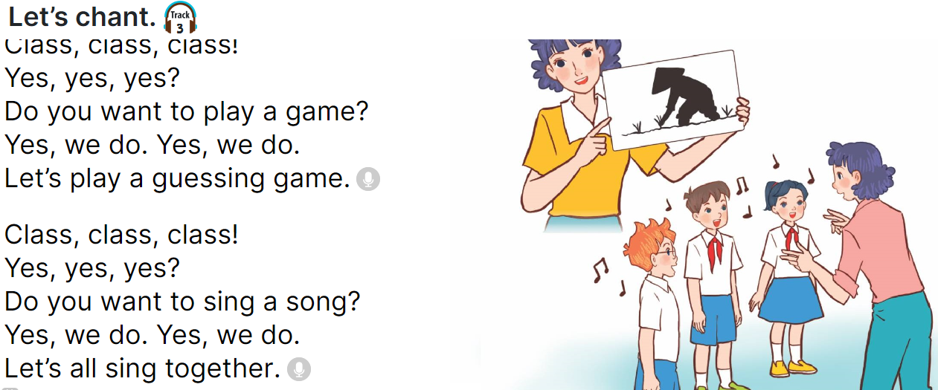  - Have Ss read the first verse of the chant.  - Play the recording of the first verse for pupils to listen.  + Play it again, line by line, for Ss to listen and repeat.  - Repeat Steps 2 and 3 for the second verse of the chant.  - Play the recording all the way through for Ss to chant and clap their hands.  Activity 2: Listen and tick  *Aims: Ss will be able to listen to and understand two instructions and choose the correct pictures.  *Procedure:  - Draw Ss’ attention to the pictures and ask questions to elicit the activities in the pictures.  + What are they doing?  + What activity are they doing?  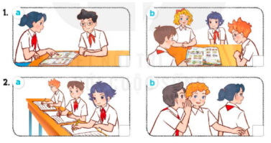  - Play the recording all the way through. Then play the recording again for Ss to listen and tick the correct pictures.  - Get Ss to swap books with a partner and check their answers before checking as a class.  - Give feedback  * Key: 1. a 2. b  Activity 3: Let’s play  *Aims: Ss will be able to review some classroom instructions by playing the game Do as I say.  *Procedure:  - Ask each student to prepare three instructions.  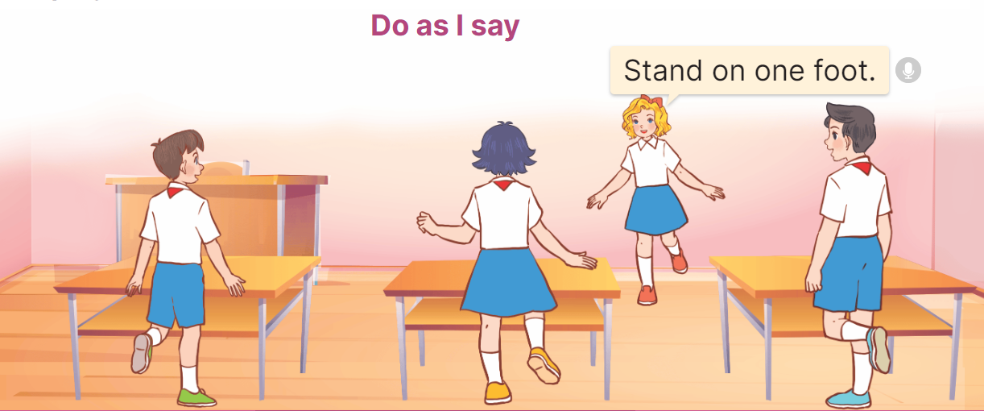  - Divide the class into two teams. Invite one student to the front to share their instructions.  + While giving each instruction, the student also acts out.  + The action may be the same or different from the instruction.  + The rest of the pupils listen and follow the given instructions.  - Any Ss who cannot follow the instruction correctly will be out of the game. The team with more remaining players gets a star.  - Keep going with other pupils. After five minutes, the team with more stars wins.  Game: Whisper  - Use phrases of classroom instructions: stand up, sit down, open your book, close your book, raise your hand, close your eyes, face down, sit nicely, ...  - Divide the class into two teams. Tell each team to form a line.  - Explain that when you whisper a phrase of classroom instructions to the first student in each line, he/ she must in turn whisper it to the second student in the line. The second student then whispers it to the third, and so on. When the phrase reaches the last student in the line, he/ she should call it out. A correct phrase scores one point.  - Count the points for each team and announce the winner. The team who has more points wins the game. | - Play the game individually.  - Get two boards from the teacher.  - Read the question and look at the pictures.  - Follow the teacher’s instructions.  - The fastest student with the correct answer gets scores.  - Ss listen and open their books.  - Ss look at the picture and state the activity the characters are doing.  - Ss read the first verse of the chant.  - Ss listen to the recording of the first verse.  + Ss listen and repeat.  - Ss follow the teacher’s instructions.  - Ss listen to the recording all the way through to chant and clap their hands.  - Ss look at the pictures and answer the questions.  - Ss listen and tick the correct pictures.  - Ss swap books with a partner and check their answers.  - Check again  - Each student prepares three instructions.  - Ss work in two teams and play the game.  - Ss play the game.  - Ss continue playing the game.  - Ss listen  -Ss listen and play the game  -Ss play the game

