Week 15 Preparing date: …………..…….., 2024
Period 57 Teaching date: …………………., 2024

Unit 9: Our outdoor activities
Lesson 1 (4, 5, 6)
A. OBJECTIVES:
By the end of the lesson, Ss will be able to:
1. Knowledge:
- listen to and understand four communicative contexts in which characters ask and answer questions about where someone was in the past.
- complete four gapped exchanges with the help of picture cues.
- revise the target vocabulary items and structures through the game Memory game.
- Vocabulary: Review
- Skills: speaking, listening, reading and writing.
2. Competences:
- Communication and collaboration: work in pairs and groups to complete the learning tasks.
- Self-control and independent learning: perform pronunciation and speaking tasks.
3. Attitude/ Qualities:
- Show their love and interest in outdoor activities.
- Show their knowledge of doing outdoor activities safely.
B. TEACHING AIDS:
- Teacher: Teacher’s guide Pages 144, 145, 146; audio Tracks 88; website hoclieu.vn, posters, laptop, pictures, textbook, lesson plan, TV or projector.
- Students: Student’s book Page 63, notebooks, workbooks, school things.
C. PROCEDURES:
Stages/ Time | Teacher’s activities | Students’ activities
1.Warm- up and review: (5’)  2.Practice: (25’)  3. Fun corner and wrap- up (5’) | Game: Missing flashcard  *Aims: to revise the learned words  *Procedure:  - Divide the class into two groups.  - Place four flash cards (theatre, aquarium, campsite, funfair) on the board.  - Have ss play the game in turns. Have ss close their eyes. Teacher removes one picture.  - Invite one student from each group to speak out the picture which disappears.  - Continue the game until all the vocabulary sets are said.  - The group with more points wins the game. Praise the winner.  - Say “Open your book page 63” and look at “Unit 9, Lesson 1(4,5,6)”.  Activity 1. Listen and tick or cross:  *Aims: Ss will be able to listen to and understand four communicative contexts in which characters ask and answer questions about where someone was in the past.  *Procedure:  - Draw ss’ attention to the pictures and identify the characters and the places. 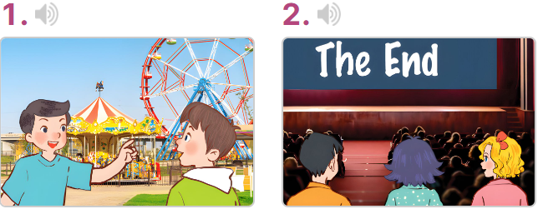  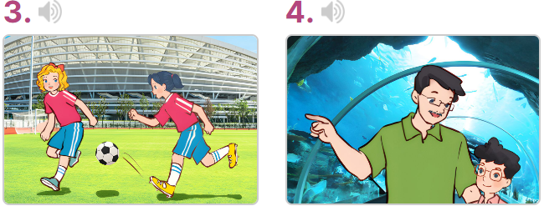  - T ask Ss to guess the answers.  + T writes Ss’guessing on the board.  - Listen to the tape:  + Play the recording  + Play the recording again for pupils to do the task.  + Play the recording a third time for pupils to check their answers.  - Get Ss to swap books with their partner, then check answers as a class.  + Write the answers on the board for Ss to correct their answers. Then checks Ss’ guessing.  - Have Ss to listen and repeat individually and in chorus  Key: 1. v 2. x 3. x 4. v  Activity 2. Read and complete  *Aims: Ss will be able to complete four gapped exchanges with the help of picture cues.  *Procedure:  - Have Ss look at the pictures and read the question and answer, and guess the missing word in the answer.  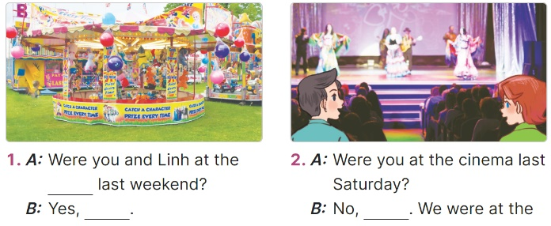  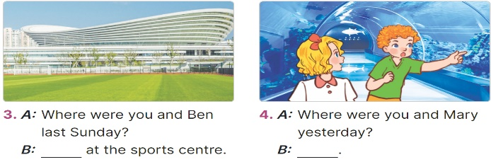  - T models: have Ss read the question and asks what words are missing (funfair)  - Give Ss a time limit to read the gapped dialogues, look at the pictures and do the task independently.  - Get Ss to swap books with a partner and check their answers before checking as a class.  + Invite one student to write the answers on the board.  - Invite two pairs of Ss to act out the completed dialogues.  Key:  1. funfair, we were  2. we weren’t, theatre  3. We were  4. We were at the aquarium  Activity 3. Let’s play  *Aims: Ss will be able to revise the target vocabulary items and structures through the game Memory game.  *Procedure:  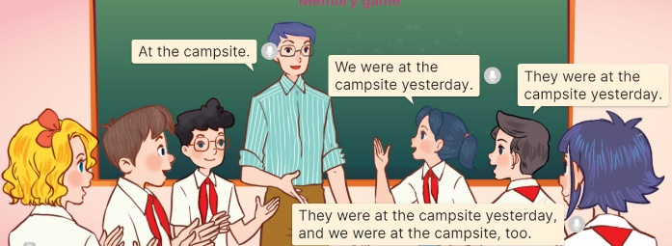  - Tell ss that they are going to revise the target vocabulary items and structures they have learnt in Lesson 1  - Invite two groups (three ss each) to the front of the class. Have ss listen to the topic (At the campsite).  + The first member of the first group (a girl) tells the place where she and her friends were yesterday (ex: We were at the campsite yesterday.)  + The second member (a boy) listens to the girl, repeats the information about the place where she and her friends were yesterday (ex: They were at the campsite yesterday.)  + The third member (a girl) repeats the boy’s information and adds in the place she and her friends were yesterday (ex: They were at the campsite yesterday. We were at the campsite, too).  - Set a time limit for ss to play the game. The group members discuss and decide the order of the speakers in the group.  - The game ends when all group members have done their roles.  - The group that says the most sentences in the shortest time will win the game.  Game: Lucky number  - Tell ss they are going to choose a number, look at the picture and answer the question or complete the question.  - Divide ss in 2 teams and play the game.  - Give points as the diamonds shown on the screen.  - Which team has more diamonds will be the winner. | -Ss listen to the teacher  -Ss play the game  -Ss play the game  - Ss open their books  -Look at the pictures and say:  + Picture 1: Minh and Nam at the funfair  + Picture 2: Mary and her friends at the cinema  + Picture 3: Mai and Mary at the sports centre  + Picture 4: A boy and his father at the aquarium  -Ss guess the answers  - Ss listen to the tape  - Ss listen again and do the task.  - Ss listen and check their answers  - Ss swap books with their partner, then check answers as a class and guessing  -Ss write the answer on the board  -Ss listen and repeat  -Ss look at the picture and say  -Ss follow the teacher  - Ss do the task independently.  - Ss swap books with a partner and check their answers.  - Ss write the answers on the board  - Pairs of Ss read the completed dialogues aloud  - Ss to the teacher  - Ss play the game  - Ss play the game  -Ss play the game  - Ss play the game.  -Ss praise the winner  - Ss to the teacher  - Ss play the game
D. ADJUSTMENTS (if necessary):
………………………………………………………………………………………….…..……………………………………………………………………………...…..…

Week 15 Preparing date: ………..….., 2024
Period 58 Teaching date: ……….….., 2024

Unit 9: Our outdoor activities
Lesson 2 (1, 2, 3)
A. OBJECTIVES:
By the end of the lesson, Ss will be able to:
1. Knowledge:
- understand and correctly repeat the sentences in two communicative contexts in which characters ask and answer questions about activities someone did in the past.
- correctly say the phrases listen to music, watch the fish, dance around the campfire, play chess and use What did you do yesterday? - We ____. to ask and answer questions about activities someone did in the past.
- use What did you do yesterday? - We ____. in a freer context.
- Vocabulary: watch the fish, dance around the campfire
- Structures:
A: What did you do yesterday?
B: We played badminton.
- Skills: speaking and listening
2. Competences:
- Critical thinking and creativity: learn how to ask and answer questions about activities someone did in the past correctly and fluently.
- Communication and collaboration: work in pairs and groups to complete the learning tasks.
3. Attitude/ Qualities:
- Show their love and interest in doing free-time activities.
- Be friendly when doing activities with their friends.
B. TEACHING AIDS:
- Teacher: Teacher’s guide Pages 147, 148, 149, audio Tracks 90; website hoclieu.vn, posters, laptop, pictures, textbook, lesson plan, TV or projector.
- Students: Students’ book Page 64, notebooks, workbooks, school things.
C. PROCEDURES:
Stages/ Time | Teacher’s activities | Students’ activities
1.Warm- up and review: (3’)  2. Presentation (15’)  3.Practice: (7’)  4. Production: (6’)  5. Fun corner and wrap- up (4’) | Game: Throw a dice  *Aims: to create a friendly and active atmosphere in the class to beginning the lesson.  *Procedure:  - Explain how to play the game. Tell the ss they are going to ask and answer the questions about where someone was in the past.  - Divide the class into two groups.  - Ask two ss from each group to play the game in turns.  - If they ask and answer the question correctly, they will throw the dice to get points for their groups.  - The group with more points wins the game. Praise the winner.  - Say “Open your book page 64” and look at “Unit 9, Lesson 2 (1,2,3)”.  Activity 1. Vocabulary.  *Aims: Ss will be able to know the vocabulary in the new lesson.  *Procedure:  -T elicits the new words  + watch the fish : xem cá (explain)  + dance around the campfire : nhảy múa xung quanh lửa trại (picture)  - T models (3 times).  - T writes the words on the board.  - Checking: Matching  Activity 2. Look, listen and repeat:  *Aims: Ss will be able to understand and correctly repeat the sentences in two communicative contexts in which characters ask and answer questions about activities someone did in the past  *Procedure:  - Have Ss look at Pictures a and b and identify the characters  + Where were Mai and Minh last Saturday?  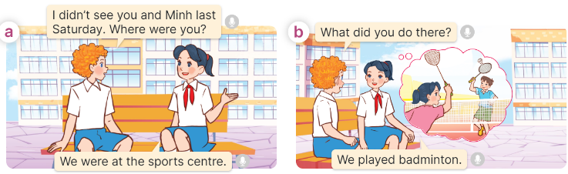  - Play the audio twice (sentence by sentence). Correct their pronunciation where necessary.  - Have Ss to practice the dialogue  - T invites a few pairs to the front of the class to practice.  - T checks pronunciation for ss.  Activity 3 Listen, point and say.  *Aims: Ss will be able to correctly use What did you do yesterday? - We ____. to ask and answer questions about activities someone did in the past.  *Procedure:  * Structures:  - T asks Ss look at picture b in activity 1 and helps Ss know the structure from the dialogue.  - T introduces new structures for Ss.  - T explains, models and gives meaning.  - Have Ss repeat the structures  A: What did you do yesterday?  B: We played badminton  *Drill pictures  - Have Ss look at the pictures and identify the characters and their activities. 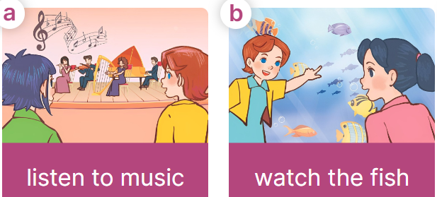  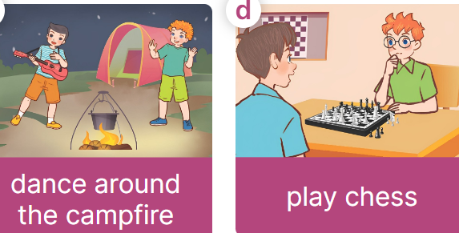  - Explain that the question and answer are used to express the activity someone did in the past and that listened is the past tense of the verb listen.  + listen - listened  + watch – watched  + dance – danced  - Have Ss point at pictures, listen and run through all the pictures.  - Have Ss point at the bubbles, listen and run through model sentences.  - Have Ss to practise:  + T asks the first picture, Ss answer  + Ss asks the second picture, T answers  + Group A asks the third picture, group B  answers  + Group B asks the last picture, group A  - Ask Ss to work in pairs to practise asking and answering the What did you do yesterday? - We ____.  - T controls and corrects.  - Invite a few pairs to point at the pictures and say the questions and answers in front of the class.  Activity 4. Let’s talk.  *Aims: Ss will be able to use What did you do yesterday? - We ____. in a freer context.  *Procedure:  - Ask Ss to look at the pictures and identify the places and characters 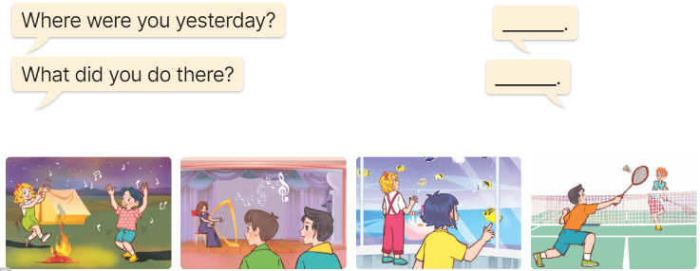  - Point at the ﬁrst building and elicit the question in the ﬁrst speech bubble Where were you yesterday? What did you do yesterday? and the answer in the second speech We were…….. We………..as an example.  - Give Ss time to work in pairs and take turns pointing at each picture to ask and answer using bubble Where were you yesterday? What did you do yesterday? We………..  - Invite a few pairs to come to the front of the classroom and act out the exchanges.  Game: Pass the ball  - Tell ss how the game is played.  - Give two different coloured balls to two pupils, a red ball (ask the question) and a yellow ball (answer the question).  - Ask ss to listen to music and pass the balls.  - Stop music suddenly.  - Have the student with a red ball fill in the question. Have the student with a yellow ball fill in the answer. | -Ss listen and pay attention  - Ss listen to the teacher  -Ss play the game  Ex:  A: Were you on the beach yesterday?  B: No, I wasn’t.  - Ss listen and open their books  -Ss listen and answer  - - Ss listen and repeat  + Choral repetition  (3 times).  + Individual repetition  (3 ss)  - Ss take note  - Ss look and match  -Look at the pictures and say.  + In picture a:  Bill: I didn’t see you and Minh last Saturday. Where were you?  Mai: We were at the sports centre.  + In picture b:  Bill: What did you do there?  Mai: We played badminton.  -Ss listen and repeat in chorus (twice)  -Ss work in pairs to practice  -Ss come to the front of the classroom to practice.  -Ss listen  - Ss look at the picture and answer.  -Ss listen  -Ss listen and repeat  -Ss repeat to the structures  - Ss look, listen and repeat  +Picture a: two girls at the theatre  + Picture b: two girls at the aquarium  + Picture c: two boys at the campsite  + Picture d: two boys playing chess  -Ss listen to the teacher’s instructions  -Ss point at pictures, listen and repeat  -Ss point at the bubbles, listen and repeat  -Ss practice in chorus  -Ss practice in chorus  -Ss work in pairs to practise asking and answering the question  - Pairs of Ss point at the pictures and say in front of the class  -Ss look at the picture and say  + two girls dancing around the campfire at the campsite,  two boys listening to music at the theatre, two girls watching the fish at the aquarium, two boys playing badminton at the sports centre  - Ss role-play to practise asking and answering questions  - Ss practise asking and answering questions in front of the class.  -Ss listen to the teacher  -Ss play the game  Ex:  A:What did you do yesterday?  B: We played football.  -Ss continute to play the game
D. ADJUSTMENTS (if necessary):
………………………………………………………………………………………….…..……………………………………………………………………………...……

Week 15 Preparing date: September …….., 2024
Period 59 Teaching date: September ………., 2024

Unit 9: Our outdoor activities
Lesson 2 (4, 5, 6)
A. OBJECTIVES:
By the end of the lesson, Ss will be able to:
1. Knowledge:
- listen to and understand a text / passage in which the character talks about activities she and her friends did at the campsite and circle the correct options.
- complete two gapped exchanges with the help of picture cues.
- To sing the song What did you do? with the correct pronunciation, rhythm and melody.
- Vocabulary: Review
- Skills: speaking, listening, reading and writing.
2. Competences:
- Communication and collaboration: work in pairs and groups to complete the learning tasks.
3. Attitude/ Qualities:
- Show their love and interest in doing free-time activities.
- Be friendly when doing activities with their friends.
B. TEACHING AIDS:
- Teacher: Teacher’s guide Pages 150, 151; audio Tracks 91; website hoclieu.vn, posters, laptop, pictures, textbook, lesson plan, TV or projector.
- Students: Student’s book Page 65, notebooks, workbooks, school things.
C. PROCEDURES:
Stages/ Time | Teacher’s activities | Students’ activities
1.Warm- up and review: (5’)  2.Practice: (25’)  3. Fun corner and wrap- up (5’) | Game: Slap the board  *Aims: to revise the learned words *Procedure:  - Divide the class into two groups. Ask ss to stand in two lines.  - Stick the cards with words they have learnt on the board.  - Call out a phrase, ex: listen to music and have the first student from each group race to slap the correct card on the board and say it correctly.  - The first student to slap the correct card wins a point for their group.  - The group with more points wins. Praise the winner.  - Say “Open your book page 65” and look at “Unit 9, Lesson 2 (4,5,6)”.  Activity 1. Listen and circle:  *Aims: Ss will be able to listen to and understand a recording in which the character talks about activities she and her friends did at the campsite, and circle the correct answers.  *Procedure:  - Ask Ss to read the questions and the answers  - Listen to the tape:  + Play the recording  + Play the recording again for pupils to do the task.  + Play the recording a third time for pupils to check their answers.  - Get Ss to swap books with their partner, then check answers as a class.  + Write the answers on the board for Ss to correct their answers.  - Have ss retell the texts with the help of the answers they have done  Key: 1. a 2. b 3.b 4.a  Activity 2. Read and complete  *Aims: Ss will be able to complete two gapped exchanges with the help of picture cues.  *Procedure:  - Have Ss look at the pictures and read and guess the missing words.  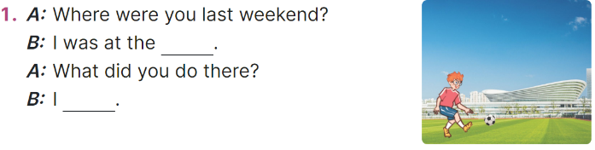  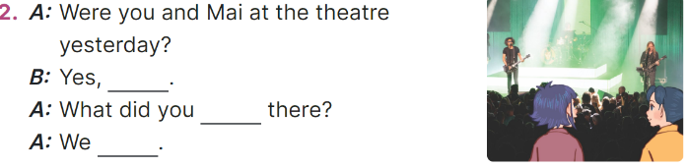  - Model the first sentences: have Ss read the question and ask what words are missing (sports centre)  - Give Ss a time limit to read the gapped dialogues, look at the pictures and do the task independently.  - Get Ss to swap books with a partner and check their answers before checking as a class.  + Invite one student to write the answers on the board.  - Invite two pairs of Ss to act out the completed dialogues.  Key:  1. sports centre, played football  2. we were, do, listened to music  Activity 3. Let’s sing  *Aims: Ss will be able to sing the song What did you do? with the correct pronunciation, rhythm and melody.  *Procedure:  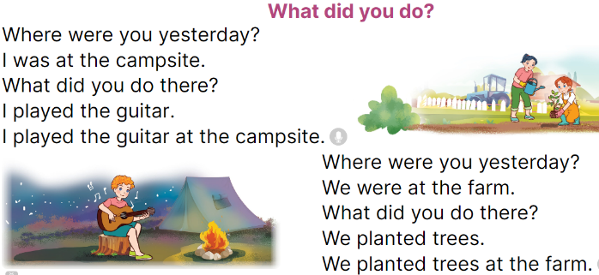  - Introduce the title and lyrics of the song: “What did you do?”  - Play the recording for Ss to listen to the whole song.  + Have them repeat the title and lyrics line by line.  + Tell Ss to point at the pictures while singing.  - Play the recording all the way through for Ss to listen to pronunciation and melody of the song.  - Play the recording line by line for Ss to listen, repeat and point to the pictures  - Play the recording for Ss to sing and do actions.  - Ask Ss to practice singing and doing actions in pairs or groups.  - Invite groups to the front of the classroom to perform the song  -T gives feedback.  Game: Matching game  - Tell the class they are going to match the phrases with the correct pictures.  - Stick the pictures and the phrases on the board. Have ss read the phrases once or twice.  - Model the Picture 1 (walk around the lake). Have one student choose a phrase, ex: walked around the lake suitable with Picture 1.  - If the ss give the correct answers, they will get stickers.  - Continue the game until all the pictures and phrases are matched. | -Ss listen to the teacher  -Ss play the game  -Ss continute playing the game  - Ss open their books  -Ss answer  - Ss listen to the tape  - Ss listen again and do the task.  - Ss listen and check their answers  - Ss swap books with their partner, then check answers as a class  -Ss check answer  -Ss retell the text, example:  We were at the campsite last Sunday. In the morning, we walked around the lake. In the afternoon, we visited the zoo. In the evening, I played the guitar.  -Ss look at the picture and say  -Ss follow the teacher  - Ss do the task independently.  - Ss swap books with a partner and check their answers.  - Ss write the answers on the board  - Pairs of Ss read the completed dialogues aloud  - Ss listen  -Ss listen to the song  - Ss listen and repeat line by line without the action.  -Ss point to the pictures while singing  -Ss listen to melody of the song  - Ss listen and sing line by line.  - Ss sing and do actions.  + Ss work in groups (two groups) to sing.  -Ss perform in front of the class.  -Ss listen  -Ss listen to the teacher’s instruction  -Ss match the picture with the correct word  -Ss continute playing game
D. ADJUSTMENTS (if necessary):
………………………………………………………………………………………….…..……………………………………………………………………………...…..…

Compiled by facebook Huong Le - 0374629390

Week 15 Preparing date: ……..….., 2024
Period 60 Teaching date: ………..….., 2024

Unit 9: Our outdoor activities
Lesson 3 (1, 2, 3)
A. OBJECTIVES:
By the end of the lesson, Ss will be able to:
1. Knowledge:
- correctly pronounce the three-syllable words with the stress on the first syllable as in ˈcinema and ˈbakery in isolation and as in the sentences I was at the ˈcinema yesterday. and We were at the ˈbakery yesterday.
- identify the stress on some three-syllable words and circle the word with a different stress pattern from the other two words.
- say the chant with the correct word stress, rhythm, and pronunciation.
- Vocabulary: Review
- Skills: speaking, listening, reading and writing.
2. Competences:
- Communication and collaboration: work in pairs and groups to complete the learning tasks.
- Self-control and independent learning: perform pronunciation and listening tasks.
3. Attitude/ Qualities:
- Show their love and interest in doing free-time activities.
- Be friendly when doing activities with their friends.
B. TEACHING AIDS:
- Teacher: Teacher’s guide Pages 152, 153; audio Tracks 93, 94, 95; website hoclieu.vn, posters, laptop, pictures, textbook, lesson plan, TV or projector.
- Students: Students’ book Page 66, notebooks, workbooks, school things.
C. PROCEDURES:
Stages/  Time | Teacher’s activities | Students’ activities
1.Warm- up and review: (5’)  2. Presentation (9’)  3.Practice: (17’)  3. Fun corner and wrap- up (4’) | Sing: What did you do? (Track 92)  *Aims: to create a friendly and active atmosphere in the class to beginning the lesson.  *Procedure:  - - Show the song on the screen.  - Ask ss to listen, sing and dance the song.  - Say “Open your book page 66” and look at “Unit 9, Lesson 3 (1, 2, 3)”.  Activity 1. Listen and repeat:  *Aims: Ss will be able to correctly pronounce the three-syllable words with the stress on the first syllable as in ꞌcinema and ꞌbakery in isolation and as in the sentences I was at the ꞌcinema yesterday. and We were at the ꞌbakery yesterday.  *Procedure:  - Have Ss point at the words ꞌcinema and ꞌbakery with the stress on the first syllable, in isolation and in the sentences I was at the ꞌcinema yesterday. and We were at the ꞌbakery yesterday.  - Play the recording for Ss to listen and repeat in chorus and individually until they feel confident.  - Let Ss work in pairs or groups, saying the words and reading the sentences.  - T invites some Ss to practice.  Activity 2. Circle, listen and check.  *Aims: Ss will be able to identify the stress on some three-syllable words and circle the word with a different stress pattern from the other two words.  *Procedure:  - Tell Ss circle the word having a different stress from each line. Then listen to the recording to check their answers.  - Set a time for Ss to do the task.  - Play the recording, once or twice, for Ss to listen and check their answers.  - Get Ss to swap books with a partner and check their answers before checking as a class.  - Play the recording again for Ss to double-check their answers.  - Invite a few Ss to read aloud all the words in the words.  Key:  1. ꞌbakery 2. ꞌcinema 3. ꞌafternoon  Activity 3. Let’s chant  *Aims: Ss will be able to say the chant with the correct word stress, rhythm, and pronunciation.  *Procedure:  - Introduce the title and lyrics of the chant.  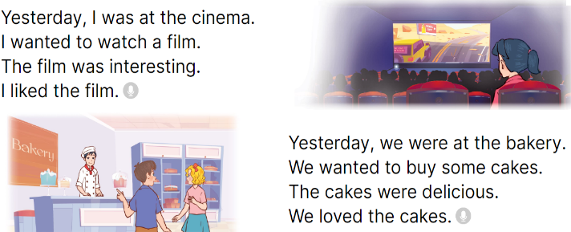  - Play the recording for Ss to listen to the whole chant.  + Have them repeat the title and lyrics line by line.  + Ask Ss to attend to three-syllable words with the stress on the first syllable in the chant, yesterday, cinema and interesting.  - Play the recording all the way through for Ss to listen to pronunciation and melody.  - Play the recording line by line for Ss to listen and repeat  - Play the recording for Ss to chant and clap along.  - Ask Ss to practice chant and clap along in pairs or groups.  - Invite groups to the front of the classroom to perform the chant  Game: Stand up - Sit down  - Tell ss how to play the game.  - Have five ss in each group take turns playing the game.  - Have ss listen to the words and stand up or sit down.  + If they hear the word with the stress on the first syllable, they will stand up.  + If they hear the word with the stress on the second syllable, they will sit down.  - Repeat the game until all the words are said. | - Ss sing and dance the song  - Ss open their books  - - Ss point and pay attention  - Ss listen to the recording again and repeat.  -Ss work in pairs and practice  -Ss say the words and sentences  - Ss pay and listen to the teacher’s explanation.  - Ss do the task  - Ss listen to the recording to check their answers (individual)  - Ss swap books with a partner and check the answers  - Ss listen again and check their answers again.  - Ss stand up and read aloud the words.  - Ss look and listen.  - Ss listen to the chant  - Ss listen and repeat line by line without clap their hands  - Ss note the rhythm and pronunciation.  -Ss listen to melody of the chant  - Ss listen and chant line by line.  - Ss chant and clap along.  - Ss work in groups (two groups) to chant  -Ss perform in front of the class.  -Ss listen  -Ss play the game  -Ss play the game
D. ADJUSTMENTS (if necessary):
………………………………………………………………………………………….…..……………………………………………………………………………...……

