Week 22 Preparing date: 9/2/ 2025
Period 85 Teaching date: 10/2 2025

Unit 13: Our special days
Lesson 1 (1, 2, 3)
A. OBJECTIVES:
By the end of the lesson, Ss will be able to:
1. Knowledge:
- use What will you do ___? – We’ll ___. to ask and answer questions about what someone will do for a special day
- listen to and demonstrate understanding of simple communicative contexts in relation to the topic “Our special days”.
- Vocabulary: Children’s Day, Teachers’ Day, Sports Day, Mid-Autumn Festival
- Structures: A: What will you do on Children’s Day?
B: We’ll sing, dance and have a party.
- Skills: speaking and listening
2. Competences:
- Communication and collaboration: work in pairs and groups to complete the learning tasks.
- Self-control and independent learning: perform pronunciation and speaking tasks.
3. Attitude/ Qualities:
- Enhance understandings of what people do on special occasions
B. TEACHING AIDS:
- Teacher: Teacher’s guide Pages 207, 208, 209, audio Tracks 21, 22, website hoclieu.vn, posters, laptop, pictures, textbook, lesson plan, TV or projector.
- Students: Students’ book Page 18, notebooks, workbooks, school things.
C. PROCEDURES:
Stages/  Time | Teacher’s activities | Students’ activities
1.Warm- up and review: (3’)  2. Presentation (15’)  3.Practice: (7’)  4. Production: (6’)  5. Fun corner and wrap- up (4’) | Sing a song: Tet’s coming  *Aims: to create a friendly and active atmosphere in the class to beginning the lesson.  *Procedure:  - Show the video on the screen.  https://www.youtube.com/watch?v=cv8d4alcdk8  - Ask Ss to listen, sing and dance the song.  - Say “Open your book page 18” and look at “Unit 13, Lesson 1 (1,2,3)”.  Activity 1. Vocabulary.  *Aims: Ss will be able to know the vocabulary in the new lesson.  *Procedure:  -T elicits the new words  + Children’s Day: ngày Quốc tế Thiếu nhi (explain)  + Teachers’ Day: ngày Nhà giáo Việt Nam (situation)  + Sports Day: ngày hội thể thao  (picture)  + Mid-Autumn Festival: Tết Trung thu (picture)  - T models (3 times).  - T writes the words on the board.  - Checking: Rub out and remember  Activity 2. Look, listen and repeat:  *Aims: Ss will be able to understand and correctly repeat the sentences in two communicative contexts in which the characters ask and answer questions about what someone will do for a special  day.  *Procedure:  - Have Ss look at Pictures a and b and identify the characters and their activities in the pictures.  + Who are they?  + Where are they?  + What are they talking about?  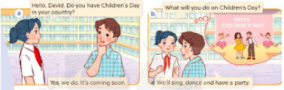  - Play the audio twice (sentence by sentence). Correct their pronunciation where necessary.  - Have Ss to practice the dialogue  - T invites a few pairs to the front of the class to practice.  - T checks pronunciation for ss.  Activity 3 Listen, point and say.  *Aims: Ss will be able to correctly use What will you do ____? – We’ll ____. to ask and answer questions about what someone will do on / at a special day.  *Procedure:  * Structures:  - T asks Ss look at picture b in activity 1 and helps Ss know the structure from the dialogue.  - T introduces new structures for Ss.  - T explains, models and gives meaning.  - Have Ss repeat the model sentences.  A: What will you do on Children’s Day?  B: We’ll sing, dance and have a party.  *Drill pictures  - Have Ss look at the picture and identify the characters and their activities  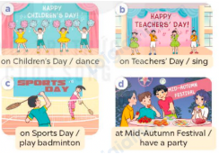  - Have Ss point at pictures, listen and run through all the pictures.  - Have Ss point at the bubbles, listen and run through model sentences.  - Have Ss to practise:  + T asks the first picture, Ss answer  + Ss asks the second picture, T answers  + Group A asks the third picture, group B  answers  + Group B asks the last picture, group A  - Ask Ss to work in pairs to practise asking and answering the question What will you do ____? – We’ll ____.  - T controls and corrects.  - Invite a few pairs to point at the pictures and say the questions and answers in front of the class.  Activity 4. Let’s talk.  *Aims: Ss will be able to correctly What will you do ___? – We’ll ___. in a freer context.  *Procedure:  - Have ss look at the picture and draw their attention to the names of four special days and the activities characters will do on / at these days.  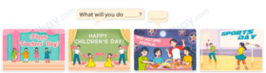  - Elicit the answer in the speech bubble and write it on the board. Get Ss to say the completed sentences.  - Have Ss role-play to practise asking the questions and giving their answers in pairs, using the structures What will you do ___? – We’ll ___.  - Invite a few pairs to point at the pictures and ask and answer questions.  Game: Spin the wheel  - Divide class into 2-4 teams  - Each team takes turns choosing a month of the year, then asks and answers using the clues shown on the screen. If the ss can successfully make a conversation, they get to spin the wheel and get points for their teams. | - Sing and dance the song together.  - Ss listen and open their books  -Ss listen and answer  - - Ss listen and repeat  + Choral repetition (3 times).  + Individual repetition (3 ss)  - Ss take note  - Ss look, remember and write  -Look at the pictures and say  +In picture a:  Mai: Do you also have Children's Day in your country, David?  David: We went to the beach.  + In picture b:  Mai: What will you do on Children’s Day?  David: We’ll sing, dance and have a party.  -Ss listen and repeat in chorus (twice)  -Ss work in pairs to practice  -Ss come to the front of the classroom to practice.  -Ss listen  - Ss look at the picture and answer.  -Ss listen  -Ss listen and repeat  -Ss repeat to the structures  - Ss look, listen and repeat  +Picture a: Some children dancing on Children’s Day  + Picture b: Some children singing on Teachers’ Day  + Picture c: Two children playing badminton on Sports Day  + Picture d: Some children having a party at Mid-Autumn Festival  -Ss point at pictures, listen and repeat  -Ss point at the bubbles, listen and repeat  -Ss practice in chorus  -Ss practice in chorus  -Ss work in pairs to practise asking and answering the question  - Pairs of Ss point at the pictures and say in front of the class  -Ss look at the picture and answer  + Four pictures showing four different activities on / at four special days  - Ss say the completed sentences.  -Ss work in pairs to ask and answer  -Ss perform in front of the class.  - Ss listen  -Ss listen and play the game  -Ss praise the winner.
Week 22 Preparing date: 9/2/ 2025
Period 86 Teaching date: 10/2/ 2025

Unit 13: Our special days
Lesson 1 (4, 5, 6)
A. OBJECTIVES:
By the end of the lesson, Ss will be able to:
1. Knowledge:
- listen to and understand two communicative contexts in which pupils ask and answer questions about what someone will do for a special day.
- listen to and demonstrate understanding of simple communicative contexts in relation to the topic “Our special days”.
- Vocabulary: Review
- Skills: speaking, listening, reading and writing.
2. Competences:
- Communication and collaboration: work in pairs and groups to complete the learning tasks.
- Self-control and independent learning: perform listening and reading tasks.
3. Attitude/ Qualities:
- Show their pride in their personal information and what someone will do for a special day.
B. TEACHING AIDS:
- Teacher: Teacher’s guide Pages 210, 211, 212; audio Tracks 23, 24; website hoclieu.vn, posters, laptop, pictures, textbook, lesson plan, TV or projector.
- Students: Student’s book Page 19, notebooks, workbooks, school things.
C. PROCEDURES:
Stages/ Time | Teacher’s activities | Students’ activities
1.Warm- up and review: (5’)  2.Practice: (25’)  3. Fun corner and wrap- up (5’) | Game: Pass the teddy bears  *Aims: to revise the learned structures.  *Procedure:  - Give two different colored teddy bears to two pupils, a black teddy bear (ask the question) and a white teddy bear (answer the question).  - Ask ss to listen to music and pass the teddy bears.  - Stop music suddenly. Have the student with a black teddy bear make a question. Have the student with a white teddy bear answer the question.  - Repeat the game several times.  - Say “Open your book page 19” and look at “Unit 13, Lesson 1 (4,5,6)”.  2.Practice: (25’)  Activity 1. Listen and tick or cross:  *Aims: Ss will be able to listen to and understand four communicative contexts in which speakers ask and answer questions about what someone will do on / at a special day.  *Procedure:  - Have ss look at the picture and elicit the activities in the pictures.  +What will they do?  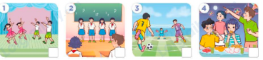  - T ask Ss to guess the answers.  + T writes Ss’guessing on the board.  - Listen to the tape:  + Play the recording  + Play the recording again for pupils to do the task.  + Play the recording a third time for pupils to check their answers.  - Get Ss to swap books with their partner, then check answers as a class.  + Write the answers on the board for Ss to correct their answers. Then checks Ss’ guessing.  - Have ss explain the answers.  Key: 1. x 2. x 3.v 4.v  Activity 2. Read and complete.  *Aims: Ss will be able to complete four gapped exchanges with the help of picture cues.  *Procedure:  - Get Ss to look at the pictures and identify the activities.  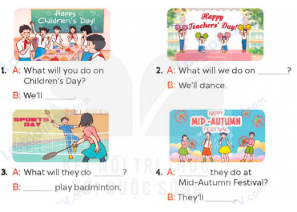  - Have Ss look at the four incomplete exchanges and elicits the options  - T models with sentence 1  + Have Ss circle the correct answer (have a party)  + Have Ss look at the picture and identify the needed information (have a party).  - Have Ss work in groups and complete the sentences 2, 3 and 4.  - Get Ss to swap books with a partner and check their answers before checking as a class.  -T gives feedbacks.  Key:  1. have a party  2. Teachers’ Day  3. on Sports Day, We’ll  4. What will, sing and dance  Activity 3. Listen, complete and sing  *Aims: Ss will be able to listen and complete the song What will you do on Children’s Day? and sing it with correct pronunciation, rhythm and melody.  *Procedure:  - Introduce the title and lyrics of the song:What will you do on Children’s Day?  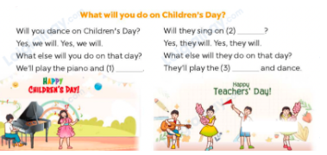  - Tell ss the aim of the activity  - Draw ss’ attention to the gapped sentences and guess the missing words and complete the sentences.  - Play the recording all the way through for ss to listen to the whole song.  - Play the recording again for them to fill in the gaps with the missing words.  - Check answers together as a class.  - Play the recording line by line for pupils to listen and repeat.  - Invite a few groups to the front of the class to sing the song.  Game: Guessing game  - Draw ss’ attention to the screen.  - Explain the rules of the game: Ss look at the clue and guess  + 1 open-picture: get 3 points  + 2 open -pictures: get 2 points  + All pictures left: 1 point . | - Ss listen to the teacher’s instruction  - Ss play the game  Ex:  A: What will you do on Teacher’s Day?  B: We’ll sing and dance.  - Continue playing the game.  - Ss open their books  -Look at the pictures and say:  + Picture 1: A group of children dancing  + Picture 2: A group of children singing  + Picture 3: Some boys playing football  + Picture 4: A group of children having a party in the moon  -Ss guess the answers  - Ss listen to the tape  - Ss listen again and do the task.  - Ss listen and check their answers  - Ss swap books with their partner, then check answers as a class and guessing  -Ss explain the answers  -Ss look at the picture and identify the activities.  -Ss look at the exchanged and pay attention  -Ss look and say the correct answer  -Ss listen and pay attention  -Ss complete the sentences  -Ss swap books with a partner and check their answers before checking as a class.  -Ss listen  - Ss listen and pay attention  - Ss listen to the teacher’s instruction.  - Ss look at the gapped sentences and guess the missing words and complete the sentences.  - Ss listen to the song  - Ss listen and fill in the gaps with missing words.  - Ss check answers together as a class.  - Ss listen to the recording, line by line, and repeat.  - Ss come to the front of the class to sing the song.  - Ss follow the teacher’s instructions.  - Ss look at the screen and guess what the word is.
D. ADJUSTMENTS (if necessary):
………………………………………………………………………………………….…..……………………………………………………………………………...……

Week 22 Preparing date: 9/2/ 2025
Period 87 Teaching date: 14/2/ 2025

Unit 13: Our special days
Lesson 2 (1, 2, 3)
A. OBJECTIVES:
By the end of the lesson, Ss will be able to:
1. Knowledge:
- understand and correctly repeat the sentences in two communicative contexts in
which characters ask and answer questions about drinks they will have at an event.
- correctly use What food / drinks will you have at the party? – We’ll have ___. to ask and answer questions about food and drinks someone will hav an event.
- use What food / drinks will you have at the party? – We’ll have ___. in a freer context.
- Vocabulary: burgers, milk tea,
- Structures: A: What food / drinks will you have at the party?
B: We’ll have milk tea.
- Skills: speaking and listening
2. Competences:
- Critical thinking and creativity: learn how to ask and answer questions about someone’s food and drinks at an event correctly and fluently.
- Communication and collaboration: work in pairs and groups to complete the learning tasks.
3. Attitude/ Qualities:
- Enhance understanding of different kinds of food and drinks at different styles of event.
B. TEACHING AIDS:
- Teacher: Teacher’s guide Pages 212, 213, 214; audio Tracks 25, 26, website hoclieu.vn, posters, laptop, pictures, textbook, lesson plan, TV or projector.
- Students: Students’ book Page 20, notebooks, workbooks, school things.
C. PROCEDURES:
Stages/ Time | Teacher’s activities | Students’ activities
1.Warm- up and review: (3’)  2. Presentation (15’)  3.Practice: (7’)  4. Production: (6’)  5. Fun corner and wrap- up (4’) | Game: Roll the dice  *Aims: to revise the sentence structures about someone who did something in the past.  *Procedure:  - Divide the class into groups of six. Have each student count the numbers from one to six.  - Ask a student from each group to roll the dice to choose a pupil asking the question.  - Ask that student to ask the question and invite another student of the group to answer the question.  - Say “Open your book page 20” and look at “Unit 13, Lesson 2 (1,2,3)”.  Activity 1. Vocabulary.  *Aims: Ss will be able to know the vocabulary in the new lesson.  *Procedure:  -T elicits the new words  + burgers: những bánh mì kẹp thịt  (picture)  + milk tea: trà sữa (picture)  - T models (3 times).  - T writes the words on the board.  - Checking: Rub out and remember  Activity 2. Look, listen and repeat:  *Aims: Ss will be able to understand and correctly repeat the sentences in two communicative contexts in  which characters ask and answer questions about drinks they will have at an event.  *Procedure:  - Have Ss look at Pictures a and b and identify the characters and predict what they are talking about.  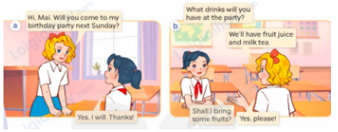  - Play the recording for them to listen.  - Play the recording again (sentence by sentence) for Ss to listen and repeat Correct their pronunciation where necessary.  - Invite a few pairs to the front of the classroom to listen to and repeat the sentences.  - T checks pronunciation for ss.  Activity 3. Listen, point and say.  *Aims: Ss will be able to use What food / drinks will you have at the party? – We’ll have ___. to ask and answer questions about food and drinks someone will have at an event.  *Procedure:  * Structures:  - T asks Ss look at picture b and helps Ss know the structure from the dialogue.  - T introduces new structure for Ss.  - T explains, models and gives meaning.  - Have Ss repeat the structures.  A: What food / drinks will you have at the party?  B: We’ll have milk tea.  *Drill pictures  - Have Ss look at the pictures and elicit identify the food and drinks.  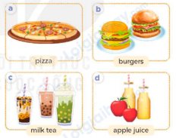  - Have Ss point at pictures, listen and run through all the pictures.  - Have Ss point at the bubbles, listen and run through model sentences.  - Have Ss to practise:  + T asks the first picture, Ss answer  + Ss asks the second picture, T answers  + Group A asks the third picture, group B  answers  + Group B asks the last picture, group A  - Ask Ss to work in pairs to practise asking and answering the question What food / drinks will you have at the party? – We’ll have ___.  - T controls and corrects.  - Invite a few pairs to point at the pictures and say the questions and answers in front of the class.  - T gives feedbacks.  Activity 4. Let’s talk.  *Aims: Ss will be able to use What food / drinks will you have at the party? – We’ll have ___. in a freer context.  *Procedure:  - Ask questions to help them identify the context.  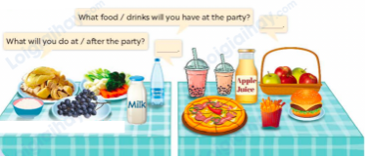  - Elicit the answer in the speech bubble and write it on the board. Get Ss to say the completed sentences.  - Have Ss role-play to practise asking the questions and giving their answers in pairs, using the picture cue What food / drinks will you have at the party? – We’ll have ___. And What will you do at/ after the party?- We___  - Invite a few pairs to point at the pictures and ask and answer questions.  - Invite some pairs of ss to ask and answer questions about the real activities  Game: Prepare for your party  - Divide the class into three teams.  - Tell the ss that they are working at a restaurant. They have to ask their customers what food and drinks they want for their parties and serve on the table.  - Ask the ss to look at pictures and read the full sentences.  - Ask ss to check their friends’ pronunciation.  - Play the game. | - Ss listen to teacher’s instruction  - Ss play the game  Ex:  A: What will you do on ____?  B: We’ll ______  - Ss open their books  -Ss listen and answer  - - Ss listen and repeat  + Choral repetition (3 times).  + Individual repetition (3 ss)  - Ss take note  - Ss look, remember and write  -Look at the pictures and get to know the characters in the pictures.  + In picture a:  Mary: Hi, Mai. Will you come to my birthday party next Sunday?  Mai: Yes, I will. Thanks!  – In picture b:  Mai: What drinks will you have at the party?  Mary: We’ll have fruit juice and milk tea.  Mai: Shall I bring some fruit?  Mary: Yes, please!  -Ss listen  -Ss listen and repeat in chorus  - Pairs of Ss listen and repeat  -Ss listen  -Ss look at the picture and answer.  -Ss listen  -Ss listen and repeat  -Ss repeat to the structures.  - Ss look, listen and answer  a: A pizza  b: Two burgers  c: Three glasses of milk tea  d: Two bottles of apple juice  -Ss point at pictures, listen and repeat  -Ss point at the bubbles, listen and repeat  -Ss practice in chorus  -Ss practice in chorus  -Ss work in pairs to practise asking and answering the question  - Pairs of Ss point at the pictures and say in front of the class  -Ss look at the picture and answer  + Some food and drinks (chicken, vegetables, rice, grapes, mineral water and milk) for a meal on the first table. Some food and drinks (apples, chips, a pizza and a burger, apple juice and milk tea) for a  party on the second table  - Ss say the completed sentences.  -Ss work in pairs to ask and answer  A:What food / drinks will you have at the party?  B:We’ll have pizza.  A: What will you do at/ after the party?  B: We’ll sing and dance  -Ss perform in front of the class.  - Ss ask and answer about their family.  -Ss listen to the teacher  - Ss play the game  - Continue playing the game.
D. ADJUSTMENTS (if necessary):
………………………………………………………………………………………….…..……………………………………………………………………………...……

Week 22 Preparing date:9/2/ 2025
Period 88 Teaching date: 14/2 2025

Unit 13: Our special days
Lesson 2 (4, 5, 6)
A. OBJECTIVES:
By the end of the lesson, Ss will be able to:
1. Knowledge:
- use What food / drinks will you have at the party? – We’ll have ___. to ask and answer questions about the food and drinks someone will have at an event
- listen to and demonstrate understanding of simple communicative contexts in relation to the topic “Our special days”.
- Vocabulary: Review
- Skills: speaking, listening, reading and writing.
2. Competences:
- Communication and collaboration: work in pairs and groups to complete the learning tasks.
3. Attitude/ Qualities:
- Enhance understanding of what people eat and drink on special occasions.
- Express their preferences for food and drinks.
B. TEACHING AIDS:
- Teacher: Teacher’s guide Pages 216, 217; audio Tracks 27; website hoclieu.vn, posters, laptop, pictures, textbook, lesson plan, TV or projector.
- Students: Student’s book Page 21, notebooks, workbooks, school things.
C. PROCEDURES:
Stages/ Time | Teacher’s activities | Students’ activities
1.Warm- up and review: (5’)  2.Practice: (25’)  3. Fun corner and wrap- up (5’) | Play a game: “Run to the corner”  *Aims: to revise the sentence structure *Procedure:  - Draw ss’ attention to the pictures and say the name of food and drinks.  - Ask 2 ss to come to the front and ask about their food and drinks they want at their parties.  + When they finish answering the questions, other players (1 from each team) will run to the pictures mentioned and say the name of that food/ drinks.  + Who faster is the winner and get 1 point for that round.  - Say “Open your book page 21” and look at “Unit 13, Lesson 2 (4,5,6)”.  Activity 1. Listen and tick:  *Aims: Ss will be able to listen to and understand two communicative contexts in which characters talk about food and drinks they will have at an event and tick the correct pictures  *Procedure:  - Elicit the names of the food and drinks  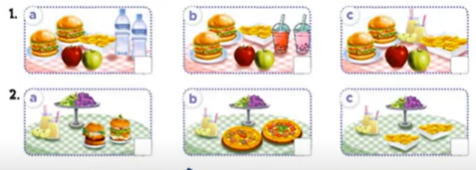  - T ask Ss to guess the answers.  + T writes Ss’guessing on the board.  - Listen to the tape:  + Play the recording  + Play the recording again and get Ss to swap books with their partners.  + Play the recording again to check answers together as a class.  + Write the answers on the board for Ss to correct their answers. Then checks Ss’ guessing.  - Play the recording, sentence by sentence, for the class to listen and repeat in chorus.  Key: 1.b 2. a  Activity 2. Read and complete  *Aims: Ss will be able to complete two gapped exchanges with the help of picture cues.  *Procedure:  - Ask Ss to identify the food and drinks someone will have at a meal / party. 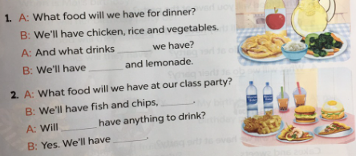  - Have Ss look at the 2 incomplete exchanges and elicits the missing words in the sentences.  - T models with the first sentence  + Ask Ss what is missing in the sentence (will).  + Have Ss look at the picture and identify the needed information (And what drinks will we have)  - Have Ss work in pairs and complete  - Get Ss to swap books with a partner and check their answers before checking as a class.  Key:  1. will, apple juice  2. burgers and pizza, we, mineral water and milk tea  Activity 3. Let’s play.  *Aims: Ss will be able to practise the target vocabulary and sentence patterns by playing the game Our Children’s Day party menu  *Procedure:  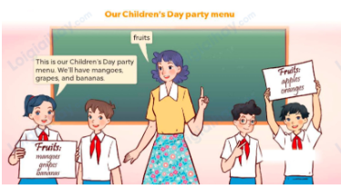  - Tell the class that the game will be played in groups of three. Ss in each group will discuss as many names of fruit, food and drinks as possible in the menu for their Children’s Day party  - Invite two or three groups to the front of the class.  - Let Ss have a time limit to make a menu (including fruit, food and drinks).  - Each group shows and tells the menu to the class. The group that says the most sentences about their menu with correct grammar will be given five points / stars.  Game: Lucky Food (ppt)  - Divides the class into 3 teams.  - Each team takes turns choosing a food/ drink and answering the question.  - T checks the answer with the whole class.  - Ss collect the points if they answer the question correctly.  - The team with the most points is the winner. | - Ss pay attention.  -Ss play the game  - Ss congratulate to the winner  - Ss open their books  - Look at the pictures and say:  1a. Two burgers, some chips, two apples and two bottles of mineral water  1b. Two burgers, some chips, two apples and two glasses of milk tea  1c. Two burgers, some chips, two apples and two glasses of apple juice  2a. Two burgers, some grapes and two glasses of apple juice  2b. Two pizzas, some grapes and two glasses of apple juice  2c. Some chips, some grapes and two glasses of apple juice  -Ss guess the answers  - Ss listen to the tape and match  - Ss listen again, match and swap books with their partners.  - Ss check their answers and guessing  - Ss answer and check  -Ss listen and repeat.  -Ss look at the picture and say  -Ss follow the teacher.  -Ss read and answer  -Ss work in pairs and fill in the gaps  - Ss swap books and check  -Ss listen and pay attention  - Ss play the game  -Ss play the game  -Ss play the game  -Ss play the game

D. ADJUSTMENTS (if necessary):
………………………………………………………………………………………….…..……………………………………………………………………………...……

