Week 20 Preparing date: 19/1/2025
Period 77 Teaching date:21/1/2025

Unit 11: Family time
Lesson 3 (1, 2, 3)
A. OBJECTIVES:
By the end of the lesson, Ss will be able to:
1. Knowledge:
- stress the correct words in Wh-questions in the questions 'When did they 'go to 'London? and 'What did they 'do in 'Finland?;
- identify and underline the missing stressed word in four questions, and to say the questions with the correct stress while listening
- say the chant with the correct pronunciation, word stress and rhythm.
- Vocabulary: Review
- Skills: speaking, listening, reading and writing.
2. Competences:
- Communication and collaboration: work in pairs and groups to complete the learning tasks.
- Self-control and independent learning: perform pronunciation and listening tasks.
3. Attitude/ Qualities:
- Show their love and interest in outdoor activities.
- Raise their awareness of doing outdoor activities carefully.
B. TEACHING AIDS:
- Teacher: Teacher’s guide Pages 188, 189, 190; audio Tracks 8, 9, 10; website hoclieu.vn, posters, laptop, pictures, textbook, lesson plan, TV or projector.
- Students: Students’ book Page 10, notebooks, workbooks, school things.
C. PROCEDURES:
Stages/  Time | Teacher’s activities | Students’ activities
1.Warm- up and review: (5’)  2. Presentation (9’)  3.Practice: (17’)  3. Fun corner and wrap- up (4’) | Game: Pass the balls  *Aims: to revise the learnt words and structures.  *Procedure:  - Give two different coloured balls to two ss, a red ball (ask the question) and a yellow ball (answer the question).  - Ask ss to listen to music and pass the balls.  - Stop music suddenly.  - The teacher raises a picture. Have the student with a red ball make a question. Have the student with a yellow ball answer the question.  - Praise ss if they do the activity well.  - Say “Open your book page 10” and look at “Unit 11, Lesson 3 (1,2,3)”.  Activity 1. Listen and repeat:  *Aims: Ss will be able to stress the correct words in Wh-questions in the questions 'When did they 'go to 'London? and 'What did they 'do in 'Finland? *Procedure:  - T gives instruction the sentences 'When did they 'go to 'London? and 'What did they 'do in 'Finland?  - Play the recording and encourage Ss to point to the word and sentence while listening  - Play the recording again and encourage Ss to listen and repeat.  - Have Ss work in pairs or groups to do this several times until Ss feel confident.  - T invites some Ss to practice.  Activity 2. Listen and underline one more stressed word. Then repeat  *Aims: Ss will be able to identify and underline the missing stressed word in four questions, and to say the questions with the correct stress while listening.  *Procedure:  - Tell ss the goal of the activity and explain that they have to listen to the recording and underline one more stressed word.  - Play the recording all the way through for ss to listen to the questions.  - Play the recording again for ss to underline one more stressed word of the questions.  - Tell ss to swap books with a partner, then check the answers together as a class.  - Have ss discuss with pupils if they can spot a pattern to what words are stressed in Wh-questions (the wh-question word, the main verb and the place).  - Play the recording again for ss to double-check their answers.  - Invite one or two ss to stand up and repeat the correct answers.  Key: 1. Sydney 2. Paris  3. When 4. do  Activity 3. Let’s chant  *Aims: Ss will be able to say the chant with the correct pronunciation, word stress and rhythm  *Procedure:  - Introduce the title and lyrics of the chant.  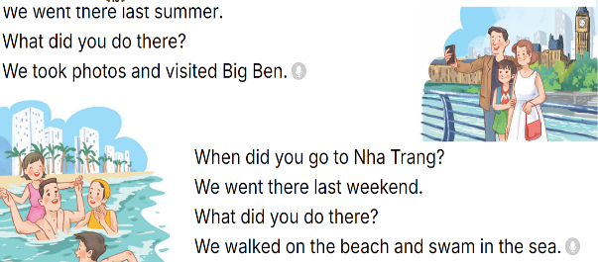  - Play the recording for Ss to listen to the whole chant.  + Have them repeat the title and lyrics line by line.  + Ask Ss to attent the word stress in the Wh-questions  - Play the recording all the way through for Ss to listen to pronunciation and melody.  - Play the recording line by line for Ss to listen and repeat  - Play the recording for Ss to chant and clap along.  - Ask Ss to practice chant and clap along in pairs or groups.  - Invite groups to the front of the classroom to perform the chant  Game: Whisper  - Tell ss how the game is played. Give an example.  - Divide the class into two groups.  - Have ss from each group stand or sit in a row.  - Whisper a sentence to the first student in each row.  - Have the first student whisper the sentence to the second student  - Have groups continue whispering the sentence until it reaches the last student.  - The last student in the row has to say out the correct sentence.  - Give the first group saying the sentence correctly one point.  - The group with more points wins. Praise the winner. | - Ss listen  -Ss listen the rules  - Ss play the game  Ex:  A: What did your family do in Sydney?  B: We saw some interesting places.  - Ss open their books  - - Ss pay attention  - Ss listen and point  - Ss listen again and repeat  -Ss work in pairs and practice  -Ss say the language in front of the class  - Ss listen to the teacher’s explanation.  - Ss listen to the questions  - Ss listen again and underline one more stressed word of the questions.  - Ss swap books and check the answers as a class.  -Ss listen to the teacher’s instruction.  - Ss listen again to double-check their answers.  - Ss stand up and repeat the correct answers.  - Ss listen to the chant  - Ss listen and repeat line by line without clap their hands  - Ss note the rhythm and pronunciation.  -Ss listen to melody of the chant  - Ss listen and chant line by line.  - Ss chant and clap along.  - Ss work in groups (two groups) to chant  -Ss perform in front of the class.  -Ss listen  -Ss play the game  Ex:  Round 1. 'When did you 'go to 'Sydney?/ 'What did he 'do in 'Paris?  Round 2. 'When did she 'go to 'England?/ 'What did they 'do in 'Thailand?  -Ss praise the winner
D. ADJUSTMENTS (if necessary):
………………………………………………………………………………………….…..……………………………………………………………………………...………………………………………….…..………………………………………………

Week 20 Preparing dat:19/1/2025
Period 78 Teaching date: 21/1/2025
Unit 11: Family time
Lesson 3 (4, 5, 6)
A. OBJECTIVES:
By the end of the lesson, Ss will be able to:
1. Knowledge:
- read and understand a paragraph about a family trip in the past by answering four questions
- complete a paragraph about someone’s family’s weekend trip by writing the target words in the gaps
- make a photo journal by sticking some photos/ pictures of the activities he/ she did somewhere with friends the previous summer, and tell the class about it.
- Vocabulary: Review
- Skills: speaking, listening, reading and writing.
2. Competences:
- Communication and collaboration: work in pairs and groups to complete the learning tasks.
- Self-control and independent learning: perform reading and writing tasks.
3. Attitude/ Qualities:
- Show their love and interest in outdoor activities.
- Raise their awareness of doing outdoor activities carefully.
B. TEACHING AIDS:
- Teacher: Teacher’s guide Pages 190, 191, 192; website hoclieu.vn, posters, laptop, pictures, textbook, lesson plan, TV or projector.
- Students: Student’s book Page 11, notebooks, workbooks, school things.
C. PROCEDURES:
Stages/  Time | Teacher’s activities | Students’ activities
1.Warm- up and review: (5’)  2.Practice: (8’)  3.Production: (18’)  4. Fun corner and wrap- up (4’) | Game: “Memory Chain”  *Aims: to create a friendly and active atmosphere in the class to beginning the lesson.  *Procedure:  -Tell ss they are going to remember the four questions in a chain.  - Divide the class into two groups. Each group has eight ss.  - Ask eight ss from each group to take turns playing the game.  - Have Student A say the first question, then have student B say the next question and so on. If a student forgets a sentence, the group must start from student A again.  - The winning group is the first one to have all members finish speaking. Praise the winner.  - Say “Open your book page 11” and look at “Unit 11, Lesson 3 (4,5,6)”.  Activity 1. Read and answer:  *Aims: Ss will be able to read and understand a paragraph about a family trip in the past by answering four questions.  *Procedure:  - Have ss read the questions carefully. Tell them to read Question 1 and pay attention to keywords such as Where, Linda’s family, go. and answer the question.  - Set a time limit for sls to do the rest of the task independently.  - Get ss to swap books with the partner and check the answers before checking as a class.  - Invite some pairs to take turns asking and answering the questions.  - Ask ss some more questions.  Ex:  When did Linda’s family go to Ha Long Bay? What did they do there on Sunday?  Did they explore the caves and eat seafood?  Key:  1. They went to Ha Long Bay.  2. They sunbathed, took some photos and swam in the sea.  3. They took a boat trip around the bay on Sunday.  4. They bought some souvenirs for their friends  Activity 2. Let’s write  *Aims: Ss will be able to complete a paragraph about someone’s family’s weekend trip by writing the target words in the gaps.  *Procedure:  - Ask ss to read the gapped sentences and fill in the gaps with information about someone’s family’s weekend trip.  - Ask Ss to read the first sentence, then elicit where they went the previous weekend (Ex: Sa Pa) and write the first sentence (Last weekend, my family went to Sa Pa.)  - Give Ss time to complete the rest of the paragraph independently.  - Get Ss to swap their books with a partner and check their spelling.  - Invite a student to read his / her completed paragraph aloud  - In groups, have ss share the activities that their family did last weekend.  - Ask Ss share with the class.  Key: Pupil’s answer  Ex: Last weekend, my family went to Sa Pa. On Saturday, we visited Sa Pa Town and went to see the mountains. We took lots of photos there. On Sunday, we went shopping in the town. My brother bought a shirt and I bought some souvenirs for my friends. Our trip was a lot of fun!  Activity 3. Project.  *Aims: Ss will be able to make a photo journal by sticking some photos/pictures of the activities he/ she did somewhere with friends the previous summer, and tell the class about it.  *Procedure:  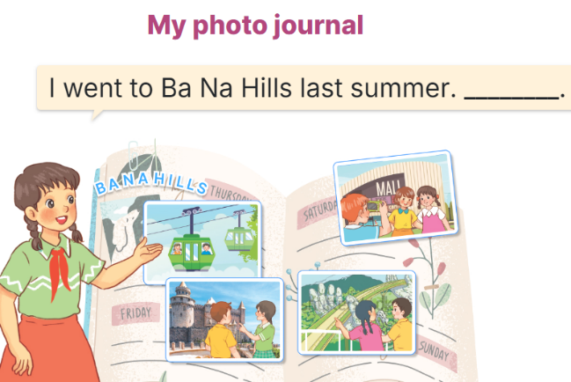  - Explain that each pupil has to show his/her photo journal which includes some photos/ pictures of friends and their activities (they have prepared at home) and tell the class about where they went and what they did there.  - Have Ss work in groups of five or six. Each student shows his / her photo journal to the group and describes what he/she and friends did somewhere last summer.  - Invite a few ss representing some groups to show their photo journals and tell the class about the activities of the friends in the photos/ pictures, Ex: I went to Ba Na Hills last summer with my friends. We took the cable car. We visited Golden Bridge…  - Have the rest of the class give comments and praise ss if they perform well.  Game: Serial reading  - Show the text on the board.  - Divide the class into groups of four.  - Have ss work in groups and read the text serially.  - Invite some ss to the front of the class and perform their work.  - Praise ss to encourage their performance. | - Ss listen  - Ss listen to the rules  -Ss play game  Ex:  'When did you 'go to 'Sydney?  'What did he 'do in 'Paris?  'When did she 'go to 'England?  'What did they 'do in 'Thailand?  - Ss open their books  - Ss read the questions carefully. Ss read Question 1 and look at keywords and scan the text for relevant information.  - Ss do the task independently.  - Ss swap books and check the answers before checking as a class.  - Ss ask and answer the questions.  - Ss answer the questions.  - Ss read the gapped sentences and fill in the gaps.  - Ss do the first gapped sentence.  - Ss complete the paragraph independently.  - Ss swap their books and check their spelling.  - Ss read the paragraphs aloud  - Ss share the activities that their family did last weekend.  -Ss share with the class.  - Ss listen to the teacher’s explanation.  - Ss work in and describes what he/she and friends did somewhere last summer.  - Ss tell the class about the activities of the friends in the photos/ pictures.  - Ss congratulate  -Ss listen to the teacher  -Ss play the game  -Ss congratulate the winner
D. ADJUSTMENTS (if necessary):
………………………………………………………………………………………….…..……………………………………………………………………………...……

Week 20 Preparing date:19/1/2025
Period 79 Teaching date: 24/1/2025

Unit 12: Our Tet holiday
Lesson 1 (1, 2, 3)
A. OBJECTIVES:
By the end of the lesson, Ss will be able to:
1. Knowledge:
- understand and correctly repeat the sentences in two communicative contexts focusing on asking and answering questions about whether someone will do something for Tet
- use Will you …… for Tet? – Yes, I will. / No, I won’t. I’ll …….. to ask and answer questions about whether someone will do something for Tet
- use Will you ……. for Tet? – Yes, I will. / No, I won’t. I’ll ……. in a freer context.
- Vocabulary: buy roses, buy a branch of peach blossoms, decorate the house, do the shopping, make banh chung, make spring rolls.
- Structures:
A: Will you buy a branch of peach blossoms for Tet?
B: Yes, I will. / No, I won’t. I’ll …….
- Skills: speaking and listening
2. Competences:
- Critical thinking and creativity: learn how to ask and answer questions about whether someone will do something for Tet.
- Critical thinking and creativity: learn how to ask and answer questions about personal information correctly and fluently.
- Self-control and independent learning: perform pronunciation and speaking tasks.
3. Attitude/ Qualities:
- Show their interest in activities for Tet holiday
B. TEACHING AIDS:
- Teacher: Teacher’s guide Pages 192, 193, 194, 195, audio Tracks 11, 12, website hoclieu.vn, posters, laptop, pictures, textbook, lesson plan, TV or projector.
- Students: Students’ book Page 12, notebooks, workbooks, school things.
C. PROCEDURES:
Stages/  Time | Teacher’s activities | Students’ activities
1.Warm- up and review: (3’)  2. Presentation (15’)  3.Practice: (7’)  4. Production: (6’)  5. Fun corner and wrap- up (4’) | Guessing the topic.  *Aims: to elicit the topic by a picture.  *Procedure:  - Show the picture about Tet holiday  - Ask ss to look at the picture and guess the topic of this unit.  - Say “Open your book page 12” and look at “Unit 12, Lesson 1 (1,2,3)”.  Activity 1. Vocabulary.  *Aims: Ss will be able to know the vocabulary in the new lesson.  *Procedure:  -T elicits the new words  + decorate the house: trang trí nhà (situation)  + do the shopping: đi mua sắm (picture)  + make banh chung: làm bánh chưng (picture)  + buy roses: mua hoa hồng (translation)  + buy a branch of peach blossoms: mua một cành hoa đào (picture)  + make spring rolls: làm nem  (picture)  + bring good luck: mang lại sự may mắn (example)  + New Year festival: lễ hội năm mới (situation)  - T models (3 times).  - T writes the words on the board.  - Checking: Rub out and remember  Activity 2. Look, listen and repeat:  *Aims: Ss will be able to understand and correctly repeat the sentences in two communicative contexts focusing  on asking and answering questions about whether someone will do something for Tet.  *Procedure:  - Have Ss look at Pictures a and b and identify the characters in the pictures.  + Who are they?  + Where are they?  + What are they talking about?  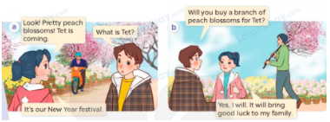  - Play the audio twice (sentence by sentence). Correct their pronunciation where necessary.  - Have Ss to practice the dialogue  - T invites a few pairs to the front of the class to practice.  - T checks pronunciation for ss.  Activity 3 Listen, point and say.  *Aims: Ss will be able to correctly say the phrases and use Will you _____ for Tet? – Yes, I will. / No, I won’t. I’ll _____. to ask and answer questions about whether someone will do something for Tet.  *Procedure:  * Structures:  - T asks Ss look at picture b in activity 1 and helps Ss know the structure from the dialogue.  - T introduces new structures for Ss.  - T explains, models and gives meaning.  - Have Ss repeat the model sentences.  A: Will you buy a branch of peach blossoms for Tet?  B: Yes, I will. / No, I won’t. I’ll …….  *Drill pictures  - Have Ss look at the pictures and say what they can see in the pictures.  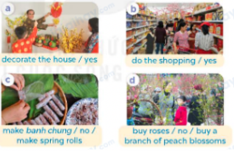  - Have Ss point at pictures, listen and run through all the pictures.  - Have Ss point at the bubbles, listen and run through model sentences.  - Have Ss to practise:  + T asks the first picture, Ss answer  + Ss asks the second picture, T answers  + Group A asks the third picture, group B  answers  + Group B asks the last picture, group A  - Ask Ss to work in pairs to practise asking and answering the question Will you ____ for Tet? –Yes, I will. / No, I won’t. I’ll ___.  - T controls and corrects.  - Invite a few pairs to point at the pictures and say the questions and answers in front of the class.  Activity 4. Let’s talk.  *Aims: Ss will be able to use Will you ___ for Tet? –Yes, I will. / No, I won’t. I’ll ___. in a freer context  *Procedure:  - Draw Ss’ attention to the picture  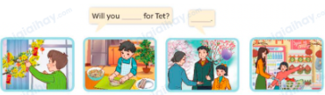  - Point at the ﬁrst building and elicit the question in the ﬁrst speech bubble Will you ___ for Tet? and the answer in the second speech Yes, I will. / No, I won’t. I’ll ___. as an example.  - Give Ss time to work in pairs and take turns pointing at each picture to ask and answer using bubble Will you ___ for Tet? - Yes, I will. / No, I won’t. I’ll ___.  - Invite a few pairs to come to the front of the classroom and act out the exchanges.  Game: Pass the teddy bears  - Give two different coloured teddy bears to two ss, a black teddy bear (ask the question) and a white teddy bear (answer the question).  - Ask ss to listen to music and pass the teddy bears.  - Stop music suddenly. Have the student with a black teddy bear make a question. Have the student with a white teddy bear answer the question.  - Repeat the game several times. | - Ss listen to the teacher  - Ss guess the topic.  - Ss listen and open their books  -Ss listen and answer  - - Ss listen and repeat  + Choral repetition (3 times).  + Individual repetition (3 ss)  - Ss take note  - Ss look, remember and write  -Look at the pictures and say.  + In picture a:  Mai: Look! Pretty peach blossoms! Tet is coming.  Andy: What is Tet?  Mai: It’s our New Year Festival.  + In picture b:  Andy: Will you buy a branch of peach blossoms for Tet?  Mai: Yes, I will. It will bring good luck to my family  -Ss listen and repeat in chorus (twice)  -Ss work in pairs to practice  -Ss come to the front of the classroom to practice.  -Ss listen  - Ss look at the picture and answer.  -Ss listen  -Ss listen and repeat  -Ss repeat to the structures  - Ss look, listen and repeat  +Picture a: a family decorating their house for Tet  + Picture b: some people doing the shopping for Tet  + Picture c: a woman making spring rolls  + Picture d: a woman and a boy buying a branch of peach blossoms  -Ss point at pictures, listen and repeat  -Ss point at the bubbles, listen and repeat  -Ss practice in chorus  -Ss practice in chorus  -Ss work in pairs to practise asking and answering the question  - Pairs of Ss point at the pictures and say in front of the class  -Ss look at the picture and say  + a boy decorating his house for Tet; a boy making spring rolls; a father and his daughter buying a branch of peach blossoms; a mother and her daughter doing the shopping for Tet  - Ss look at the first building and elicit the missing words in speech bubbles and say the completed sentences.  - Ss role-play to practise asking and answering questions  - Ss practise asking and answering questions in front of the class.  - Ss listen  -Ss listen and play the game  Ex:  A: Will you decorate the house for Tet?  B: Yes, I will.
D. ADJUSTMENTS (if necessary):
………………………………………………………………………………………….…..……………………………………………………………………………...………………………………………….…..………………………………………………
Week 20 Preparing date: 19/1/2025
Period 80 Teaching date: 24/1/2025

Unit 12: Our Tet holiday
Lesson 1 (4, 5, 6)
A. OBJECTIVES:
By the end of the lesson, Ss will be able to:
1. Knowledge:
- listen to and understand two communicative contexts in which characters ask and answer questions whether someone will do something for Tet, and tick the correct pictures
- complete four gapped exchanges with the help of picture cues
- sing the song Tet is a happy time for us. with the correct pronunciation, rhythm and melody.
- Vocabulary: Review
- Skills: speaking, listening, reading and writing.
2. Competences:
- Communication and collaboration: work in pairs and groups to complete the learning tasks.
- Self-control and independent learning: perform listening and reading tasks.
3. Attitude/ Qualities:
- Show their pride in their personal home and address.
B. TEACHING AIDS:
- Teacher: Teacher’s guide Pages 195, 196, 197; audio Tracks 17; website hoclieu.vn, posters, laptop, pictures, textbook, lesson plan, TV or projector.
- Students: Student’s book Page 13, notebooks, workbooks, school things.
C. PROCEDURES:
Stages/ Time | Teacher’s activities | Students’ activities
1.Warm- up and review: (5’)  2.Practice: (25’)  3. Fun corner and wrap- up (5’) | Game: Help Kitchen Gods  *Aims: to revise the learned sentence structures.  *Procedure:  - Explain how to play the game.  - Tell ss it’s the end of year, so they are going to help the Kitchen God collect all the reports.  - Ss take turns to choose the houses, look at the pictures, ask and answer the questions.  - Check the Ss’ answers as a whole class.  - If they give the correct answers, they can get a report.  - Ss take turns to choose all the houses and collect all the reports.  - After they get all the reports, teacher acts as the Kitchen God and say: “Well done! You helped me to collect all reports. Now I will go and report good things that you did this year to the King of Heaven. Happy New Year!”  - Say “Open your book page 13” and look at “Unit 12, Lesson 1 (4,5,6)”.  Activity 1. Listen and number:  *Aims: Ss will be able to listen to and understand two communicative contexts in which characters ask and  answer questions about whether someone will do something for Tet and tick the correct  pictures.  *Procedure:  - Elicit and ask questions to elicit the home in the pictures  + What can you see in this picture?  + Where are they?  + What do they do?  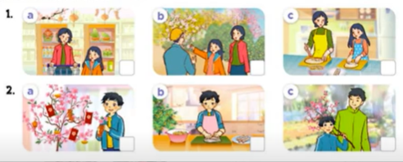  - T ask Ss to guess the answers.  + T writes Ss’guessing on the board.  - Listen to the tape:  + Play the recording  + Play the recording again for pupils to do the task.  + Play the recording a third time for pupils to check their answers.  - Get Ss to swap books with their partner, then check answers as a class.  + Write the answers on the board for Ss to correct their answers. Then checks Ss’ guessing.  - If time allows, play the recording, sentence by sentence, for Ss to listen and repeat individually and in chorus Key: 1. c 2. d 3. b 4. a  Activity 2. Read and complete.  *Aims: Ss will be able to read and complete four gapped exchanges with the help of picture cues.  *Procedure:  - Have Ss read the question and answer, and guess the missing word in the question.  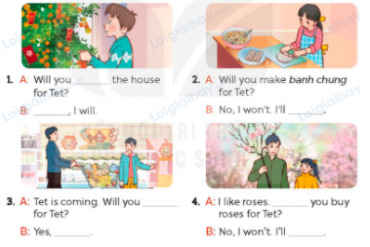  - Have Ss look at the four incomplete exchanges and elicits the missing words in the sentences.  - T models with sentence 1  + Have Ss look at the picture and identify the needed information (decorate).  - Have Ss work in groups and complete the exchanges 2, 3 and 4.  - Get Ss to swap books with a partner and check their answers before checking as a class.  - Invite four pairs of Ss to act out the four completed exchanges in front of the class  Key:  1. decorate; Yes  2. make spring rolls  3. do the shopping; I will  4. Will; buy a branch of peach blossoms  Activity 3. Let’s sing.  *Aims: Ss will be able to sing the song Tet is a happy time for us. with the correct pronunciation, rhythm and  melody.  *Procedure:  - Introduce the title and lyrics of the song: “Tet is a happy time for us”  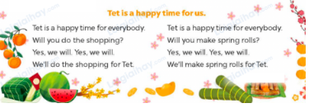  - Play the recording for Ss to listen to the whole song.  + Have them repeat the title and lyrics line by line.  + Tell Ss to point at the pictures while singing.  - Play the recording all the way through for Ss to listen to pronunciation and melody of the song.  - Play the recording line by line for Ss to listen, repeat and point to the pictures  - Play the recording for Ss to sing and do actions.  - Ask Ss to practice singing and doing actions in pairs or groups.  - Invite groups to the front of the classroom to perform the song  -T gives feedback.  Game: Get the lucky money  - Tell ss that they are going to play in 2 teams.  - Choose a number and answer the questions about whether someone will do something for Tet.  - If their answers are correct, ss will get 10 points. There are two lucky numbers with 20 points for each correct answer.  - Teams with more points will be the winner. | - Ss listen  - Ss play the game  - Ask and answer the question  - Continue playing the game.  - Ss open their books  -Look at the pictures and say:  + Picture 1a: a mother and her daughter doing the shopping  + Picture 1b: a mother and her daughter buying a branch of peach blossoms  + Picture 1c: a mother and her daughter making spring rolls  + Picture 2a: a boy decorating the house  + Picture 2b: a boy making spring rolls  + Picture 2c: a boy buying a branch of peach blossoms with his father  -Ss guess the answers  - Ss listen to the tape  - Ss listen again and do the task.  - Ss listen and check their answers  - Ss swap books with their partner, then check answers as a class and guessing  -Ss listen and repeat  -Ss look at the picture and identify personal information in each picture.  -Ss look and follow the teacher demonstrating the exchange 1.  -Ss answer: (Will you decorate the house for Tet?).  -Ss complete the sentences  -Ss swap books with a partner and check their answers before checking as a class.  -Ss read the completed exchanges aloud.  - Ss listen  -Ss listen to the song  - Ss listen and repeat line by line without the action.  -Ss point to the pictures while singing  -Ss listen to melody of the song  - Ss listen and sing line by line.  - Ss sing and do actions.  + Ss work in groups (two groups) to sing.  -Ss perform in front of the class.  -Ss listen  -Ss listen  -Ss play a game  - Ss continue playing the game.  -Ss praise the winner
D. ADJUSTMENTS (if necessary):
………………………………………………………………………………………….…..……………………………………………………………………………...…..…

