Week 19 Preparing date: 12/1/ 2025
Period 73 Teaching date: 13/1/ 2025

Unit 11: Family time
Lesson 1 (1, 2, 3)
A. OBJECTIVES:
By the end of the lesson, Ss will be able to:
1. Knowledge:
- understand and correctly repeat the sentences in two communicative contexts focusing on asking and answering questions about whether someone did something in the past.
- correctly say the words and use Did you ……? - Yes, I ……. I …….. to ask and answer questions about whether someone did something in the past;
- correctly use Did you ……? - Yes, I …… I …….. to ask and answer questions about whether someone did something in the past in a freer context
- Vocabulary: take a photo, collect seashells, walk on the beach, buy postcards.
- Structures: A: Did you swim?
B: Yes, I did. I swam with my mother.
- Skills: speaking and listening
2. Competences:
- Communication and collaboration: work in pairs and groups to complete the learning tasks.
- Self-control and independent learning: perform pronunciation and speaking tasks.
3. Attitude/ Qualities:
- Show their love and interest in outdoor activities.
- Raise their awareness of doing outdoor activities carefully.
B. TEACHING AIDS:
- Teacher: Teacher’s guide Pages 178, 179, 180, 181, audio Tracks 1, 2, website hoclieu.vn, posters, laptop, pictures, textbook, lesson plan, TV or projector.
- Students: Students’ book Page 6, notebooks, workbooks, school things.
C. PROCEDURES:
Stages/  Time | Teacher’s activities | Students’ activities
1.Warm- up and review: (3’)  2. Presentation (15’)  3.Practice: (7’)  4. Production: (6’)  5. Fun corner and wrap- up (4’) | Sing a song: Chicken dance  *Aims: to create a friendly and active atmosphere in the class to beginning the lesson.  *Procedure:  - Show the song on the screen.  https://www.youtube.com/watch?v=WZJAIkmT3Rg&t=10s  - Ask Ss to listen, sing and dance the song  - Say “Open your book page 6” and look at “Unit 11, Lesson 1 (1,2,3)”.  Activity 1. Vocabulary.  *Aims: Ss will be able to know the vocabulary in the new lesson.  *Procedure:  -T elicits the new words  + take photos: chụp hình (mime)  + collect seashells : nhặt vỏ sò  (picture)  + walk on the beach : đi bộ trên bãi biển (picture)  +buy postcards: mua bưu thiếp  (picture)  - T models (3 times).  - T writes the words on the board.  - Checking: Rub out and remember  Activity 2. Look, listen and repeat:  *Aims: Ss will be able to understand and correctly repeat the sentences in two communicative contexts focusing  on asking and answering questions about whether someone did something in the past.  *Procedure:  - Have Ss look at Pictures a and b and identify the characters and their activities in the pictures.  + Who are they?  + Where are they?  + What are they talking about?  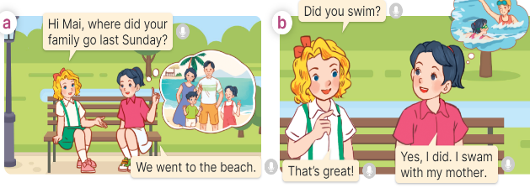  - Play the audio twice (sentence by sentence). Correct their pronunciation where necessary.  - Have Ss to practice the dialogue  - T invites a few pairs to the front of the class to practice.  - T checks pronunciation for ss.  Activity 3 Listen, point and say.  *Aims: Ss will be able to correctly say the words and use Did you …….? - Yes, I …... I …… to ask and answer questions about whether someone did something in the past.  *Procedure:  * Structures:  - T asks Ss look at picture b in activity 1 and helps Ss know the structure from the dialogue.  - T introduces new structures for Ss.  - T explains, models and gives meaning.  - Have Ss repeat the model sentences.  A: Did you swim?  B: Yes, I did. I swam with my mother.  *Drill pictures  - Have Ss look at the picture and identify the characters and their activities in the past.  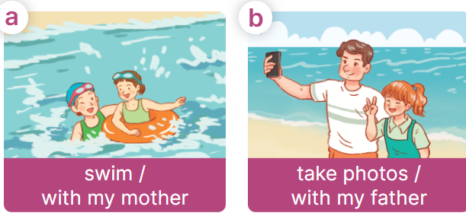  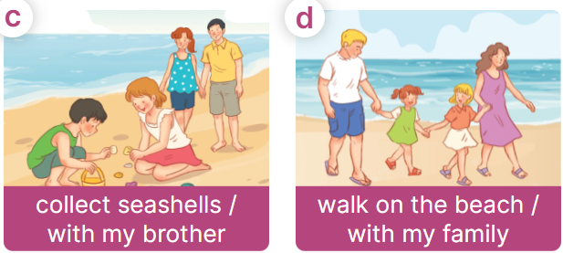  - Explain that the question and answer are used to express the activity someone did in the past and that swam is the past tense of the verb swim  + swim – swam + take – took  + collect – collected  + walk - walked  - Have Ss point at pictures, listen and run through all the pictures.  - Have Ss point at the bubbles, listen and run through model sentences.  - Have Ss to practise:  + T asks the first picture, Ss answer  + Ss asks the second picture, T answers  + Group A asks the third picture, group B  answers  + Group B asks the last picture, group A  - Ask Ss to work in pairs to practise asking and answering the question Did you ……?  B: Yes, I ……. I ………  - T controls and corrects.  - Invite a few pairs to point at the pictures and say the questions and answers in front of the class.  Activity 4. Let’s talk.  *Aims: Ss will be able to correctly use Did you …….? - Yes, I ……... I …... to ask and answer questions about whether someone did something in the past in a freer context.  *Procedure:  - Have ss look at the picture and ask questions to help them identify the context  +What can you see in the picture?  +What are they doing?  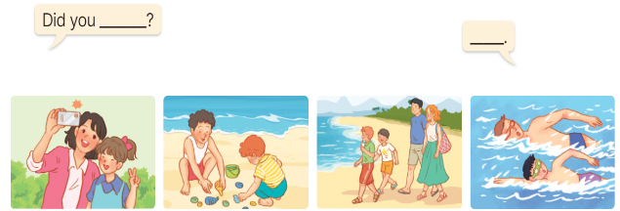  - Elicit the answer in the speech bubble and write it on the board. Get Ss to say the completed sentences.  - Have Ss role-play to practise asking the questions and giving their answers in pairs, using the picture cue.  - Invite a few pairs to point at the pictures and ask and answer questions.  Game: Lucky animals  - Divide the class into two groups.  - Have two ss from each group take turns to choose an animal and do the task.  - If the group chooses a lucky animal, they will get points and continue the next turn.  - Get corresponding points for their group.  - Continue with the other ss.  - The group that gets the most points wins. Praise the winner. | - Sing and dance the song together.  - Ss listen and open their books  -Ss listen and answer  - - Ss listen and repeat  + Choral repetition (3 times).  + Individual repetition (3 ss)  - Ss take note  - Ss look, remember and write  -Look at the pictures and say  +In picture a:  Mary: Hi Mai, where did your family go last Sunday?  Mai: We went to the beach.  + In picture b:  Mary: Did you swim?  Mai: Yes, I did. I swam with my mother.  Mary: That’s great!  -Ss listen and repeat in chorus (twice)  -Ss work in pairs to practice  -Ss come to the front of the classroom to practice.  -Ss listen  - Ss look at the picture and answer.  -Ss listen  -Ss listen and repeat  -Ss repeat to the structures  - Ss look, listen and repeat  +Picture a: a girl swimming with her mother.  + Picture b: a girl taking photos with his father.  + Picture c: a girl collecting seashells with her brother.  + Picture d: a girl walking on the beach with her family.  -Ss listen to the teacher’s instructions  -Ss point at pictures, listen and repeat  -Ss point at the bubbles, listen and repeat  -Ss practice in chorus  -Ss practice in chorus  -Ss work in pairs to practise asking and answering the question  - Pairs of Ss point at the pictures and say in front of the class  -Ss look at the picture and answer  + a girl taking photos with her mother; a boy collecting seashells with his brother; a boy walking on the beach with his family; a boy swimming with his father  - Ss say the completed sentences.  -Ss work in pairs to ask and answer  -Ss perform in front of the class.  - Ss listen  -Ss listen and play the game  -Ss continue to play the game.  -Ss praise the winner.
D. ADJUSTMENTS (if necessary):
………………………………………………………………………………………….…..……………………………………………………………………………...……

Week 19 Preparing date: 12/1/2025
Period 74 Teaching date: 13/1/2025

Unit 11: Family time
Lesson 1 (4, 5, 6)
A. OBJECTIVES:
By the end of the lesson, Ss will be able to:
1. Knowledge:
- listen to and understand four communicative contexts about people doing activities in the past and match four characters with the correct pictures.
- read and circle the correct answers with the help of the picture cues.
- listen to and complete the song Did you swim last Sunday? and to sing it with the correct pronunciation, rhythm and melody.
- Vocabulary: Review
- Skills: speaking, listening, reading and writing.
2. Competences:
- Communication and collaboration: work in pairs and groups to complete the learning tasks.
- Self-control and independent learning: perform listening and reading tasks.
3. Attitude/ Qualities:
- Show their love and interest in outdoor activities.
- Raise their awareness of doing outdoor activities carefully.
B. TEACHING AIDS:
- Teacher: Teacher’s guide Pages 181, 182, 183; audio Tracks 7; website hoclieu.vn, posters, laptop, pictures, textbook, lesson plan, TV or projector.
- Students: Student’s book Page 7, notebooks, workbooks, school things.
C. PROCEDURES:
 | Teacher’s activities | Students’ activities
1.Warm- up and review: (5’)  2.Practice: (25’)  3. Fun corner and wrap- up (5’) | Game: Card passing  *Aims: to revise the learned structures.  *Procedure:  - Stick the cards on the board. Ask ss to say the words related to the cards.  - Hand out the cards to different ss around the class.  - Play the song “Hello song” and ask ss to pass the cards to the ss next to them while the music is playing.  - Stop the music suddenly. Invite a student who is holding the card to ask the question “Did you swim yesterday?”. Ask another student to answer, ex: Yes, I did. I swam with my sister.  - Play the music again and repeat the activity.  - Say “Open your book page 7” and look at “Unit 11, Lesson 1 (4,5,6)”.  Activity 1. Listen and match:  *Aims: Ss will be able to listen to and understand four communicative contexts about people doing activities in the past and match four characters with the correct pictures.  *Procedure:  - Elicit the characters’ names and the activities in the pictures.  +What’s his/ her name?  +What are they doing?  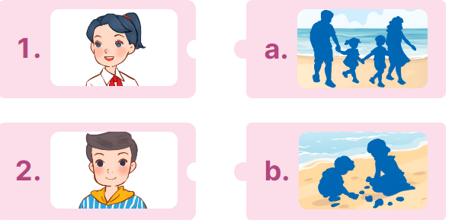  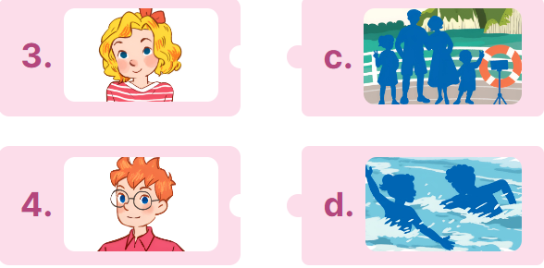  - T ask Ss to guess the answers.  + T writes Ss’guessing on the board.  - Listen to the tape:  + Play the recording  + Play the recording again for pupils to do the task.  + Play the recording a third time for pupils to check their answers.  - Get Ss to swap books with their partner, then check answers as a class.  + Write the answers on the board for Ss to correct their answers. Then checks Ss’ guessing.  - Have ss explain the answers.  Key: 1. a 2. d 3.b 4.a  Activity 2. Read and circle.  *Aims: Ss will be able to read and circle the correct answers with the help of the picture cues  *Procedure:  - Get Ss to look at the pictures and identify the characters  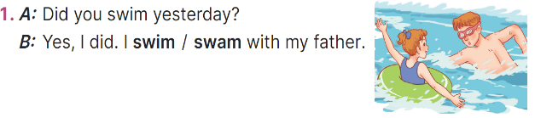  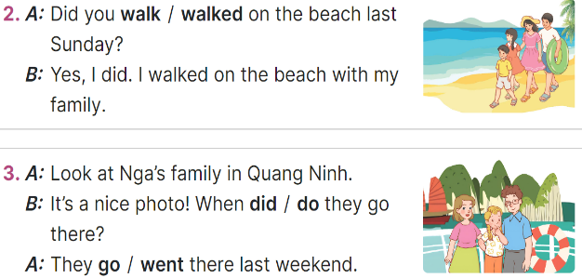  - Have Ss look at the three incomplete exchanges and elicits the options  - T models with sentence 1  + Have Ss circle the correct answer (swam)  + Have Ss look at the picture and identify the needed information (swam).  - Have Ss work in groups and complete the sentences 2, 3 and 4.  - Get Ss to swap books with a partner and check their answers before checking as a class.  -T gives feedbacks.  Key:  1. swam; 2. walk;  3. did; went; 4. were; buy  Activity 3. Listen, complete and sing  *Aims: Ss will be able to listen to and complete the song Did you swim last Sunday? and to sing it with the correct pronunciation, rhythm and melody  *Procedure:  - Introduce the title and lyrics of the song:“Did you swim last Sunday?”  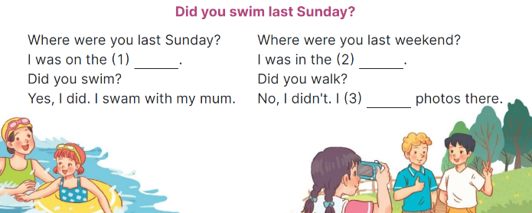  - Tell ss the aim of the activity  - Draw ss’ attention to the gapped sentences and guess the missing words and complete the sentences.  - Play the recording all the way through for ss to listen to the whole song.  - Play the recording again for them to fill in the gaps with the missing words.  - Check answers together as a class.  - Play the recording line by line for ss to listen and repeat.  - Invite a few groups to the front of the class to sing the song.  Key: 1. beach 2. park 3. took  Game: Who’s faster?  - Explain how the game is played: each group will make a question and an answer for a picture given.  - Model the activity. Stick a phrase on the board (swim/ last Sunday). Have two ss come to the board and write the question and answer.  - Divide the class into four groups. Give each group a piece of paper and a picture. Give two minutes for pupils to do the task.  - Have each group stick the piece of paper on the board. Check the answers as the class.  - The group finishing first and having correct answers wins. Praise the winner. | - Ss listen to the teacher’s instruction  - Ss play the game  - Continue playing the game.  - Ss open their books  -Look at the pictures and say:  + 1. Mai 2. Nam  3. Lucy 4. Ben  + Picture a: a family walking on the beach  + Picture b: a boy and a girl collecting seashells  + Picture c: a family taking photos.  + Picture d: a boy and a girl swimming in the sea  -Ss guess the answers  - Ss listen to the tape  - Ss listen again and do the task.  - Ss listen and check their answers  - Ss swap books with their partner, then check answers as a class and guessing  -Ss explain the answers  -Ss look at the picture and identify the characters  -Ss look at the exchanged and pay attention  -Ss look and choose the correct answer  -Ss listen and pay attention  -Ss complete the sentences  -Ss swap books with a partner and check their answers before checking as a class.  -Ss listen  - Ss listen and pay attention  - Ss listen to the teacher’s instruction.  - Ss look at the gapped sentences and guess the missing words and complete the sentences.  - Ss listen to the song  - Ss listen and fill in the gaps with missing words.  - Ss check answers together as a class.  - Ss listen to the recording, line by line, and repeat.  - Ss come to the front of the class to sing the song.  - Ss listen  -Ss listen and play the game  Ex:  A: Did you swim last Sunday?  B: Yes, I did. I swam with my mother.  - Ss continute playing the game
D. ADJUSTMENTS (if necessary):
………………………………………………………………………………………….…..……………………………………………………………………………...……

Week 19 Preparing date: 12/1/2025
Period 75 Teaching date: 15/1/2025

Unit 11: Family time
Lesson 2 (1, 2, 3)
A. OBJECTIVES:
By the end of the lesson, Ss will be able to:
1. Knowledge:
- understand and correctly repeat the sentences in two communicative contexts focusing on asking and answering questions about what someone did somewhere in the past.
- correctly say the words and use What did your family do in ____? - We ___. to ask and answer questions about what someone did somewhere in the past.
- correctly use What did your family do in _____? - ___. and What did your family do there? – ……. in a freer context.
- Vocabulary: take a boat trip around the bay, eat seafood, see some interesting places and buy souvenirs.
- Structures: A: What did your family do in Ha Long?
B: We took a boat trip around the bay.
- Skills: speaking and listening
2. Competences:
- Critical thinking and creativity: learn how to ask and answer questions about what someone did somewhere in the past correctly and fluently.
- Communication and collaboration: work in pairs and groups to complete the learning tasks.
3. Attitude/ Qualities:
- Show their love and interest in outdoor activities.
- Raise their awareness of doing outdoor activities carefully.
B. TEACHING AIDS:
- Teacher: Teacher’s guide Pages 183, 184, 185, 196; audio Tracks 5, 6, website hoclieu.vn, posters, laptop, pictures, textbook, lesson plan, TV or projector.
- Students: Students’ book Page 8, notebooks, workbooks, school things.
C. PROCEDURES:
Stages/ Time | Teacher’s activities | Students’ activities
1.Warm- up and review: (3’)  2. Presentation (16’)  3.Practice: (6’)  4. Production: (5’)  5. Fun corner and wrap- up (4’) | Game: Lucky star game  *Aims: to revise the sentence structures about someone who did something in the past.  *Procedure:  - Divide the class into 2 groups: boys and girls.  - Tell ss they are going to look at the pictures and ask and answer the questions about the pictures.  - Have two ss from each group take turns to choose a star and do the task.  - If they ask and answer the question correctly, they will get one point. If they don’t ask and answer the question correctly, the other group will ask and answer.  - If the group chooses a lucky star, they will get one point and continue the next turn.  - Get corresponding points for their group.  - Continue with the other pupils.  - The group that gets the most points will win. Praise the winner.  - Say “Open your book page 8” and look at “Unit 11, Lesson 2 (1,2,3)”.  Activity 1. Vocabulary.  *Aims: Ss will be able to know the vocabulary in the new lesson.  *Procedure:  -T elicits the new words  + take a boat trip around the bay : đi du lịch bằng tàu thuỷ vòng quanh vịnh (picture)  + eat seafood : ăn hải sản (picture)  + see some interesting places: thăm 1 vài nơi thú vị (picture)  + buy souvenirs.: mua quà lưu niệm  - T models (3 times).  - T writes the words on the board.  - Checking: Rub out and remember  Activity 2. Look, listen and repeat:  *Aims: Ss will be able to understand and correctly repeat the sentences in two communicative contexts focusing on asking and answering questions about what someone did somewhere in the past.  *Procedure:  - Have Ss look at Pictures a and b and identify the place, characters and their activities in the pictures.  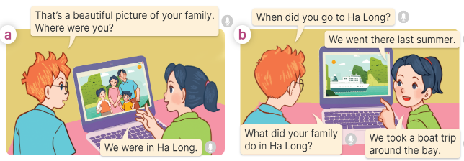  - Play the recording for them to listen.  - Play the recording again (sentence by sentence) for Ss to listen and repeat Correct their pronunciation where necessary.  - Invite a few pairs to the front of the classroom to listen to and repeat the sentences.  - T checks pronunciation for ss.  Activity 3. Listen, point and say.  *Aims: Ss will be able to correctly say the words and use What did your family do in ….? - We …... to ask and answer questions about what someone did somewhere in the past.  *Procedure:  * Structures:  - T asks Ss look at picture b and helps Ss know the structure from the dialogue.  - T introduces new structure for Ss.  - T explains, models and gives meaning.  - Have Ss repeat the structures.  A: What did your family do in Ha Long?  B: We took a boat trip around the bay.  *Drill pictures  - Have Ss look at the pictures and elicit the activities of the characters in each picture.  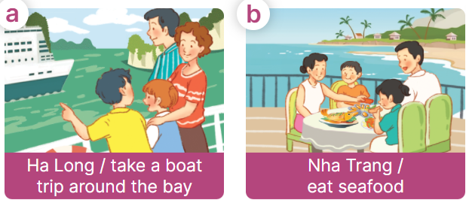    - Explain that the answer is used to express the activity someone did in the past and that took is the past tense of the verb take  + take – took + eat – ate  + see – saw + buy - bought  - Have Ss point at pictures, listen and run through all the pictures.  - Have Ss point at the bubbles, listen and run through model sentences.  - Have Ss to practise:  + T asks the first picture, Ss answer  + Ss asks the second picture, T answers  + Group A asks the third picture, group B  answers  + Group B asks the last picture, group A  - Ask Ss to work in pairs to practise asking and answering the question What did your family do in ….? - We …...  - T controls and corrects.  - Invite a few pairs to point at the pictures and say the questions and answers in front of the class.  - T gives feedbacks.  Activity 4. Let’s talk.  *Aims: Ss will be able to correctly use What did your family do in _____? - ___. and What did your family do  there? – ___. in a freer context.  *Procedure:  - Ask questions to help them identify the context.  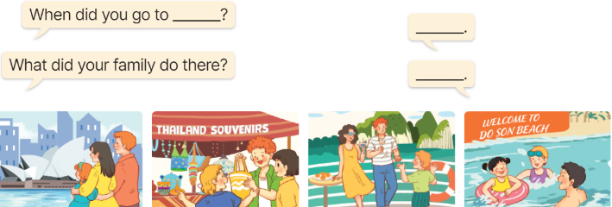  - Elicit the answer in the speech bubble and write it on the board. Get Ss to say the completed sentences.  - Have Ss role-play to practise asking the questions and giving their answers in pairs, using the picture cue What did your family do in _____? - ___. and What did your family do there? – ___.  - Invite a few pairs to point at the pictures and ask and answer questions.  - Invite some pairs of ss to ask and answer questions about the real activities: when and what someoe’s family did in the past.  Game: Matching the word with the correct picture  - Tell ss how the game is played. Give an example.  - Put the pictures on the board. Point to each picture one at a time for ss to say the time.  - Give cards with phrases to different pupils. Ask them to come to the front of the class and put their card below the appropriate picture, ex: the pupil with the card “buy souvenirs” puts his / her card below the picture “a picture of someone buying souvenirs”.  - Praise ss if they do the activity well. | - Ss listen to teacher’s instruction  - Ss play the game  Ex:  A: Did you take a photo yesterday?  B: Yes, I did. I took a photo with my sister.  - Ss open their books  -Ss listen and answer  - - Ss listen and repeat  + Choral repetition (3 times).  + Individual repetition (3 ss)  - Ss take note  - Ss look, remember and write  -Look at the pictures and get to know the characters in the pictures.  + In picture a:  Ben: That’s a beautiful picture of your family. Where were you?  Mai: We were in Ha Long.  – In picture b:  Ben: When did you go to Ha Long?  Mai: We went there last summer.  Ben: What did your family do in Ha Long?  Mai: We took a boat trip round the bay.  -Ss listen  -Ss listen and repeat in chorus  - Pairs of Ss listen and repeat  -Ss listen  -Ss look at the picture and answer.  -Ss listen  -Ss listen and repeat  -Ss repeat to the structures.  - Ss look, listen and answer  a. family taking a boat trip around Ha Long  b. a family eating seafood in Nha Trang  c. a family visiting Sydney  d. a family buying souvenirs in Singapore  -Ss listen to the teacher’s instruction  -Ss point at pictures, listen and repeat  -Ss point at the bubbles, listen and repeat  -Ss practice in chorus  -Ss practice in chorus  -Ss work in pairs to practise asking and answering the question  - Pairs of Ss point at the pictures and say in front of the class  -Ss look at the picture and answer  + a family visiting some interesting places in Sydney; a family buying souvenirs at the souvenir shop in Thailand; a family taking a boat trip at Ha Long Bay; a family swimming in the sea in Do Son  - Ss say the completed sentences.  -Ss work in pairs to ask and answer  + We went there last summer.  + We visited some interesting places.  -Ss perform in front of the class.  - Ss ask and answer about their family.  -Ss listen to the teacher  - Ss play the game  - Continue playing the game.
D. ADJUSTMENTS (if necessary):
………………………………………………………………………………………….…..……………………………………………………………………………...……

Week 19 Preparing date:12/1/2025
Period 76 Teaching date: 15/1/2025

Unit 11: Family time
Lesson 2 (4, 5, 6)
A. OBJECTIVES:
By the end of the lesson, Ss will be able to:
1. Knowledge:
- listen to and understand two communicative contexts about where someone went and what someone did in the past and circle the correct options.
- complete two gaped exchanges with the help of picture cues.
- reinforce the use of target vocabulary for asking and answering questions about past activities and travel destinations by playing the When and What game.
- Vocabulary: Review
- Skills: speaking, listening, reading and writing.
2. Competences:
- Communication and collaboration: work in pairs and groups to complete the learning tasks.
3. Attitude/ Qualities:
- Show their love and interest in outdoor activities.
- Raise their awareness of doing outdoor activities carefully.
B. TEACHING AIDS:
- Teacher: Teacher’s guide Pages 181, 182 audio Tracks 7; website hoclieu.vn, posters, laptop, pictures, textbook, lesson plan, TV or projector.
- Students: Student’s book Page 9, notebooks, workbooks, school things.
C. PROCEDURES:
Stages/ Time | Teacher’s activities | Students’ activities
1.Warm- up and review: (4’)  2.Practice: (27’)  3. Fun corner and wrap- up (4’) | Play a game: Multiple choice (ppt)  *Aims: to revise the learnt words and structure  *Procedure:  - Place several flashcards (take a boat trip around the bay, eat seafood, see some interesting places, buy souvenirs) and the options on the board.  - Have ss take turns choosing the correct answer for each picture.  - If they choose the correct answers, they will get gifts from the teacher.  - Praise ss if they do the game well,  - Say “Open your book page 9” and look at “Unit 11, Lesson 2 (4,5,6)”.  Activity 1. Listen and circle:  *Aims: Ss will be able to listen to and understand two communicative contexts about where someone went and what someone did in the past and circle the correct options.  *Procedure:  - Draw ss’ attention to the conversations and the answer options.  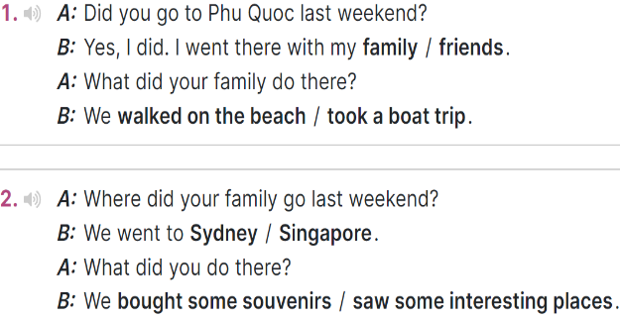  - T ask Ss to guess the answers.  + T writes Ss’guessing on the board.  - Listen to the tape:  + Play the recording  + Play the recording again and get Ss to swap books with their partners.  + Play the recording again to check answers together as a class.  + Write the answers on the board for Ss to correct their answers. Then checks Ss’ guessing.  - Play the recording, sentence by sentence, for the class to listen and repeat in chorus.  Key: 1. family; took a boat trip  2. Sydney; saw some interesting places  Activity 2. Read and complete  *Aims: Ss will be able to complete two gapped exchanges with the help of picture cues  *Procedure:  - Have ss look at the pictures and identify the places, the characters and the activities in the pictures.  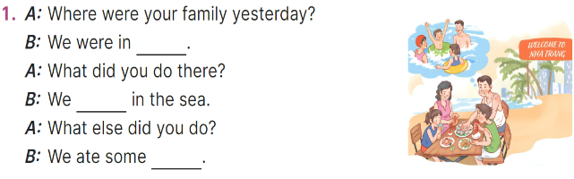  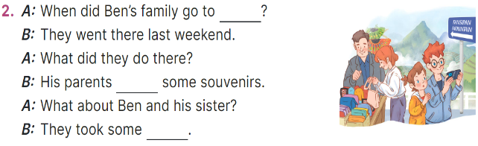  - Have Ss look at the 2 incomplete exchanges and elicits the missing words in the sentences.  - T models with the first gapped  + Ask Ss what is missing in the sentence (Nha Trang).  + Have Ss look at the picture and identify the needed information (We were in Nha Trang.).  - Have Ss work in pairs and complete  - Get Ss to swap books with a partner and check their answers before checking as a class.  Key:  1. a dolphin, Why  2. pizza, don’t, a sandwich  Activity 3. Let’s play.  *Aims: Ss will be able to reinforce the use of target vocabulary for asking and answering questions about past activities and travel destinations by playing the When and What game  *Procedure:  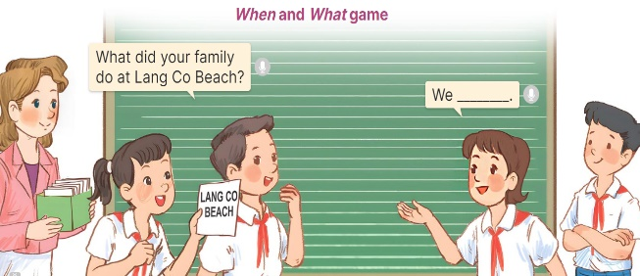  - Tell ss that they are going to play the When and What game and use the past tense form of irregular verbs such as take, eat, buy, swim and go.  - Divide ss into Team A and Team B and explain the rules  - Team A and Team B switch roles  - Set a time limit for ss to play the game. When the time is up, the team that has provided more correct answers is the winner.  - Invite a few groups to the front of the class to play the game.  Game: Pass the balls  - Give two different coloured balls to two pupils, a red ball (ask the question) and a yellow ball (answer the question).  - Ask ss to listen to music and pass the balls.  - Stop music suddenly.  - The teacher raises a picture. Have the student with a red ball make a question. Have the student with a yellow ball answer the question.  - Praise ss if they do the activity well. | - Ss pay attention.  -Ss play the game  -Ss play the game  - Ss congratulate to the winner  - Ss open their books  - Look at the pictures and say  -Ss guess the answers  - Ss listen to the tape and match  - Ss listen again, match and swap books with their partners.  - Ss check their answers and guessing  - Ss answer and check  -Ss listen and repeat.  -Ss look at the picture and say  -Ss follow the teacher demonstrating the exchange 1.  -Ss read and answer  -Ss work in pairs and fill in the gaps  - Ss swap books and check  aa  -Ss listen and pay attention  - Ss play the game  -Ss play the game  -Ss play the game  -Ss play the game  Ex:  A: What did your family do in Sydney?  Pupil B: We saw some interesting places.

D. ADJUSTMENTS (if necessary):
………………………………………………………………………………………….…..……………………………………………………………………………...……

