Unit 3: A TRIP TO THE COUNTRYSIDE
Period 16
Date of preparing: 23- 10- 21 Lesson 1: Listen and read
Date of teaching: 26- 10- 21
I. Objectives:
By the end of the lesson, Ss will be able to:
Talk about life and activities in the country .
II.Language contents:
a.Grammar: modal COULD with WISH.
Prepositions of time, Adverbial clauses of result
b.Vocabulary: banyan tree, entrance, shrine, river bank, bamboo forest, home village, countryside, picnic, buffalo, journey
III.Techniques: pair work, elicitation, question and answer
IV.Teaching aids: laptop
V.Procedures:
Stages/ Time | Contents | Notes
Warm up  3’  Presentation  5’  Practice  10’  10’  Consolidation  5’  Homework  2’ | -What does your mother / your father do ?  - What do they often do everyday?  T: What activities do you often do?  What activities do you like doing in the countryside?  You are going to listen and read a text about Ba’s visit to the countryside.  *Vocabulary:  bamboo forest: [bæm'bu:] lũy tre  home village: [houm] ['vilidʒ] quê nhà  shrine: [∫rain] miếu thờ  banyan tree: ['bæniən] [tri:]cây đa  entrance ['entrəns](n): lối vào >< exit(n)  [ 'eksit]  river bank (n)  buffalo (n)  journey (n)  a. True or false. Then correct the false sentences.  1 . F  2. T  3 . F: There is a big old banyan tree at the entrance to the village.  4 . F: People had a snack under the banyan tree.  5. F  6 . F: People had a picnic on the river bank.  7 . F  8 . F: Liz took a lot of photos to show the trip to her parents.  9 . T  b.Answers:  1. It’s 60 kms to the North of HaNoi.  2 . Ba and his family got to the village by bus.  3 . The banyan tree is at the entrance to the village.  4 . They saw the shrine of a Vietnamese hero on the mountain.  5.They had a picnic on the river bank.  6.Liz wishes she could visit Ba’s village again.  *Prepositions of time:  after, at, on, in.  EX: They have a rest after a hard working week.  Talk about the activities they do or their parents do every day.  - Writing the activities they or their parents do everyday.  - Reading the text and do exercises again into their notebooks.  - Preparing : Speak/ listen | T asks Ss some questions about the countryside  Ss answer  Presenting the new lesson.  Listening to the tape  Presenting vocabulary  (picture)  VNmese meaning  (picture)  (picture)  VNmese meaning  (picture)  (picture)  VNmese meaning  Reading in chorus  In individual- copying- asking the meaning for each word  Reading the text and doing T or F  Explaining the model doing .  Doing in individual  Checking with their partner.  Giving feedback  Reading the text again and answering the questions  Giving feedback  T asks Ss to give some prepositions of time in the text  Giving example

Unit 3: A TRIP TO THE COUNTRYSIDE
Period 17
Date of preparing: 28- 10- 21 Lesson 2: Speak
Date of teaching: 02- 11- 21
I. Objectives:
By the end of the lesson, Ss will be able to:
Ask for and give information about their own village.
II.Language contents:
a.Grammar: modal COULD with WISH.
Prepositions of time.
b.Vocabulary: pick up , pond, .route , parking lot
III.Techniques: pair work, elicitation, question and answer, game
IV.Teaching aids: laptop
V.Procedures:

Stages/ Time | Contents | Notes
Pre-speaking  6’  While-speaking  15’  Post-speaking  12’  Homework  2’ | * Noughts and crosses : Questions words  Preparing nine cards with numbers on one side and the words on the other.  Sticking the cards on the board and asking Ss to choose the number. Turning over the cards and making questions with the question words on them (who, where, when, what, how far,which, how many, is, are )  a./ EX: T practices with a student.  A: Where is your home village?  B: It’s to the west of the city.  A: How far is it from the city?  B: It’s about 15 kms from the city.  A: How can you get there?  B: We can get there by bus.  A: How long does it take to get there?  B: It takes an hour.  A: What do people do for a living in your village?  B: They plant rice and raise cattle  A: Does your village have a river?  B: There aren’t any rivers, but there is a big lake.  → I wish I studied English well.  → He wishes he were a pilot.  -Writing a short paragragh about your home village. | Playing a game  Ss will chose take turn the number and make question using the word on it  EX: What-  What are you doing?  T- S do a model  Pair work  Asking and answer about their partner’s home village, using the information in the box.

Unit 3: A TRIP TO THE COUNTRYSIDE
Period 18
Date of preparing: 28-10-21 Lesson 4: Read
Date of teaching: 02-11-21
I. Objectives:
By the end of the lesson, Ss will be able to:
Understand the text in details and complete the summary.
II.Language contents:
a.Grammar: Prepositions of time
Adverb clauses of result
b.Vocabulary: exchange students, grow maize, past-time, standard time.
III.Techniques: pair work, elicitation, question and answer
IV.Teaching aids: laptop
V .Procedures:
Stages/ Time | Contents | Notes
Pre-reading  8’  While-reading  8’  8’  5’  Post-reading  4’  Homework  2’ | -Telling students what “ exchange students ” means.  Introducing the text which is about Van an exchange student. He is from HCM city. He is now studying in the USA . He is living with the Parker family on a farm outside Columbus , Ohio.  Telling what they know about life in the country on the farm.  - What do they do?  - What do they grow/ raise ?  - How do they relax ?  T writes on the board  * Guiding questions:  1. How long will Van stay then?  (till the beginning of October)  2.What do Mr & Mrs Parker do ?  3. How many children do they have?  4. What does Van do after finishing his homework?  a/. maize - corn  feed - give food to eat  grocery store- where people buy food and small things  part - time - shorter or less than standard time.  Collect- bring things together.  - Guiding questions:  - What does Mr Baker do?  - What does Mrs Baker do?  - Where does she work?  - Does Van help on the farm?  b/ 1. Ohio  2. Farmer  3. works part – time at a grocery store  4. Peter 5.Same  6. After 7. farm  8.They watch/ watches  9.baseball 10. member  -Reading the text many times  -Writing the summary into their notebooks.  -Learning vocabulary by heart. | T can explain in Vietnamese.  T introduces the content of the text.  T asks Ss to tell  -  Feedback  Correction  Listening to the text  Reading the text and answering the guiding questions  Giving feedback  Reading the text and matching the words in column A with the explaination in column B  write down their answers  Giving feedback  Reading the text and answering the questions  Giving feedback  Reading the summary  Completing it using the information from the passage  Doing in individual.  Giving feedback  Telling the main content of the passage ( or making the interview )

Unit 3: A TRIP TO THE COUNTRYSIDE
Period 19
Date of teaching:05- 11- 21 Lesson 5: Write.
Date of teaching:09- 11- 21

I. Objectives:
By the end of the lesson, Ss will be able to:
Write a short paragraph, describing a story happened in the past, a picnic in the countryside.
II.Language contents:
a.Grammar: Past simple tense
Prepositions of time
b.Vocabulary: lay out, blanket, site
III.Techniques: pair work, elicitation, question and answer
IV.Teaching aids: lap top,
V.Procedures:

Stages/ Time | Contents | Notes
Pre-writing  5’  5’  While-writing  15’  Post-writing  8’  Homework  2’ | - Have you ever gone to a picnic?  - When/ where did you go ?  - How did you get there?  - What did you do?  - When did you come back home?  - Did you enjoy it?  *New words:  to lay out: trải, dọn  site [sait]: địa điểm  blanket ['blæηkit]: chăn, mền  * Notes: use the simple past tense.  Talking to the class about what they can see in each picture.  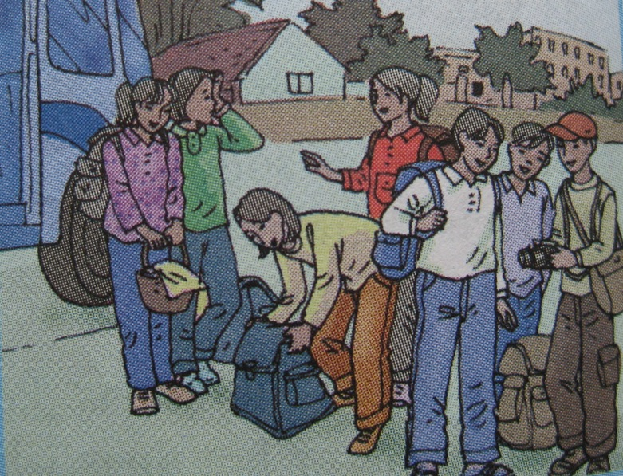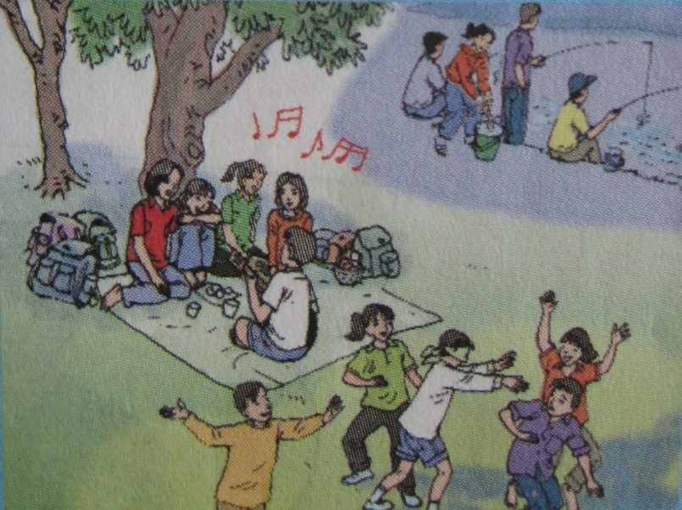  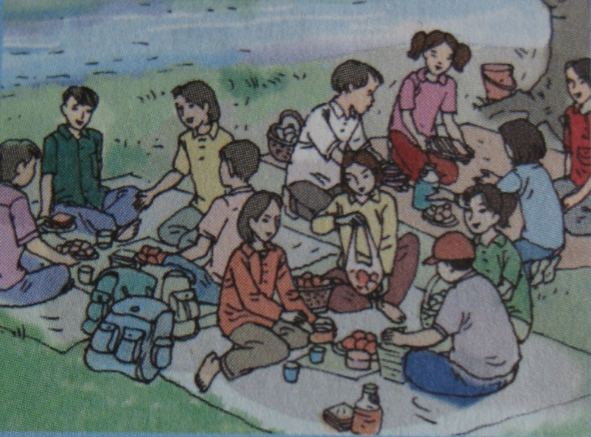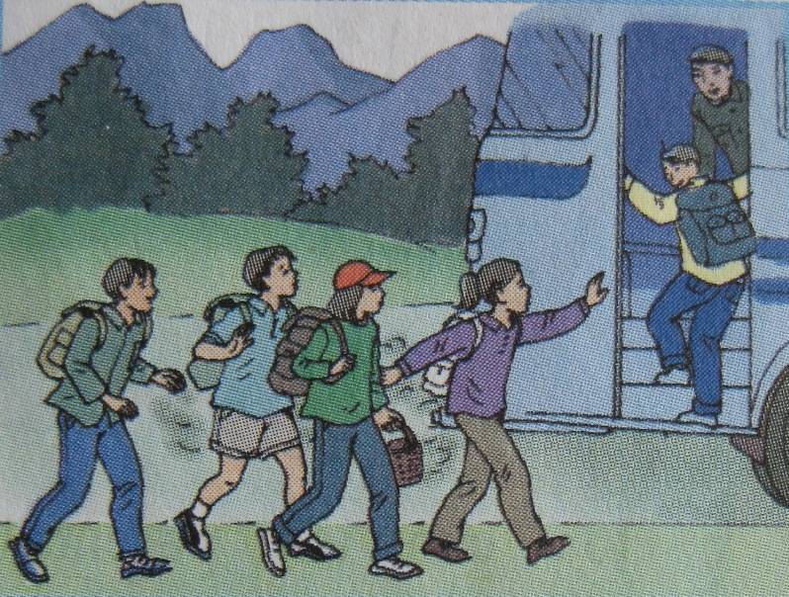  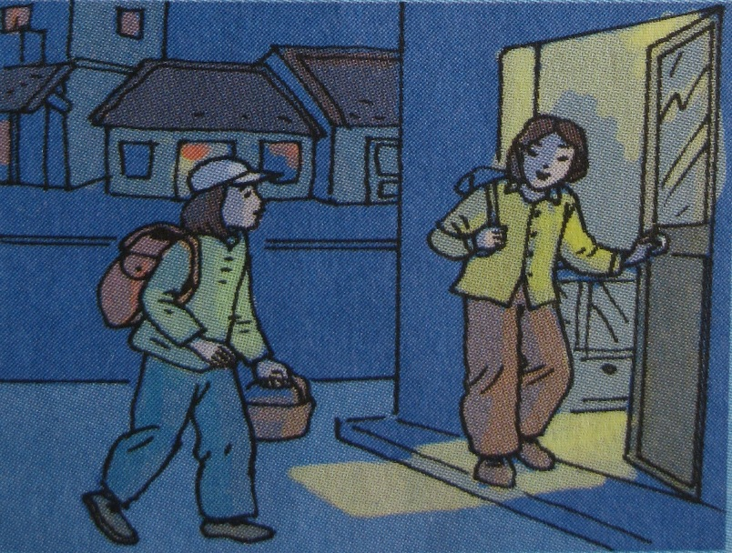  Calling Ss to go to the board and tell.  Ss write a passage entitled  “ A country picnic ”  It was a beautiful day, my friends and I decided to go on a picnic.  T can add more words in order to write easier.  *Suggested writing:  It was a beautiful day, my friends and I decided to go on a picnic.We took a bus to the countryside and then walked about 20 minutes to the picnic side next to the river. We put down the blankets and laid out the food. After meal we played the games. ”What song is it ? “ and blind man’s buff . Late in the afternoon, we went fishing. We enjoyed our picnic. When we looked at the time, it was nearly 6.30 PM. We hurriedly gathered our things and ran to the bus stop. We were lucky to catch the last bus and we arrived home very late in the evening.  Correcting the writing  -Writing their passage after correction in their notebooks.  -Looking at the pictures and telling about a country picnic. | T asks  Ss answer some questions about going on a picnic.  T shows pictures on the screen.  Explaining the exercise.  Reading the cues  Presenting vocabulary  Looking at the pictures, describing them  Giving feedback  T writes a model sentence  Ss use the pictures and cues to write the passage  In individual  T collects the tasks and corrects  Choosing some writing to correct

Unit 3: A TRIP TO THE COUNTRYSIDE
Period 20
Date of preparing: 05- 11- 21 Lesson 6: Language focus
Date of teaching: 09- 11- 21
I. Objectives:
By the end of the lesson, Ss will be able to use the past simple with WISH, prepositions of time and adverb clauses of result.
II.Language contents:
a.Grammar: Past simple with “ wish ”, Prepositions of time , Adverbs clauses of result.
b.Vocabulary: itinerary, depart (v).
III.Techniques: pair work, elicitation
IV.Teaching aids: laptop, smart phone
V.Procedures:
Stages/ Time | Contents | Notes
Warm up  10’  Activity 1  10’  Activity 2  5’  8’  Homework  2’ | * Sentence build:  1. Study English / well  2. be / pilot.  3. wearther / fine .  4. go/ hiking / climbing / our friends .  5. live / big city  6. not rain / often.  7. not work / weekends  8. be / intelligent.  .  I. Wish Clauses:  a. Ba / can have / new bicycle  → Ba wishes he could have a new bicycle.  Express future wish  b. Hoa wishes she could visit her parents.  c. I wish I passed the exam.  d. We wish it did not rain.  e. He wishes he could fly.  f. They wish they stayed in Hue.  * Saturday, Christmas day, winter, September, the evening, 10th October  7 o’clock, night, noon  Prepositions word  At 7 o’clock  Night  noon  On Christmas day  September  10th October  In the evening  September  winter  II. Prepositions of time:  In, on, after, till, until, between, before, up to…….  EX: They have a rest after a hard working week.  2/ page 30  a. at b. on  c. between d. at / till  e. after f. up to  3/ page 30  a. at b. at / in  c. in d. for  e. in f. at  On the first day  What does he do on the first day? The second day ?  What time does the meeting at Raffles center begin ? finish?......  Doing all exercises again in to their notebooks.  Making 3 wishes about the present or future | Ss write the full sentences using “ I wish”  Reviewing the past simple with WISH  T gives pictures on the screen  T presents example  Explaining the way to use of it.  T gives all the pictures on the screen.  Ss write in individual.  Giving feedback  Correction  T gives the table and asks Ss to match the prepositions with the words on the list.  Feedback  Correction.  Presenting the prepositions of time and telling the way to use of them.  Looking at the itinerary and using the prepositions in the box to the example (a)  Group work  Giving feedback  Completing the sentences with at, on, in, for  In individual in pair  Feedback - Correction.
  → Wish + S + V – ed/2 (be : were)
  → Wish + S + could + infi

Unit 3: A TRIP TO THE COUNTRYSIDE
Period 21
Date of preparing: 13- 11- 21 Lesson 6: Language focus
Date of teaching: 16- 11- 21
I. Objectives:
By the end of the lesson, Ss will be able to use the past simple with WISH, prepositions of time and adverb clauses of result.
II.Language contents:
a.Grammar: Past simple with “ wish ”, Prepositions of time , Adverbs clauses of result.
b.Vocabulary: itinerary, depart (v).
III.Techniques: pair work, elicitation
IV.Teaching aids: laptop
V.Procedures:
Stages/ Time | Contents | Notes
Warm up  5’  Activity 1  8’  Activity 2  10’  Activity3  10’  Homework  2’ | Give your wishes  Adverb clauses of result  T : What did everyone do when they felt tired?  Ss: Everyone felt tired and hungry so they sat down under the tree and had a snack.  - Use :to express the result of the statement before.  Meaning : do đó.  1 .e Hoa worked hard, so she passed her exam.  1.e 2. a 3.d 4. b 5. C  Use because to rewrite the sentences  EX: Hoa passed the exam because she worked hard  Do the same 2,3,4,5,6  *Rewrite the sentences as directed  1.What a pity! He can’t come here.  → I wish.....  2.He can’t pass the examination.  → He wishes....  3. She was very tired, so she went to bed.  → She went.....  4. He didn’t go to school because he was ill.  He was...........  *. Choose the correct answer  1. My village is about 80 km……. the suoth of Ho Chi Minh City.  A. in B. at c. To D. for  2. We have some .. students for the program.  A. exchange B. exchanged  C. to exchange D. exchanging  3. We have lived in Ha Noi ….. four year.  A. in B. since C. for D. at  4. I wish you….. us someday.  A. visit B. will visit C. visited D. would visit  5. It rained heavily, …………..I can’t go to the movies with you.  A. and B. but C. because D. so  6. We have many well………….teachers here.  A. qualify B. quality  C. qualified D. qualification  7. Do you know………..  A. when comes the bus  B. when the bus comes  C. when will the bus come  D. when does the bus come  Doing all exercises again in to their notebooks.  Making 3 wishes about the present or future | Ss write the full sentences using “ I wish”  Reading the text again from “Liz met Ba’s family…” and answering  - Explaining .  Explaining the model  Matching the half sentences  In pair  Giving feedback  Correction.  Ask ss to rewrite the sentences  Feedback- correction  Ask ss to do  Feedback- correction

