Planning date: 12– 02 – 2023
Teaching date: 13 – 02 – 2023
Period 64: Unit 8: TOURISM
Lesson 3: A CLOSER LOOK 2
I. OBJECTIVES: By the end of the lesson, Ss will be able to:
1. Knowledge:
a. Vocabulary: review
b. Grammar: Articles: other uses
2. Competences:
- be able to use a/an/the and zero article correctly and appropriately
3. Qualities:
- be interested in the usage of the articles
II. TEACHING AIDS:
1. Materials: Textbooks, plan
2. Equipment: A laptop connected with TV, textbooks
III. PROCEDURES:

Stages/Time | Contents | Notes
Warm up & Lead –in  5’  Presentation  7’  Practice  7’  9’  9’  6’  Homework:  2 mins | Example:  - There is an attraction in our area.  - The traffic in my area is not much, so it’s convenient  for tourists to travel.  * ARTICLES: OTHER USES  REMEMBER! BOX  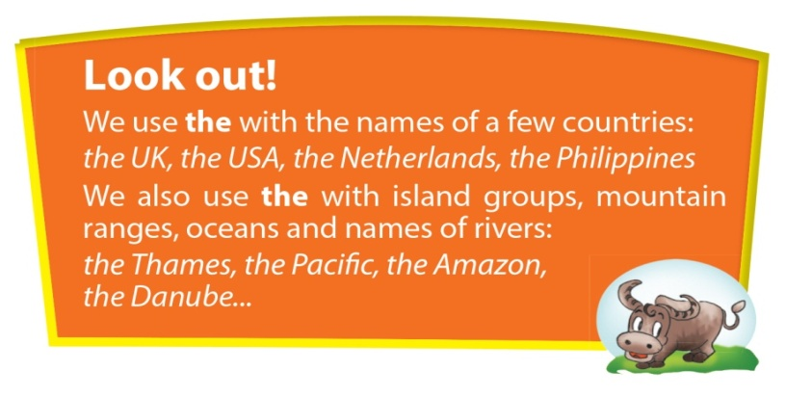  1. Complete the text with a/an, the, or zero article.  Key: 1. a 2. the 3. the 4. the  5. The 6. Ø 7. The 8. Ø  9. Ø 10. The 11. Ø 12. Ø  13. the 14. an  2. a. Ask and answer the questions. Choose from the list. Use the if necessary.  Key: 1.the Forbidden City 2. the Thames  3. Lake Baikal 4. Ha Long Bay  5. Son Doong Cave 6. the Statue of Liberty  b. Tell your answers to a partner and ask him/ her to guess which answers are not true.  3. a. Write answers to the questions, using a, an, the or zero article in each answer. Give three true answers, but two untrue ones.  1. What colour and type of bicycle would you like to have?  2. Which holiday destination do you prefer: city, mountains, seaside?  3. Where would you like to go on holiday next?  4. What’s your favourite time of the year?  5. Have you ever travelled anywhere by plane? Please explain.  b. Tell your answers to a partner and ask him/her to guess which answers are not true.  4. Make full sentences from the words/ phrases, adding articles as needed. Then mark them as true (T) or false (F)  1. The original name of Ha Noi was Phu Xuan. F  2. The most famous Egyptian pyramids are founded at Giza in Cairo. T  3. There is a city called Kiev in America. F  4. My Son, a set of ruins from ancient Cham Empire, is a UNESCO World Heritage Site. T  5. English is the first language in many countries outside the United Kingdom.  - Review a, an, the  - Do exercise in workbook  - Prepare for Communication | -Greetings  -Lead in new lesson by asking some examples using a/an/the  -Ss work in groups, using extra boards. When they finish their sentences, tick them on the board. (T limits the time)  -T comments and introduces new lesson  -T explains carefully the uses of a/an/the and zero article in the REMEMBER! box.  -T introduces the special use of the Look out! box. Refer back to the conversation in Getting started and ask Ss to find the special use of the  -T has Ss work individually to complete the task. Then have them compare their answers with a partner’s.  -Give the correct answers and explain the use of a certain article in some cases.  -Ss work in groups and study the proper names in the list, and try to agree on which of these names have before them. Then Ss ask and answer the questions.  -Ss work in pairs  -Ss work individually  -Feedback and correction  -I would like to have a normal black bicycle.  -I prefer to have holiday in a mountain.  -I’d like to go to Paris on next holiday.  -I love summer.  -I have never travelled anywhere by plane because I haven’t any chance.  -Ss work individually  -Feedback and correction  -Ss work individually  -Feedback and correction  Lead Ss to do at home

